Letter 1


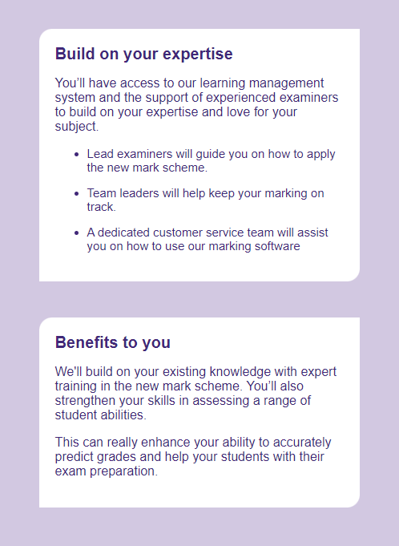
Business Address: TeachingTimes
205 The Jubilee Centre, 130 Pershore St,
Birmingham, B5 6ND, UK,
Company Reg No: 02445043.
Tel: +44 (0) 121 224 7599 | Fax: +44 (0) 121 224 7598
www.teachingtimes.com | enquiries@teachingtimes.com
Letter 2

Dear teacher,
We're excited to share the latest updates and opportunities with you in the newest instalment of our EF Teacher Zone newsletter.
The EF Teacher Development Certificate starts Thursday 16th of February at 17.00 CET.
Learn all about the latest advances in teaching technology and hone your skills as an educator. Our free online teacher training program will refine your teaching skills, introduce you to the latest teaching techniques and provide you with new lesson inspiration.
Register now

Teacher Webinars
Dates & Topics
W1. Speak Out
February 16th, 2023 - 17:00 hrs CET
W2. Effective error correction
February 23rd, 2023 - 17:00 hrs CET
W3. Effective assessment
March 2nd, 2023 - 17:00 hrs CET
W4. Success with CLIL
March 9th, 2023 - 17:00 hrs CET
W5. Motivating language learners
March 16th, 2023 - 17:00 hrs CET
W6. Bottom up listening
March 23rd, 2023 - 17:00 hrs CET
Reminders and notifications will only be sent to those who register.
Register for free

March 10th, 2023 — New deadline to win
Get inspirEd with EF and win one of 20 study trips to the UK for you and a colleague! You could also win one of 25 InspirEd Language Days for your high school.
Travel to London for three days with fellow teachers to attend exclusive sessions and exchange ideas with international colleagues.
All those who sign up will be invited to an exclusive online global language teaching seminar.
Would you like to participate?
Sign up here


Letter 3



Dear Hanna Kryszewska,
Please consider contributing to the Special Track on "Trans- and Inter-Disciplinary Research, Education, and/or Communication" to be held in the context of 14th International Multi-Conference on Complexity, Informatics and Cybernetics: IMCIC 2023, which has been based in Orlando, Florida, USA, and will take place on March 28 - 31, 2023.
You should submit your abstract (300-600 words) at: https://www.iiis-2023conf.org/Spring-SpecialEvents
Accepted articles for which at least one author registered for the conference will be published in
- The IMCIC 2023 proceedings (2000-5000 words), which has been indexed by SCOPUS since 2010.
- A special issue, or section, of the Journal of Systemics, Cybernetics, and Informatics (2000-10000 words), indexed by DOAJ (Directory of Open Access Journals, considered a white-list), since 2003.
- Printed Open-Book (2000-10000 words). Articles for this book should be written FOR Inter-Disciplinary Communication.
No charges, additional to the conference registration fee, will be required for 2 and 3.
Deadlines
January 27, 2023: Submission of Abstracts (300-600 words). It should be made via the web page which URL has been given above. Please do not send it by e-mail, or through the options provided on the conference website under the tab "Authors".
February 14, 2023: Submission of the full papers (2000-5000 words, maximum 8 two-column pages) related to accepted abstracts.
February 28, 2023: Uploading of the final version of the paper through the conference website
Expected deadlines regarding the other two publications are included in the more detailed Call for Articles and Reviewers for this special event, which has been posted at the URL given above.
Both synchronous and asynchronous virtual presentations are possible. Therefore, the authors who participate virtually in the conference have the option of:
- Submitting a slide show and/or a pre-recorded video of their presentation (asynchronous presentation) or
- Making their presentation via Zoom (synchronous presentation)
Additionally, each paper to be presented at the event, virtually or in-person, may be read and commented on, via electronic forums, and evaluated by those participants who have registered for the conference.
Keynote speakers will be selected from registered authors whose submissions are among the best according to their external reviewers. The identification of the best submissions will be based on the quantitative and qualitative evaluation of the reviewers and the percentage of reviewers recommending the acceptance of the submission as related to all the reviewers who made their respective reviews. For this reason, we recommend you to submit your paper early.
Thank you for your time, and we look forward to your contribution.
Respectfully,
IMCIC-TIDREC 2023 Organizing Committee

Letter 4

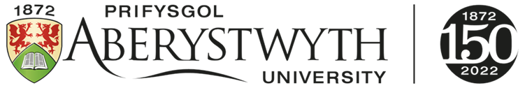

DATGANIAD I’R CYFRYNGAU - MEDIA RELEASE
AU1523
Dydd Iau 19 Ionawr 2023 / Thursday 19 January 2023
I’w ryddhau ar unwaith / For immediate release
Gallai athrawon iaith ddefnyddio nofelau graffeg yn hytrach na thraethodau wrth asesu myfyrwyr  Gellid defnyddio clownio, dramâu radio a nofelau graffeg i asesu myfyrwyr sy’n dysgu ieithoedd, yn ôl gwaith sy’n cael ei arwain gan Brifysgol Aberystwyth.  Mae addysgu ieithoedd modern yn aml yn dibynnu ar asesiadau traddodiadol fel gwaith ysgrifenedig a phrofion gramadeg i fesur perfformiad y myfyrwyr.  Serch hynny, mae tîm o academyddion Ieithoedd Modern yn ysbrydoli athrawon a myfyrwyr i fabwysiadu ffyrdd newydd a chreadigol o ymchwilio i ieithoedd ac o asesu myfyrwyr sy’n dysgu ieithoedd – trwy gyfrwng celf.  Mae'r tîm wedi lansio'r ‘Creative Modern Languages Hub’, adnodd ar-lein rhad ac am ddim sy'n cynnig enghreifftiau o ddulliau asesu creadigol ac ymchwil artistig o'r Deyrnas Unedig a thu hwnt.  Mae arweinydd y prosiect, Dr Alex Mangold – darlithydd yn yr Adran Ieithoedd Modern ym Mhrifysgol Aberystwyth - yn egluro:  "Fel athrawon sy’n dysgu ieithoedd modern, gallwn fesur sgiliau iaith myfyrwyr trwy osod traethawd neu arholiad llafar. Serch hynny, rydym yn awyddus i ysbrydoli athrawon i feddwl ‘y tu allan i'r blwch’. Bwriad ein casgliad eang o enghreifftiau o ddulliau asesu creadigol yw tanio'r dychymyg a dangos y potensial y gall creadigrwydd artistig ei gynnig.  "Gall ymarferion creadigol ac ymchwil artistig myfyrwyr gynnwys blogiau, podlediadau, ffilmiau byrion, gosodweithiau celf, nofelau graffeg, barddoniaeth, paentio, ffotograffiaeth, monologau theatrig, clownio, animeiddiadau, perfformiadau digidol a cherddoriaeth."  "Mae'r dulliau hyn yn gwahodd myfyrwyr i wneud pethau mewn ffyrdd gwahanol a mwy diddorol ac, yn y pen draw, gallent annog mwy o fyfyrwyr i astudio ieithoedd modern yn ein prifysgolion."  Mae’r tîm yn gobeithio y bydd eu casgliad o enghreifftiau yn ysbrydoli cydweithwyr a myfyrwyr i arbrofi â mathau creadigol o asesu ac ymchwil artistig ym maes Ieithoedd Modern, gan ddangos i fyfyrwyr sut y gall astudio iaith fodern danio’u potensial creadigol.  Ariannwyd y prosiect gan Wobrau Datblygu Talent yr Academi Brydeinig 2021.  Mae'r Tîm Ieithoedd Modern Creadigol yn cynnwys Dr Alex Mangold (Prifysgol Aberystwyth), Dr Sarah Pogoda (Prifysgol Bangor) a Fernando Castellano-Banuls (Prifysgol Aberystwyth).  Mae'r ‘Creative Modern Languages Hub’ ar gael ar-lein yn https://creativemodernlanguages.uk.  Diwedd  Llun:  Enghraifft o Brifysgol Galway, Iwerddon. Llyfr i blant a grëwyd gan fyfyriwr fel rhan o fodiwl yn Sbaeneg am lenyddiaeth plant.  Credyd: Pilar Alderete Diez (Prifysgol Galway, Iwerddon)  Dolenni:  Creative Modern Languages Hub  Rhagor o Wybodaeth:  Dr Alex Mangold, Adran Ieithoedd Modern, Prifysgol Aberystwyth  arm@aber.ac.uk  Alice Earp, Cyfathrebu a Materion Cyhoeddus, Prifysgol Aberystwyth  ale@aber.ac.uk  Prifysgol Aberystwyth www.aber.ac.uk  Sefydlwyd Prifysgol Aberystwyth yn 1872 ac mae’n brifysgol addysgu ac ymchwil flaenllaw. Enillodd wobr Ansawdd y Dysgu The Times/Sunday Times Good University Guide ddwy flynedd yn olynol, a chafodd ei henwi’n Brifysgol y Flwyddyn yng Nghymru yn 2020. Yn ôl Arolwg Cenedlaethol y Myfyrwyr 2022, mae Aberystwyth ar y brig yng Nghymru ac yn ail yn y DU o’r prifysgolion a restrwyd yng nghanllaw prifysgolion y Times / Sunday Times 2023. Dengys y Fframwaith Rhagoriaeth Ymchwil diweddaraf (REF 2021) bod 98% o'r ymchwil a gyflwynwyd gan Aberystwyth o safon ryngwladol neu'n uwch, a dros 75% ohono o safon sy'n arwain yn y byd neu'n rhagorol yn rhyngwladol. Mae'r Brifysgol yn gymuned o oddeutu 8,000 o fyfyrwyr a 2,000 o staff, â'r nod o ddarparu addysg ac ymchwil sydd yn ysbrydoli mewn awyrgylch cefnogol, creadigol ac eithriadol. Elusen gofrestredig rhif 1145141. |  | Language teachers could ditch essays in favour of graphic novels  Language learning could be assessed through clowning, radio plays and graphic novels, according to work led by Aberystwyth University.  Modern language teaching often relies on traditional assessments like written work and grammar tests to measure student performance.  However, a team of Modern Languages academics are inspiring teachers and students to adopt new and creative ways of researching language and assessing language learning - through art.  The team have launched the Creative Modern Languages Hub, a free online resource which provides examples of creative assessment and artistic research from the UK and beyond.  Project leader, Dr Alex Mangold - a Lecturer in the Department of Modern Languages at Aberystwyth University - explains:  “As modern languages teachers, we can measure the language skills of students by setting an essay or an oral examination. However, we want to inspire teachers to think outside the box. Our wide-ranging collection of creative assessment examples is intended to fire the imagination and demonstrate the potential that artistic creativity can bring.  “Creative student exercises and artistic research can include blogs, podcasts, short films, art installations, graphic novels, poetry, painting, photography, theatrical monologues, clowning, animations, digital performances and music.”  “These methods invite students to do things in different and more interesting ways, and could ultimately encourage more students to study modern languages at our universities.”  The team hope that their collection of examples will inspire colleagues and students to experiment with creative forms of assessment and artistic research in the field of Modern Languages, and demonstrate to students the creative potential that studying a modern language can unleash.  The project was funded by the British Academy Talent Development Awards 2021.  The Creative Modern Languages Team consists of Dr Alex Mangold (Aberystwyth University), Dr Sarah Pogoda (Bangor University) and Fernando Castellano-Banuls (Aberystwyth University).  The Creative Modern Languages Hub is available online at https://creativemodernlanguages.uk.  Ends  Image:  An example from the University of Galway, Ireland. A children’s book created by a student as part of a module in Spanish about children’s literature.  Credit: Pilar Alderete Diez (University of Galway, Ireland)  Links:  Creative Modern Languages Hub  Further Information:  Dr Alex Mangold, Department of Modern Languages, Aberystwyth University  arm@aber.ac.uk  Alice Earp, Communications and Public Affairs, Aberystwyth University  ale@aber.ac.uk  Aberystwyth University www.aber.ac.uk  Established in 1872, Aberystwyth is a leading teaching and research university. Twice winner of The Times/The Sunday Times University of the Year for Teaching Quality, it was Welsh University of the Year in 2020. In the 2022 National Student Survey, Aberystwyth is ranked the best university in Wales and second in the UK for student satisfaction of the universities featured in 2023 The Times/ The Sunday Times Good University Guide. In the latest Research Excellence Framework, REF 2021, 98% of the University’s research activity was of an international standard or higher with over 75% being ‘world leading’ or ‘internationally excellent’. The University is a community of around 8,000 students and 2,000 staff committed to delivering inspirational education and research in a supportive, creative and exceptional environment. Registered charity No 1145141

Letter 5

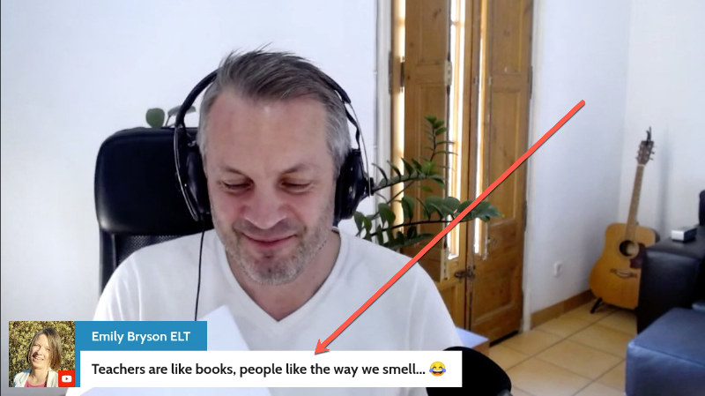
Hello Hanna
Last week, I went LIVE on YouTube to explore possible uses for ChatGPT – a powerful artificial intelligence chatbot that is now available to the public.
Here are three short highlights from the session:
1. ChatGPT writes an essay in the style of Yoda from Star Wars (07:54)
️ HIGHLY RECOMMENDED ️
This video will give you an overview of what ChatGPT can do and what teachers should be aware of
Click here to watch the video
2. Why don't you ChatGPT it! (03:29)
Like Google, ChatGPT will soon become a verb
Click here to watch the video
3. ChatGPT writes a story (09:36)
Taking inspiration from story dice
Click here to watch the video
During the LIVE, we had a discussion about whether or not teachers will be replaced by ChatGPT. My favourite comment came from Emily Bryson who pointed out that we are in no danger of losing our jobs for one very good reason:
"Teachers are like books, people like how we smell." 

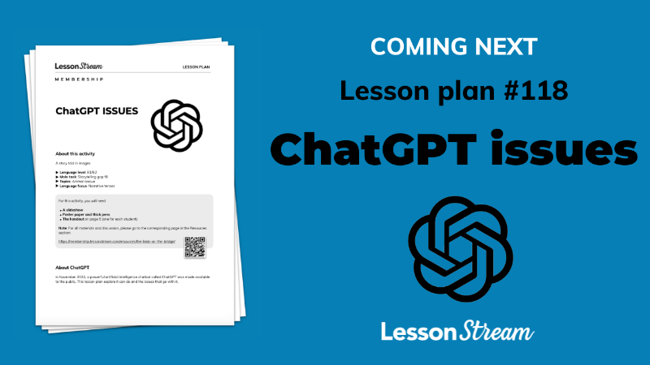

You might know Emily. She is an author, teacher trainer and doodler extraordinaire. And later today (THURSDAY), she will be joining us in the LessonStream Membership to introduce us to the wonderful world of graphic facilitation.
- Date: January 19th 2023 (TODAY!)
- Time: 7pm CET (Barcelona time)
- Click here to convert to your time zone
You can find out more about Emily and download her free ebook at her website:  https://www.emilybrysonelt.com/

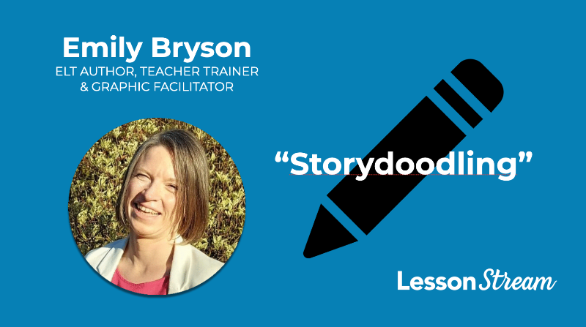

Join the LessonStream membership

Also in the LessonStream Membership:
• Resources: Lesson plan #118 (coming next week) will allow you and your students to explore issues around ChatGPT.
• Teacher development: Members can now access unit eight in the Story Course: "Teacher talk techniques: 26 qualities & techniques to develop your voice as a pedagogical instrument."
Click here for more about the LessonStream Story Course
It would be great to have you on board 
Thank you for reading!
Jamie

Join the LessonStream membership



