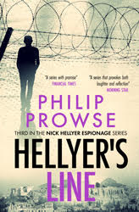

From aRetired TEFLer: Helleyer’s Line

Philip Prowse, UK

… hugely enjoyable and distinctive … blends the almost absurdist complexities required of the espionage genre with honed humour and meticulous historical research MORNING STAR 04/12/2022

A series with promise FINANCIAL TIMES A series that provokes both laughter and reflection MORNING STAR

Nick Hellyer hunts a British diplomat turned Russian spy as the Greek military junta collapses in Athens and invading Turkish tanks storm across Cyprus.
Unravelling motives for the betrayal of country and the trust of others takes him into a world of divided loyalties, private tragedies and public massacres.
Sexual blackmail by the KGB, dirty tricks from the CIA and Greek terrorist attacks induce flashbacks to past traumas as he sieves suspects. A nightmarish interrogation while high on LSD opens up a path of self-discovery which leads him to the heart of a labyrinth of deceit.

ISBN 978-1-3999-2319-4 amazon.co.uk amazon.com

For more information go to the bottom of the page

