Visual Representations as a Means to Motivate Students and Curb Feelings of Isolation in Distance Learning
Alena Hradilová and Barbora Chovancová, the Czech Republic

Barbora Chovancová and Alena Hradilová are both teachers of English for Lawyers at Masaryk University Language Centre in Brno, Czech Republic, and they take pride in writing their own teaching materials, focusing also on the visual aspects to promote student well-being. Recently, they have co-written and published a book of texts and accompanying activities entitled Pravnická angličtina (Legal English) aimed at Czech lawyers, law students, translators and other professions with vested interest in the language of law.

Selecting personal anecdotes to share with students is a fragile dance between opening up and maintaining appropriate boundaries. Finding ways to weave in personal stories may offer an effective instructional tool and a means through which teachers can build trust with students.
(Jorgensen: 2022)
Introduction
The aim of this article is to show how conscious inclusion of visual content and pictorial self-disclosure may positively influence the learning experience of students in distance learning. Online courses, regardless of whether taken voluntarily or not, are not conducive to forming personal relationships, be it among the course participants themselves or between the course participants and the teacher. Student well-being and community building have therefore become increasingly important considerations in designing any teaching materials, and language courses are no exception. Studies carried out by both medical (Browning et al. 2021) and pedagogical experts (Dennis 2022) attest to the fact that newer generations of students appear to be more psychologically vulnerable and need to be treated with greater care. This article outlines how visual representations may help to build and sustain good working relationships among learners and to boost their motivation.
It has been shown that the affective and social dimensions form a crucial part of success in language learning (Mercer and Dörnyei 2020), and student well-being has recently gained prominent attention among both scholars and practitioners (Mercer 2022, Waters 2021). It is now viewed as an essential element in ELT, a human right in its own right as Mercer (2022:14) points out. It is thus the role of the teacher to foster an environment in which students can flourish. This can be relatively easily achieved in the classroom, but with distance learning this requires advanced planning. Some of the commonly used strategies may involve well-planned student work on small group projects or students being put into break-out rooms to have a chance to practice communication skills and build personal relationships.
Apart from class management strategies, it is also important for the teacher to insist on including visual aspects in online classes. Many teachers attest to the problem of student reluctance to use their cameras when working online. Such lack of visual stimulation seems to be one of the triggers for feelings of isolation, especially as students’ private lives are often filled with images posted on Instagram and other social media. The teacher should be firm in requesting that the students keep their cameras on. But all is not lost even if, for whatever reason, it is not practicable. This void may be at least partly filled by using still images to introduce members of the class and to lead students through the course. The best results are undoubtedly achieved by a combination of both – moving and still images representing the students and the teacher. Thoughtful pictorial self-disclosure by the teacher may set boundaries, giving an example the students may follow. Students may participate by adding their own photos, co-creating a positive course atmosphere, helping to build community, and to a certain extent even contributing to the course content.

Why use images in distance learning
Feelings of isolation in language learning online
Even before the impact of COVID-19, the question of student isolation, loneliness, and anxiety in online teaching had been addressed by numerous studies (Owens et al. 2009, Croft et al 2010, Sadeghi 2019, Ajmal and Ahmad 2019). As a burning issue since the pandemic, recent literature mentions a lack of positive attitude, motivation, and cooperation resulting in the feeling of isolation (Almazova et al. 2020, Kaisara and Bwalya 2021, Noor et al. 2020). Bruggeman et al. (2022) also discuss social challenges like “maintaining sustainable communication with communities of inquiry” and deal with the question of the lack of informal human contact and the controversy of entering the student’s personal space. Hapsari (2021: p. 47) advises that collaborative learning with peers proves to be a helpful tool to overcome these issues. We took this advice on board and focused on promoting student well-being, cooperation, and motivation in the then unfamiliar-for-us context of online education.
Can visuals really help?
The effectiveness of using images to illustrate a point or to help struggling students grasp difficult concepts has long been recognised in language teaching and learning, going as far back as the scholar Comenius’ teaching in the 17th century. The same still holds true in today’s modern world (Wojewoda 2018). Additional compelling reasons cited for using images in language teaching include to enhance creativity, engage visually oriented students, and help students express their feelings.
Pictorial self-disclosure, whether images of oneself or things related to oneself, on the part of both teachers and students, is beneficial for building a classroom community (Jackson 2021). This is echoed by Henry and Thorsen (2021), who, citing Zhang et al. (2009), state that teachers perceive the reasons for self-disclosure as twofold: strengthening the learning content (e.g., examples from the teacher’s life to illustrate a point), and, equally important, promoting a positive atmosphere in the classroom and bonding with the students, which the authors term “relational” self-disclosure.
During the enforced lockdowns of the pandemic, the affective impact of using visual images has come to the forefront of teachers’ attention, overshadowing, or at least equalling, the original illustrative purpose. In distance learning, sharing images can help to promote social and emotional connectedness, factors that promote mutual trust, warmth, and empathy in the group, which are crucial for language learning (Dörnyei and Ushioda 2021). Crucially, it also fosters student ownership of class content, as students need to take an active part in selecting or making images.
Another strictly practical advantage of using visual images for language work online is that it is a manageable, convenient, and quick-to-set activity. Pictures can easily and readily be shared online by students, as they generally tend to store them on their devices or social media. Students can choose pictures they like to show and share, and even shy students generally own pre-selected illustrative (status) pictures they feel positive about.
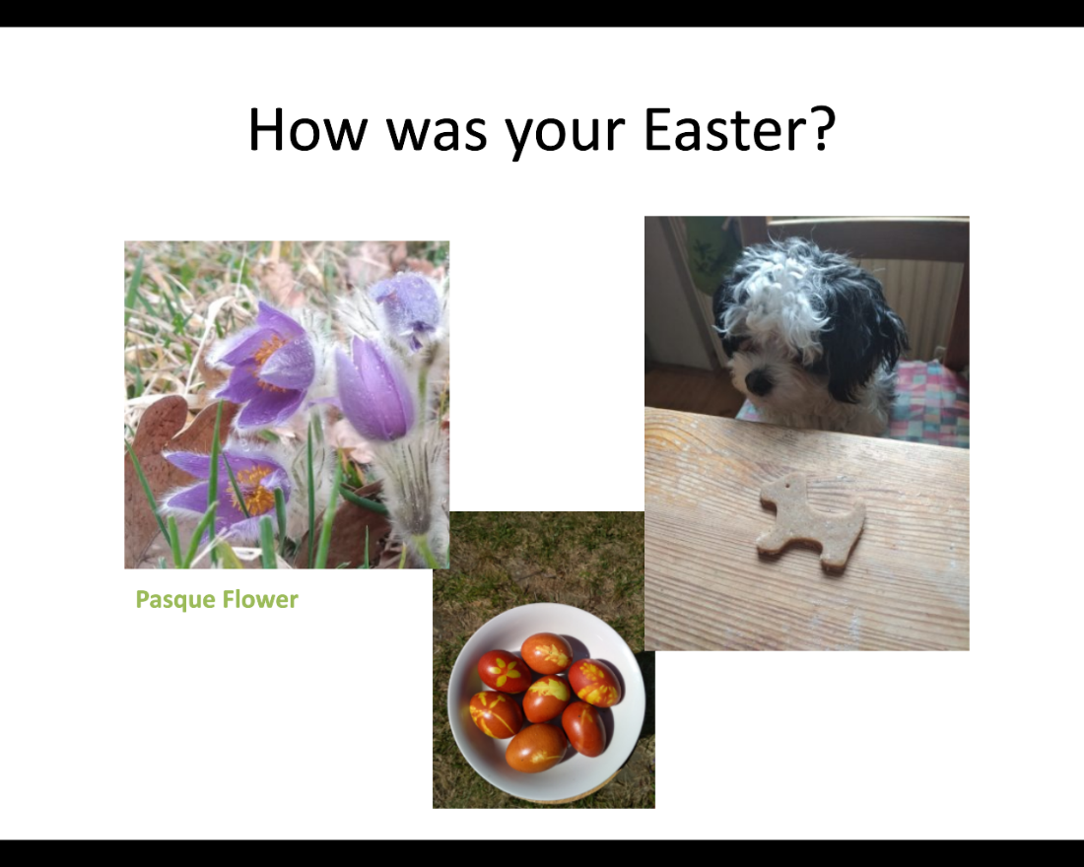
Fig. 1: An attempt at creating emotional connectedness: setting up a sharing warm-up task

Building “us”
There is no way around it—a two-dimensional image of a teacher’s face on screen cannot fully replace the presence of a real living and breathing person in the classroom. Building personal connections online is doubtlessly more difficult and requires careful planning. As Annala (2020) puts it: “The physical distance between teachers and learners and between learners as a group called for careful attention to community-building processes.”
A classroom in our teaching situation can indeed be seen as a community of practice. Its features correspond to Wenger-Trayner’s (2015) definition of a community of practice as a group that “share a concern or a passion for something they do and learn how to do it better as they interact regularly.” To enhance the building of such community of practice, we need to attend to its typical features, which are the domain that helps to establish the group identity; community as a group of interacting people; and practice, e.g., past knowledge, future learning, and mutual trust. The domain is established at the beginning of the course via setting common goals for the course and allowing students to voice their expectations. The other two features can prove to be more sensitive and complicated in online environments, as the community aspect calls for quality communication and practice requires mutual trust.
Sharing common attitudes, interests, or personal features through visual representation may function as conversation boosters and further communication based on shared images aids in socializing, icebreaking, and strengthening social bonds, which form the foundation for mutual trust. The first step is to make a student-friendly environment in the videoconferencing platform, both by using a cordial style in the messages and via visual means. Some more tips on how to build good classroom relationships are shared in the next section (How to use images in distance learning).
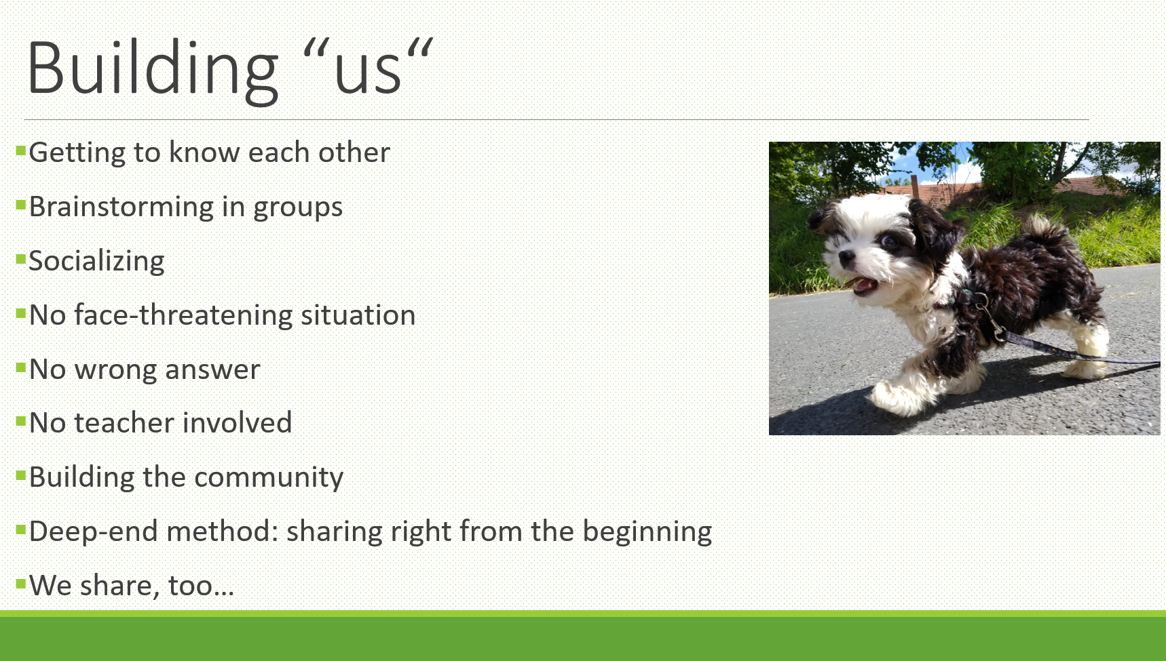
Fig. 2: To-do list for teachers
No face-threatening situations
Another advantage of personalized and simple tasks based on sharing visual representations is that the purpose of their use in the session is established as semi-formal, informal, and openly playful. The ever-present imperative of no wrong answers and no peer criticism must therefore be remembered and frequently voiced. Hapsari (2021) suggests that anxiety in students in online environments may be connected with their urge to get everything right. Making mistakes is considered embarrassing (Hapsari 2021: 46) and thus should be avoided. This may result in a lack of confidence to participate actively while online and on camera. However, activities involving shared images take place mostly in private student groups, very often taking the form of brainstorming (hence no criticism), icebreakers, and unstructured free talk. The teacher is often excluded, waiting outside the break-out rooms for the groups to bring the selected and mutually approved results of the discussion or a product to be shared with the whole class. Such a learning situation is thus safe, partly informal, and does not allow for much (if any) embarrassing feedback either from the teacher or from peers.
Images have been introduced in our classroom to be shared by both students and teachers. The following section offers some thoughts on if, when, and how a teacher can or indeed should share pictures and some tips on activities for student sharing.

How to use images in distance learning
Teacher self-disclosure via photo images
One of the ways to build a good teacher–student relationship is through mindful teacher self-disclosure, i.e., sharing information in the classroom “about a self that may or may not be related to the subject content, but reveal information about the teacher that the students are unlikely to learn from other sources” (Sorensen 1989: 260, as cited in Henry and Thorsen 2021). Teacher self-disclosure can have a positive impact on the classroom atmoshpere, increase student motivation, and promote communication (Henry and Thorsen: 2021).
“In ordinary day-to-day situations, such as language classrooms, interaction partners have established relationships” (Henry and Thorsen: 2021). With law students, their expectations regarding teacher–student relationships may be somewhat blurred. The students may either base these expectations on their secondary school language classes or relate them to their recent experiences from university law seminars, which may be at opposite extremes. According to their own accounts, subject-specific teachers (law teachers) tend to be more formal, and the format of communication is often of the teacher interacting with a few most communicative/brightest students in a question-answer-comment format. Communication in some seminars is reportedly more constrained by the fear on the part of the students of giving a wrong answer and losing face, in some extreme cases even being humiliated (Course feedback English for Lawyers 4, Spring 2021). In an online context, student expectations may be even more unpredictable. It is, therefore, advisable to establish the preferred principles of interaction and disclosure and to start building mutual trust early on.
In an online environment, teacher disclosure does not necessarily have to be oral; it can also take a visual form. During online seminars, students were encouraged to share pictures of everyday activities (the way I relax/keep sane in lockdown) or season-specific pursuits (pictures of Easter decorations), and the same was done by the teacher, who had a small puppy who found its way into the weekly PowerPoint presentations, revealing aspects of the teacher’s private life, e.g. nature walks and outings, parts of the living space, and creating a positive atmosphere in which many of the students started sharing pictures of their pets or generally things that made them happier and capable of coping with the situation. The inclusion of these visual images played a manifold role: creating a pleasant atmosphere, emphasizing well-being, promoting playfulness and creativity, arousing curiosity (what situation will the dog be presented in today), and showing care.
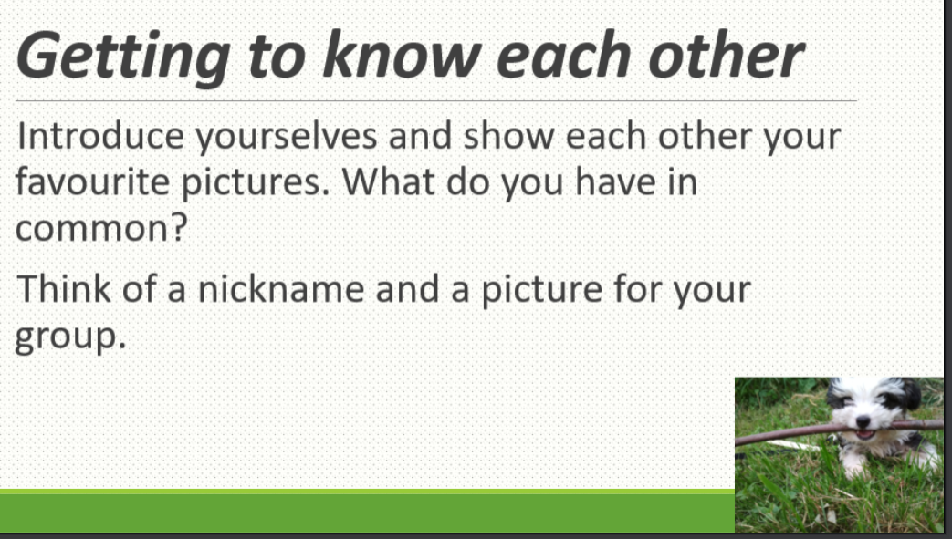
Fig. 3: Example warm-up task
Do the same rules apply to face-to-face interaction?
Conscious inclusion of visual images, and activities based on them, was later introduced to students in voluntary online international sessions with the aim to build personal relationships and define group identity. Interestingly, they also proved to be successful in a hybrid teacher training workshop for language teachers given at a Learner Autonomy SIG at IATEFL 2022. The collected feedback seems to indicate that they work equally well under the new “back-to- normal” circumstances, be it voluntary online or hybrid settings or face-to-face lessons, as shown below.
During the online sessions, it was the teacher’s conscious aim to use the puppy images. When the normal face-to-face lessons were restored, this practice was discontinued, as it was believed to be superfluous, but no effort was made to remove all the images from the PowerPoint slides and some of the dog photos remained there. Even this reduced visual content was viewed as worthy of unprompted, positive comments by a number of students in their end-of-course feedback. Out of 28 feedback forms, the dog was mentioned 3 times explicitly in answer to the following question: What did you enjoy about the whole course/this semester in particular? The responses were: I was looking forward to see (sic) the teacher’s dog. Very lovely. / The dog in presentations (sic) was cute. And group presentations were fun too. / The dog. Overall interactivity. The omnipresent good vibes! The structure of this course is second to none. One student even included a pictorial representation of a stick-figure dog (feedback collected on paper, English for Lawyers, Spring 2022). It was interesting to note that only one student questioned their presence in the presentation, saying s/he can see no point in them being there.

Keeping the balance right: what to share and not to share
The opening motto of this article mentions “a fragile dance between opening up and maintaining appropriate boundaries” among group members and “weaving in personal stories” in order to “build trust” (https://www.edutopia.org/article/connecting-students-through-strategic-sharing). “Weaving in” is an accurate expression to describe how the use of images is planned and incorporated into the course design as an integral part of the community-building pillar for a course. Images in different forms become a natural and integral part of the course. We adopt the deep-end method wherein both the teacher and students start sharing images from the very beginning of the course. In some cases, bringing a photo to describe and share is set even earlier as a pre-course task. This sets the mood and atmosphere of the whole course.
As far as boundaries are concerned, there has been no explicit effort made to define rules of what is appropriate to share and what constitutes inappropriate or insulting images. So far, it has proven to be enough to teach by example and to rely on the university students’ general overall decency, social intelligence, and common sense.
Sample activities involving student-shared images
The following list describes example activities where an image is used for classroom work:
- Write an “About me” blog entry and use a photo of yourself that you like (at the beginning of a new term as an icebreaking activity).
- Choose a photo that would represent how you are feeling right now (as an icebreaker, motivation/energy-booster).
- Take a photo of something that can be described in legal terms, e.g., a photo of someone buying a magazine, a dishevelled room to illustrate a burglary (to revise new vocab, used as an interactive group activity where fellow students make guesses about the legal issue, brainstorming).
- Share the photos from the previous activity and vote for the best photo (for review, rounding up).
- Take a photo of the Easter decorations in your room/house (for community building, sharing, well-being).
- Take a photo of the best present you got this Christmas (for community building, sharing, well-being).
- Choose a picture that would represent your team (for community building, humour, creativity).
- Tell us or share a picture of what makes you happy these days (for community building, sharing, well-being).
- Make a meme that represents a newly learnt concept, rule, or vocabulary item (for review, community building, humour, creativity).
- Make a mind map of what you learnt in class today using pictures (for review, creativity).
Many of these activities are easily adaptable to face-to-face classrooms (selecting and showing existing photos, taking new photos, graphically editing existing pictures, when working on group identity, etc.) and we consider them just as effective.
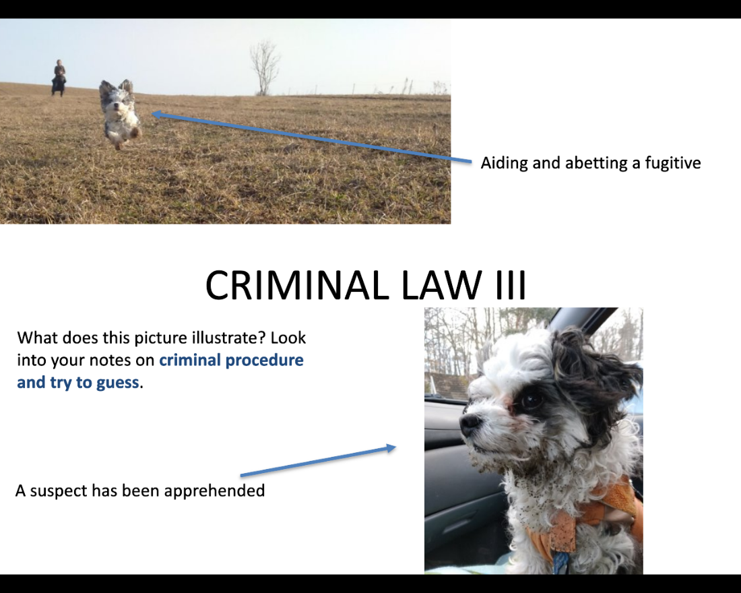
Fig. 4: Preparation for the activity “Take a photo of something that can be described in legal terms we’ve just learnt”
Student reflection on the visual aspect of the lessons
This is how the students in the second term of law studies felt about their online English for Lawyers 2 course in Spring 2021 (samples selected from 30 replies). The questionnaire was generally worded (What did you like about the Legal English classes?) and no specific prompt about the visual aspect was included. The fact that the students chose to comment on it unprompted seems to show that to them it was an important aspect worthy of comment.
- I liked photos of this little dog during every lesson and our friendly teacher. I also liked the fact that I didn’t have to be stressed during our lessons because we weren’t under pressure and the teacher was nice to us, we didn’t have to be ashamed when we didn’t know something.
- I really liked your photos of the dog - it is encouraging and I am more optimistic in the morning. I also enjoyed your teaching method, positive attitude and speaking with my colleagues in pairs.
- Always very friendly and had liked that each lesson was different, we did a various kinds of work (sic), we talked a lot during the lessons and everyone was involved in the talk. I also enjoyed the colorful presentations with nice pictures. Positive vibes only. I think I learned a lot.
- I liked the variety of the course as there were many different activities we did, such as watching some videos, reading texts, speaking in pairs... I really enjoyed working in breakout rooms. What I appreciate is the way the lessons were held, I mean the presentations with exercises, pictures, homeworks (sic) etc. They make the lesson easy to follow and I believe I remember the information much better when seeing it. Eventually, I need to say that I learned a lot during the course.
- I also appreciate, how our teacher cares about us, asking about our Easter break (i.e. students were asked to share photos) etc., so it’s not just about the things we should learn.

Conclusions

It is our view that images can be carefully woven into the fabric of ESP course design, regardless of the age and specialisation of the learners. Pictorial representations are effective, and easily manageable by the teacher, and, moreover, they promote student autonomy and self-expression, which strengthens their ownership of the content. Images can have a two-fold use in the language classroom. They can be used as a basis for particular teaching activities, but they can also serve, jointly or independently of such a task, to build a community and promote well-being. The latter goal can be achieved by a careful mix of student sharing and teacher self-disclosure, which can be both oral and visual, as this article has demonstrated.
Student well-being has deservedly become a buzzword in modern language methodology and given the present instability in the world, it is bound to remain so. Our contribution, as presented in this article, concerned the visual sharing and pictorial self-disclosure used in online teaching that resulted from the urgent need to curb student loneliness in induced online education. The concept, however, worked equally well in voluntary online sessions where the participants were only relatively isolated and can also be translated into hybrid or face-to-face teaching contexts. So, referring again to the fragile dance we quote as the motto for this article, regardless of whether the question “May I have this dance” is metaphorically asked in the classroom or online, the teacher should tread softly and carefully plan their steps but should not be afraid to say yes. In our opinion, it is well worth the effort because when one joins the others on the dance floor there is less chance to feel isolated.
Literature
Ajmal, M., & Ahmad, S. (2019). Exploration of anxiety factors among students of distance learning: a case study of Allama Iqbal open university. Bulletin of Education and Research August,41(2), 67-78.
Almazova, N., Krylova, E., Rubtsova, A., & Odinokaya, M. (2020). Challenges and opportunities for Russian higher education amid COVID-19. Education Sciences. 10(12), 368. https://doi.org/10.3390/educsci10120368
Annala, H. (2020). Interview: How to design an online course. https://cjvict.edublogs.org/2020/09/23/how-to-design-an-online-course/#.Yuo_pXZBzcs.
Browning M. H. E. M., Larson L. R., Sharaievska I., Rigolon A., McAnirlin O. & Mullenbach L., et al. (2021). Psychological impacts from COVID-19 among university students: Risk factors across seven states in the United States. PLoS ONE 16(1).
Bruggeman, B., Garone, A., Struyven, K., Pynoo, B. & Tondeur, J. (2022). Exploring university teachers’ online education during COVID-19: Tensions between enthusiasm and stress. Computers and Education Open, 3. https://doi.org/10.1016/j.caeo.2022.100095
Croft, M., Dalton, A., & Grant, M. (2010). Overcoming isolation in distance learning: building a learning community through time and space. Journal for Education in the Built Environment, 5(1), 27-64.
Dennis, M. J. (September 2022). Post-pandemic: Some ‘forever’ changes to higher education. University World News, 3, https://www.universityworldnews.com/post.php?story=20220902154032439
Dörnyei, Z., & Ushioda, E. (2021). Teaching and researching motivation (3rd ed.). Harlow: Longman.
Hapsari, C. (2021). Distance learning in the time of Covid-19: Exploring students’ anxiety. ELT Forum: Journal of English Language Teaching, 10(1), 40-49.
Henry, A., & Thorsen, C. (2021). Teachers’ self-disclosures and influences on students’ motivation: A relational perspective. International Journal of Bilingual Education and Bilingualism, 24(1), 1-15.
Jackson, J. T. (2021). Ethnography: Building a Thriving Classroom Community in the Face of a Pandemic. Claremont Graduate University School of Education: Teacher Education. https://scholarship.claremont.edu/cgu_sec/2.
Jorgensen, R. (2022). Connecting With Students Through Strategic Sharing, https://www.edutopia.org/article/connecting-students-through-strategic-sharing
Kaisara, G., & Bwalya, K. J. (2021). Investigating the E-learning challenges faced by students during Covid-19 in Namibia. International Journal of Higher Education,10(1), 308-318. https://doi.org/10.5430/ijhe.v10n1p308
Mercer, S., & Dörnyei, Z. (2020). Engaging Language Learners in Contemporary Classrooms. Cambridge: Cambridge University Press.
Mercer, S. (2021). An agenda for well-being in ELT: an ecological perspective. ELT Journal,75(1), 14–21. https://doi.org/10.1093/elt/ccaa062
Noor, S., Isa, F.M., & Mazhar F.F. (2020). Online teaching practices during the Covid-19 pandemic. Educational Process International Journal 9(3), 169-184.
Owens, J., Hardcastle, L., & Richardson, B. (2009). Learning from a distance: the experience of remote students. Journal of Distance Education, 23(3), 53-74.,
Sadeghi, M. (2019). A shift from classroom to distance learning: advantages and limitations. International Journal of Research in English Education, 4(1), 80-88.
Waters, L. (2021). Positive education pedagogy: shifting teacher mindsets, practice, and language to make wellbeing visible in classrooms. The Palgrave handbook of positive education, 137-164. Palgrave Macmillan, Cham.
Wenger, E., McDermott R., & Snyder W. (2002). Cultivating communities of practice: Guide to Managing Knowledge, Harvard Business School Press.
Wenger-Trayner, E. & Wenger-Trayner, B. (October 2015). Introduction to communities of practice - A brief overview of the concept and its uses. https://www.edutopia.org/article/connecting-students-through-strategic-sharing
Wojewoda, M. (2018). The Concept of Image According to John Amos Comenius and New Media. Philosophy and Canon Law 4, 85-99. https://www.ceeol.com/search/article-detail?id=892627
Please check the Pilgrims f2f courses at Pilgrims website.

Please check the Pilgrims online courses at Pilgrims website.

