‘We Stand on the Shoulders of Giants’: In Celebration of the Life of N.S.Prabhu

remembered by Alan Maley, UK

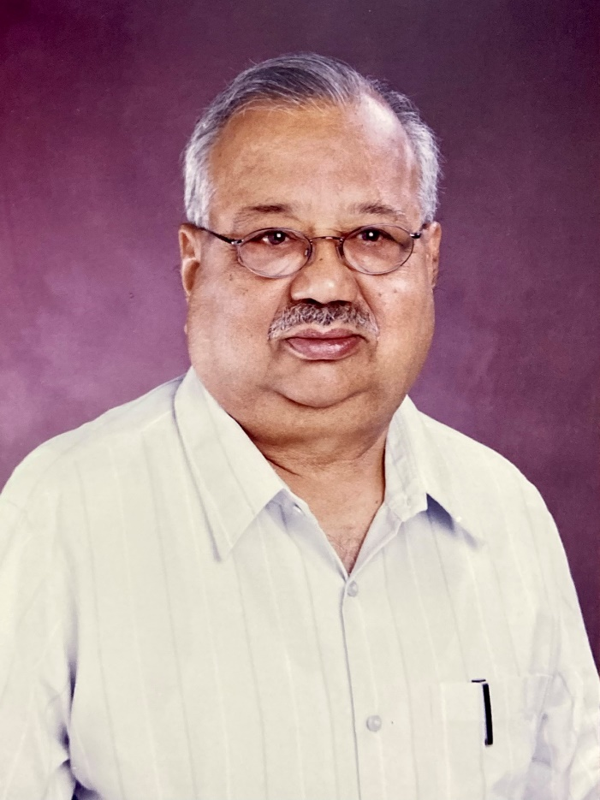

With Prabhu’s passing, the ELT profession has lost one of its giants. For those of us who knew him personally, this is self-evident, as it is for those who knew him only through his work. It is however likely that many readers may never have heard of him – and are unaware of just how much of their beliefs and practices were influenced by his thinking.
Prabhu was both iconic, in having developed new perspectives on language teaching and teacher training, and iconoclastic in challenging accepted beliefs and methodology.
This is best exemplified in his Bangalore Project (1979-84). In setting up this project, he was in fact challenging the status quo of English Language Teaching in India at the time. The dominant paradigm was the Structural/Situational approach. This operated on the basis of a carefully-graded syllabus of structural items and restricted vocabulary. The basic assumption was that learning outcomes could be predicted. Learners were assumed to learn what teachers taught. Prabhu took issue with this approach, arguing that teaching and learning were not necessarily reciprocal processes, as the title of one of his provocative articles suggests: ‘Teaching is at most hoping for the best’ (Prabhu 2019: 241-252). He went further however, arguing that by engaging learners in problem-solving tasks, they would learn the language incidentally while their conscious attention was actively focussed on a cognitively-demanding task. To put his theory to the test, he worked for 5 years with a number of primary and middle schools in Bangalore, (Karnataka State, South India). He subsequently published an account of the experiment along with his theoretical framework in Language Teaching Pedagogy (Prabhu 1987). His work inspired further development of the Task-based Learning (TBL) by the Willises and others (Willis 1996). So he is rightly considered the godfather of Task-based learning.
One of the consequences of the task-based approach to language learning was its effect on views of teacher training. Clearly, it was of little use to train teachers in preparation for a set of predictable procedures, if in fact, the teaching process required them to be able to operate in an unpredictable context. Prabhu conceived of teacher expertise in terms of what he called the ‘Teacher’s sense of plausibility’ (Prabhu 2019:331-340). What he meant by this was that whatever kind of formal training undergone by teachers, they would inevitably interpret it in the light of their own beliefs and experiences about teaching and learning. And this was not conceived of as a fixed state but a constantly-evolving development in response to ongoing experience and to new theoretical and practical inputs. So his ideas restored teacher agency as teachers progressively developed personal theories of learning. (Ramani 1987. pp 3-11). In current terms we would call this Continuing Professional Development (CPD).
His independent thinking should come as no surprise, given that he had already shown signs of it in his early collaboration with WWS Bhaskar in publishing English Through Reading, 1 & 2(1974, 1975), well before Krashen and the Extensive Reading movement promoted acquisition through reading. And in co-developing a new concept language course, the Gul Mohar series (1974), which is amazingly still going strong 50 years later. (Prabhu et al. 1974)
As I have suggested, many teachers may be unaware of his work. This is partly due to the fact that his seminal work took place in India, far from the metropolitan centres of ELT power. Also to the fact that the only book he published outside India was Language Teaching Pedagogy (1987). For a deeper understanding of the originality of his thinking, we are now fortunate, thanks to the editorial efforts of Geetha Durairajan, to have the collected articles published in his lifetime, in Perceptions of Language Pedagogy (2019). This chronologically-arranged collection shows the development of Prabhu’s ideas from 1966 till 2018. It is a treasure house of material for teachers to take inspiration from, and for teacher trainers to exploit in their courses.
Prabhu did not seek the limelight but it was nonetheless fitting that in 2021 he was given the ELTons Lifetime Achievement Award.
He will be remembered for his sharp intellect, his original ideas, his practical wisdom and his humane care for colleagues and students. We shall not see his like again.
Note: Thanks are due to Prabhu’s daughter Vidya, Paul Gunashekar, Mike Garman and Keith Johnson for help with details.

References

Bhaskar, W.W.S. & Prabhu, N. S. (1974, 1975) English Through Reading (1 & 2.) Madras: Macmillan.
Prabhu, N.S. et al. (1974) Gul Mohar: Language for Life. Hyderabad: Orient Black Swan
Prabhu, N.S. (1987) Second Language Pedagogy. Oxford: Oxford University Press.
Prabhu, N.S. (ed. Durairajan, G.) (2019) Perceptions of Language Pedagogy. Hyderabad: Orient Black Swan.
Ramani, E. (1987) Theorizing from the classroom. ELT Journal, Vol 41, Issue 1. pp 3-11.
Willis, J. (1996) A Framework for Task- Based Learning. London: Longman

