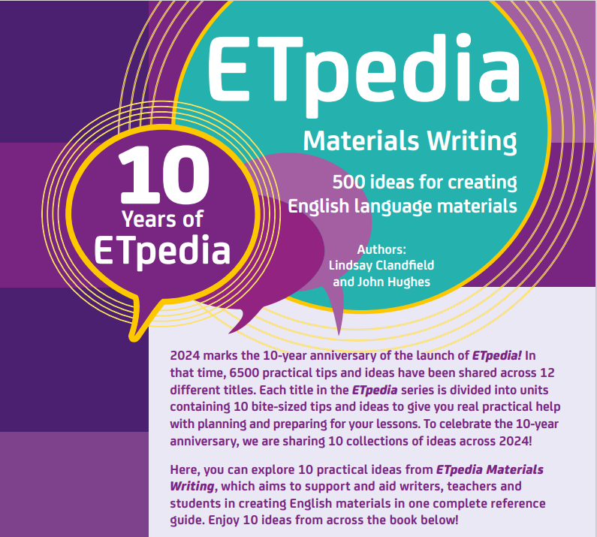

You can download the ideas at the bottom of this page.

