Mentoring Teachers: Supporting Learning, Wellbeing and Retention by Angi Malderez

review by Mariana Serra, Argentina
Acknowledgement
Special thanks to my dear Ana García Stone for her constructive feedback.
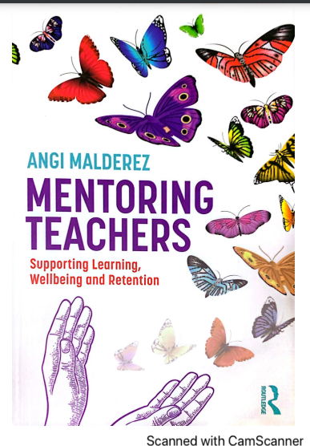

As a mentor of teacher researchers who is always trying to improve their own practice for the benefit of my mentees as well as for personal and professional reasons, I approached this book with great enthusiasm. As soon as I started reading it, I could not put it down and read it from cover to cover sharing with Angi Malderez her passion for mentoring. Captivating from beginning to end, this practical handbook contains ‘some background ideas, some theory’ and at the same time Malderez describes her non-judgemental approach and her five-mentor-role model.

In terms of structure, the book consists of ten chapters which are followed by an appendix and an index. In all the chapters, Malderez explains the way the chapter is organised and gives reasons for such an organisation. At the end of each chapter and before the References section, she tells the reader what comes next and invites her audience to read on. The author begins the book by expressing her deep gratitude towards those who accompanied her during her writing process.

By stating that her view on teacher mentoring relates to ‘helping mentees learn teaching’, in her introductory chapter entitled Introduction and definitions, Malderez tells the reader who she is and who she imagines the readers are, what her book is and what it is not. She also shares with her audience the reasons for writing her handbook, what she hopes her audience can find in it and describes her mission as helping mentors stay off-line, non-evaluative and non-judgemental, supportive of mentees' wellbeing and psychosocial needs, individualised and tailored to the specific and changing needs of each mentee, developmental and growth oriented, promoting mentees’ ‘learnacy’ and empowering and enabling mentees to become autonomous (ONSIDE) (Hobson, 2016). The author goes on to describe concisely the five roles a mentor plays (each of which is presented in detail in Chapters 2 to 6), the crucial importance of a mentor’s work, the three types of teacher knowledge mentors have and use and makes reference to concepts like scaffolding, mentoring, coaching and includes tables to make her ideas clearer to her audience. Reference to notions such as learning, metaphors and mentor’s words are made before a summary of each chapter is included. Malderez also refers to the way the book can be read at the very end of this chapter.
While Chapter 1 begins with a thinking task, Chapters 2 to 6 address each of the five mentor roles described in Malderez’s approach. Each of them starts with a brief explanation about the way they are organised. Mentees’ assessment is dealt with in Chapter 7 which is divided into four parts: some of her own stories when being assessed, the concept of assessors and assessing teachers, the comparison between assessors and mentors and the last part is devoted in detail to what mentors do. Ideas, practices and theories which the writer and some of her colleagues found useful for developing as a mentor are dealt with in detail in Chapter 8.
In Chapter 9, the author explains the two ways in which she looks at the concept of ‘stories’: as a way of understanding teacher knowledge and as an old didactic tool before stating that the purpose of sharing three stories with the readers is because mentors have found it helpful to experience and because they have had an impact on their own development. The first one is her favourite in relation to her view of the notion of mentoring and an inspiration for the cover of her book; the second one shows clearly the five roles mentors play and the third one relates to the notion of noticing. Commentaries in the form of messages about different ideas taken from the stories by diverse mentors have been included at the end of this chapter.
Malderez starts Chapter 10 by making reference to her aims when writing her book directed at teachers becoming mentors and practising mentors in any context. In order to illustrate the way mentoring influences mentors’ development, to suggest further advances in the field of mentoring and to encourage beginning mentors, the writer shares three professional stories of people who have developed as mentors or have undertaken mentor courses. Therefore, her final chapter ends with the author expressing thanks to the reader for reading her book, for being her source of inspiration, for the work each of the readers does as a mentor wishing them ‘instances of flow, fun and satisfaction’ and encouraging further development during their mentoring journeys.

The clarity with which this book has been written and organised makes it a very user-friendly resource for all mentors of teachers in different contexts. By emphasizing the importance of mentors remaining ONSIDE and avoiding judgementoring, this book makes a practical contribution to teachers becoming mentors as well as to practising mentors and challenges some established views, processes and practices. In Mentoring Teachers Supporting Learning, Wellbeing and Retention, mentors will not only learn about an original approach to mentoring but they will also find the writer’s accounts from her own experiences, stories, commentaries, tasks and new inspiration from a passionate and experienced mentor. Malderez talks directly to the reader from beginning to end offering all her expertise and the desire to share an empowering type of mentoring during which mentors and mentees enjoy successes, mentees meet their needs for ‘freedom and choices’ being able to enjoy the beneficial aspects of effective mentoring- learning of teaching and of reflective practice, wellbeing and retention.

You can read extracts of the book here.

References
Hobson, A.J. (2016). Judgementoring and how to avert it: introducing ONSIDE mentoring for beginning teachers. International Journal of Mentoring and Coaching in Education. Vol. 5, N°. 2, pp.87-110.

Please check the Pilgrims f2f courses at Pilgrims website.

