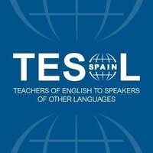

Convention 2025

TESOL-SPAIN 48th Annual National Convention
14-16th March, 2025

www.TESOLSPAINBurgos2025.com

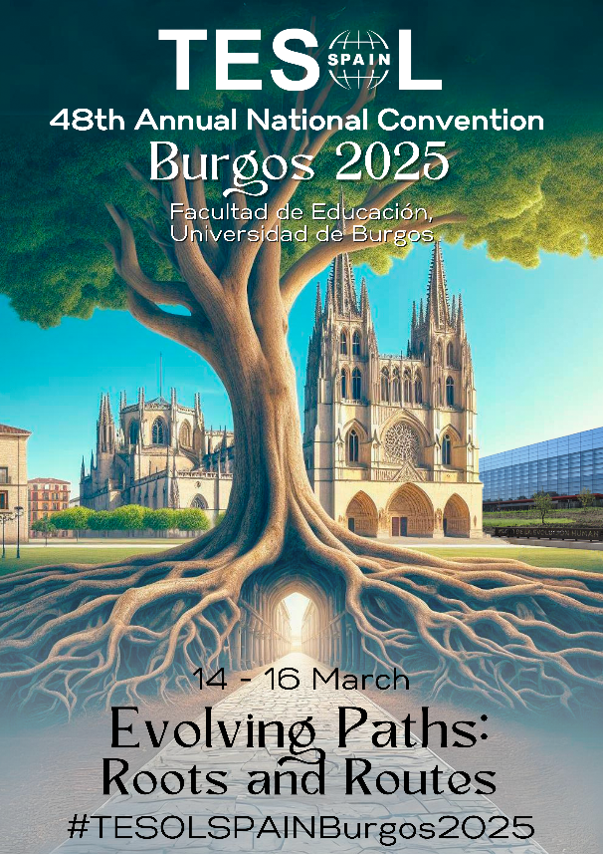

The 2025 convention theme, Evolving Paths: Roots and Routes, encapsulates the dynamic journey of learning and teaching English as a second language. It suggests a progression, an ongoing process where the 'roots' represent the foundational knowledge and cultural heritage that each individual brings to the learning environment.

And what better place to explore evolution from the roots than a city whose vision of the future is based on studying the origins of human thought and speech. It seeks this understanding along so many different paths, with each individual following their unique journey ahead in the world of learning and communication.
Educators need to know how to teach in the challenging situations that face us in today's world-, the challenges of AI, the tragedies of refugees and wars, the importance of citizenship competence, celebrating diverse abilities and learning styles while also acquiring and in depth knowledge of areas such as materials design, evaluation, assessment practices, literacy development and to be able to put all of this into practice in a way which will enhance learning. We must reflect on how we currently approach our classrooms and what our teaching will look like in the future, as COMMUNICATION has to be the final goal of all the multiple paths the ELT teacher may follow.

The convention offers participants a wide range of presentations by national and international speakers, plenary and keynote presentations, papers, workshops and roundtables. It is attended by a wide variety of EFL professionals including teachers from infant, primary and secondary schools, EOIs, universities, technical schools and academies as well as teacher trainers, materials writers, and course planners. Publishers, ELT researchers, members of exam boards, and national and international authors also take part.

We welcome presentations which deal with creativity and innovation, critical thinking and problem solving, communication and cooperation, ICT literacy, bilingualism and multilingualism, AI, mediation, and topics relevant to the competences in the 2030 Agenda for Sustainable Development and its 17 Sustainable Development Goals (SDGs), as well as presentations which are of wide general interest to language teachers working in different sectors and with students of all ages.

https://www.tesol-spain.org/en/pages/5/convention-2025.html

