Visually Impaired Students Train Teachers How to Teach Them

Stephen Reilly Jr, Egypt

Stephen Reilly Jr works as a Senior Teacher at the British Council in Cairo, Egypt. His current interests lie in teaching reading, teacher mentoring, the integration of special educational needs (SEN) students, and teachers’ own second language learning. In his free time, he’s learning to read Arabic, one consonant at a time.


Summary

Stephen Reilly Jr describes a teacher-training session for teachers in Cairo, Egypt on how teachers can better teach the visually impaired given by two blind students. The students prepared and rehearsed the sessions with him before delivering them to some thirty teachers blindfolded throughout. As this event was considered to be a resounding success, he encourages other teaching centres to follow this lead.

Two blind students from our British Council English language classes in Cairo gave our teachers training sessions earlier this year on how to better teach learners with visual impairment.

Reasoning for the sessions

We’d been running in-house training sessions on teaching special educational needs (SEN), the aim of which was on promoting inclusion in our classrooms. However, it dawned on us after the sessions that the actual voices of the SEN students were going unheard, and so we thought ‘Why don’t we get them to train us?’ Thus stepped up Rehab and Shrooq, two blind women from our B1 and B2 levels.

Preparation

We prepared the training sessions with them by determining the content, the sequence of activities, and a Q&A session with questions from the teachers to our student teacher trainers. Shrouq and Rehab also agreed to the suggestion that the teachers be blindfolded throughout the training because, as Rehab exclaimed, ‘then we trainers will be the strongest in the room’. And so it proved to be.

Entering the session

Just before the session commenced, the teachers gathered on the teaching centre balcony, blindfolded themselves with scarves, then groped their way down the corridor to the classroom darkened with blacked-out windows for the event. After much stumbling and bumping into walls, doors and each other, they finally found chairs and sat down. Thus, the first lesson was learnt: people with visual impairment require more time to carry out some tasks than sighted people, therefore teachers should consider this when estimating timing in lesson plans, and setting up and concluding classroom activities.

Do’s

Shrouq and Rehab then introduced themselves to the teachers and launched into a Do’s and Don’ts section for teaching the visually impaired. One ‘Do’ was that teachers break down listening and reading activities into fewer sections. Setting many questions prior to an audio recording task requires that visually impaired students memorise them, and then listen out for the answers to each one, and this can result in memory overload. And although the working memories of our two visually impaired students outperform others’ within the teaching centre, the audio exercises are nonetheless easier for them when broken down into smaller, more manageable segments of two or three questions only. Their advice applies to written text and reading exercises too.

A second ‘Do’ was ‘Notify us of the lesson material well in advance’. Many visually impaired students rely on friends and family members to read them the text of material prior to lessons, the success of which depends on the latters’ availability and English levels. Others read text through text-to-speech screen readers such as Immersive Reader on MS Word, and Read Out Loud on Adobe. However, managing these features efficiently requires some ease with IT and so SEN students’ ability to handle them varies. Therefore the earlier students receive the material, the better they perform in class.

Don’ts

The first ‘Don’t’ was ‘forget to include us when using the board’. Our teacher trainers asked that we make our lessons less board-focussed, which has, admittedly, become a tendency in today’s projector- and IT-dependent classrooms. Boards then should be used sparingly in classes with SEN students.

The second ‘Don’t’ was ‘pair us with random classmates to read the text on the board to us’. Classmates who read text or describe images to the visually impaired students must have a good range of vocabulary to understand what they’re reading and intelligible pronunciation to be understood.

Q&A session and experience of blindness

Finally, our animators hosted an instructive and revealing Q&A section during which they fielded questions from the teachers on their daily lives. As we listened to Shrouk and Rehab, we ealized that both had quite different experiences of blindness. One’s was from birth, the other’s acquired much later; one was a fluent reader of Braille, the other was a beginner; one was highly IT-literate and flipped through several screen readers simultaneously, whilst the other grappled with one only; and one depended on her family for all outings, whereas the other navigated public transport unaccompanied around Cairo. This section of the training highlighted the necessity and importance of dialogue between the teachers and visually impaired students so that we may discover about and better respond to their educational needs.

Take-aways

So, once the scarves had been taken off, what were the teachers’ take-aways? For one, deprived of their vision throughout the session, they had become more aware of the concentration levels demanded to follow a lesson amidst the background noise of air fans, footsteps, barking dogs, slamming doors, busy traffic, and the clamour of other students speaking. It’s essential then to eliminate unwanted distractions so that the visually impaired students can concentrate better.

A second take-away was the importance of addressing each other by our names to indicate systematically who we are speaking to.

Two more take-aways were those mentioned above: granting more time to visually impaired students to complete tasks and breaking up listening and reading tasks into manageable chunks so that they have time to answer all questions.

Lastly, and perhaps most importantly, Shrouq asked that they be treated first and foremost ‘as human beings and not as people with problems’.

Conclusion

These sessions were both for the teachers and the visually impaired students an enriching encounter. By making our students into teacher trainers, we inverted the habitual roles of teacher-student and we gave ourselves our first real opportunity to have an open and honest discussion about visual impairment. Considering that the teachers left the session with tangible measures to apply in their classrooms and a deeper understanding of visual impairment, the sessions were considered, all in all, a note-worthy success. We in the academic team look forward to more SEND students (and teachers) training our teaching centre staff.

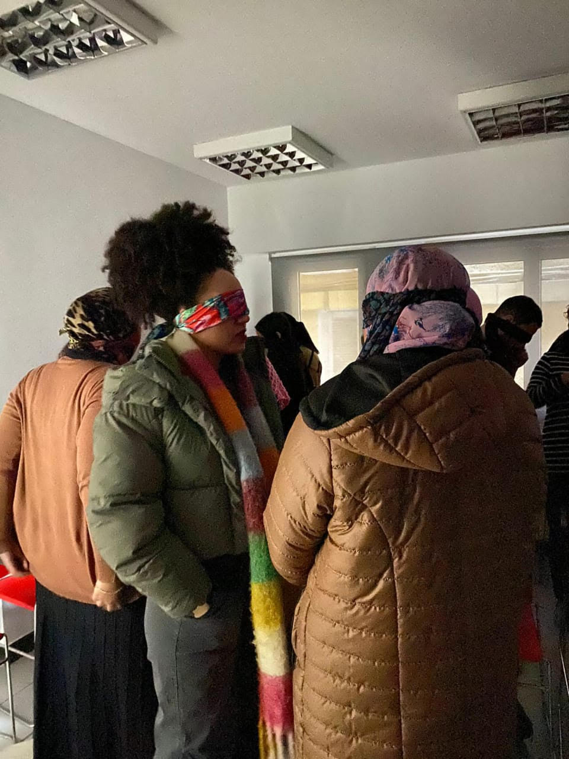
Photos taken by iPhone in Night mode

References
https://www.teachingenglish.org.uk/professional-development/teachers/inclusive-practices/articles/teaching-english-blind-students

https://www.teachingenglish.org.uk/professional-development/teachers/inclusive-practices/articles/needs-visually-impaired-vi-learners

Delaney, Marie. 2016. Special Educational Needs, OUP.

Please check the Pilgrims f2f courses at Pilgrims website.

