RO-HU Regional ELT Conference in Oradea, Romania, 21- 22 September, 2024
attended by Stefania Ballotto, Pilgrims
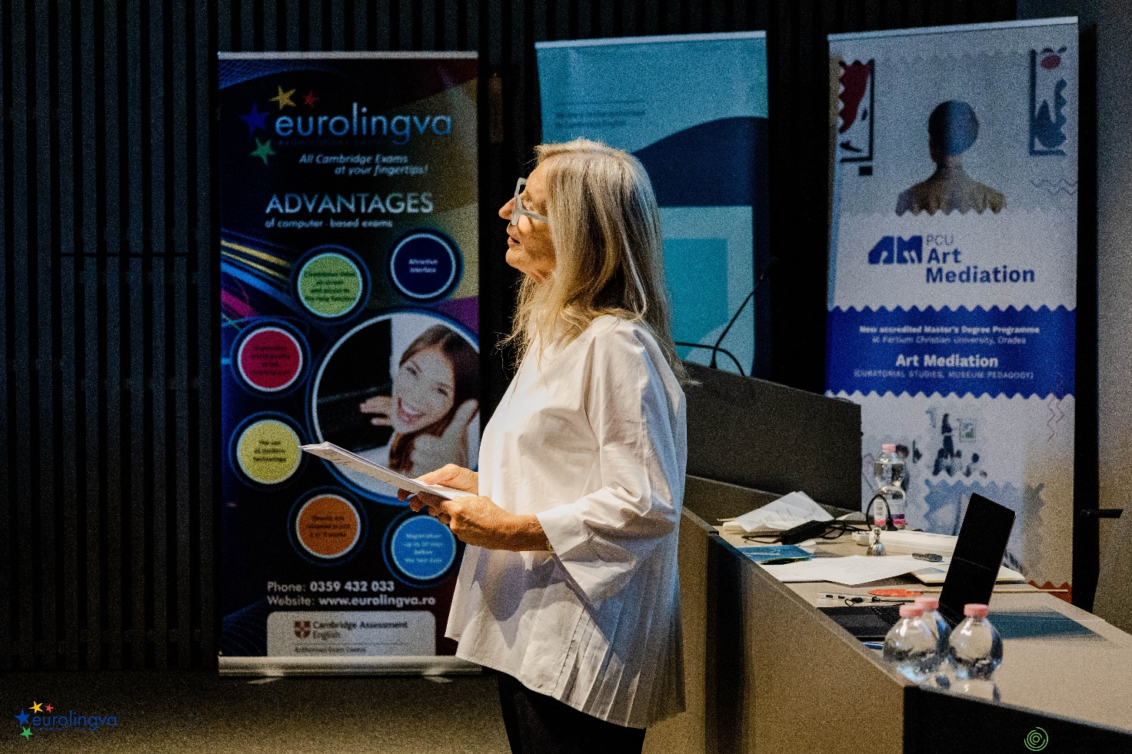

Attending the recent RO-HU Regional ELT Conference in Oradea, Romania, 21- 22 September, 2024 where I represented PILGRIMS was an absolute privilege.
The impeccable organisation set the tone for an event that was both professional and inspiring. From the warm welcome to the highly participative attendees, every aspect reflected a deep commitment to excellence. This thanks to expertise of the hosting team for creating such an unforgettable event.
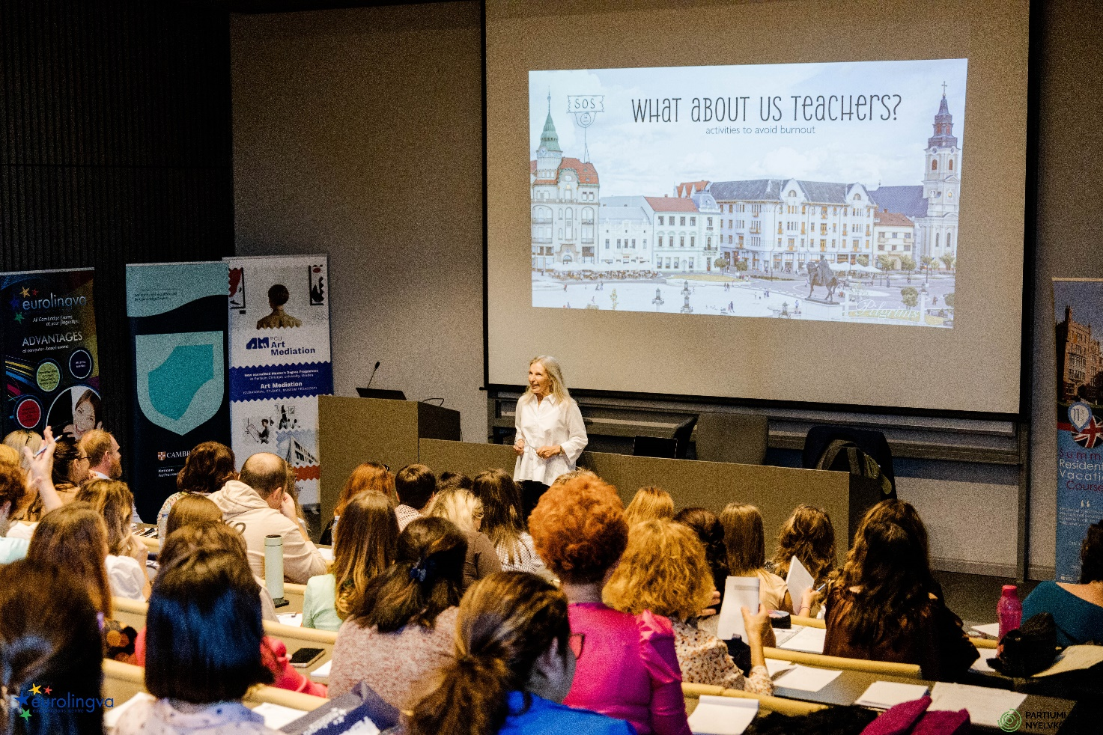

A hallmark of this conference was the exceptional care and attention provided to all the participants.

As a speaker, representing PILGRIMS, I was honoured to deliver a plenary session,”How to avoid burnout” and lead a masterclass focussed on “Writing skills”, both of which were met with enthusiastic engagement.It was evident that the attendees and my fellow speakers brought a wealth of experience and curiosity.
The hospitality was truly exceptional. We were incredibly well looked after, with delicious food that added a delightful cultural touch to the experience.
This event also underscored the strength of a long-standing collaboration between PILGRIMS and EUROLINGUA. Their consistent excellence and hospitality have made every visit over the years memorable, and this year was no exception.
Each encounter strengthens our professional relationship, and it’s always a pleasure to be part and witness the growth of their initiatives.
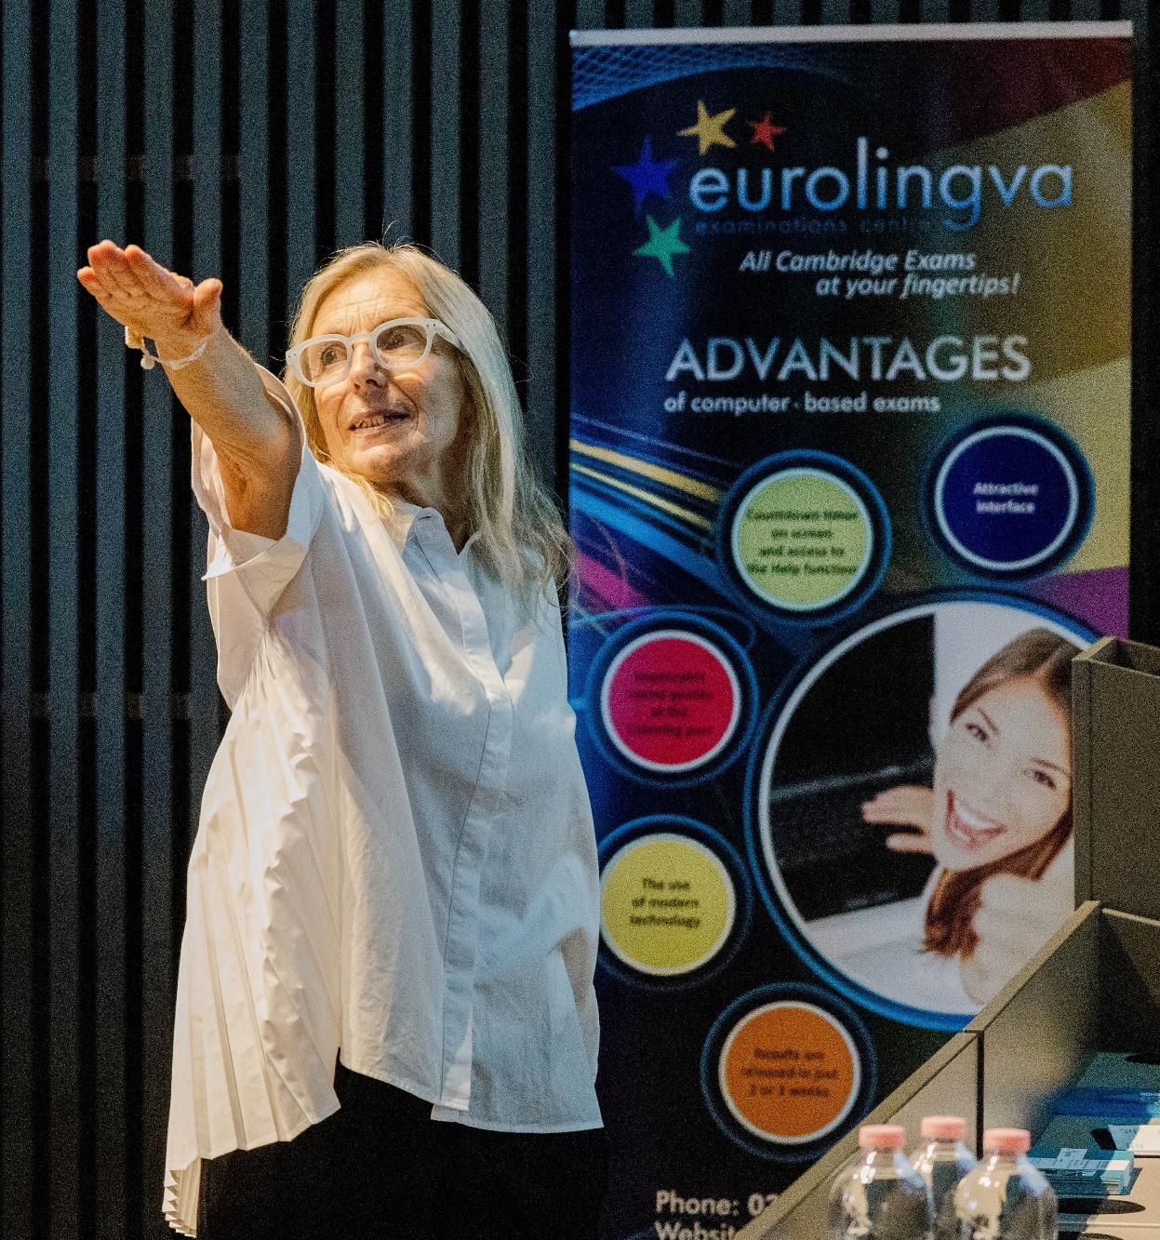
We look forward to continuing this fruitful partnership in the years to come.
Thank you to all the team!

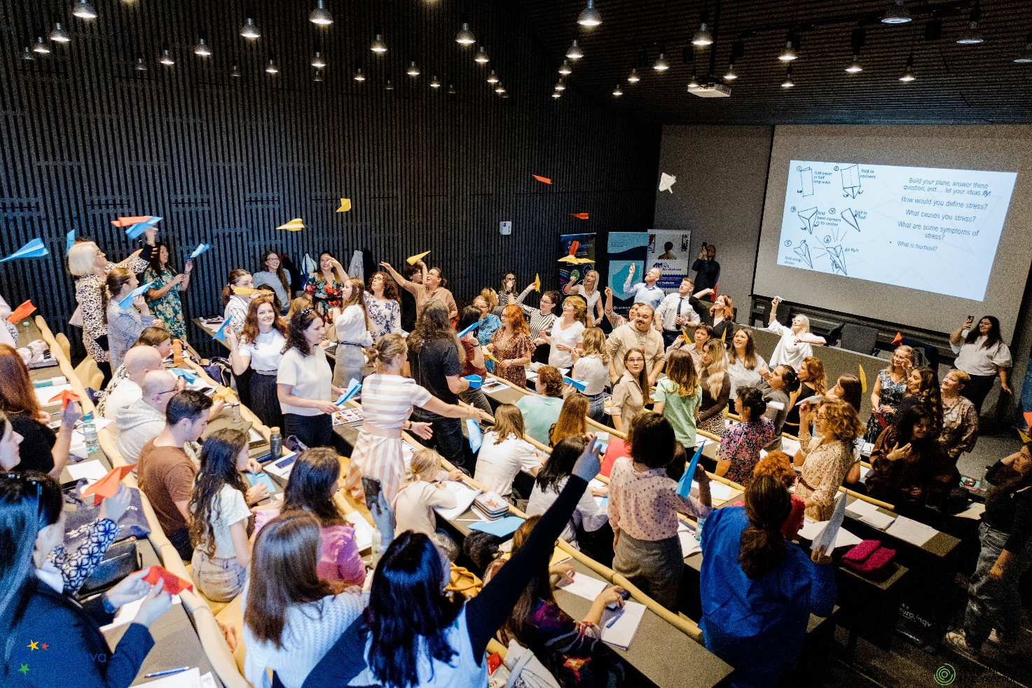
Please check the Pilgrims f2f courses at Pilgrims website.

