Beyond Curriculum: Teaching ELT through a CLIL Multidisciplinary Class
Eugenia P. Iskos, Greece
Joanna Chletsi, Greece

Eugenia Iskos is an English and Biology teacher with experience teaching in the USA and Greece from Kindergarten to College levels. She has degrees in English Language Teaching from Aristotle University, Greece, a Genetics degree from the University of Minnesota and a Masters degree in Science Education. She loves teaching and wants to inculcate a love of knowledge to all her students. Email: jiskos@anatolia.edu.gr
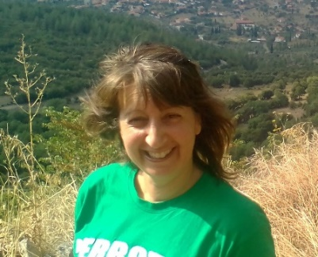

Joanna Chletsi is an English teacher currently working for Anatolia Elementary school. She graduated from the English department in Aristotle University of Thessaloniki and has a Masters degree in Pedagogy and Creative Learning. She taught K-12 and college English in private institutions and schools, colleges in the UK and in Greece.. She is interested in semantics, methodology, translation of literature and scientific documents, culture as well as teaching drama. Email: joanna@anatolia.edu.gr



Introduction
With the advent of AI, foreign language teaching has entered a new era. Students need a new skill set to face the challenges of a world where translations and facts are easily retrieved. Primarily, people need to be able to judge the information that is turned over by AI and the internet in terms of accuracy, relevance and effectiveness. To meet these challenges, a multidisciplinary class was created that dealt with a central question in an ELT environment. Students were involved in analyzing and thinking about teacher projected central questions through Art, History, Science and even Economics. Combining information from different resources, drawing comparisons, working with others, thinking critically about material and creating content were the skills that were taught in this class. Some of these skills are also what is important to own as we enter an age where truth and reality may not be so evident and our ability to think critically and cooperate with others will become vital to our understanding of the world and survival.
The thinking behind the class
Most schools usually teach subjects in a very contained format such as English, History etc. that may no longer adequately represent skills needed in today’s world. People don’t often remain at the same job and often utilize many subject areas. Engineers not only require STEM knowledge, but also creativity and human behavior. How can you create an app to view restaurants if you lack social skills to understand your customers and artistic and articulation skills to make your product appealing? This multidisciplinary class brings different subject areas together to answer a question; to show students that knowledge transcends tidy boxes of subject matter. A second purpose for this class was to emphasize the pursuit of knowledge. Often in English classes, skills such as phonics, skimming and scanning for information in reading texts and grammar are emphasized. However, knowledge of the content in our texts is often dealt as secondary. According to E.D Hirsh 2015 in “Why Knowledge Matters”, content knowledge is integral as part of the neurological and social development of children. A third purpose of this class is for children to acquire social skills through group activities projects and discussions. These incorporate the kind of work that is expected of them in the future. Combining all these aspects of this class can also be seen as learning English through practice and creating meaning.
Description of the class
Our multidisciplinary class is an elective for elementary grades 5 and 6 and for students ages 11-12 years old. Each year the class strives to answer a different question through multiple approaches. The two questions that have been dealt with in consecutive years are “What values did the 20th century impart?” and “What is power”. Modules were created for each aspect of the question.
For example, the 20th century values question was divided into:
- An introduction to the topic of colonialism
- Early 20th century influences such as the development of technologies, the dominance of the two main economic philosophies of Marxism and Capitalism, and Art influenced by technology.
- WWI through Art, Technology and Colonial perspectives
- Social Movements (Labor, Feminism, Self-Determination of countries)
- How Science of the latter half of the 20th century affected society.
- Modernism-Art and non-linear way of thinking.
The “What is Power” Class is divided into bigger modules with many sub-topics.
- Power is Language
- Words as influencers of thought
- Bullying-emotional connection of words
- Advertising -influential concept of words/language
- Power is Knowledge
- How education influences change and position in society.
- Empires: How different kinds of knowledge allowed empires to rise.
- Power is Image
- Pictures as influences-Iconic photographs
- Advertising
- Art influencing people throughout history
- Power is having resources
- Resources-importance and definition
- Resources in the past vs. resources in the present
This multidisciplinary classroom revolved around student production of material and classroom discussions with the teacher acting as material curator and coach. These classroom activities ranged from SEL, cooperative group and critical thinking activities to those promoting creativity, diversity and student voice. All these kinds of activities encompass skills and needs which students practice indirectly through a purposeful knowledge journey to answer a wide-reaching question.
Bringing together various sources to learn critically
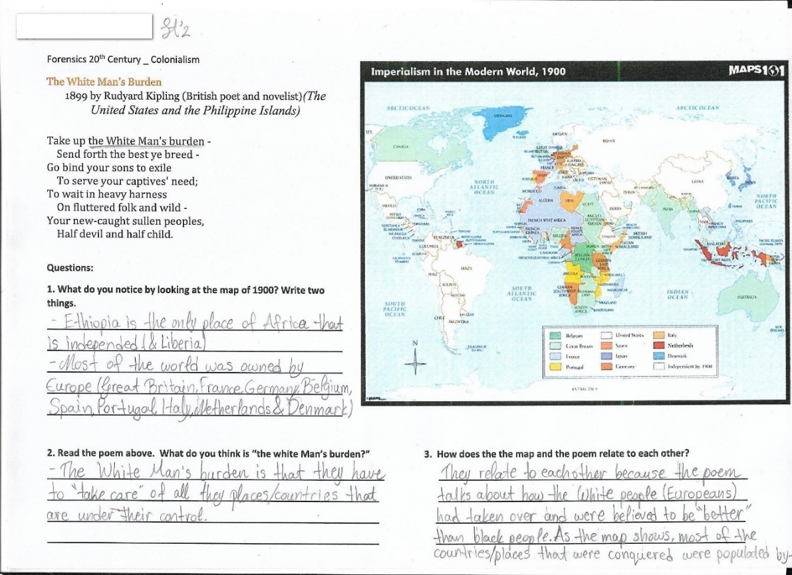
In a multidisciplinary class, various subjects are utilized for learning. These sources were used at times as a springboard to a concept, to develop an idea in more detail and to also contrast and compare with other views. Often historical sources and artistic expressions were used in conjunction to raise awareness of the ramifications of a concept.
Figure A: Map of 1900 showing Colonialism with Rudyard Kipling’s Poem, “White man’s Burden
For example, on the topic of colonialism, students studied a map of 1900 and an excerpt of Rudyard Kipling’s poem on “White Man’s Burden”. In groups, they analyzed and drew conclusions on open ended questions that did not lead them on, but allowed them to think independently. Students “discovered” colonialism based on trends on the map and by the “white man’s burden” that the poem alluded to. Discussing concepts within a group helped weaker individuals understand and also gradually trained them to understand material. It was important to value the different perceptions that students may have on the content. This pluralistic approach helped all students engage in speaking and contributing in English. Discussions on this topic had many students dwell on parallels to the modern world resulting in their own question, “Is there a form of colonialism now?”
Activities that promoted creativity
Creativity is another skill that is important in today’s world that many experts say needs to be cultivated in schools Gong, 2019). Multidisciplinary teaching allows for imaginative activities to often show the culmination of knowledge.
Creative activities helped students explore a topic on their own, show what they learned and also allow students to differentiate according to their own personal talents. Some examples of creative activities were the creation of a newspaper for a certain time period, a dramatic act of a concept, poetry writing and drawing. They involve applying different intelligences so that students of various abilities could use their talents and gain confidence to work in a more complex environment.
Students created a newspaper activity on the beginning of the 20th century which drew together knowledge about Art, Advertising and History of that time. They were able to use their artistic, organization and writing skills to present material that made an impression. This activity made students aware not only of the historical influences of the time period, but also what goes into creating a newspaper. Students became more conscious of titles, the placement of articles, images and even advertisements that reflect the time period discussed.
As part of the “Words are Power” module students engaged in poetry writing in order to use words that create an emotional response in others.
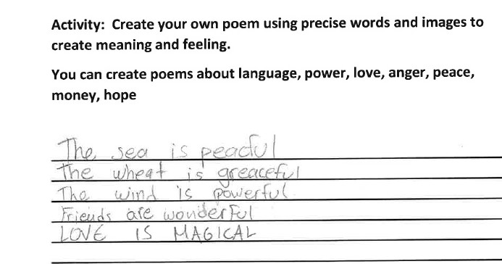
Figure B: Student Poem showing the power of words.

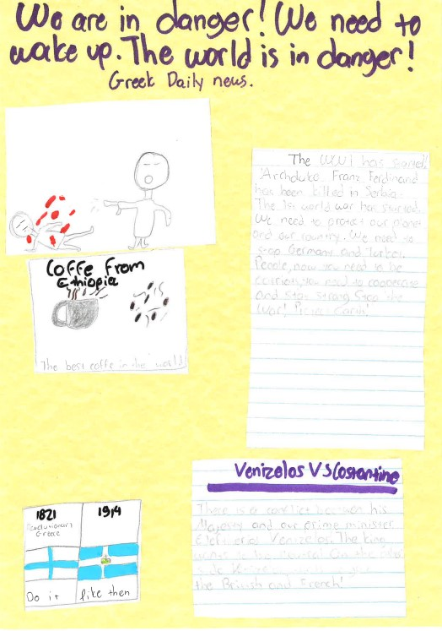
Figure C: Early 20th century newspaper showing historical events, advertisement and images.
Enhancing understanding of others and society with SEL
Steinberg (1997) argues in his book that the sense of morality is achieved through a multidiscipliary study. Viewing an ethical issue through philosophy, through a science and culture there is a more holistic and comprehensive conclusion on what is moral at a given time. Our multidisciplinary class also applied similar principles to develop a sense of justice and understanding toward each other and our society and towards creating a healthy social emotional individual. Students in this class experienced different viewpoints (Casel 2019) both through texts, videos and art and through working with each other.
In the “Words are Power” module, students dramatized the use of negative and positive responses to given situations to show how words affect a person’s emotional well-being after a confrontation. In the same module, students created advertisements and jingles to reflect on the influence that words and images have on targeted audiences. However, working together to produce these activities also teaches young people how to consider the relationships between each other so that everyone has an input and a voice in their project.
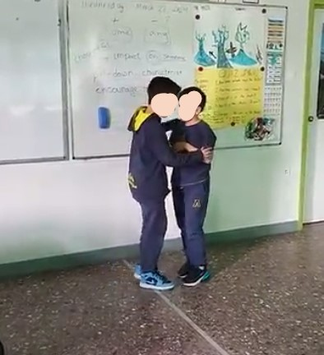
Figure D: Students acting out a scene on a coach using encouraging words towards his player.
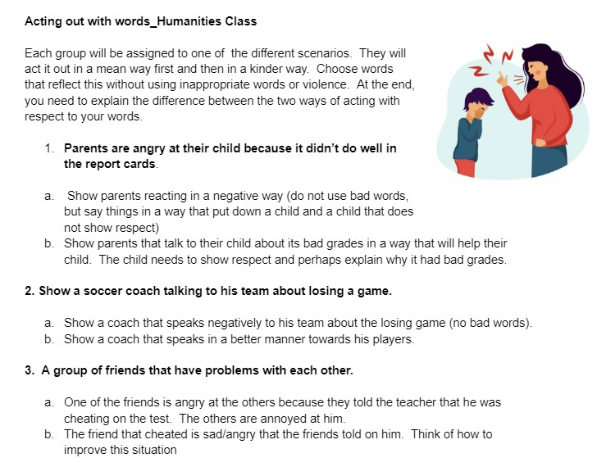
Figure E: Activity showing the different scenarios students acted out to show the power of words in a social setting.
It was also important for students to learn to see other points of view so they are sensitized to other people. This was achieved through activities that asked them to think about people in certain situations in society both in age-related situated such as family and school, but also more complex that involved historical and cultural contexts. For example, they were asked to view a worker’s and a woman’s point of view when discussing social movements. Students need to be presented with situations where they learn to delve into other perspectives in order to have better relationships with other people and develop a social responsibility. In a study of undergraduate students, Kolomiiets et. Al (2021) state the necessity in providing opportunities where young people discuss social issues, try to solve them and engage in activities that have a social context.

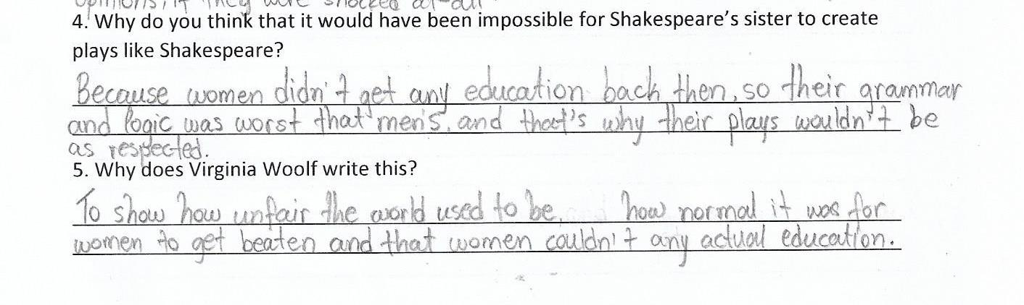
Figure F: Looking at a woman’s perspective

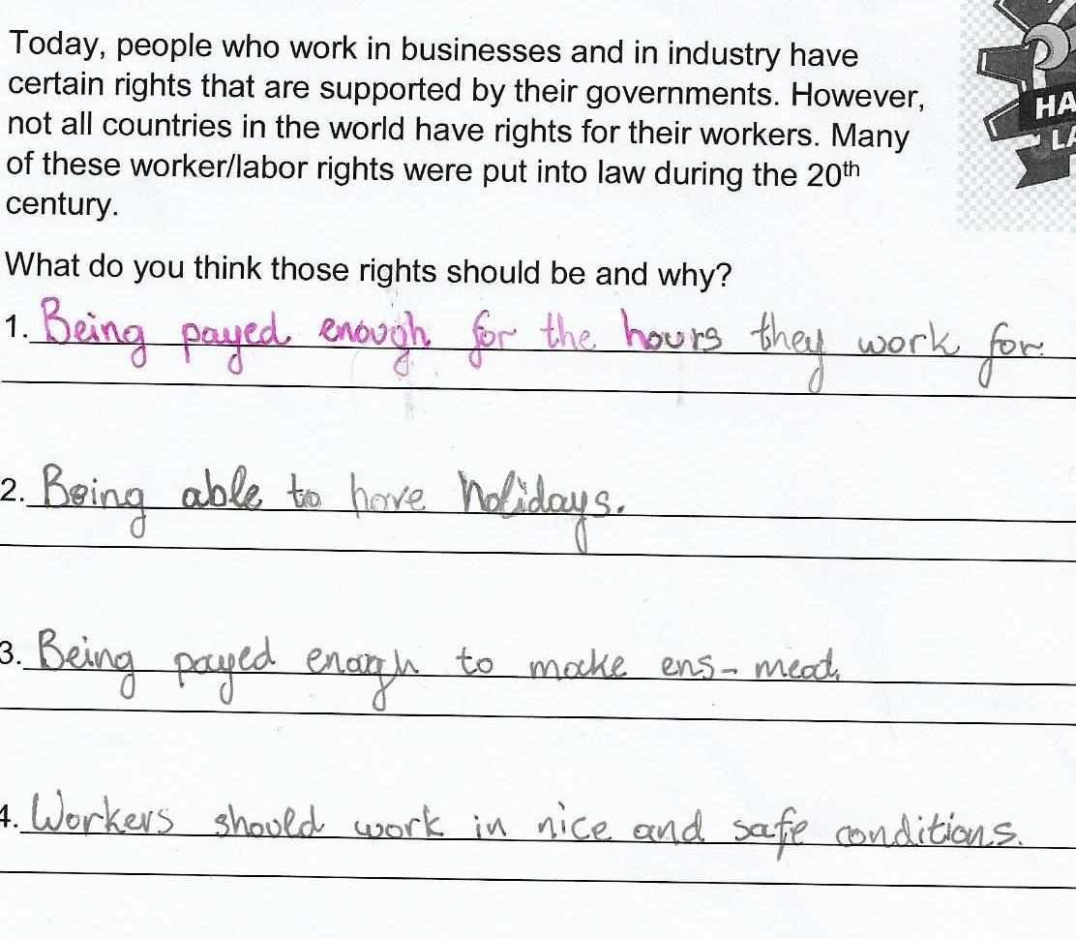
Figure G: Discussing work issues through the perspective a worker.

Collaboration for deeper learning
All activities in the class involved a form of collaboration. Students formed groups to analyze information, to present information, to produce their own interpretations of ideas. Groups changed so that students were able to work with different people so that they could see different viewpoints and talents, to improve their language skills and become more confident. Often, the ideas and conclusions developed in small groups were shared with the entire class. In the end, students were able to change their perspective as they gained more information, challenge in their own prior conception. Collaboration involved from introductory activities, to creative to finally reflective ones.
In an introductory activity, students used mind maps to brainstorm their own understanding of the second question on “What is Power” as an opening activity of the class. This was used to prime students into thinking critically how power is entagled in many different aspects of our lives. There were some more simplistic depictions and then more complex depictions of power notions. By the time everyone shared their findings, all students started to think about the concept of power in different ways. Students who had taken the multidisciplinary elective class the previous year had developed a more complicated way of thinking and it was apparent in their mind map.
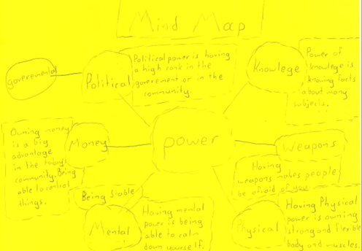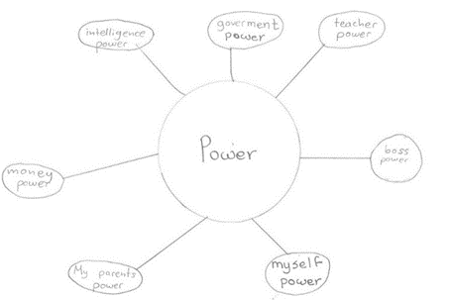

Figure H: Introductory mind map activity on the concept of power.
In another activity, students chose an image and presented their reasoning on why it was powerful. After discussing the power of words through various formats (poetry, culturally, advertisement etc), we reflected on the words that we can’t live without. The variety of words written on the board were indicative of the different approaches of our class such as SEL, social justice and the influence of media. Students wrote words such as peace and justice (social awareness), kindness and happiness (SEL) to pasta and burger (advertisement) . Through collaboration, students also drew connections between different content areas and developed a more complicated way of thinking. In an activity where students had to respond to early 20th century art, there was a much richer response than when we individually looked at separate art pieces.
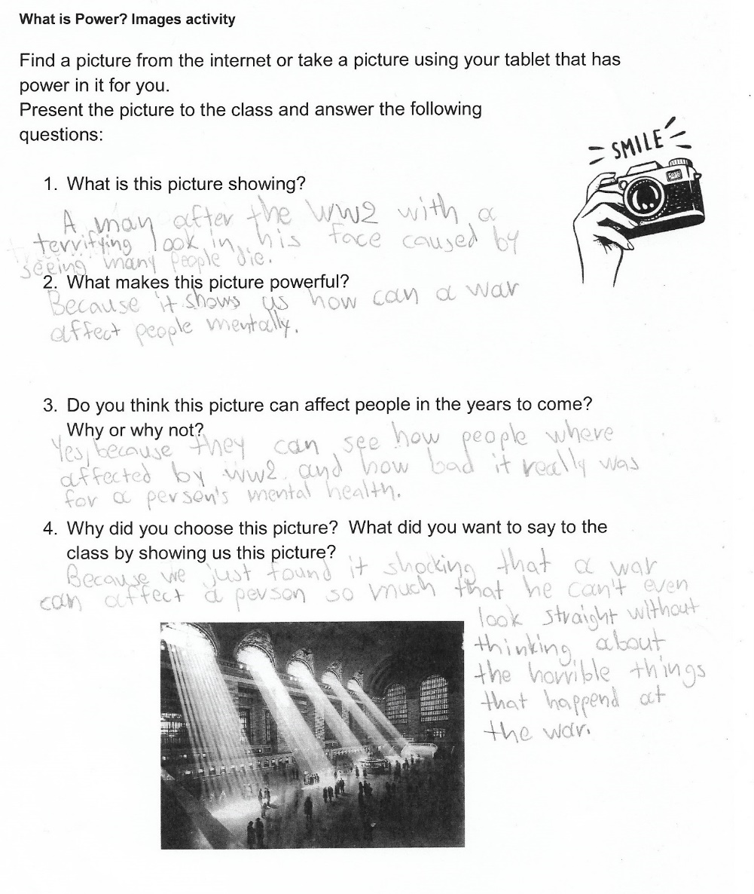
Figure I: Choosing and presenting a picture of power.

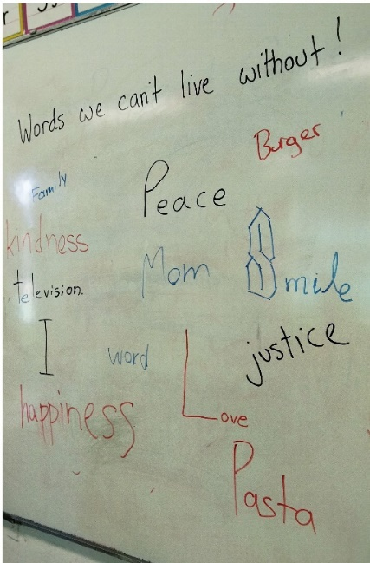
Figure J: Words we can’t live without.
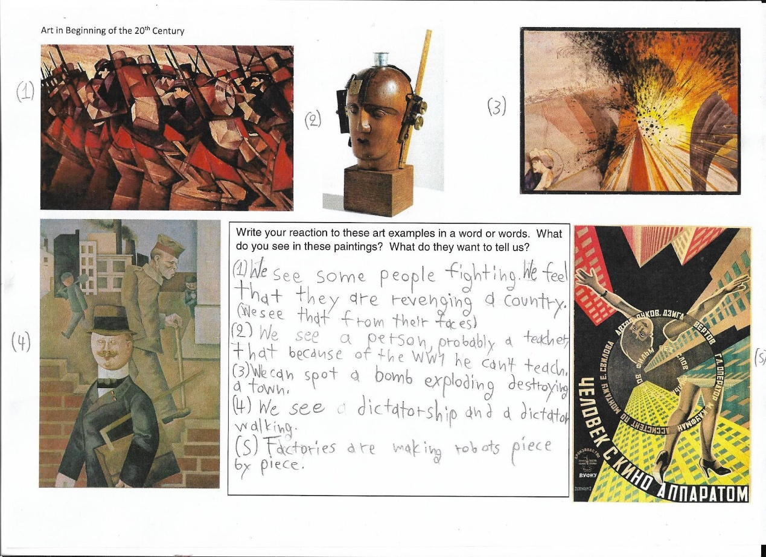
Figure K: Interpreting Early 20th century art pieces.
Some students drew connections with WWI, others with the technological advances of the time and even with politics. As Britton (2004) stated “ a collaborative school structure of accepting, adapting, and planning for change is an effective way to increase student learnng under ever-changing circumstances”, similarly, in the classroom, conversations between groups depicted this dynamic process of reaching an understanding of the material.
A greater knowledge base as a trajectory for more
Students in this class were exposed to a large amount of knowledge though they were not formally assessed on it. However, understanding of that knowledge was evident in classroom discussions and writing assignments. Students learned about art, economics, history and science without a conscious effort. It occurred within a need to understand an event or an art piece. Why did the artist paint this? How did technology influence the 20th century? The twentieth century and the concept of power contain a wealth of knowledge that was not possible to cover comprehensibly.
However, that was not the goal. Students were exposed to several ideas that served as a trajectory to research or just be curious for more knowledge or understanding on their own. Subjects such as social movements, economic theories such as Laissez faire and Marxism and Artistic styles such as Futurism, Fauvism and more prompted students to look for current trends and want to look more deeply. Sharma (2023) mentions that a multidisciplinary approach in a course may motivate students who may not have been vested in a given subject like Biology. Students by becoming interested in a wider frame of science may consider learning about it if taught in a creative way.
This interest in other disciplines was evident when discussing scientific revolutions of the twentieth century in class. Some students were impressed about Atomic Theory and paid more attention in their Science class. In another instance, discussion on capitalism led students to wonder about current political parties and their economic platforms. Which party is closer to the capitalistic views? There were students who were fascinated with the World Wars so that they began to read on war technology and political figures. Attaining knowledge was a great component of the class and not just skills such as skimming and scanning. Students retained information because of their involvement with it and were able to recall it later on (Hirsch, 2015).
Conclusions
Creating the multidisciplinary class was a challenge. The most difficult part was to gain a sense of cohesiveness in order to combine a variety of subject matter in a manner that gives a sense of purpose and interest while allowing for students to discover their own connections and understanding of the material. The choice of material was another important factor, since it was important to present a balance of viewpoints. When discussing capitalism, it was critical to have the Marxist perspective, too.
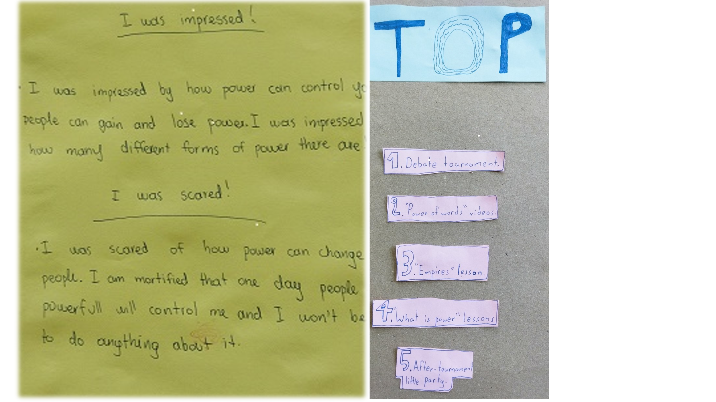
Figure M: End of the year reflections
The class had a great impact on students. A student said that, “This is the first time that I enjoyed learning about history.” Some were impressed with the concepts or brought forth feelings on them. Many students also became passionate about subjects that they were exposed to for the first time. Others became more interested in politics and world economics and how they related to each other. The topics of this class were challenging. However, most students rose to the challenge even though much of the material and concepts could be considered secondary school and not primary school. It would be interesting to follow these students into secondary school and see the impact this class had on their academic and social progress.
One of the more impressive outcomes was the lectical progress of students. Students assimilated a lot of complex words such as empire, movements, perspective and more. Students became more verbose as the class progressed mostly because they were interested in contributing to our interesting conversations. The class’s success in our school was evident in the fact that more than a third of the students were sixth graders that had taken the class the previous year and wanted to participate in such a multidisciplinary class again.
Multidisciplinary classes are important to teach in schools. Students need to develop a sense of social responsibility (Wray-Lake, 2011) at a young age so they can make ethical choices concerning themselves, others and nature in the complex future awaiting. In our case the class cultivated cooperation, a social conscience, critical thinking, knowledge that didn’t extend only to the English language, but on a wider scale and overall developed a more holistic way of understanding the world. Hopefully, some of the skills and knowledge they acquired will help them navigate through the myriads of information that is present in our tech-savvy world and be open-minded to all knowledge and diversity of people. Our experience showed us that any general question such as “Why do people live in communities? and “What improves human life?” can be used to create a diverse experience for students. A teacher can consider what aspects to include or even historical points in the human experience. Do we juxtapose primitive to more advanced cultures? Do we include work-life balance as what improves the human condition? Should we add culture? This multidisciplinary experience also enriches the teacher and both teacher and student learn to view human experience and knowledge from different aspects hopefully moving towards a better future.

References
Britton, Cindi R. (2004). A Multi-case study of Elementary School Grade -level Team Collaboration and Student Achievement University of La Verne ProQuest Dissertations & Theses.
Diaz, S. (2023). The Multidisciplinary Approach to Building AI products Data and AI retrieved 7/5/2023 https://qubika.com/blog/the-multidisciplinary-approach-to-building-ai-products/
Gong, Shiqi (2019). On the Cultivation of Middle School Students’ Creativity English Language Teaching 13. 134. 10.5539/elt.v13n1p134.
Hirsch, E.D., (2015). Why knowledge matters: Rescuing our children from failed educational theories. Harvard Education Press.
Kaspar, K.L., Massey, S.L. (2023). Implementing Social-Emotional Learning in the Elementary Classroom. Early Childhood Educ J 51, 641–650
Kolomiiets, Lesia & Shulga, Galyna & Lebed, Iuliia. (2021). Formation of Social Responsibility of Young People in the Process of Obtaining Higher Education. Society. Integration. Education. Proceedings of the International Scientific Conference. 1. 292-305. 10.17770/sie2021vol1.6417.

Sharma, A (2023). Multi-Disciplinary Education of Teaching and Learning in Higher Education. International Journal of Advanced Research in Science, Communication and Technology (IJARSCT) V3 Issue 5 June
Steinberg, D. (2020). The Multidisciplinary Nature of Morality and Applied Ethics. Springer Nature Switzerland AG 2020

Wray-Lake, L., & Syvertsen, A. (2011). The developmental roots of social responsibility in childhood and adolescence. In C. Flanagan & B. Christens (Eds.), Youth development: Work at the cutting edge. New Directions for Child and Adolescent Development, 134, 11-25. doi: 10.1002/cd.30

Please check the Pilgrims f2f courses at Pilgrims website.

