Towards Inclusive Learning Environments in Higher Education: A Glance into Perspectives from Education and Language Studies

Yasemin Yelbay Yilmaz, Turkiye

Yasemin Yelbay Yilmaz is an English language researcher from Turkiye. She holds a PhD in Applied Linguistics. Her research interests include quality assurance in higher education, vocabulary learning, and professional development of teachers.
Email: yaseminyelbay@gmail.com

Introduction
When I attended EUA's event titled "BWSE for 2030: PLA1: Towards an Inclusive EHEA by 2023," I had a general understanding of inclusion based on my knowledge and reflections, grounded in both personal experience and observations: “Inclusion is important in higher education.” “Of course.” “We must exert more effort in this regard.” “But of course!” However, attending the event and collaborating with experts in the field, as well as students, colleagues and stakeholders from different countries and backgrounds, made me realize that there is much more to learn about this subject. Inclusion is somewhat like a mirage—clear from a distance but increasingly blurry as you approach—a vast, multi-dimensional, and constantly changing space with unclear boundaries. Although people may agree on the importance of inclusion as being 'good,' 'right,' or a 'moral obligation,' translating these concepts into practice can lead to diverse interpretations (Koutsouris, 2014). Therefore, there is a need for a deeper understanding of how inclusion is generally addressed in higher education (HE), and how it is disseminated through mechanisms and institutions. As mentioned earlier, given the multidimensional nature of the topic, questions can be posed not only about finding the correct definition but also on different levels:
- How does the level of inclusion in HE institutions impact the overall educational experience for students?
- What are the experiences of students from diverse backgrounds in terms of academic achievement, sense of belonging, and engagement in HE?
- What institutional policies and practices contribute to or hinder the promotion of inclusion in HE?
- What are the long-term effects of an inclusive HE experience on the personal and professional lives of graduates?
- What challenges do HE institutions face in implementing effective diversity and inclusion policies, and how can these challenges be addressed?
Asking these crucial questions from within the classroom, at the institutional level, and through broader networks is essential for raising awareness among all stakeholders in this field. This topic is not only a significant concern for practitioners who have direct contact with students in the classroom, such as teachers, but also for everyone involved in shaping education policies at the national, regional, and global levels. Therefore, it is natural for this issue to encompass and influence foreign language educators as well.
Over the years, numerous studies have been conducted in the field of inclusion, as evidenced by the extensive body of literature. However, despite its significance, there is a pressing need for more extensive research to ensure that these studies permeate throughout the entire spectrum or intricacies of a HE institution. Otherwise, concepts of inclusion, when mentioned, might remain mere buzzwords, creating positive impressions but failing to transcend into meaningful practices for vulnerable or disadvantaged groups dependent on such initiatives. Felten and Barnett (2023) provide insight into this concern in their introduction by saying that unity is rarely supported on campus and most HE institutions are structured in ways that make organizational sense but may not reflect the experiences and needs of our students. The aim of this study is to outline a general framework for teachers, practitioners, and leaders interested in the subject but less familiar with the debated concepts in the field and by doing so, it seeks to pave the way towards a common understanding. To quote Sapon-Shevin, "Social justice can only be realized when we dive into, rather than run away from, discussions of inequality and oppression, and we have a moral obligation as early childhood educators to work towards that possibility" (2017, 1)
Theoretical Framework of Inclusion in Education
Over the past few years, inclusive principles and practices have been gaining traction within university agendas, policies, and teaching and learning approaches. However, in the context of HE, there is still a long way to go before we can claim full inclusion, and many challenges must be addressed to align educational practices with the principles of inclusive education (Morina, 2016). It can be asserted that studies on inclusion gained momentum from the early 1990s. During that period, the discourse primarily revolved around issues related to disability and learning difficulties. Parker highlights this stating, "The inclusion in higher education of students with disabilities and learning difficulties has become a matter of concern within the past eight years" (1998). Notably, discussions during these times focused on the context of disability. Parker further notes that initiatives by the Higher Education Funding Council, aimed at promoting greater inclusion, showed some success in improving access to higher education and raising awareness across the sector. The emphasis was on ensuring full participation by students with disabilities in the learning environment once they entered university (Parker, 1998). While disability was a prominent topic in the early discussions, the dialogue expanded, encompassing a broader range of considerations and implications for HE access.
Despite various definitions from multiple perspectives, a central principle of any inclusive pedagogy seems to revolve around the recognition of difference and how it is perceived—whether as a form of stigmatization or as a means of acknowledging individuality (Stentiford & Koutsoris, 2021). While "inclusion" serves as a term that inherently describes itself, there exist worldwide variations in the understanding of what this term encompasses. The concept of "under-represented groups" lacks a universally agreed-upon definition, exhibiting variations across continents and countries (Salmi and Sursock, 2017). In a study, 48 policy documents were analyzed from the websites of the ‘elite’ research universities in the UK and it was found that inclusion was rarely defined clearly, and that tensions, complexity and pedagogical implications of inclusion were not discussed (Koutsouris, Stentiford and Norwich, 2022). According to Salmi and Sursock, even though all European countries share the common goal of increasing participation in HE, there is no official European definition of under-represented groups endorsed by the Commission (2017). In most regions of the world, each nation establishes its equity target groups based on its unique social context and political culture. In the realm of equity in HE, four categories are frequently cited as equity target groups (Salmi and Bassett, 2014): individuals from the lowest income groups, women, groups with a minority status linked to their ethnic, linguistic, religious, cultural, age, or residence characteristics, people with disabilities. In a recent study involving 119 faculty members from ten Spanish public universities, Marquez and Melero-Aquilar discovered that a significant portion of faculty members is unfamiliar with the term inclusive education and among those who are acquainted with the term, diverse interpretations and meanings emerge based on their level of familiarity with the concept (2022). In the study they found three categories of areas where inclusion emerged in HE, inclusive education as equal access, inclusive education as attention to students with disabilities and inclusion as inclusive teaching practices. Lawrence-Brown uses the term ‘inclusion’ broadly and views inclusive education not as a form of special education but as critical pedagogy in their book where she focuses on a broad range of traditionally marginalized differences including, but not limited to disabilities, cultural/linguistic/racial background, gender, sexual orientation and class (Lawrence-Brown & Sapon-Shevin, 2015,2)
When addressing issues of inclusivity, it is hard to separate them from the UNDP's Sustainable Development Goals (SDGs). The United Nations adopted the Sustainable Development Goals (SDGs), also known as the Global Goals, in 2015, serving as a comprehensive initiative to address poverty, protect the environment, and ensure global peace and prosperity by 2030. Consisting of 17 integrated goals, the SDGs recognize the interdependence of actions across various domains and emphasize the necessity of balancing social, economic, and environmental sustainability in development efforts. The attainment of these goals in diverse contexts requires the collaborative input of creativity, expertise, technology, and financial resources from all segments of society (UN Website, 2023) Inclusion in higher education is crucial for both social justice and talent development reasons and is directly associated with the achievement of SDG 4.3 (Salmi, 2020). This SDG aims to "ensure equal access for all women and men to affordable quality technical, vocational, and tertiary education, including university." Following the aforementioned study by Salmi and Bassett defining equity target groups (2014), in another study, Salmi conducted a survey across 71 countries as part of a study of the World Access to Higher Education Day (WAHED) (Salmi, 2019). The survey revealed that several countries have introduced 16 new sub-categories within the overarching "minority" classification when identifying equity target groups such as first-generation students, victims of sexual abuse/violence, single mothers, deported migrants, students who do not speak the national language and families with more than three children to name a few. As evident, the concept of inclusion cannot be considered separately from the SDG’s. One of the supporting pieces of evidence is the direct correlation of the inclusion concept with multiple SDGs.

It is essential to highlight the work of researchers Booth and Ainscow, who conducted a study titled the Index for Inclusion (2002). This comprehensive document serves as a valuable resource for institutions and individuals seeking guidance in advancing their educational settings. Contrary to the common association of inclusion with students who have impairments or special educational needs, the Index for Inclusion, as proposed by the authors, redefines inclusion as being about the education of all children and young people. The dimensions addressed in the index encompass creating inclusive culture, producing inclusive policies, and evolving inclusive practices (Booth and Ainscow, 2002). However, the significance of these three factors has been insufficiently investigated at the higher education (HE) level, consequently, there is a lack of a comprehensive overview, and students continue to encounter challenges in each of these aspects (Emmers et al, 2020)
Although numerous studies have been conducted in the field, there is a perceived need for further research in the higher education area. The significance of the current study lies in its effort to contribute to the existing body of research by examining the landscape of higher education research in relation to the concept of inclusivity with perspectives from education and language studies.

Method
In this study, an analysis has been conducted regarding the scholarly research carried out on the subject of ‘inclusion in higher education’, with a focus on the keywords used in inclusion in higher education research since its appearance in scholarly work as a term. This study is crucial to reveal how individual studies spanning the expansive landscape of higher education, much like threads in a canvas, contribute to the overall understanding of the subject.
Within the scope of the study, publications available in the Web of Science (WoS) were surveyed to identify the concepts used in the field (how these concepts are expressed in terms of words and phrases) and to reveal which countries and research areas have been more actively engaged in this regard. For this purpose, an analysis of WoS data outputs was conducted. In this analysis, on November 7, 2023, the researcher performed a search using the keywords "inclusion" and "higher education" on the WoS website without applying any additional filters. Thus, the aim was to scrutinize research in the field of higher education in terms of the concept of inclusion. As a result of the keyword search in the Web of Science Core Collection, 9338 studies were listed. These studies were filtered using Web of Science categories, retaining only those related to education, teaching, language and linguistic studies, higher education, and multidisciplinary studies, resulting in a total of 3575 studies. The rationale behind applying the aforementioned filter to the categories is an endeavor to align the outcomes more closely with education and language teaching, especially within higher education. The inclusion of multidisciplinary studies is aimed at capturing any relevant research conducted in the fields of education, teaching, language and linguistic studies, and higher education.
The data obtained from WoS was analyzed using the VoSViewer software (Van Eck and Waltman, 2010). For this purpose, the data extracted from the WoS database was uploaded to this software. In order to observe the extent to which concepts have proliferated, a criterion was set in the study that the search words “inclusion” and “higher education” must have occurred at least five times in each text extracted from the WoS database. By incorporating this criterion, the researcher aimed to ensure that the identified scientific papers explicitly addressed the search terms. The rationale behind this was that the mere occurrence of the term "inclusion" once in a study does not guarantee that the paper centrally revolves around the concept of 'inclusion.' Establishing a minimum occurrence threshold of five keywords per paper resulted in a reduction of the total keywords from 7409 to 397. The researcher accepted this threshold as a measure to sufficiently narrow down the keywords, ensuring that the papers distinctly focused on the intersection of inclusion and higher education. Simultaneously, it provided a comprehensive representation of the distribution across the research landscape.
The analyses of the data have yielded two types of outputs. The first output of the analysis involves the concept maps for the keywords "inclusion" and "higher education." From this representation, it has been elucidated which concepts have been intensively utilized over the years (Table xx) and which concepts have relatively recently become subjects of discussion (Table xx). Secondly, the output of the software, consisting of concepts (keyword list), has been thematically grouped by considering these emergent concepts. Braun and Clark's methodology (2008) was adopted for thematic grouping, and additionally, co-word analysis was performed (Callon, Courtial, & Laville, 1991). The concepts extracted from the VosViewer software output (in this case, words or phrases) were obtained by conducting co-occurrence frequency analysis within the same software. Co-occurrence frequency analysis is an examination that indicates the strength of the relationship between the studied concepts (Van Eck, & Waltman, 2010)
The limitations of this study include the fact that the analysis was conducted solely based on one database, WoS. While the inclusion of other databases could suggest that the data might be more comprehensive, working with a single database was necessary to avoid evaluating the same article as two separate studies when the same article is scanned in two different databases, which could cast doubt on the validity and reliability of the study. In the future, replicating these studies with data from different databases is possible. Another limitation is the restriction of the reviewed studies to education, teaching, language and linguistic studies, higher education, and multidisciplinary studies. The researcher opted for the concept of inclusion to be specifically limited to the field of education and language teaching in higher education, aiming to provide a reference source for teachers, school administrators, and policy makers in the field of education and language teaching. Analyses related to different categories can be conducted, allowing for discussions related to various dimensions of the topic.
Results
As a result of the keyword search conducted in the Web of Science Core Collection, 9,338 studies were listed. These studies were filtered based on Web of Science categories, retaining only those related to education, teaching, language and linguistic studies, higher education, and multidisciplinary studies resulting in a total of 3,575 studies. Upon examining these studies, it was observed that the first studies on inclusion and higher education were conducted in 1992, and the number has gradually increased each year, with a notable surge in research in 2021. The process that began with four studies in 1992 reached the highest number in 2022 with 1,268 studies. (Table 1)
Year of Publication | Number of Publication | Year of Publication | Number of Publication | Year of Publication | Number of Publication
2023 | 864 | 2012 | 321 | 2001 | 4
2022 | 1268 | 2011 | 260 | 2000 | 6
2021 | 1204 | 2010 | 189 | 1999 | 4
2020 | 980 | 2009 | 142 | 1998 | 6
2019 | 893 | 2008 | 56 | 1996 | 4
2018 | 691 | 2007 | 43 | 1994 | 3
2017 | 640 | 2006 | 35 | 1993 | 3
2016 | 499 | 2005 | 23 | 1992 | 4
2015 | 455 | 2004 | 17
2014 | 380 | 2003 | 11
2013 | 329 | 2002 | 2

Table 1: The distribution of higher education inclusion research indexed in WoS in years

The studies conducted between 1992 and 2023 reveal that, according to Web of Science (WoS) categories, the first five extensively researched categories in this field are Education, Education Research, Social Sciences Interdisciplinary, Education Scientific Disciplines, Multidisciplinary Sciences, and Education Special categories. When examined by countries, the top five countries conducting the most studies in the field of inclusion in higher education are the United States (21.20%), the United Kingdom (11.94%), Spain (11.16%), Australia (9.37%), and Brazil (6.79%). In light of this data, it can be stated that over 60% of studies on inclusion in higher education are conducted in these countries.

Analysis of the WoS outputs revealed that studies conducted on inclusion in higher education, are related to the following SDGs in descending order: SDG03 Good health and wellbeing, SDG04 Quality Education, SDG10 Reduced Inequality, SDG13 Climate Action, SDG05 Gender Equality, SDG11 Sustainable Cities and Communities, SDG09 Industry Innovation and Infrastructure, SDG07 Affordable and Clean Energy, SDG12 Responsible Consumption and Production, SDG01 No Poverty.

The visual representation of the concept map showing the co-occurrence of the words "inclusion" and “higher education” with other words in research is depicted in Figure 1. The figure illustrates how the terms "higher education" and "inclusion" are predominantly associated with certain keywords in research and the strength of their relationships with co-occurring concepts. This representation is significant in revealing the complexity of the subject and highlighting how the concept of inclusion in higher education is interconnected and manifests in various contexts. Prominent clusters of keywords include disability, social inclusion, inclusive education, students, well-being, e-learning, pedagogy, and gender. These keyword clusters have undergone further analysis, and the researcher has compiled words that could fall under the same thematic heading.

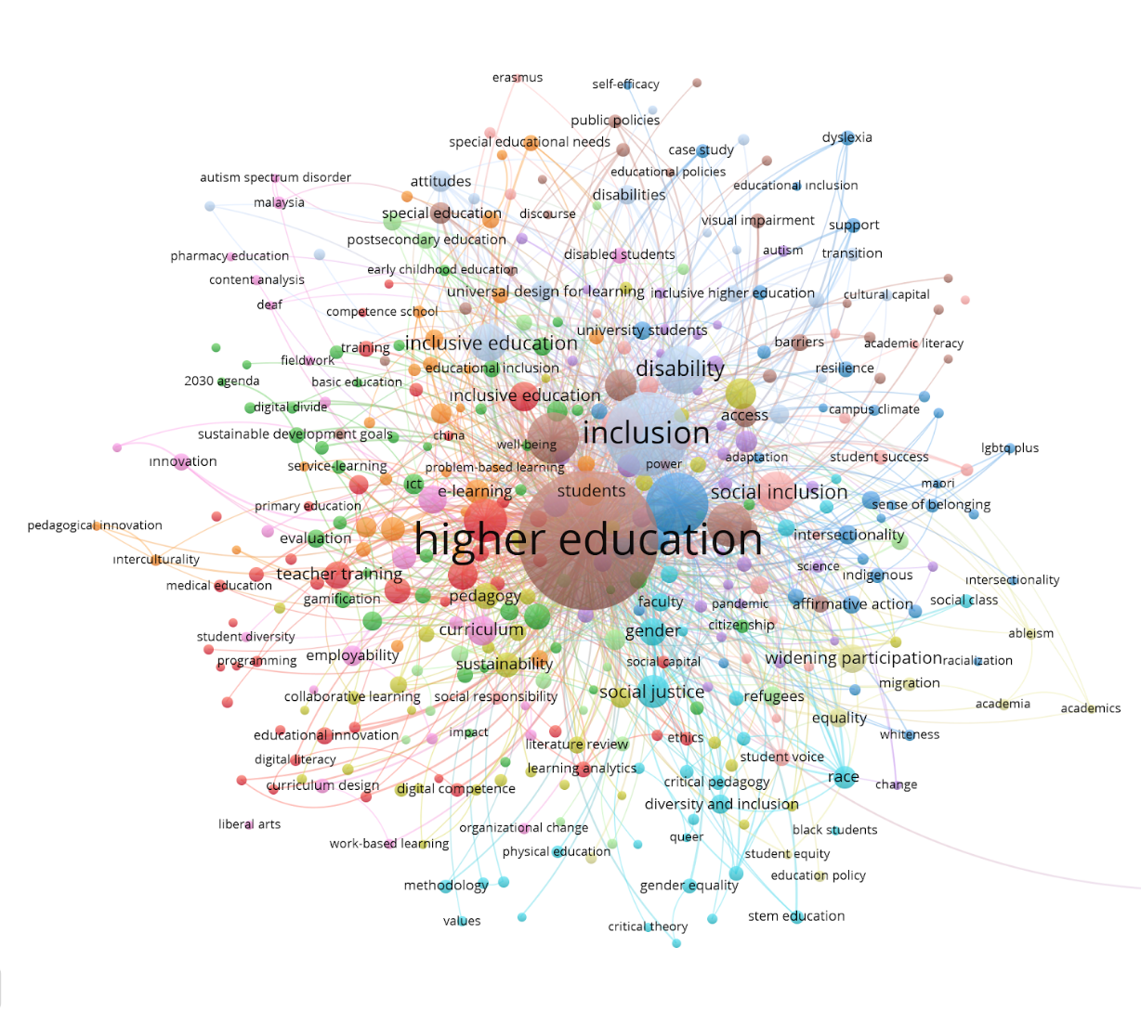

Figure 1: Visual representation of the co-occurence analysis

The VoSviewer software also provided outputs regarding which concepts have been relatively recently discussed in the literature. In this overlay visualization, there is a presentation of the concepts discussed in the field within the range of 2016-2021 and the ordering of these concepts from older to more recent. In this visual, concepts shown in purple are older, while as we move towards yellow, we see which concepts related to inclusion and higher education have been more recently discussed (Figure 2). Accordingly, at first glance, we observe that recently, in the context of inclusion and higher education, concepts such as faculty members, initial teacher education, virtual reality, educational innovation, sustainable development goals, student diversity, diversity and inclusion, STEM education, pandemic, ableism, LGBT+, and academics are being discussed. We also understand that these same concepts, along with the limitation of the time range provided in the field, have been discussed since 2021 (or earlier) in conjunction with disadvantage, social inclusion, Bologna Process, disabled students, and writing concepts.

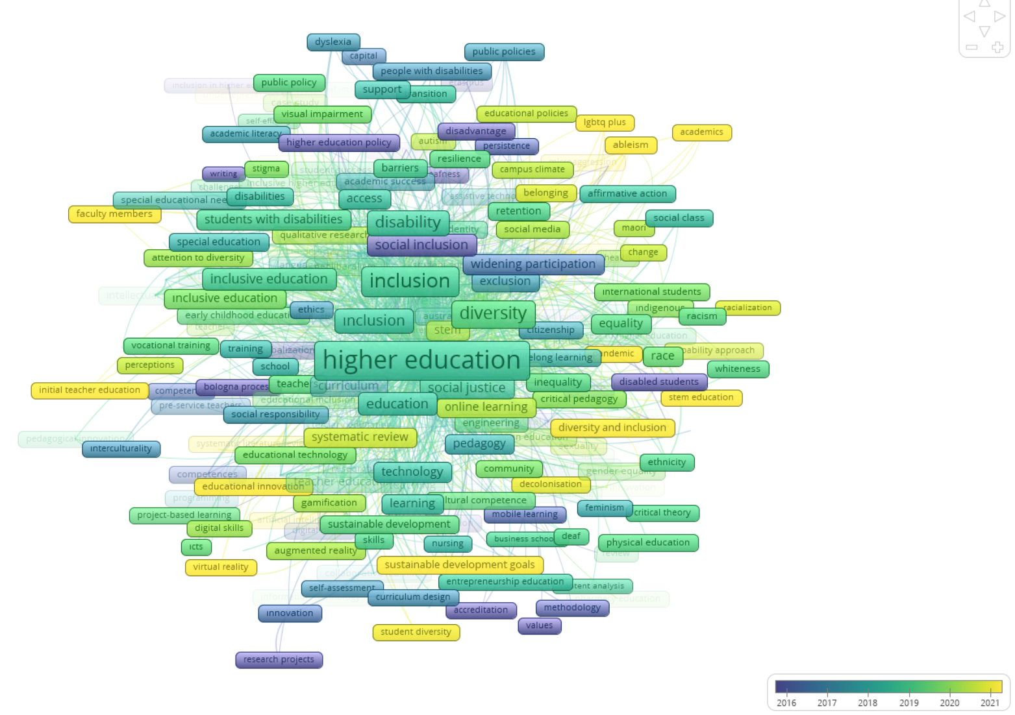

Figure 2: Overlay visualization of the co-occurence analysis between 2016-2021

The acquired words have been thematically analyzed and grouped around the following main themes concerning studies on inclusion and higher education: educational policies and systems, access and inclusion, diversity and equality, teaching and learning methods, technology and innovation, globalization and internationalization, social issues and awareness, economics and employment, community and collaboration, health and well-being (Table 2). There is also a set of concepts that do not neatly align with any of the aforementioned categories. However, the quantity of these terms is not substantial enough to significantly impact the study. As a result, the researcher has retained them and they have not been incorporated into the list provided in the table below.

Main Themes | Keywords
Educational policies and systems | academic performance, accreditation, assessment, curriculum, distance education, educational inclusion, educational strategies, educational technology, higher education policy, secondary education, special education, tertiary education, undergraduate education, university education.
Access and Inclusion | access, access to education, access to higher education, accessibility, accommodations, inclusion, inclusive education, inclusive higher education, widening access, widening participation
Diversity and Equality | affirmative action, black students, diversity, diversity and inclusion, gender, gender equality, gender equity, racialization, racism, social class, social inclusion, social inequality, social justice, whiteness
Teaching and Learning Methods | active learning, active methodologies, blended learning, flipped classroom, flipped learning, game-based learning, gamification, learning analytics, learning and teaching, learning environment, learning outcomes, pedagogical innovation, pedagogy, problem-based learning, project-based learning, scoping review, self-assessment, self-efficacy, self-regulated learning, student engagement, student participation, student success, teaching, teaching methods, teaching practices, work-integrated learning, virtual learning environment
Technology and Innovation | artificial intelligence, e-learning, innovation, virtual reality, Moocs, technology, technology enhanced learning, information and communication technologies,
Globalization and Internationalization | Bologna process, Erasmus, globalization, international education, internationalization, interculturality, international students
Social Issues and Awareness | ableism, activism, discrimination, diversity and inclusion, gender, human rights, identity, lgbtq+, mental health, raze, racism, social capital, social exclusion, social inequality, social justice, social media, social networks, social responsibility, social support, stigma, wellbeing
Economics and Employment | employment, labor market, employability, graduate employability, work-based learning,
Community and Collaboration | community, community engagement, community of inquiry, community of practice, co-creation, collaboration, cooperative learning, partnership, service-learning, teamwork
Health and Wellbeing | Health, mental health, wellbeing

Table 2: Category themes after thematic analysis of keywords

Discussion

The results indicate that the concept of inclusion has found a prominent place in the field of higher education, and studies have gradually increased over the years. Furthermore, it is observed that in recent years, previously unexplored topics in the field have entered the agenda of researchers in the field of education and have begun to be discussed.

When examining the number of countries conducting research about inclusion in higher education, it is evident that more studies need to be conducted both on the global and local level. Apart from countries that have been leading in this field for many years, it is crucial for researchers in every country to work on their local realities and contribute to the international literature, which is significant for the inclusion of this issue in global education policies. While each higher education system is unique, the increasing mobility and collaboration opportunities among universities, initiated by processes such as the Bologna Process, along with emerging concepts like "University Without Walls" emphasize the importance of developing a shared understanding of inclusion in higher education on a global scale. A report by the European University Association (EUA) puts this concept as a vision for 2030 and lists trends and challenges towards that goal (EUA, 2021). In this publication, EUA recognizes that, although the conditions and characteristics of universities throughout Europe differ and are heavily influenced by their respective local, regional, and national contexts, certain overarching external trends can be identified. The report identifies persisting social disparities and demographic changes in many European countries as a trend that puts social systems under pressure stating “...this makes lifelong learning, access, equity and inclusion key concerns for Europe’s universities, which provide education for half of each cohort of young people graduating from secondary school, as well as for all those who return to university later in life. This makes it necessary to provide for the needs of a more diverse student population.” As this understanding is developing, higher education systems may need to work both at the country level and within international organizations to check if they address common issues such as; How do we define the concept of inclusion? Are we in agreement on the groups we have identified for providing inclusive education? Do we have common policies or commitment statements on this matter that we share with the public? Are we monitoring the effectiveness of our inclusion policies? To what extent do we gather feedback from target groups and internal and external stakeholders during these assessments? Are we effectively using the collected feedback for improvements? What mechanisms do we have in place to ensure the quality assurance of these defined processes and make them sustainable? When we can answer these questions at both the local and global levels, it may be possible to develop a common stance in higher education.
In their study Salmi and D'Addio give an example from Bolivia stating that a child born in rural Bolivia has a mere 1.7 percent likelihood of pursuing higher education, in stark contrast to the 51 percent probability for the offspring of a professional in La Paz (2021). Similarly, children in various developing nations encounter formidable challenges, such as race, gender, geographic origin, and socioeconomic status, which significantly impact their access to education, their ability to remain enrolled, and their chances of completing secondary education (Salmi and D'Addio, 2021). This is a strong example of why the Sustainable Development Goals (SDGs) are crucial objectives for 2030. Understanding how the concept of inclusion is intertwined with these SDGs highlights the significant importance of this issue for the future of the world in both 2030 and beyond. Embracing, experiencing, and endorsing such shared principles in higher education is essentially in the education system. Salmi and D’Addio also state that ensuring equity in access and success within higher education is not a mere luxury but an imperative consideration. Achieving the educational SDG’s, particularly SDG 4.3, demands concerted efforts to dismantle the financial and non-monetary barriers faced by numerous groups worldwide (2021). When we look at the themes given in Table 2 and the keywords associated with these themes, one sees how little an issue that is important for all stakeholders of higher education and SDG's has been addressed. Health and wellbeing appear to be one of the less discussed topics within the context of inclusion and HE institutions. It would be correct to note that looking at the relationship between well-being and health and the presence or absence of inclusive practices will provide very important insights.
The Index for Inclusion developed by Booth and Ainscow might be considered as a useful tool for individual HE institutions to start working on inclusion within the institution (2002). In higher education, educators may foster an inclusive culture characterized by inclusive values and an open climate that welcomes all students. This might involve implementing inclusive practices, such as employing inclusive strategies and fostering collaboration to support students defined as equity groups in the institution. Additionally, educators should establish inclusive policies, incorporating best practices and developing policy plans based on the principles of universal design for learning.
Every HE institution is unique and always-changing. It is clear that no system can be prescribed a one size fits all design. Numerous HE institutions responded positively to the changes in inclusion work and set up offices to cater to the educational requirements of students with disabilities. They have integrated the use of new technologies and adopted inclusive educational practices. Nonetheless, the mere presence of these initiatives falls short of guaranteeing students the right to quality education, free from discrimination and in accordance with the principles of inclusive education. It is not enough for the university to guarantee access to students with disabilities. Its policies and practices must be revised to ensure that education is inclusive – guaranteeing that all the students can participate fully and that all can benefit from a process of quality teaching and learning (Morina, 2016). There is still the need to reach a consensus on simply how inclusive practices look like. Therefore, before resisting open dialogue within the institution and dismissing a uniform inclusion approach in and around higher education systems as being utopic or impractical, HE institutions might consider saving space for dialogue concerning the aims and objectives of their institutions. This space facilitates discussions and debates exploring the necessity and potential strategies to challenge deeply rooted traditions that maintain exclusive practices

References

Booth, T. and Ainscow, M., (2002) Index for Inclusion: Developing Learning and Participation in Schools. Centre for Studies on Inclusive Education, United Kingdom. https://www.csie.org.uk/resources/translations/IndexEnglish.pdf

Braun, V. and Clarke, V., (2006) Using thematic analysis in psychology, Qualitative Research in Psychology, 3:2, 77-101, DOI: 10.1191/1478088706qp063oa

Callon, M., Courtial, J. P., and Laville, F. (1991). Co-word analysis as a tool for describing the network of interactions between basic and technological research: The case of polymer chemsitry. Scientometrics, 22(1), 155–205.

Emmers, E., Baeyens, D. and Petry, K. (2020) Attitudes and self-efficacy of teachers towards inclusion in higher education, European Journal of Special Needs Education, 35:2, 139-153, DOI: 10.1080/08856257.2019.1628337
EUA (2021). Universities Without Walls- A vision for 2030 https://eua.eu/downloads/publications/universities%20without%20walls%20%20a%20vision%20for%202030.pdf
Koutsouris, G., Stentiford, L., & Norwich, B. (2022). A critical exploration of inclusion policies of elite UK universities. British Educational Research Journal, 48, 878–895. https://doi.org/10.1002/berj.3799

Koutsouris, G. (2014). Young people’s preferences for social interaction in terms of homophily and social inclusion: A critical discussion about respect. European Journal of Special Needs Education, 29(4), 521–535. https://doi.org/10.1080/08856257.2014.93354

Lawrence-Brown, D., & Sapon-Shevin, M. (2015, April 26). Condition Critical—Key Principles for Equitable and Inclusive Education. Teachers College Press
Márquez, C., & Melero-Aguilar, N. (2021). What are their thoughts about inclusion? Beliefs of faculty members about inclusive education. Higher Education, 83, 829 - 844.

Moriña, A., (2017) Inclusive education in higher education: challenges and opportunities, European Journal of Special Needs Education, 32:1, 3-17, DOI: 10.1080/08856257.2016.1254964

Nunan, T., Rigmor, G., & McCausland, H. (2000). Inclusive education in universities: Why it is important and how it might be achieved. International Journal of Inclusive Education, 4(1), 63–88. https://doi.org/10.1080/136031100284920.

Parker, V., (1998) UK initiatives to promote inclusion in higher education for students with disabilities, European Journal of Special Needs Education, 13:2, 189-199, DOI: 10.1080/0885625980130205

Salmi, J., 2020, https://unesdoc.unesco.org/ark:/48223/pf0000373689)

Salmi, J., 2019, https://worldaccesshe.com/wp-content/uploads/2019/11/What-Works-November-18-Final-Jamil-Salmi.pdf
Salmi, J. and D’Addio, A., (2021) Policies for achieving inclusion in higher education, Policy Reviews in Higher Education, 5:1, 47-72, DOI: 10.1080/23322969.2020.1835529
Salmi, J., (2018). All Around the World –Higher education equity policies across the globe. The Lumina Foundation. https://worldaccesshe.com/wp-content/uploads/2018/11/All-around-the-world-Higher-education-equity-policies-across-the-globe-.pdf

Salmi, J., and A. Sursock (2018). “Access and Completion for Underserved Students: International Perspectives.” Washington DC: American Council on Education.Salmi, J. (2017). The Tertiary Education Imperative: Knowledge, Skills and Values for Development. Boston and Rotterdam: Sense Publishers.

Salmi, J. and R. M. Bassett (2014). “The equity imperative in tertiary education: Promoting fairness and efficiency.” International Review of Education. Volume 60, Issue 3 (2014), Page 361-377.

Sapon-Shevin, M. (2017), “On the Impossibility of learning “Not to See”: Colorblindness, Invisibility and Anti-Bias Education”, International Critical Childhood Policy Studies Journal. Special Issue, Volume 6 No 1

Stentiford, L., and Koutsouris, G., (2021) What are inclusive pedagogies in higher education? A systematic scoping review, Studies in Higher Education, 46:11, 2245-2261, DOI: 10.1080/03075079.2020.1716322

UNDP, https://www.undp.org/sustainable-development-goals Retrieved on 01.11.2023

UNESCO, https://unesdoc.unesco.org/ark:/48223/pf0000373689, Retrieved on 30.10.2023

Van Eck, N. J., & Waltman, L. (2010). Software survey: VOSviewer, a computer program for bibliometric mapping. Scientometrics, 84(2), 523–538.

Please check the Pilgrims f2f courses at Pilgrims website.

Please check the Pilgrims online courses at Pilgrims website.

