Using AI in Learning and Teaching
found on LinkedIn

A Wonderful Crowdsourced Collection of 101 Creative Ideas from 21 Countries for Using AI in Learning and Teaching
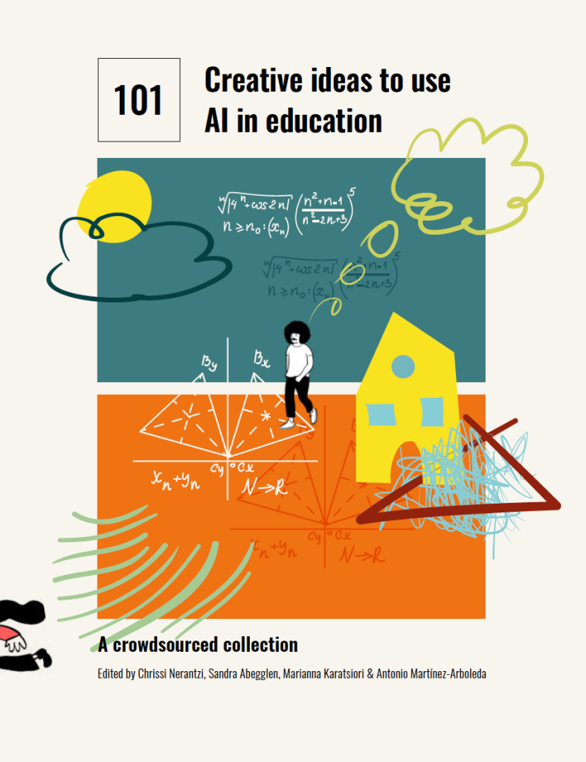

https://creativehecommunity.wordpress.com/2023/06/23/oa-book-101-creative-ideas-to-use-ai-in-education/
Nerantzi, C., Abegglen, S., Karatsiori, M. and Martínez-Arboleda, A. (Eds.) (2023). 101 Creative ideas to use AI in education. A collection curated by #creativeHE. Graphic Design by Bushra Hashim. CC-BY-NC-SA 4.0.

Using AI to write better emails in a second language

It can be a valuable tool to enhance communication and language proficiency. Here are some ways someone can leverage AI for this purpose:
1. AI-Powered Language Translation: Use AI language translation tools to translate emails from your native language to the second language and vice versa. This can help you ensure that your message is accurately conveyed, reducing the risk of misunderstandings.
2. Grammar and Spelling Checkers: AI-powered grammar and spelling checkers can assist in identifying errors and suggesting corrections in your email writing. They can help you improve the accuracy and clarity of your messages.
3. Contextual Language Suggestions: Some AI writing tools provide contextual language suggestions as you type. These suggestions can help you find the right words and phrases that are commonly used in business emails in the second language.
4. Email Templates: AI can generate email templates tailored to specific purposes, such as job applications, client inquiries, or follow-ups. These templates can be customized with your specific information and language preferences.
5. Language Exchange with AI Chatbots: Engage in language exchange with AI-powered chatbots designed for language practice. These interactions can enhance your conversational abilities and writing skills.
It's essential to use AI tools as aids rather than relying solely on them. Language learning is a dynamic process that involves practice, immersion, and real-life interactions.


