New Titles from Crown House Publishing
Press release 1
“Full of invaluable, easy-win ideas to help the busy SEND leader save time and effort in their demanding yet extremely rewarding role. It is a book of little gems!”
– Natalie Packer, SEND Consultant, NPEC Ltd, author of The Perfect SENCO and The Teacher’s Guide to SEN

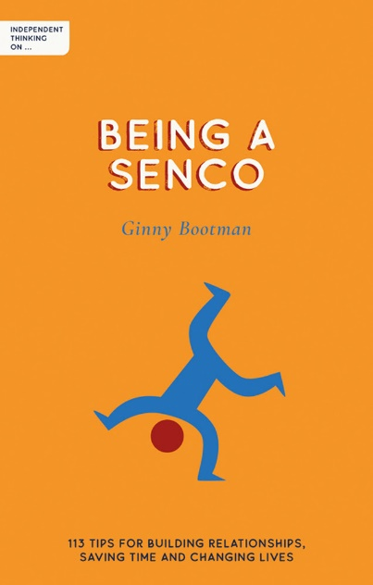
Independent Thinking on Being a SENDCO: 113 tips for building relationships, saving time and changing lives
By Ginny Bootman
ISBN: 9781781354247
Price: £11.99
Published by: Independent Thinking Press
Date of publication: 31st May 2023
An informative guide that identifies simple, tried and tested ways to build and cement strong relationships between all those who work with children with additional needs, whether they are teachers, parents, carers or outside agencies.

Ginny Bootman explores 113 practical tips and tricks for being a SENDCO...

SEND = Special Educational Needs and Disabilities
SENDCO = Special Educational Needs and Disabilities Coordinator, i.e. a shoulder to cry on, an ear, a voice, a champion, an advocate, a family counsellor, an interpreter, a chaperone, a fan, a messenger (don’t shoot), a friend, a fixer, an inventor, a holder of hands, a promise-maker, the one who always has tissues, a meeting organiser, a reassuring face in a crowded room, a smile, an expert, someone’s last hope, an ally, a connection. The educational professional who campaigns tirelessly on behalf of the children who need more support than most to navigate a system that, at times, seems purposefully set up to make them fail. Phew, now take a breath.

When it comes to being a SENDCO, it isn’t just the magnitude of the job itself, which is as challenging as it is rewarding on a good day, it is also about the little things.
It is the little things that make a difference to the children in our care, whether it be a conversation with teachers, children or parents, allowing a child to eat their lunch in a particular order or be seated in a place that suits their needs, or little thoughtful acts of kindness such as tweaking a worksheet – it is the seemingly trivial acts that can make a big difference.
It is hard being a SENDCO. As an experienced teacher and SENDCO with responsibility for four primary schools, Ginny Bootman would know. When she began her teacher training journey over 30 years ago, it was in a tough school with tough teachers. There was no time for empathy. It was all about survival.
But even then, as a teaching assistant, a class teacher, a head and, finally, a SENDCO, Ginny understood the power she had to make a difference to the children who needed it most by listening carefully and responding with creativity, determination and, most importantly, empathy. Now in her new book, Independent Thinking on Being a SENDCO, Ginny has distilled this understanding into 113 tips for building relationships, saving time and changing lives.
“As SENDCOs, we can help children, often against the odds. When the system seems to be working against us, we can give them what they need in the here and now. I know we never have enough time, but I hope that the many time-saving tips in this book will free up time to do what I refer to as the yum-yums – those precious moments we get to spend with the wonderful children in our care. We help to provide a spider’s web of trust for these children, and my hope is that this book will help readers to consider which threads are already strong and which need strengthening further.”


Perhaps the biggest lesson of all for SENDCOs is this one: you don’t know everything, and that is OK. There are too many issues, too many children, too many families, too many situations and too many variables. No one knows it all, so beware those who think they do. It isn’t only OK to say you don’t know, it is you at your professional best. It isn’t a weakness but a strength.

The book shares practical advice to help readers be the best SENDCO they can be, the SENDCO their children need them to be and the one they know they can be. It is full of tips to save time and energy, little hacks to help readers overcome obstacles and bumps in the road, and proven strategies that will help them build more effective relationships.
“These relationships will benefit everyone who comes into contact with the amazing children in our care. It also extends to parents/carers and to the professional teams outside the school environment who play a part in helping children. Together, we can help children, often against the odds. And we can love our role too; I should know.”

Suitable for SENDCOs, primary and secondary school teachers and leaders, as well as parents of children with additional needs.

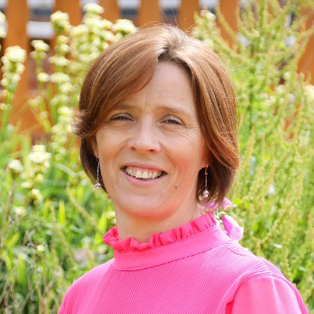
Ginny Bootman is an experienced teacher and SENDCO with responsibility for four primary schools, as well as a regular speaker at national SEND conferences. She is passionate about the impact of relationships within education, particularly for those working with children with additional needs, and is determined to improve understanding of the pivotal role that these relationships play within the school environment.

Articles and interviews available
Ginny is available for interview, expert comment or by-lined articles on a range of topics, such as:
• Working with outside agencies as a SENDCO
• Time-saving tips for busy SENDCOs
• An empathy-based approach to building strong relationships with parents
• How to support the class teacher as a SENDCO
• The PACE approach to SEND – employing playfulness, acceptance, curiosity and empathy in all your interactions
• Auditing SEND provision

Press release 2
“A wonderful set of resources from which anyone facilitating professional learning can draw. The cards simplify, clarify and deepen understanding, building community and confidence in the process as they demystify self-regulation and metacognition.”
– Bill Lucas, Professor of Learning, University of Winchester

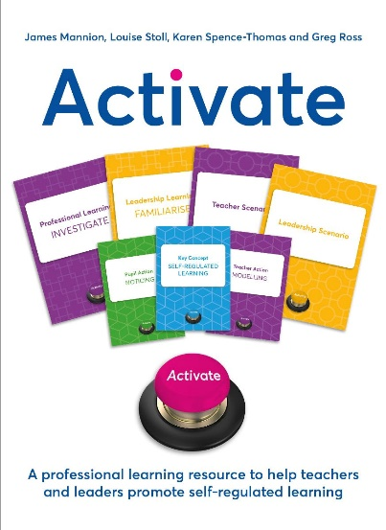
Activate: A professional learning resource to help teachers and leaders promote self-regulated learning
by James Manion, Louise Stoll, Karen Spence-Thomas and Greg Ross
ISBN: 9781785837050
Price: £34.99
Published by: Crown House Publishing
Date of publication: 27th October 2023

A card-based professional learning resource that aims to improve pupils’ experiences and outcomes by promoting self-regulated learning among leaders, teachers and pupils.

The key to nurturing more confident, proactive learners in schools

It’s widely recognised that self-regulated learners are more effective learners. For example, in England, the Education Endowment Foundation (EEF) suggests that ‘metacognition and self-regulation’ are among the most impactful things a school can focus on, providing ‘very high impact for very low cost, based on extensive evidence’.¹ However, teachers and leaders are often unsure precisely what ‘metacognition and self-regulation’ means – or what these ideas look like in practice.
In order to understand what self-regulated learning and metacognition are in practice, we need clear definitions:
• Metacognition: Monitoring and controlling your thought processes (thinking about your thinking).
• Self-regulation: Monitoring and controlling your feelings and behaviours (how you interact with the external world).
We can see that these ideas mirror one another in that they both involve monitoring and controlling. By doing so, an individual can gain an increasing awareness of how they respond in certain situations and of the choices they can make in controlling how they respond to those situations in future.
Clearly, if it’s possible for teachers to ‘activate’ children and young people to become the drivers of their own learning, then there’s a strong case for doing so. Activate is a card-based professional learning resource that aims to do just that by promoting self-regulated learning among leaders, teachers and pupils. This unique card set, designed by James Mannion, Louise Stoll, Karen Spence-Thomas and Greg Ross, enables time-pressed teachers, leaders and support staff to understand the theory and practice of self-regulated learning in an incredibly accessible way.


It comprises six sets of resource cards (83 cards in total) and a clear and detailed facilitator guide, together with an extensive bibliography and additional downloadable materials. Working through the Activate activities will enable teachers and leaders to realise the potential of these powerful ideas when working with pupils, whilst helping them to regulate their own learning.

Professional learning resources are most impactful when they are adapted by practitioners to suit the needs of their particular context, rather than being taken off the shelf and implemented in a uniform way. Teachers and leaders in schools know their setting, their colleagues and their pupils best. The authors therefore encourage all teachers and leaders to adapt the ideas and practices from Activate to suit their own environment. In doing so, the reader will be modelling some of the key concepts involved in self-regulated learning.

Suitable for all teachers and leaders looking to create more confident, proactive, self-regulated learners.

1 Education Endowment Foundation, ‘Metacognition and Self-Regulated Learning: Guidance Report’, London: Education Endowment Foundation, 2021, pp. 4. Available at: EEF_Metacognition_and_self-regulated_learning.pdf (d2tic4wvo1iusb.cloudfront.net)

“Exceptionally clearly written and presented, based in robust cognitive science, Activate is really, really, really, really useful and practical. Use the materials, follow what it says on the tin, and a 21st-century school worthy of the name can be yours for the asking.”
– Guy Claxton, author of The Learning Power Approach and co-author of Powering Up Your School


Dr James Mannion is the Director of Rethinking Education, a teacher training organisation dedicated to improving educational outcomes through self-regulated learning, implementation science, and practitioner research. He has a Masters in Person-Centred Education from the University of Sussex, and a PhD in Self-Regulated Learning from the University of Cambridge. Previously, James taught in secondary schools for 12 years.


Dr Louise Stoll is Professor of Professional Learning at the UCL Centre for Education, IOE and an international consultant, focusing on how school and system leaders create capacity for learning. Louise is a former president of the International Congress for School Effectiveness and Improvement and has worked with the OECD on several initiatives. She has co-developed many materials supporting leaders to connect research evidence and practice.


Karen Spence-Thomas is a former schoolteacher and Associate Professor (Teaching) at the Centre for Educational Leadership, IOE. She specialised in designing and facilitating tailored professional development programmes for school leaders in the UK and internationally. She also co-led the centre’s R&D network of schools, promoting teacher inquiry as a basis for professional development.


Greg Ross is an Associate Professor (Teaching) at the UCL Centre for Educational Leadership, IOE. He specialises in the design and delivery of evidence-informed professional learning programmes for teachers and school leaders, in partnership with ministries of education, non-governmental organisations, and international school groups. Greg’s research focuses on the leadership of curriculum change. Before joining the IOE, Greg was a senior leader and English teacher in secondary schools.

Press release 3
“Essential reading for anyone concerned about the disadvantage gap in schools. It is both sensitive and punchy: sensitive in its framing of the considerable disadvantages for many pupils and punchy in its bold, yet workable suggestions for addressing these.”
– Mary Myatt, education writer, speaker and curator of Myatt & Co

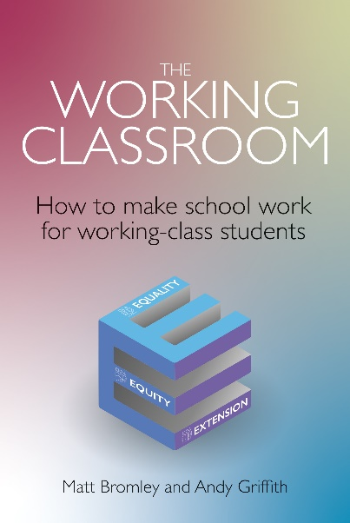
The Working Classroom How to make school work for working-class students
by Matt Bromley and Andy Griffith
ISBN: 9781785836985
Price: £18.99
Published by: Crown House Publishing
Date of publication: 31st October 2023
Offers practical strategies and tools to help secondary schools address the needs of working-class students, including building cultural capital and designing learning that is more engaging to working-class students.

How can we make school work for working-class students?

Working-class students are disadvantaged by the education system, not by accident but by design. That’s the bold claim of two experienced educationalists in their new book on the disadvantage gap in schools, The Working Classroom.
Similarly, in a debate around what a socially just education would look like, Cambridge University Professor of Education Diane Reay writes that “Working-class children get less of everything in education – including respect.”¹ Those who work in the education sector have a moral obligation to do something – and urgently – to address this situation. It’s unacceptable simply to stand by and let the class and wealth divide continue to grow in a society where wealth and social status, rather than ability and effort, dictate educational attainment and success in later life. Reay goes on to say “If you’re a working-class child, you’re starting the race halfway round the track behind the middle-class child. Middle-class parents do a lot via extra resources and activities.”²
Schools do amazing work to support children from disadvantaged backgrounds, but in their powerful new book The Working Classroom, Matt Bromley and Andy Griffith enable teachers and school leaders to do more. Matt and Andy firmly believe the education system is rigged in favour of the privileged. Working-class students are disadvantaged from day one: all too often their birth is their destiny; they start at a disadvantage and end at a disadvantage. This disadvantage comes in many forms but cultural poverty, where some students have relative knowledge gaps compared with their more affluent peers, can be addressed successfully by schools.

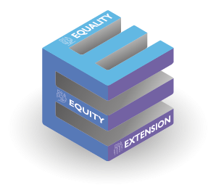
The only way to truly fix inequality is, of course, by reducing inequality. Although the authors acknowledge that the systemic nature of inequality requires society at large to change, there are actions that school leaders and teachers can take now to help working-class students compete equitably at school and in later life.

The authors say: “We need to be deliberate in how we design our core curriculum, how we plan and target curriculum interventions, how we design curriculum enhancements, and how we train staff and interact with parents and other stakeholders.”
The Working Classroom explores ways that schools can mitigate some of the effects of classism and help working-class students get a better start in life, so that ability and effort, not where you are born and how much money you inherit, dictate success in school and in later life. The book details realistic ways in which schools can close these knowledge gaps and, in so doing, create a socially just education system – one that builds on the rich heritage of the working class, rather than seeing their background as a weakness. It offers practical ways for students and families to build on the best of working-class culture, whilst also empowering teachers, students and parents to change the system.
This book focuses on three strands of support that schools can offer to help counter the classism that is inherent in the education system:
• Equality through the core curriculum and extra-curricular activities.
• Equity through curriculum adaptions and interventions.
• Extension through curriculum extras and enhancements.
The Working Classroom aims to help teachers and school leaders make more of a difference, more of the time. Backed up by research and case studies, the book is a practical resource that is easy to dip into when help and advice are needed most. The authors draw on their own experiences of working in and supporting schools in challenging circumstances, including working directly with working-class students and their parents.

Suitable for both teachers and leaders in a secondary school or sixth-form college setting who seek to support social change in education.

1 D. Reay, ‘Working-class children get less of everything in education – including respect’, The Guardian, 2017, https://www.theguardian.com/education/2017/nov/21/english-class-system-shaped-in-schools
2 Ibid

“This is an excellent book: very well referenced, analytical, packed with stories and providing a commanding compendium of practical ideas for the classroom.”
– Roy Blatchford, Chair of ASCL’s The Forgotten Third and author of The A – Z of Great Classrooms


Matt Bromley is an education writer and advisor with over twenty years experience in teaching and leadership including as a secondary school headteacher, FE college vice principal, and multi-academy trust director. Matt is a journalist, public speaker, ITT lecturer, and school improvement advisor. He also remains a practising teacher, working in secondary, FE and HE settings.


Andy Griffith has a proven track record for creating high-impact training courses and interventions with students, teachers and leaders. His major career motivation is for education to be an engine for social justice. In the past seven years, alongside his school development work, Andy has developed programmes for students that have had a positive impact on their academic results as well as building their cultural capital.

Press release 4
“In a power-packed compact volume, Kristian Still presents an extraordinarily well-researched guide to support teachers as they practically employ retrieval through quizzes, self-tests and other memory-stimulating activities.”
- Margaret A. Lee, educator, consultant, co-author of Mindsets for Parents

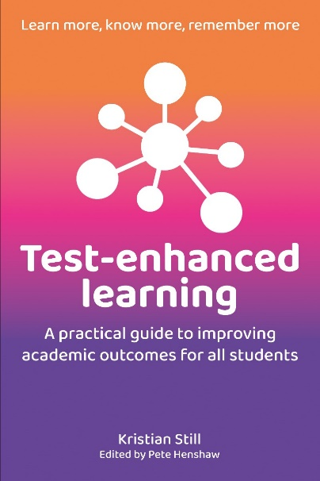
Test-Enhanced Learning:
A practical guide to improving academic outcomes for all students
by Kristian Still
ISBN: 9781785836589
Price: £16.99
Published by: Crown House Publishing
Date of publication: 13th February 2023

An informative guidebook that explores the wealth of evidence behind and the benefits of test-enhanced learning, spaced retrieval practice and personalisation.

Raising pupil achievement: refuting the stigma around testing

Testing in education is somewhat of a contentious issue. In some quarters, there is a regrettable mistrust and even an aversion to testing from many teachers. Tests have acquired an unfortunate association with damaging forms of accountability, including top-down, managerial forms of school leadership and heavy-handed, highly questionable use of data in schools.
If we anticipate that pupils will forget much of what we teach them, however, then the requirement to reteach is obvious. Testing is therefore extremely valuable mnemonically and metacognitively, signposting what to reteach and to whom. Learning is said to occur when information from working memory is transferred to long-term memory through conscious processing – linking new knowledge to what is already in our memory, or prior knowledge. When retrieving that information, an associative chain reaction modifies that memory, promotes consolidation (storage) and slows forgetting.
Test-enhanced learning, more commonly referred to as the testing effect or retrieval practice, is about putting memory to the test in a host of learning situations. In the classroom, this could be via various retrieval methods, including low-stakes quizzes, self-tests and other memory-stimulating activities.


Knowledge of forgetting is very much a part of test-enhanced learning and spaced retrieval practice – as much as knowledge of remembering. Forgetting is not the opposite of remembering; rather, we have to forget some things in order to remember others. And, as it turns out, we ‘need’ to forget in order to learn and relearn.

In his practical new book, Test-Enhanced Learning, experienced school leader Kristian Still explores the wealth of research behind the approach, its direct and indirect benefits and details the components of testenhanced learning (i.e. cognition, repeated retrieval practice, spaced learning, interleaving, feedback and elaboration, successive relearning, metacognition and motivation), both inside and – just as importantly – outside the classroom.
His interest in this area of research started with Kristian simply trying to find a solution to what his pupils needed most at that time: being able to access knowledge that allowed them to better understand the texts being taught in class. He noticed an impact on pupil attainment and classroom culture that accompanied the introduction of test-enhanced learning and personalised spaced retrieval, with improved attention and pupil confidence, fewer distractions, better notetaking, far more robust class discussions and improved punctuality. But it became so much more than this. It became an iterative investigation on how to create a successful and secure classroom climate, to seek teaching effectiveness and learning efficiency at the same time as reducing teacher workload, and that is when Test-Enhanced Learning was born.
The book provides a blueprint for all teachers and schools to improve the academic outcomes of their students and to achieve this in ways that improve the motivation of learners and boosts their confidence in lessons. It is supported by real, classroom-based routines that have been tried and tested by both Primary and Secondary teachers, as well as a number of practical case studies.
Alongside Test-Enhanced Learning, Kristian has designed an accompanying digital flashcard system that aims to boost learning and reduce teacher workload – the Remembermore app. Co-designed with pupils and supported by a host of teachers, school leaders, applied cognitive psychologists and data scientists, it is an open and free web portal that supports bespoke quizzing in classrooms, offers personalised spaced retrieval practice and reports usable learner metrics and teaching insights that will inform teaching practice.

Suitable for all teachers in all settings.

“I highly recommend this book and consider it to be a launch of a new era in which context and techniques are intelligently integrated.”
Oliver Caviglioli, co-author of the Teaching WalkThrus books


Kristian Still is a Deputy Head at Academic Boundary Oak School, an independent private school in Hampshire. He has over 20-years’ experience as a head teacher and senior leader with a MsEd in Kinesiology, BSc in Sports Science, and a Level 5 Coaching and Mentoring. Kristian shares a keen interest in education leadership, evidence informed practice and #edutech.

