Generation Next: How to talk to your kids about climate crisis

Caroline Hickman, UK

Caroline Hickman has a background in mental health social work. She is a psychotherapist and lecturer at the University of Bath researching children and young people’s emotional responses to climate change globally examining eco-anxiety and distress, eco-empathy, trauma, moral injury, and the impact of climate anxiety on relationships.

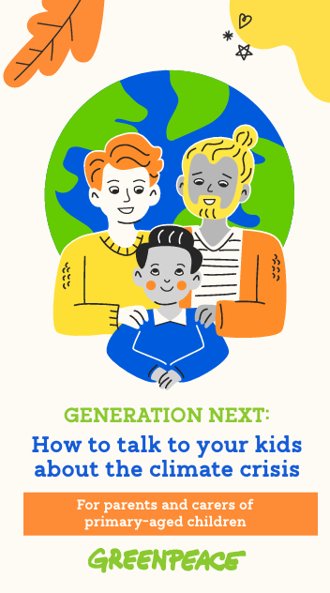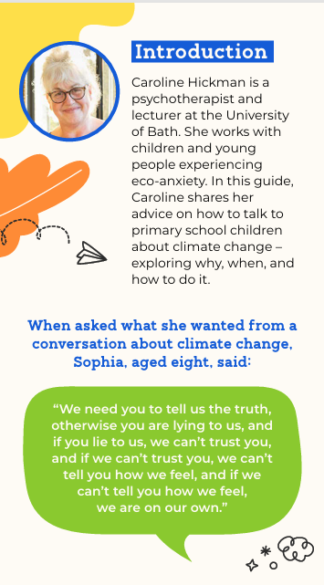
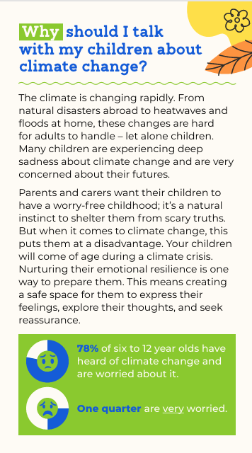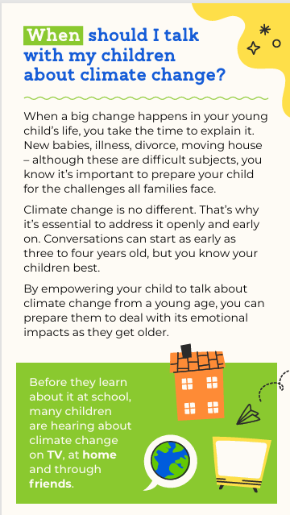

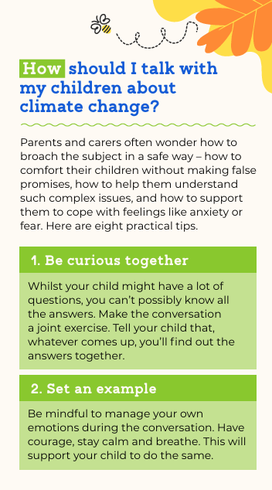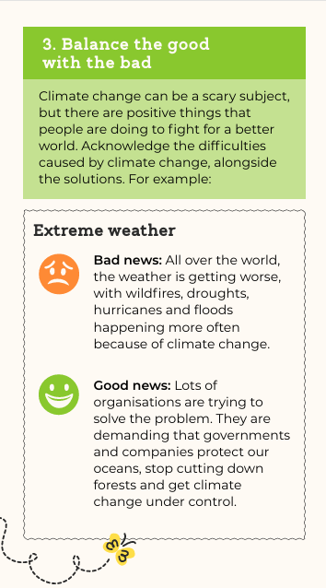

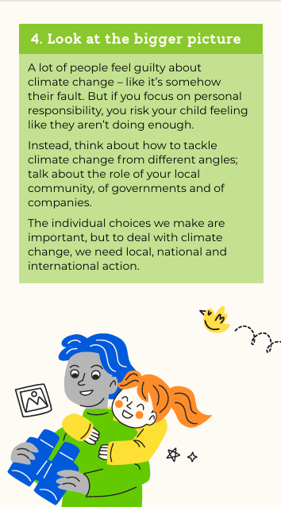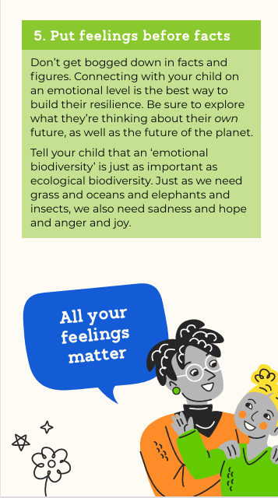

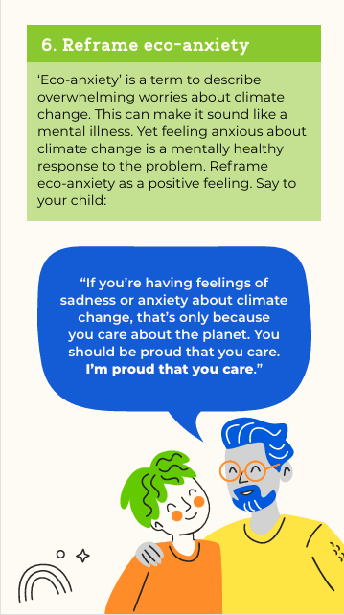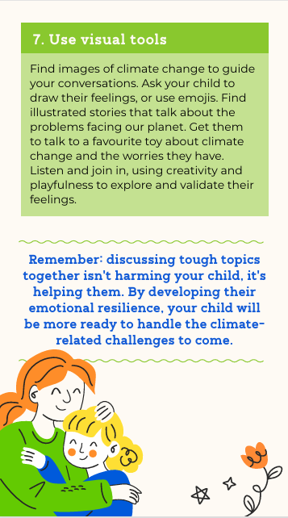

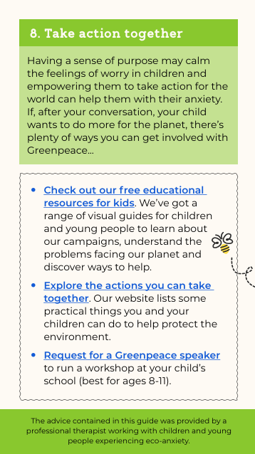

You can download the pdf at the bottom of this page.

Coming soon! Please check the Pilgrims in Segovia Teacher Training courses 2026 at Pilgrims website.

Please check the Pilgrims f2f courses at Pilgrims website.

