Human Trafficking and Modern Slavery: Probably in your Home... and Quite Possibly in Your School

Judy Boyle, Greece

Judy Boyle is the founder of The NO Project, an award-winning, arts-based, global educational campaign against modern slavery and human trafficking. She has been involved in anti-slavery educational actions for over 23 years. Judy is a teacher, trainer, researcher and author. Her background also includes professional theatre and filmmaking. In 2022, Judy directed and produced It’s Just Business, an award-winning, surreal short film against modern slavery based on a spoken-word poem by a 16-year-old high school student. We would love to hear from teachers who would like to pilot the material. Please do contact us: judy@thenoproject.org

‘You may choose to look the other way, but you can no longer say you do not know.’
William Wilberforce, Abolitionist (1759 –1833)

The NO Project award-winning lesson plans

The NO Project has created free, downloadable teaching resources on human trafficking and modern slavery. Each lesson is based on a true narrative and is approached with dignity, sensitivity and respect. Designed for upper secondary, young adult and adult learners, The NO Project lessons are ideal for both on-line teaching and in the classroom. Each unit includes slides, artwork, authentic interviews, videos, lexical input, original listening material, and a gentle step-by-step teacher’s guide. Also provided are student autonomous learning resources with suggestions for project-based actions beyond the class. These teaching resources have been featured in the Master’s in Education Program at Havard Graduate School of Education and are being used by thousands of educators worldwide.
The teaching material was created in partnership with The Rights Lab, Nottingham University, UK. Email: judy@thenoproject.org

The two lessons we focus on today, Cocoa Truth and Eyes Wide Shut although quite different, both involve extreme exploitation of minors - children and teens for profit. Another place, another time this could be the students in your class...and with the case of Eyes Wide Shut, a victim of the crime of Trafficking in Persons (TIP) might be in plain sight sitting right in front of you in your class.

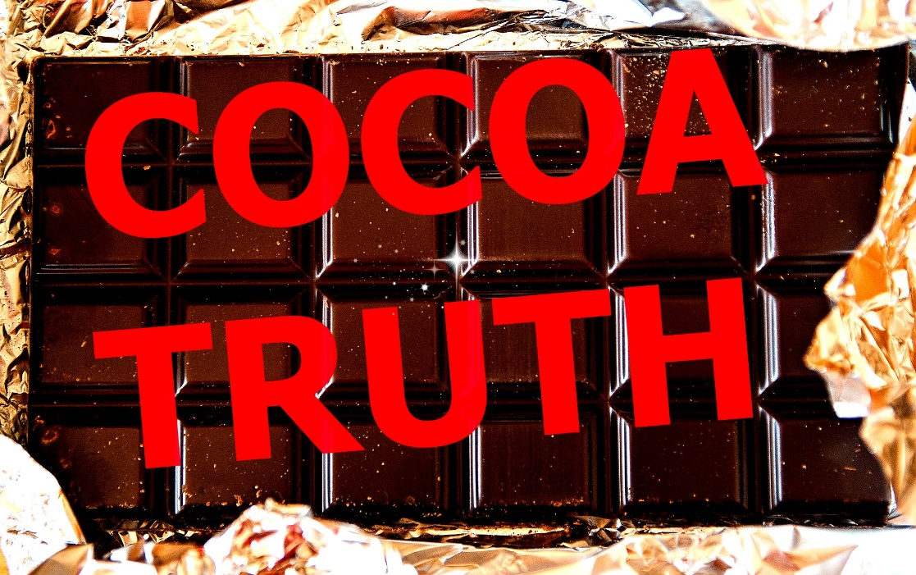

Cocoa Truth

Are you fond of chocolate? Milk, dark, white? With fruit perhaps or do you prefer a salted caramel? What about rich chocolate cake with cherries or raspberries?
And which do you prefer - chocolate with or without slavery in it?
No matter how you might consume this delicious cocoa-based product, be it hot chocolate in winter or a fresh chocolate croissant for breakfast, there is reasonable chance it could have a backstory of slavery.

Cocoa Truth addresses the used of forced labour, including forced child labour in the cocoa industry. The lesson also addresses how we, as consumers of cocoa-based products in particular chocolate can use our buying power to influence chocolate companies. The lesson takes a different point of view, initially not focusing on people enslaved in the supply-chain of cocoa, but rather on Peter, a successful young company owner whose business is booming – but at what cost? By accident Peter’s world is turned upside down when he learns of the reality behind the cocoa that is helping his profits soar.

As with all lessons created by The NO Project, there are so many diverse ways to adapt the teaching resources to you specific context – be it through use of images, headlines, statements, narratives. Whatever choice you make, as described in the Teacher’s Guide of each lesson, a main goal is to engage the student’s genuine curiosity, intrigue and intellectual and emotional commitment to the theme. Go gently, but clearly. We do NOT endorse shock tactics or sensationalism. The content, as one would expect, is confronting.

Coming back to the lesson Cocoa Truth, look at these two short excerpts below from ‘Peter’s Story’ – the narrative that provides the basis for this lesson. What questions do you want answered after reading these two segments? Also, the free resources also include an audio recording of Peter’s Story for classroom use too.

Download the lesson Cocoa Truth and discover further content – including an authentic first-hand interview with ‘Kira’ the director of a shelter for minors who have been trafficked and forced to work on the cocoa plantations.
I am the owner of several businesses: an award-winning chocolate company, a number of cafes and an exclusive catering company - working mostly with high-end clients.
I started with practically nothing. I work extremely hard, and I love what I do.
Now back home, I was exhausted. I turned on the TV and I happened to hear the word chocolate - which, of course, got my attention. But as I watched, my heart froze.
On the screen were pictures of children and teenagers like I’d never seen before. Their bodies were covered in cuts and scars. One little boy, tears running down his cheeks, was saying how much he missed his mother. An older boy showed the camera his back – it was covered in marks where he’d been beaten. Another showed an injury on his leg, a deep cut through to the bone. It was horrific.


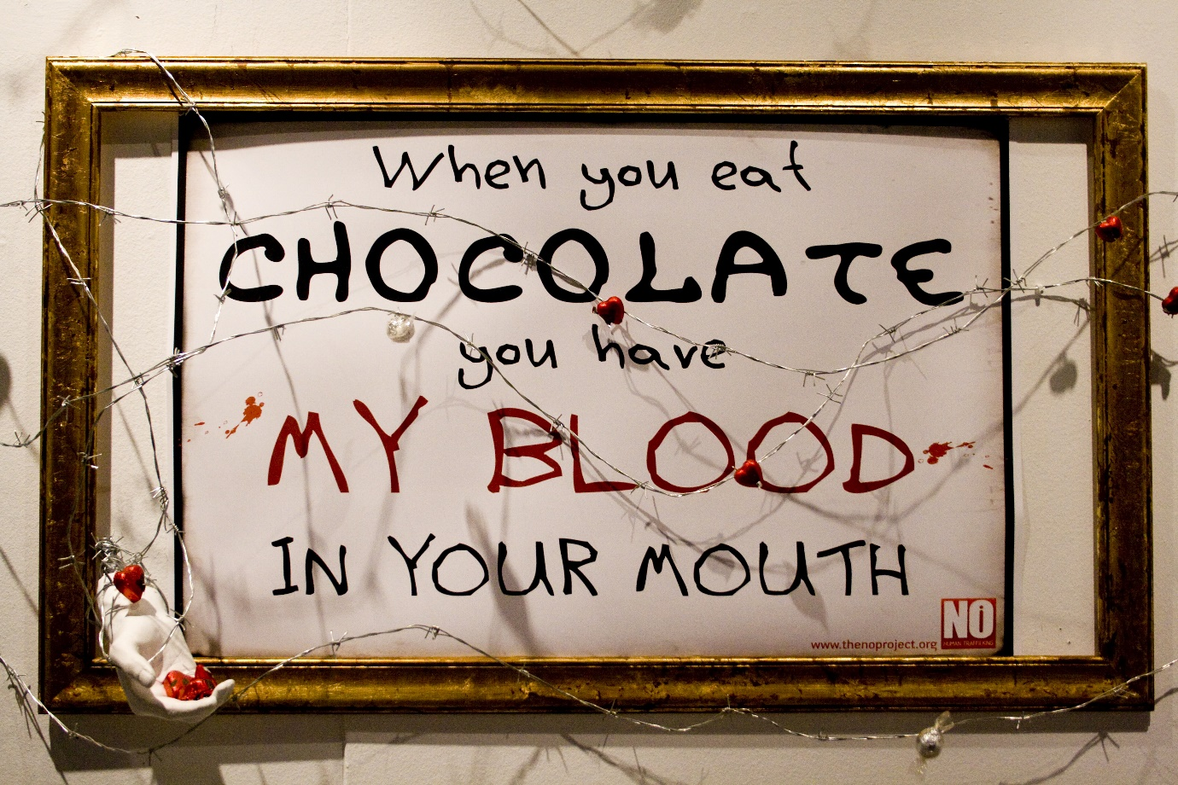

Eyes Wide Shut
As you’ll discover in the Teacher’s Guide for Eyes Wide Shut, again the pedagogic goal is to engage the students’ curiosity and allow them time to come up with their own ideas. As with all The NO Project lessons, we approach each theme gradually and gently, adding more key information as the lesson unfolds. Please see the slides and Teacher’s Guide for further reference.
Eyes Wide Shut is based on a true narrative by ‘Sarah’ a school girl in the UK. As the lesson title suggests the lessons draws attention to the fact that ‘nobody seems to notice’ what was really going on – from her foster family, to school teachers, to even court Judges. Or if they did notice, they chose not to take action. Eyes Wide Shut also addresses the process of grooming, and a handout is provided in the resources with the specific goal of prevention. We realise that this content may be confronting, but the integrity, courage and willingness of educators to address this crime in the class could alter the course of someone’s life profoundly.


Here are some segments from Sarah’s narrative.
My name is Sarah and from the age of 10 to 12 I was groomed by a gang of men in the UK. The men made friends with me, and they really seemed to care for me. I had been a child in foster care since I was three years old and although I had lived in many different foster homes, nobody really looked after me. I was alone and vulnerable, so I easily became the gang’s next victim.

I was sold every day to many different men. I would have a minimum of seven clients a day, but that would usually go up to around 12 to 16. The trafficking gang had complete control over my life – every minute of the day. Even while on my Year 8 school trip to France, my traffickers arranged for me to work at night while I was there.

Throughout those years nobody noticed what was happening to me. I became a very angry teenager, and I would get in a lot of trouble all of the time. But nobody wanted to find out why. No one cared that a 14-year-old was working on the streets at 2am. No one asked why a 15-year-old was going in to hotel rooms with older men, or why a child was hardly ever in school and when she did go – she was exhausted. It took seven years for me to be seen. Seven years of torture, control and hell.

Coming soon! Please check the Pilgrims in Segovia Teacher Training courses 2026 at Pilgrims website.

Coming soon! Please check the Pilgrims f2f courses at Pilgrims website.

