Inspirational Stories: Bringing Environmental Activists into the Classroom
Margit Szesztay, Hungary
Margit Szesztay teaches at the Department of English Language Pedagogy at ELTE University in Budapest. In addition to general ELT methodology, she runs courses on language development for teachers, group dynamics, the creative teacher, group facilitation, global issues, and the teacher as educator. Email: margit.szesztay@gmail.com

Why young environmental activists can inspire
When I bring issues related to the climate emergency and sustainability into the classroom, I often encounter feelings of being overwhelmed and powerless. Many teenagers and higher education students I have met are paralyzed by the size and complexity of these problems and feel that nothing they could do matters. Some say that it is up to corporations, governments, and scientists to solve the complex problems facing humanity. Others believe that it is simply too late.
Based on my experience, one way to break out of these negative and debilitating attitudes is through stories of young people making a difference. Recently I have co-authored an exam preparation book (Major-Szesztay, 2024) in which sustainability is a recurrent theme. In particular, we focus on inspirational young people who are at the forefront of bringing about change. Sierra Robinson is one such person. At the time of her TED talk in 2019, she was a 17-year-old environmental activist campaigning for regenerative agriculture. She is someone my students can identify with because of her age and because she starts her talk by acknowledging how easy it is to feel overwhelmed and powerless when we reflect on the state of our planet. However, she then continues to tell her own story which can move and inspire her listeners.
How classroom activities get students ready for online talks
These days young people watch a lot of YouTube videos and online talks. These are often consumed like ‘fast food’ as they watch one clip after another without fully taking in the content or reflecting on the message. Giving students a lead-in task before viewing can be a good way to ensure that they watch and listen more thoughtfully. There are now several publications that advocate for such an approach, for example, the Keynote series by National Geographic.
I like to give my students a pen & paper task before asking them to watch an online talk (although they can do the task on their tablets, as well). In the case of Sierra’s TED talk, I give them a reading comprehension task: they need to match the questions and answers of an interview. To solve the task, they need to read the text carefully and grasp the meaning of each sentence. This kind of deep engagement tends to arouse curiosity about the person behind the story. It also provides scaffolding for the viewing that follows, as students are already familiar with the skeleton of Sierra’s story.
Below you can see the kind of lead-in task that students do – this one has been taken from the exam preparation book. The first page shows the questions of the interview, and the second page contains her responses which need to be matched with the questions.
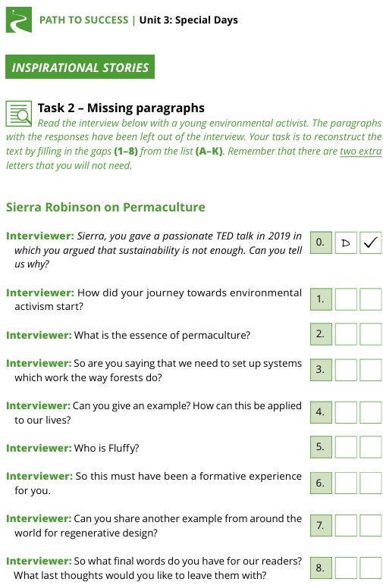

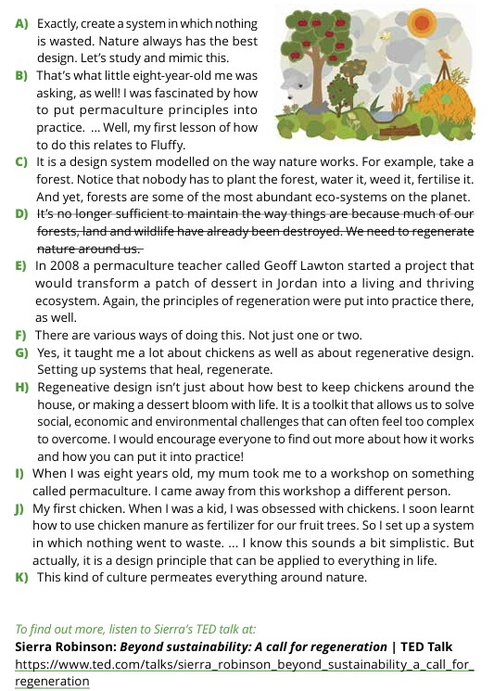
I found that after engaging with the matching task above, students are more motivated to listen and get more out of the viewing and listening experience. During follow-up discussions they refer to specific content more often, rather than just making general comments. This also means that Sierra’s TED talk becomes more memorable for them: both in terms of content and in terms of the language she uses to tell her story. She ends her talk by asking: what could you do to be part of the regenerative movement that is happening around the world? Having engaged deeply with her story, this question is more likely to spark reflection and lead to meaningful discussion in the classroom.
References
Dummet, P. Stephenson, H. Lewis L. (2016) Keynote. National Geographic.
Major É. and M. Szesztay (2024) Path to success. Eötvös Publishing.
Robinson S. (2019) Beyond sustainability: a call for regeneration. TED talk. https://www.youtube.com/watch?v=GlzLwVweDpQ

Please check the Pilgrims f2f courses at Pilgrims website.

Please check the Pilgrims online courses at Pilgrims website.

