Green Standard Schools
Jonathan Dykes, Spain

Jonathan Dykes has worked in language school management most of his professional life. He was the founder of several private language schools, as well as Net Languages, one of the world’s first Web-based language schools. He also co-founded Green Standard Schools, a not for profit association that aims to encourage language schools everywhere to become more environmentally sustainable. Email: jonathan@greenstandardschools.org



“IT’S WORSE, MUCH WORSE THAN YOU THINK.”
This is the opening sentence of a book called ‘The Unhabitable Earth’ written by American author David Wallace-Wells, first published in 2019.
The book goes on the explain the many ways in which humans are degrading our precious, delicate environment, and outlines the dire consequences facing much of life on earth if we don’t do something radical to change our ways.
In the short period since the book was published the situation has become even worse. Last year, 2023, ended with what Professor Petteri Taalas, Secretary-General of the United Nations World Meteorological Organisation, described as a “cacophony of broken records”.
Greenhouse gas levels were at a record high. Global land and sea temperatures were at a record high. Antarctic sea ice was at a record low and, predictably enough, sea level rise was at a record high.
Extreme weather events including deadly floods and storms, extreme heat and drought, and associated wildfires, affected many parts of the world, exacerbating the challenges faced by hundreds of millions of people.
Added to this tidal wave of misery are the millions of premature deaths that are caused each and every year by breathing the polluted air that comes from burning fossil fuels such as wood, coal and oil, and products of oil such as petrol and diesel.
And of course we’re not just polluting the air. Rivers are full of sewage, oceans are full of plastic (according to one study there could be more plastic then fish in our ocean by 2050) and much of our land is being contaminated by a deadly cocktail of chemicals and waste.
Millions of plant and animal species are also suffering the consequences of our reckless behaviour. Whole ecosystems are collapsing, and a mass extinction is well under way.
So what can we those of us working in the language teaching sector do? Can we really make a difference?
“The greatest danger to the planet is the assumption that someone else will save it.”
Robert Swan – English explorer and activist
This is one of the ideas that motivated me to start Green Standard Schools.
I was also motivated by the thought that my generation was leaving the world in a much worse state than it was when we arrived on the scene, and I wanted to do whatever I could to ensure that my daughter’s generation wouldn’t be left to clean up our deadly mess.
But why another association?
Back in the late noughties I had become convinced that we needed to do something to lessen the impact that the language school I was responsible for was having on the environment. I was also convinced that we needed to set our sights on obtaining some sort of accreditation as a ‘green school’. This would give us something concrete to work towards and would ensure that my idea didn’t end up as a well-intentioned but ultimately ineffective slice of wishful thinking.
To be honest, I also thought that obtaining accreditation as an environmentally friendly language school could also be good for our business, in that it might help us attract students who were also concerned about what was happening to our planet.
I looked around to see what organisations offered serious accreditation for environmental sustainability and eventually opted for the EU’s Eco Management Audit Scheme (EMAS, for short).
Obtaining EMAS accreditation proved to be rather more of a challenge than I had anticipated, and it also turned out to be quite expensive; we needed to have a part-time environmental officer on our staff, and two external audits each year.
It was also evident that the EMAS accreditation process, while rigorous, wasn’t entirely relevant to our kind of business.
Fast forward to 2019 and I had what seemed to be a bright if rather ambitious idea: why not design a new accreditation system specifically for the global language teaching sector that would be equally rigorous, but also entirely relevant and, just as important, affordable?
I discussed the idea with a number of colleagues and although some didn’t think it would work, there was enough enthusiasm from enough people to make me want to make it reality.
With the help of a Colombian lady called Martha Liliana Marin, who had obtained a MSc in Sustainable Development from the University of Sussex, we designed a radically new accreditation system and by September 2020 we were ready to go.
This probably wasn’t the best time to launch anything, given that almost all the world’s language schools were in lockdown, but we decided to announce our foundation anyway. What did we have to lose?

Green Standard Schools
Green Standard Schools was established with the following three primary aims:
1. To lessen the impact that language teaching has on the environment by developing a set of policies and practices that language teaching institutions can adopt and adhere to.
2. To award accreditation against to those schools that can demonstrate that they have adopted a wide range of these policies and practices.
3. To develop pedagogical resources designed to encourage environmental sustainability in language teaching and learning.
The first of these aims is summarised on our website as ‘The 12 Commitments’.
The second aim, awarding accreditation to schools, merits a brief explanation in terms of how the process works.
We started from the premise that we didn’t want to send inspectors around the world for two obvious reasons: firstly it would increase the cost of our services significantly and secondly it would of course also generate an additional carbon footprint, which was precisely what we were trying to avoid. But we needed our system to be rigorous, we didn’t want it to be just another ‘greenwashing’ exercise.
The solution was to devise a self-assessment questionnaire that schools could complete themselves. But it would be a self-assessment with a difference.
After a certain amount of piloting, we eventually settled on a form that consists of 50 YES/NO questions. These questions cover everything that a language school does that has any sort of environmental impact. The questions are divided into the following sections:
- Energy
- Water
- Purchasing
- Recycling
- Accommodation & Food
- Travel
- Teaching and Training
- Social activities
- Nature
- Commitment
Crucially, we wanted the form to work both for schools that provided courses mostly to their local community (so-called ‘community schools’) and schools that imported most of their students from other countries (study abroad schools). Some of the questions are more relevant to one type of school (e.g. accommodation and food) but most questions are entirely relevant to all schools.
As mentioned, the questions are all YES/NO type questions. The key here is that if a schools answers YES to any of the questions, they then have to provide some sort of evidence that will allow our assessors to verify that they are in fact doing what they say they are doing. This evidence could be in the form of a policy document, an Excel, a photo, a link to a website ..; we leave it up to the school to decide. So for example, the very first question on the form (from the Energy section) asks:
1. Do you monitor and record the amount of energy you use in your school?
(We ask this question on the grounds that you can manage items more effectively if you measure them.)
If the school answers Yes, we expect to be able to see how they do this. In this case the evidence could be in the form of an Excel worksheet that lists their energy consumption over time (recommended); or it could simply be a copy of the last half a dozen or so of their energy bills, where their consumption is recorded.
Schools upload the evidence to the GSS platform and then, when they have completed all 50 questions, they submit the form for our evaluation.
Our assessors award points, both for the answers given, and for the evidence provided. So the evidence is crucial.
The total number of points available is 200, and we decided that schools need to achieve a minimum score of 130 points in order to be eligible for accreditation. Which means they don’t have to be perfect (no school is) but they do have to demonstrate that they are serious about environmental sustainability across a broad range of their practices.
Two important points to note:
1. The cost to schools of submitting a self-assessment form is 0. In other words, we are providing a free Environmental Audit to any language school that is interested.
2. We provide feedback on each question answered. Often this includes suggestions on how schools can improve their performance.
Some schools achieve accreditation at the first attempt, but the majority of applicants don't make the minimum score required the first time they submit their form. In these cases, we encourage schools to introduce some of the suggestions we have made in our feedback, and then resubmit their form, once they can demonstrate that they have implemented some of these changes.
Schools generally appreciate the feedback we provide. Here's an example of some feedback on our feedback:
“It is great to have the areas where we can improve highlighted so clearly, as many of them would have been things we wouldn't have thought of doing. We're very pleased to be working towards this.”
Those schools that do achieve the minimum score required, are then invited to become members of our association. This involves paying a modest membership fee (needed to cover our expenses) but schools that are members of certain national or multinational associations may be eligible for a significant discount on our standard fees.
We currently have around thirty accredited members from eleven different countries. Not all of these schools concentrate on teaching English, we also have schools that specialise in teaching French, Spanish, Italian, and German.
Study materials
As mentioned previously, we also want to encourage language schools to discuss environmental issues more frequently with their students. Most modern course books include a chapter called ‘Our planet’ or something similar, but this is often just one unit from ten, meaning that environmental issues are largely ignored 90% of the time. Our contention is that we can and must do better. Globally, the language teaching industry is working with 10s of millions of students each year. If we can make even a small proportion of these students reflect on how they can modify their behaviour to become more environmentally sustainable, the total impact could be really significant.
To help schools introduce environmental issues more frequently into their classes, we have developed a series of detailed lesson plans and other study resources for teachers of English, French, and Spanish. As the development of these study materials was cofinanced by an Erasmus+ project, they are available free of charge to language teachers everywhere.
To access the lesson plans simply click on this link.
The lesson plans contain links to all necessary resources, including original videos, Power Point presentations, etc.
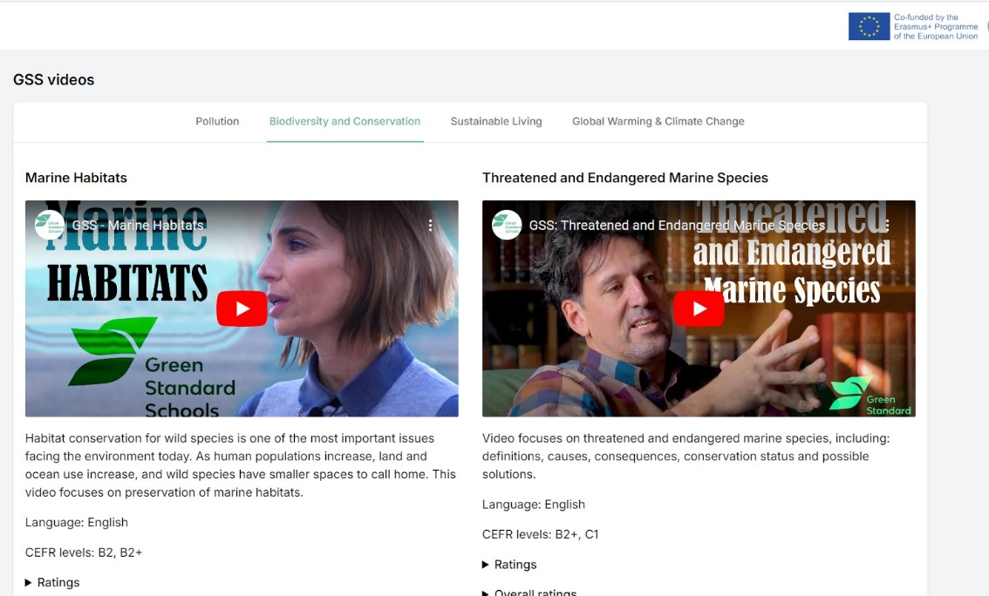

We would very much appreciate your feedback on any of the materials you use, as this will help us improve the development of more materials in future. You will find a feedback form in the link here.

In conclusion GSS is aiming to make a difference. Teachers can help in at least three ways:
- Firstly you can try to introduce more environmental issues into your lessons, using the materials we have developed, or some of the other study materials available on the Internet. You can of course do this without modifying the language learning outcomes. In other words, students can achieve the same level of mastery of skills, grammar, vocabulary, and so on, while also discussing what’s happening to our planet.
- Secondly you can do your best to ensure that your teaching is as eco-friendly as possible. Apart from the obvious steps you can take, such as switching off lights when you leave the room, or only engaging heating or cooling systems when really needed, you can also try to cut down on paper consumption by abandoning the photocopier and, where possible, using digital study tools and materials instead. Even recycled paper takes a lot of energy and water to produce!
- Thirdly you can try to encourage you managers to take the plunge and apply for GSS accreditation. This won’t be quick or simple, but it will oblige managers and all the staff to review their processes and highlight those can be modified. In most cases this process should be good for the environment, and good for the school.
For further information on GSS, visit our website which is:
https://greenstandardschools.org
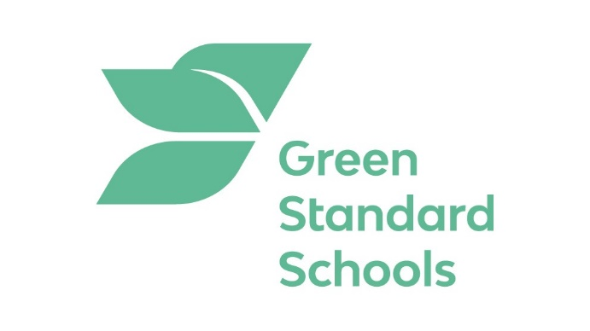

Please check the Pilgrims f2f courses at Pilgrims website.

Please check the Pilgrims online courses at Pilgrims website.

