Climate Singing

Jeremy Harmer, UK

Jeremy Harmer is a trainer teacher and writer, especially of methodology title such as The practice of English Language Teaching and How to Teach English (Pearson) and 50 Communicative activities (Cambridge). But even before he entered the language teaching profession he was a singer-songwriter in clubs in London and elsewhere. He continues to sing and write and narrate and runs a folk club and an annual folk festival as well as playing (viola) in two symphony orchestras. Jeremy’s songs are on his 2024 album “We carry on” (www.otherloves.co.uk) and can also be found on Spotify and Apple Music.

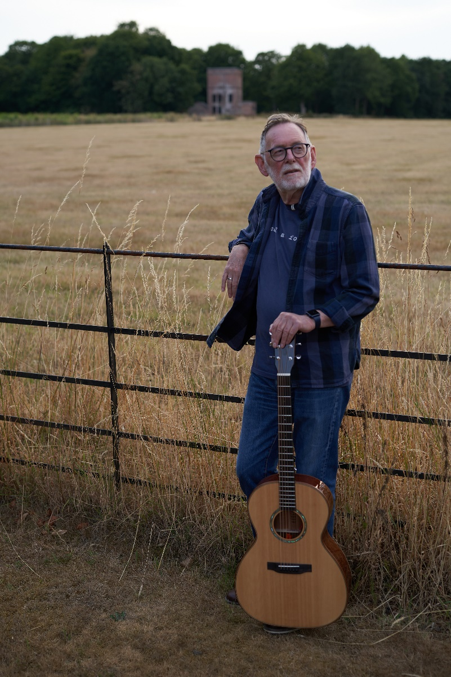

Code red

In 2021 a 2500-year-old olive tree, still fertile, in the Rovia olive grove was consumed by fire when blazes hit the Greek island of Evia. The UN secretary general Guterres said The climate crisis is a code red for humanity.

In the sweet olive grove of Rovia
an old olive tree stood wide and proud.
Fertile and venerable its ancient trunk
was at least ten adult people round.
It harboured the myths of the island clan
The history flowing up through the soil;
Where the giants and the Titans had battled for power
before peace and tranquillity told hold

CHORUS
Code red is the warning you can hear.
Code red is the warning we should fear.
Code red is plain for all to see.
Code red sealed the fate of the old olive tree.

As the sun rose higher and the temperature soared.
The air was so hot you could hardly breathe.
Then wisps of smoke from the forests and hills
rose gently from the earth just like a wreath.
And the old tree shuddered, it was dying of thirst.
In in its long life this had never come to pass.
As its wood dried up and smoke turned into flame
and the old olive tree turned into ash

CHORUS

So we build our roads, and we drive through tracks for trains
but a woodland lost will never come again,
And we burn down the jungles for our soya and our meat
and the gasses float to air, a human stain.
On the island of Evia land stands sad and empty.
a wilderness of ashes and bare stone.
Poseidon sheaths his trident and weeps dry tears of rage
at Hera’s land’s forever lost and gone

CHORUS

Jeremy Harmer – voice & guitar
Joshua Lynch – cello

Audio available at https://hea-r.me/product/we-carry-on-jeremy-harmer/

Calling your name (the world is on fire)

A love song

I sit on this hillside, the valley beneath me
Wondering how we managed so far how we got to be here
The storms and the heatwaves, the folly the carelessness
This beautiful country. Its forests and meadows its streams and its rivers
The love and the fear
Now the fear

CHORUS
The world is on fire and all I can think of
Is having you here by my side
The world is in flames the forests are burning
And all I can think of is calling your name
Again and again
over hedgerow over drystone, over loch over glen
Again and again
Calling your name

From up here the dark clouds are coming on over
The paths of the rain the sudden flash floodings, the sheets of the storm
I may be quite safe here but way below me
The water is rising they’re all going under
Life as we knew it once is jagged and torn
Is torn

CHORUS

I sit on this hillside and pray for a miracle
A change of direction, a future for all that we know and believe
For the ones that we love, the ones that come after
For this earth that has nurtured us, fed us and watered us
Inspired us and kept us
Or am I naïve?
Am I naïve?
Jeremy Harmer – guitar & vocals
Bryan Causton – mandolin
Joshua Lynch – cello
Pauline Vallance clasárch & backing vocals
Penni McLaren Walker – backing vocals

Audio available at https://hea-r.me/product/we-carry-on-jeremy-harmer/

Judy’s song (He dreams of flowers in the meadow)

How would you feel if a climate activist interrupted your event with orange dye? Supportive? Angry?

She takes the tube from Turnham Green her rucksack contents all unseen
She thinks of who she’s letting down as she goes on her way
But she is sure that she is right taking part in their great fight
If they don’t act now how will she ever have her say
And she’ll stand up there before the crowd
All orange, nervous, head unbowed
She’ll hear the jeers, beat down her fear
Her thinking absolute and clear.
She’ll tell them what she’s come to say
We have to act right now today
Ain’t no time to stop and pray
The time is now, cause…

CHORUS
It’s getting hotter in the desert
It’s getting hotter in the town
It’s getting hotter in the great big friendly ocean
It’s getting hotter, hotter all around
It’s getting hotter than it’s ever been before
It’s getting hotter everywhere
It’s getting hotter in the wetlands and the forests
It’s getting hotter, and no one seems to care

There used to be some water here, not barren earth and dried up ears
A life time on a farm he’s worked now the corn is baked and gone
Looks around the dusty ground hears only silence what a sound
His tears fall down cause they can’t stay they’ll be gone before the dawn
But where they’ll go he doesn’t know
Who’ll let them live what will they sow
How can he feed the kids at home
He dreams of flowers in the meadow
He thinks ‘the whole world’s on the move
Just trying to live nothing to prove’
Th only thing they’ve got is love
but love is not enough…’snot enough when..

CHORUS

Water’s come right to their door, they can’t live here anymore
Soon they’ll all be moving on with memories, tears and songs
We watch them go but we’re ok, life seems good in its own way
But when the fire’s comes to our door then nothing’s right anymore
‘cept love she thinks as she stands tall before the crowd to give her all (X2)
‘Cept love, ‘cept love,’cept love… And she says

CHORUS

It’s getting hotter and no one seems to care
Hotter, hotter, hotter
She’ll say ‘Please care’

Jeremy Harmer – voice & guitar
Pauline Vallance – backing vocals

Audio available at https://hea-r.me/product/we-carry-on-jeremy-harmer/

Please check the Pilgrims f2f courses at Pilgrims website.

Please check the Pilgrims online courses at Pilgrims website.

