Developing and Validating the Level Descriptors for English as a Second Language Curriculum in Sri Lanka
W. A. M. Chapa Welagedara, S. A. D.Samaraweera, Kalani Verosha Geeganage, Sri Lanka

W. A. M. Chapa Welagedara is currently working as a permanent lecturer at the Lyceum Campus, Sri Lanka and prior to that she served as the Head of the Department of English at the National Institute of Education (NIE) Sri Lanka. Lecturing at Bed and Diploma programmes, developing curricular materials, instructional materials, and conducting professional development programmes for English Language Teaching (ELT) community are the key tasks of her job profile. She has obtained her Master degree from the University of Kelaniya and the Post Graduate Diploma in Education from Colombo University.

Email: chapa1973@gmail.com, chapaw@lyceumcampus.lk

Dr. S. A. D. Samaraweeera is currently serving as the Deputy Director General of the Faculty of Languages, Humanities and Social Sciences at the National Institute of Education in Sri Lanka. He has obtained the Doctorate from the Management and Science University, Malaysia and the M. Phil in English from English and Foreign Languages University, Hyderabad, India. He is interested in research studies related to Education. Email: darshana@nie.edu.lk

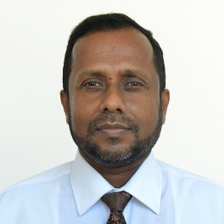

Kalani Verosha Geeganage presently works as an Assistant Lecturer at the National Institute of Education (NIE), Sri Lanka. Her duties at NIE are to contribute to the curriculum and material development process and teacher training programmes. She is interested in research areas related to curriculum development and material development for English language. She is a master degree holder from the University of Kelaniya, Sri Lanka. Email: kalverosha@gmail.com, kalverosha@nie.edu.lk
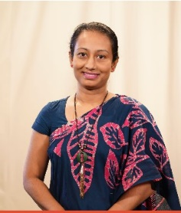

Abstract
This study attempts in streamlining English as a Second Language curriculum by developing and validating language ability descriptors (Level Descriptors) as a means to convert language cognition into realistic application within the general education system in Sri Lanka and to set up a common platform to work on for all stake holders of English language education which could be potentially beneficial in achieving their targets. The operational methodology adopted was mainly based on a documentary analysis on previously developed ability level descriptors and a survey to collect responses from the stake holders in the field of English Language Education in Sri Lanka to seek their opinion in order to validate the developed descriptors. Hence, the study was conducted in two phases as developing the Level descriptors and getting them validated upon the responses collected from the stake holders through a questionnaire. Common European Framework of Reference on language assessment, national educational goals, Social and emotional learning concepts, developed Global Citizenship education curriculum framework and 21st century skills were considered as fundamentals when developing the six staged Level Descriptors for the period of grade 1-13. The findings revealed that the stake holders of different spheres in the field of education have accepted the developed, six -staged Level descriptors as a standard language ability reference which can be considered as a common language ability reference that has been formulated according to both local and international demands of language competence. (The study focuses on educational reforms 2025 within Sri Lankan education system)

Background and the significance of the study
Sri Lankan general education covers both primary and secondary education consisting of approximately 10,400 schools of which 9,410 (90%) are government schools. The balance consists of around 70 private schools, 700 pirivena schools and about 200-250 international schools. The government and pirivena schools offer the national curriculum and the students sit for the national examinations while international schools offer foreign curricula and prepare students for international examinations. (NEC doc, 2016) The teachers to serve in Government schools are mainly provided with the initial teacher training at 19 National Colleges of Education (NCoE) established in different parts of the country. Other than that teaching appointments are given to the graduates and higher diploma holders produced by Sri Lanka Institutes of Advanced Technological Education (SLIATE) based on the number of vacancies available especially in rural areas.
Teaching of English as a Second Language begins formally from Grade three and carried out on a skill-based, competences driven path way. The special programme promoting listening and speaking skills named as Activity Based Oral English (ABOE) is in operation during the Key stage 1 and Key stage 2 in the primary section. The highest educational qualification identified for English language in the general school system is the General Certificate of Education - Ordinary Level (G.C.E O/L) and the General Certificate of Education - Advanced Level (G.C.E A/L) examinations which are held at the end of Grade 11 and grade 13.
There has been much discussion on the fact that English Language Teaching in Sri Lanka during the past decades, has not been able to fulfill its prime duty of producing competent language users, who are capable of facing the innumerable challenges emerge due to increasing demands of the world. As Wijesekara D.H (2014) has clearly pointed out, English Language Teaching (ELT) in Sri Lanka has not been able to achieve its intended objectives. According to De Mel (2007) English Language results at Ordinary Level (O/L) are also questionable since the majority of those who pass the said examination do not possess the level of communication skill required by the job market. Hence Wijesinghe (2004) comments on the quality of English teaching in the mainstream as extremely low. This situation has highlighted the need of changing directions of the fundamental concerns of curriculum designing process.
Absence of a common platform for the stakeholders of the system of education in Sri Lanka to work on has been highlighted as one of the main issues that hinders upgrading the language proficiency standards of the students. In previous curriculum reforms, the National Institute of Education (NIE) developed the English language curriculum, teacher instructional materials and conducted teacher training sessions targeting curriculum reforms. The Department of Educational Publications developed instructional materials for the students based on the curriculum developed by the NIE. The Department of Examinations set the national level examination papers. Since all the three institutes performed the duties assigned to them in segregation, achieving the ultimate targets of English language education has appeared unapproachable. Thus, the necessity of a common platform to work on in achieving language proficiency standards relevant to identified stages of the language continuum of the learner within general education system has been identified and highlighted by many scholars in the field of Sri Lankan education system.
In addition, the existing assessment procedure in Sri Lanka to evaluate the English language proficiency of the learner also has been questioned by the stake holders for its purely examination-oriented nature which diminishes the original language learning purpose as a medium of communication. Since, the students are graded based on the final marks they obtain for the summative assessments administered, no provision is given for determining the actual level of language competence of a learner. Grading them based on the final mark they obtain at summative assessments has prevented the learner from achieving diverse language performance through individual learning styles which is proved to be the best method to become competent language users. Therefore, the evaluation procedure administered by the Department of Examinations subject to heavy criticisms, as the system does not possess a pre-determined common reference for the language proficiency of the learner at identified stages to consider as the minimum language ability expected within a particular stage of learning. As a result, the grades achieved at the summative evaluation make no meaningful connection to neither learners’ actual language capabilities nor expected language achievement based on the national educational goals. Although the issue has been identified by many scholars, not a single, systematic attempt has been made to remedy the issue.
Considering the aforesaid factors, the importance of creating a common scale to evaluate students’ language performance which will be mutually beneficial for all stake holders of Sri Lankan ESL community was felt needed in order to ensure upgrading of ESL standards by maintaining a well-knit operational mechanism. It is expected that this language ability scale will act as a common reference framework to combine the work done by the above-mentioned stakeholders which drives towards achieving a common goal of developing the English language proficiency level of the students through planning and the development of curriculum and curricular materials, testing and assessment and certification aligned with the proficiency levels. So that, this study targets at introducing Level Descriptors (LDs) for English as a Second Language (ESL) curriculum in Sri Lanka and to validate them based on stakeholders’ opinions.

Figure 1A: The existing operational mechanism of ESL education in Sri Lanka.
Source: Author developed
The image 1.1A depicts the existing, isolated work culture of the three main Institutes that are responsible for English language education in Sri Lanka. One-way feeding has been encouraged from NIE to the Department of Publications and to the Department of examinations.

Educational publications

NIE

Level Descriptors
Dept.of examinations
Clearly defined reference for curriculum development, material designing and evaluation
Mutually beneficial feedback

Shared responsibility and accountability

Figure 1B: Proposed operational mechanism of ESL education in Sri Lanka.
Source: Author developed
As presented with the image 1.1B, it is expected that proposed Level descriptors will set a common target for all stake holders to perform their tasks within a clearly defined boundary in mutually agreeable nature with a sense of shared responsibility and accountability. In order to make this proposal a reality, the Department of English of the NIE, as the national authority in developing English language curricula for the general education System in Sri Lanka has identified the importance of developing level descriptors covering grade 1-13 to serve the purpose of providing an overview of the stages of language development through which the English language learners in Sri Lankan school system expected to progress in order to improve language proficiency. Further, it is expected to use these descriptors as a common platform for the different stakeholders in the field of education such as curriculum developers, material developers, teachers, teacher educators, paper setters etc. to work on in the process of upgrading the standards of language proficiency of the students and in assessing the level of achievement of the students.
Proposed curriculum reform and the mission of the NIE
National Institute of Education, Sri Lanka established under the Act No. 28 of 1985 bears the sole authority for curriculum development of the general education system in Sri Lanka. National Institute of Education in collaboration with the Ministry of Education and National Education Commission initiates the curriculum development process in Sri Lanka considering the socio economic, cultural and political needs of the country. The curriculum cycle of the Sri Lankan education is based on two concepts as reforming the curriculum and revising the curriculum. Reforming the curriculum is based on the learned lessons from the existing curriculum and the socio economic, cultural and political needs of the country. A curriculum reform take place once in 8 years in Sri Lanka. Curriculum revision is done with the purpose of aligning the existing curriculum with the improvements of the rapidly changing world. Here the curriculum developer’s responsibility is to identify the nature of the revision needed and implement the identified changes without making the process complicated to the teachers and the learners. Two revision cycles are done within one reform cycle.
The NIE is presently heading towards a massive curriculum reform that will be implemented from year 2023. The proposed curriculum reform has been initiated considering the socio economic, cultural and political needs of the country with the grander goal of moulding the younger generation to face the challenges of and beyond 21st century. Accordingly, the curriculum framework for the general education system in Sri Lanka is presented with the identified six main educational goals as given below.

Figure 2: National Educational Goals
Source: Author developed

The general education in Sri Lanka is aiming at producing an active Contributor to sustainable National Development of the country who is healthy and contributes actively and productively to the production process with a deep understanding of how to make use of the local, regional, national, and global challenges and opportunities. He is expected to be a life-long self-directed learner who updates the self to interact with the dynamic and changing world. At the same time the education targets at creating an effective and efficient work-oriented citizen who is skilled and employable; an asset to the nation, organization, and his/her team; who contributes in active and positive manner with people/customer and take actions in a proactive, practical and pragmatic manner as a dynamic team player who is able to perform his tasks with dignity and pride in professional manner. To mould our learners as an entrepreneur or a person with entrepreneurial mindset who is creative, innovative, and constructive; thinks out of the box; takes risks to introduce new ideas, processes, concepts, products, and services to address local and global market needs, to provide employment opportunities and to reduce poverty and regional disparity is another goal identified at national level. The next identified goal is to make him a patriotic citizen who loves Sri Lanka; promotes sustainable use of natural resources; respects and values Sri Lankan heritage and cultural diversity, peace and social harmony with independent mind set as a responsible citizen; an effective member of family, immediate community, larger community; and thinks globally and acts locally. After all the last two goals are to produce a good human being who respects human rights and possesses acceptable moral values and thereby becomes a member of a happy family who values human relations; is democratic in decision making and implementing decisions; is aware of the rights and responsibilities towards others; lives a life full of commitment, caring, and sharing.
Along with the identified national educational goals, the following concepts have been integrated into the national curriculum. Hence, concepts like 21st century skills, Global citizenship education, Social Emotional Learning and Mindfulness has been integrated in the proposed curriculum framework with the purpose of creating a younger generation with balanced personalities.21st century skills can be divided into three main categories as Learning skills, Literacy skills and Life skills.
Learning skills | Literacy skills | Life skills
- Critical thinking | - Information | - Flexibility
- Creativity | - Media | - Leadership
- Collaboration | - Technology | - Initiative
- Communication |  | - Productivity
 |  | - Social skills
Table 1: 21st century skills

Human development through education ensures the sustainable development and peaceful co-existence in a country. System of education aimed at human development creates successful citizens in every facets of life. Global Citizenship Education can be considered as an essential component in a system of education targeting human development. Therefore identified 12 themes under the concept of Global Citizenship Education (GCED) are also incorporated into the proposed National Curriculum Framework. They are Democracy and good governance, multicultural society, human rights and duties, law and justice, international relations, global issues and sustainable development, world of work, health and well-being, conﬂict resolution, decision making, dealing with new technologies, and happy family and society. Further, the concepts of Social Emotional Learning and Mindfulness are integrated in to the national curriculum with the purpose of inculcating humane qualities and creating balanced personalities. Under Social and Emotional Learning (SEL) five pillars; self-awareness, self-management, social awareness, relationship skills, and responsible decision-making have been considered.
A reflection on literature
A considerable vacuum in literature has been noticed on developing and validating level descriptors in both local and international arena of research. But in many research studies, the level descriptors have been administered as a means of evaluation of the cognitive ability of learners. In order to obtain a clear understanding of level descriptors, an investigation into its operational definitions would be necessary.
As defined by the United Nations’ Educational, Scientific and Cultural Organization (UNESCO) cited in quality research international website (retrieved in April 2022) “the level descriptors are statements that provide a broad indication of learning appropriate to attainment at a particular level, describing the characteristics and context of learning expected at that level. They are designed to support the reviewing of specified learning outcomes and assessment criteria in order to develop particular modules and units and to assign credits at the appropriate level.”
As described in Sheffield Hallam University (retrieved in April 2022) web site Level Descriptors present ‘the level of challenge, complexity, and autonomy expected of a learner on completion of a defined and bounded learning activity such as a module or course of study.’ Further they explained Level Descriptors as a means of providing a description of progression of learning in all three domains. Hence, they are in the opinion that the Level Descriptors ‘represent one articulation of the expected learning gain of learners as they progress through higher education.’
According to the University of Exeter website (2007) a level descriptor is a generic statement describing the characteristics and contexts of learning expected at a particular level. NICATS (1999, p. 7) defined level descriptors as statements which describe the types of learning demand which the learner will encounter at each level.
Proficiency Level Descriptors published online for the California English Language Development Standards states that Level descriptors stand for students’ knowledge, skills and abilities in each stage which depicts what students know and can do when they reach to each stage and are important for the curriculum developers to provide instructions for language development, language teaching and decide the academic content related to each level. Level descriptors also guide the teachers to understand what the students know and can do at each stage which helps them to plan the lessons preparing the set of instructions to be given to the students and selecting the methods that should be followed for effective teaching learning process to take place
Methodology
This Research was scheduled to be carried out using the mixed method based on both quantitative and qualitative data. In order to fulfill the pre-determined objectives, two phases were identified and methodology that was used in the two phases is discussed separately.
The first phase was dedicated for Developing Level Descriptors (LDs) and validating Level Descriptors was conducted as the second phase.
Phase 1
The phase one of the study was conducted in six stages as given in image 1.2.
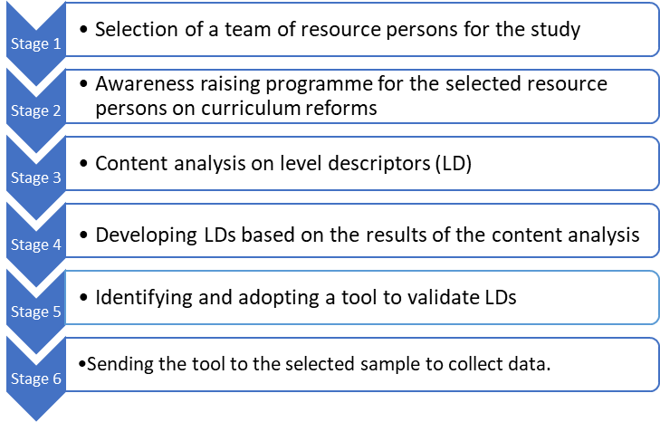
Figure 3: Key stages in phase one

A team of 20 resource personnel who have been rendering their service to different levels in the field of Education was selected based on their ESL expertise.
Teachers | 06
RESC members | 05
ISAs | 02
Directors (English) | 02
Representatives from the department of publications | 01
Representatives from the MOE | 01
Representatives from the NIE | 03
Total | 20
Table 2: Breakdown of the selected resource persons
Then a two-day awareness raising session was conducted on educational reforms to be implemented in the year 2023 and the task ahead. This team worked throughout the whole study.
In the next stage, a content analysis was conducted considering the literature related to developing level descriptors within English Language Arts curriculum. In this activity, the rationale behind developing level descriptors was highlighted and essential areas to cover in developing level descriptors, and strengths and limitations in forming level descriptors in curriculum designing were identified.
Based on the findings of the content analysis, level descriptors for ESL curriculum was developed. When designing the level descriptors, national education goals, 21st century skills, global citizenship attributes, character development concepts, social and emotional learning strategies, and support from language towards subject integration were considered as prime concerns. Each level was aligned with the identified language ability levels in the Common European Framework of Reference in order to maintain the internationally benchmarked language proficiency.
Foundation Level  Grade  1 & 2  Key Stage 1 | Can follow a short simple spoken text delivered clearly and slowly related to the most immediate personal relevance and learning areas.
Foundation Level  Grade  1 & 2  Key Stage 1 | Can interact with others politely using short simple memorized words, phrases and expressions to exchange limited personal information and express immediate personal needs.
Foundation Level  Grade  1 & 2  Key Stage 1 | Can talk about self and home using memorized words and phrases.
Foundation Level  Grade  1 & 2  Key Stage 1 | Can pick up familiar names, words and basic phrases in a very short simple narrative text when slowly and carefully articulated.
Foundation Level  Grade  1 & 2  Key Stage 1 | Can sing simple songs and rhymes with meaningful actions and expressions.
Foundation Level  Grade  1 & 2  Key Stage 1 | Can use words and phrases from memory to engage enthusiastically in collaborative activities demonstrating civic values and basic life skills.
Level 1  Grade  3 & 4  Key Stage 2 | Can follow a short simple spoken text delivered clearly and slowly on familiar topics related to learning areas addressing real life.
Level 1  Grade  3 & 4  Key Stage 2 | Can interact with others politely using short simple memorized utterances to express needs, feelings and ideas and exchange information on a limited range of topics in everyday situations and learning areas.
Level 1  Grade  3 & 4  Key Stage 2 | Can talk about self, home and school related to real life using known words and familiar utterances appropriately.
Level 1  Grade  3 & 4  Key Stage 2 | Can read aloud words and phrases and simple sentences in meaningful chunks related to learning areas addressing real life.
Level 1  Grade  3 & 4  Key Stage 2 | Can demonstrate understanding of words, in simple sentences in familiar contexts related to learning areas addressing real life.
Level 1  Grade  3 & 4  Key Stage 2 | Can answer predictable questions on short simple texts in limited contexts related to learning areas addressing real life.
Level 1  Grade  3 & 4  Key Stage 2 | Can copy and write words, phrases, short simple sentences and short simple connected texts related to learning areas addressing real life following the conventions of writing.
Level 1  Grade  3 & 4  Key Stage 2 | Can sing simple songs and rhymes and recites simple poems with meaningful actions and / or expressions and presents personal feelings creatively through different modes
Level 1  Grade  3 & 4  Key Stage 2 | Can use simple words and phrases to engage enthusiastically in collaborative activities demonstrating civic values and basic life skills.
Level 2  Grade 5  Key Stage 3 | Can follow a simple spoken text delivered clearly and slowly on familiar topics related to learning areas addressing real life.
Level 2  Grade 5  Key Stage 3 | Can interact with others politely in simple conversations on a limited range of topics related to learning areas addressing real life situations.
Level 2  Grade 5  Key Stage 3 | Can talk about self, home, school and neighbourhood using known words and familiar utterances appropriately.
Level 2  Grade 5  Key Stage 3 | Can read aloud short simple texts in meaningful chunks related to learning areas addressing real life.
Level 2  Grade 5  Key Stage 3 | Can derive the meaning of unfamiliar words in a text related to learning areas addressing real life and use them in similar contexts meaningfully.
Level 2  Grade 5  Key Stage 3 | Can answer questions on short simple texts related to learning areas addressing real life.
Level 2  Grade 5  Key Stage 3 | Can write words, phrases, simple sentences and simple connected texts related to learning areas addressing real life following the conventions of writing.
Level 2  Grade 5  Key Stage 3 | Can express personal thoughts and feelings creatively enjoying simple action rhymes, songs, poems and stories verbally or non-verbally.
Level 2  Grade 5  Key Stage 3 | Can use limited language expressions to engage enthusiastically in collaborative activities demonstrating civic values and basic life skills.
Level 3  Grade 6, 7, 8 & 9 | Can follow a simple spoken text delivered clearly on familiar topics related to real life and the respective curricular contents.
Level 3  Grade 6, 7, 8 & 9 | Can politely interact with others, displaying empathetic listening skills, using short, simple and meaningful utterances in conversations related to real life and the respective curricular contents.
Level 3  Grade 6, 7, 8 & 9 | Can talk about familiar topics related to real life and the respective curricular contents.
Level 3  Grade 6, 7, 8 & 9 | Can derive the meaning of unfamiliar words related to real life and the respective curricular contents and use them in other contexts to communicate meaningfully.
Level 3  Grade 6, 7, 8 & 9 | Can answer questions based on simple texts related to real life and the respective curricular contents.
Level 3  Grade 6, 7, 8 & 9 | Can meaningfully communicate in different contexts through digital and print media using words, simple, compound and complex sentences and short texts following the conventions of writing.
Level 3  Grade 6, 7, 8 & 9 | Can recite simple poems, sings songs and relates stories and respond by expressing personal feelings and ideas.
Level 3  Grade 6, 7, 8 & 9 | Can meaningfully use language expressions to demonstrate civic values and basic life skills.
Level 4  Grade 10 & 11 | Can follow an extended spoken text delivered clearly on familiar topics related to real life and the respective curricular contents.
Level 4  Grade 10 & 11 | Can politely interact with others, displaying empathetic listening skills, using simple and meaningful utterances in conversations related to real life and the respective curricular contents.
Level 4  Grade 10 & 11 | Can create, perform and present tasks, expressing attitudes, opinions, and logical arguments in different contexts using diverse language expressions.
Level 4  Grade 10 & 11 | Can derive the meanings of unfamiliar words related to real life and the respective curricular contents and use them in other contexts to communicate logically and meaningfully.
Level 4  Grade 10 & 11 | Can logically and accurately answer questions based on factual and literary texts.
Level 4  Grade 10 & 11 | Can meaningfully communicate in different contexts and modes, using simple, compound and complex sentences and a variety of simple connected texts following the conventions of writing.
Level 4  Grade 10 & 11 | Can recite simple poems, sings songs and relates stories and respond by expressing personal feelings and ideas.
Level 4  Grade 10 & 11 | Can meaningfully use a range of language expressions to demonstrate civic values and basic life skills.
Level 5  Grade 12 & 13 | Can follow an extended spoken text delivered clearly on a topic related to real life and the respective curricular contents.
Level 5  Grade 12 & 13 | Can politely interact with others, displaying empathetic listening skills, using meaningful utterances in conversations related to real life and the respective curricular contents.
Level 5  Grade 12 & 13 | Can create, perform and present tasks, expressing attitudes, opinions and logical arguments in different contexts critically and spontaneously using diverse language expressions.
Level 5  Grade 12 & 13 | Can derive the meanings of unfamiliar words related to real life and the respective curricular contents and use them in a variety of contexts to communicate logically and meaningfully.
Level 5  Grade 12 & 13 | Can logically and accurately answer questions based on complex factual and literary texts.
Level 5  Grade 12 & 13 | Can meaningfully communicate in different contexts and modes using simple, compound and complex sentences and a variety of detailed texts connected with each other following the conventions of writing.
Level 5  Grade 12 & 13 | Can recite simple poems, sings songs and relates stories and respond by expressing personal feelings and ideas.
Level 5  Grade 12 & 13 | Can meaningfully use diverse language expressions to demonstrate civic values and basic life skills.
Figure 4: Developed Level descriptors for English Language
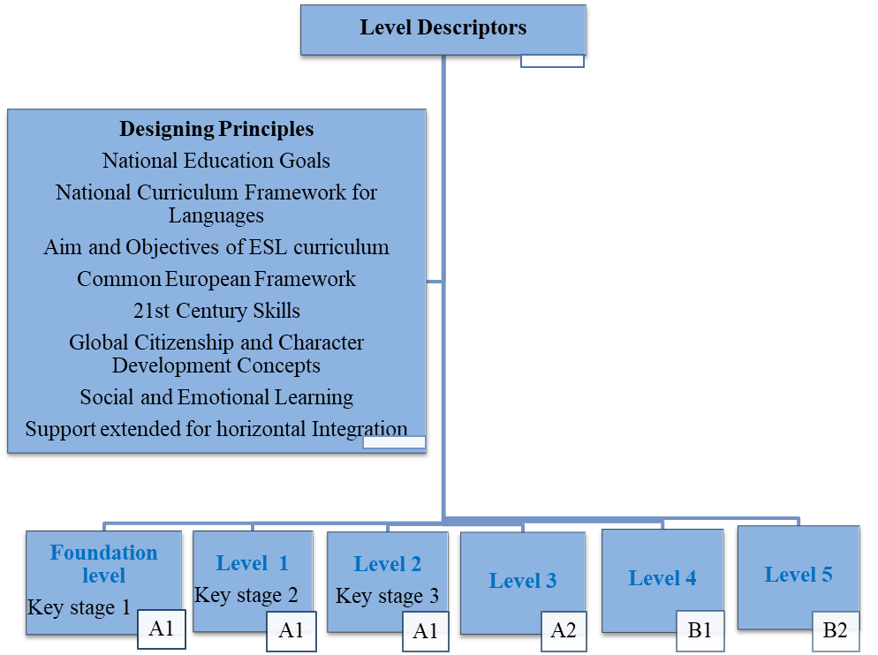
Figure 5: Development of Level Descriptors aligned with CEFR
Source: author developed

An in-depth study was conducted prior to developing a tool for data collection to accumulate a general idea regarding how and what aspects have been considered in evaluation tools of this nature. Accordingly, a tool was developed to serve our purpose based on the fundamental requirements to be used in the process of validating the developed level descriptors. Each item of the data collection tool was prepared to be presented with a five-point Likert scale which enables the conversion of qualitative data into quantitative data. Further the tool was converted into a Google document and data collection was conducted as an online survey with the purpose of analyzing data digitally using graphs, charts and diagrams.
Key aspects considered | Number of questions given in the questionnaire | Allocated Marks
General Information | 3 | -nil-
Relationship between the descriptors and the national goals | 6 | 5x6=30
Support provided to achieve the full competence in ‘languaging’ | 6 | 5x6=30
Degree of the integration of 21st century skills within descriptors | 12 | 5x12=60
Integration of Global citizenship education | 5 | 5x5=25
support provided for cross curricular integration. | 2 | 5x2=10
Suggestions for improvement | 1 | -nil-
Total marks allocated |  | 155
Table 3: Construct of the data collection tool

In the next step, the tool was sent to 100 stakeholders, comprised with ESL teachers, staff of Regional English Support Centres, In Service Advisors, Directors, Officials of the Ministry of Education, Officials of the Department of Examinations, and the university lecturers. After assigning selected 150 stakeholders into five groups of 30 members, five awareness programmes were conducted. Within 2 days of each awareness programme, the teams were made aware of the purpose of developing the level descriptors, concepts in-cooperated in level descriptors and the process of validating the developed level descriptors. Then they were assigned the task to complete the tool converted into a google document. The data collection tool was a semi structured questionnaire.
Group 1 | 30 participants | 2-day awareness programme
Group 2 | 30 participants | 2-day awareness programme
Group 3 | 30 participants | 2-day awareness programme
Group 4 | 30 participants | 2-day awareness programme
Group 5 | 30 participants | 2-day awareness programme
Table 4: Participants of the awareness raising workshops
Phase 2
The second phase was mainly dedicated for the validation process of the level descriptors. During this phase, the collected data was analyzed in order to get the stake holders’ opinion under five main aspects; relationship between the descriptors and the national educational goals, support provided to achieve the full competence in ‘languaging’, Degree of the integration of 21st century skills within descriptors, Integration of Global citizenship education and the support provided for cross curricular integration.

Figure 6: Key stages in the research activities in phase 2
Based on the responses given for the unstructured items given in the data collection tool it was expected to highlight the suggestions provided by the stakeholders for further improvements of the level descriptors.
Results and analysis
A six staged level descriptors commencing from foundation level up to Level four could be developed for the schooling age from grade 1 to grade 13 of the general education in Sri Lanka. Each stage was aligned with CEFR in order to present the English language ability of the learner against an internationally benchmarked assessment reference. In addition to create the citizen demanded for local requirements as defined by the national educational goals each level descriptor was explained with a context enriched with 21st century skills, Social and emotional learning concepts, and Global Citizenship education concepts.
The questionnaire administered to obtain the opinion of the stake holders regarding the developed level descriptors provided the following information for further considerations.
Responses received for the first three questions given in the questionnaire revealed that 65% of the sample who participated in the online survey possess more than 10 years teaching experience and out of the 24% have more than 20 years’ experience in the field of English language education. Based on the data it was made aware that 26% of the respondents are currently serving in schools and 25 % are serving in Regional English Support Centres (RESCs). Since the RESC trainers are also in the category of teachers, 49% of our respondents can be identified as teachers who have first hand experience in classroom teaching learning process. When considering the highest educational qualification of the respondents 68% out of the total sample possess a general degree while 57% holds a Diploma certificate in teaching. The rest of the 35% are teachers with teacher training certificate from a Teachers’ college.

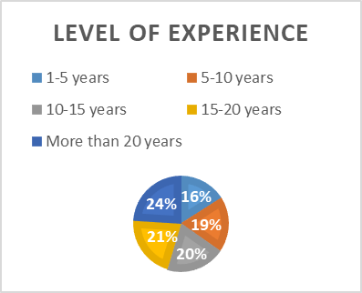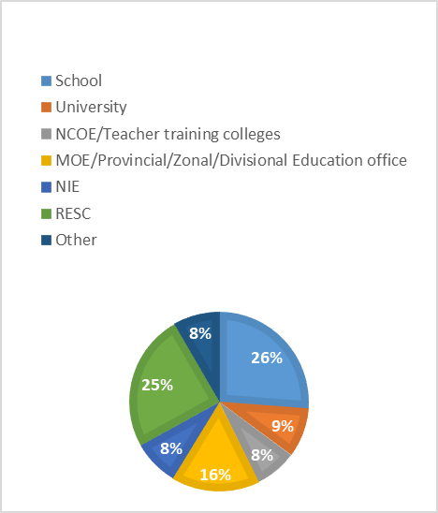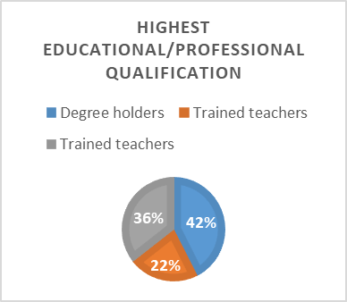
Figure 7: Level of Experience Figure 8: work place Figure 9: Highest qualificaton
The initial five questions in the data collection tool were to obtain the opinion of the stake holders with regard to the link between national educational goals and the developed level descriptors. When analyzing the data, it came into light that more than 50% of the stake holders who participated n the survey is supporting the fact that there is an identifiable link to the national educational goals within the developed descriptors. On the contrary a few, approximately 7% in total, hold the view that there is no direct connection between educational goals like producing an entrepreneur or a person with entrepreneurial mindset or efficient and effective self-employer.
Table 5: Responses obtained for National Educational Goals

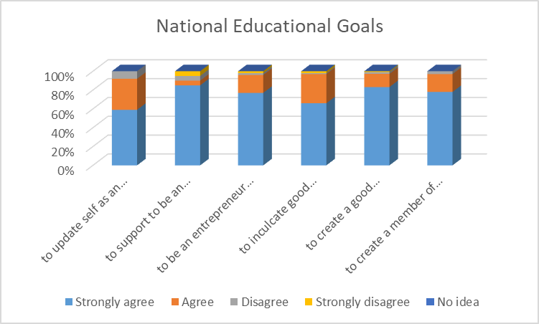
Figure 10: Responses obtained for National Educational Goals

A total agreement could be witnessed with the percentage ranging from 77%- 97% for ‘strongly agree’ scale in all the 5 questions asked based on how ‘languaging’ is promoted within the level descriptors.97% have strongly agreed to the point that Level descriptors are developed with a sufficient space for listening and speaking enhancement. Only a 4% have reported totally disagree with the fact that level descriptors support subject integration.
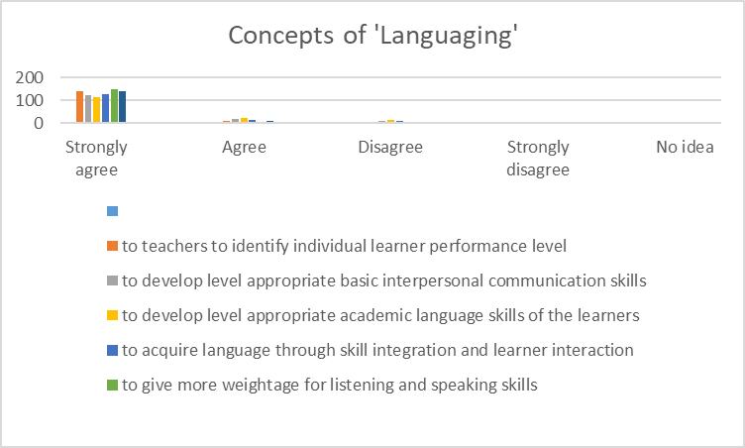
Figure 11: Integration of ‘languaging’ within level descriptors
The responses received for the questions based on 21st century skills gave evidence to prove the fact that level descriptors have sufficiently accommodated the 21st century concepts. More than 65% have voted for ‘strongly agree’ in all 12 concepts presented to them.
Table 5: Responses for the questions on 21st century skills

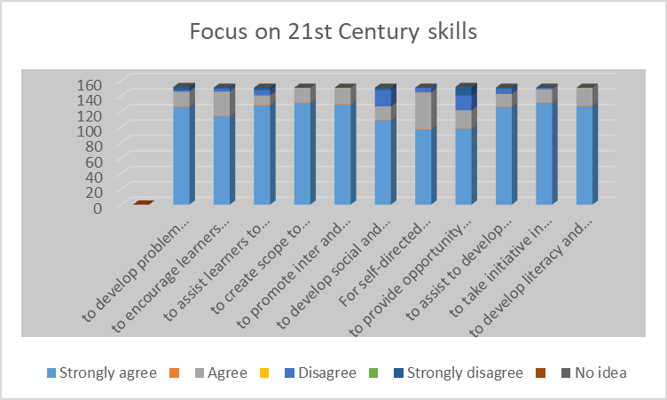
Figure 12: Responses for the questions on 21st century skills

Integration of Global Citizenship Education concepts within the developed level descriptors has been approved by the respondents as follows. An average of 40% of the respondents has approved all the GCED concepts highlighted in the questionnaire.
Table 6: Responses for the questions on GCED concepts

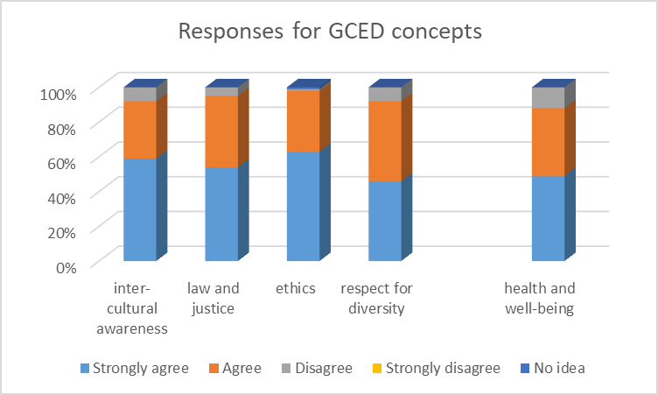
Figure 13: Responses for the questions on GCED concepts

Based on the responses received for the questions to get the opinion on language support it was evident that 88% of the respondents of the sample have agreed to the provision provided within descriptors for language support in mastering non-language subjects.
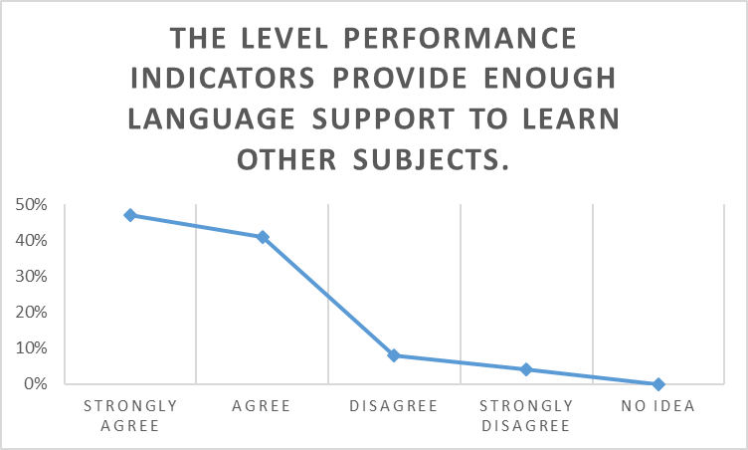
Figure 14: Language support provided for learn non-language subjects
The responses received for the question on incremental progression of language skills among level descriptors were more towards positive trend and it was evident that only 6% have expressed their disagreement with regard to the incremental progression.
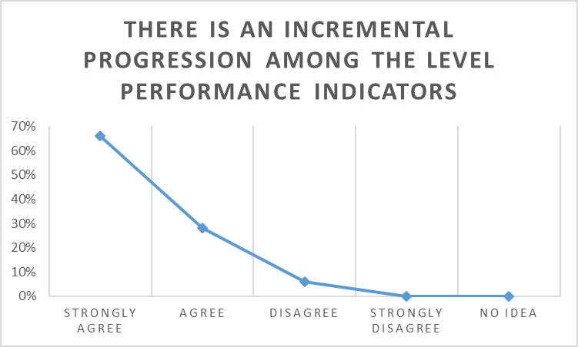
Figure 15: Incremental progression among the Level Performance Indicators
When considering the over- all point of view of the stake holders upon the focused aspects with regard to developing and validating Level Descriptors, a surpassing of the expected achievement level can be witnessed. Irrespective of a few aspects like drawing direct connections with the entrepreneurial skills and employability skills respondents have made satisfactory remarks on the developed level descriptors as a Language ability reference and also its functional aptitudes within linguistic margins.

 | Criteria | Strongly agree | Agree | Disagree | Strongly disagree | No idea
National Goals | to update self as an active contributor to the national development and to interact with the dynamic and changing world | 59% | 33% | 8% | 0% | 0%
National Goals | to support to be an effective and efficient employable citizen | 85% | 5% | 5% | 5% | 0%
National Goals | to be an entrepreneur or a person with entrepreneurial mind set | 77% | 19% | 2% | 2% | 0%
National Goals | to inculcate good morals to be a patriotic citizen through language | 66% | 31% | 1% | 2% | 0%
National Goals | to create a good human being | 89% | 15% | 2% | 1% | 0%
National Goals | to create a member of a happy family. | 78% | 19% | 3% | 0% | 0%
Languaging | to teachers to identify individual learner performance level | 93% | 6% | 1% | 0% | 0%
Languaging | to develop level appropriate basic interpersonal communication skills | 82% | 11% | 5% | 1% | 0%
Languaging | to develop level appropriate academic language skills of the learners | 77% | 15% | 8% | 0% | 0%
Languaging | to acquire language through skill integration and learner interaction | 84% | 8% | 5% | 4% | 0%
Languaging | to give more weightage for listening and speaking skills | 97% | 3% | 0% | 0% | 0%
Languaging | to use language for enjoyment | 93% | 7% | 0% | 0% | 0%
21st Century Skills | to develop problem solving and critical thinking skills | 84% | 13% | 1% | 3% | 0%
21st Century Skills | to encourage learners in developing personality and leadership quality | 76% | 20% | 3% | 1% | 0%
21st Century Skills | to assist learners to gain digital literacy | 85% | 8% | 5% | 2% | 0%
21st Century Skills | to create scope to develop 4Cs | 87% | 13% | 0% | 0% | 0%
21st Century Skills | to promote inter and intra personal skills | 86% | 14% | 0% | 0% | 0%
21st Century Skills | to develop social and cultural skills | 73% | 11% | 14% | 2% | 0%
21st Century Skills | For self-directed learning | 65% | 31% | 4% | 0% | 0%
21st Century Skills | to provide opportunity to deal with technology | 65% | 15% | 13% | 7% | 0%
21st Century Skills | to assist to develop decision making skills | 84% | 11% | 5% | 1% | 0%
21st Century Skills | to take initiative in academic and social situations | 87% | 11% | 1% | 0% | 0%
21st Century Skills | to develop literacy and numeracy | 85% | 15% | 0% | 0% | 0%
Civic Values | inter-cultural awareness | 59% | 33% | 8% | 0% | 0%
Civic Values | law and justice | 54% | 41% | 5% | 0% | 0%
Civic Values | ethics | 63% | 35% | 1% | 0% | 1%
Civic Values | respect for diversity | 46% | 46% | 8% | 0% | 0%
Civic Values | health and well-being | 49% | 39% | 12% | 0% | 0%
Scope & Sequence | The level performance indicators provide enough language support to learn other subjects. | 47% | 41% | 8% | 4% | 0%
Incremental Progression | There is an incremental progression among the level performance indicators | 66% | 28% | 6% | 0% | 0%
Table 7: Overall view point of the stake holders

The information can be presented in a graphical form as given in figure 16.
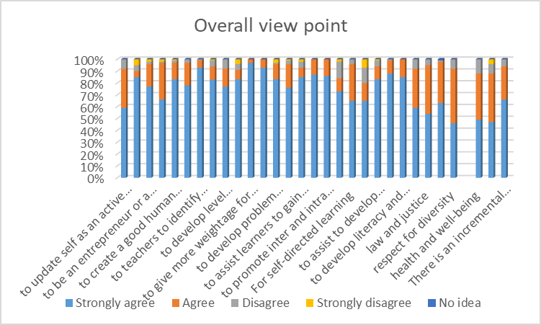
Figure 16: Overall view point

Recommendations and limitations
The number of participants involved in the survey is comparatively less and as a result, the survey results needs to be verified with an acceptable number of participants against the focused population. The validation process could have been conducted more effectively, after the implementation of the proposed curriculum reforms in 2023 since it provides sufficient time for the stake holders to familiarize with most of the concepts that are highlighted and focused in level descriptors.
Since this is the initial attempt of developing level descriptors for the general education system in Sri Lanka, repetition of administering the questionnaire with more stake holders’ participation is needed within regular intervals, in order fill the gaps and to upgrade it according to the linguistic competence requirements based on the socio-economic demands of the country. Even the data collection tool needs to be revisited in order to suit the everchanging language ability demands. But most importantly any modification or any form of a change with regard to the level descriptors need to be conveyed at its earliest to all responsible parties to avoid irreversible mistakes.
Further, this study offers the opportunity to any interested academic to work on developing a proper monitoring system to investigate whether the developed level descriptors perform as the common reference in all language related missions in general education within the country. In addition, with the development of level descriptors, a need of a national Language assessment framework based on the level descriptors has also been emerged paving the way for researches to work on with.

References
De Mel, S. (2007). The Politics of Education and Unemployment. Daily News, September 22.
Selemani, M., undated, The Use of National Assessment to Enhance The Quality of Technical Education, National Council for Technical Education (NACTE) Dar es Salaam, Tanzania.as cited in https://www.qualityresearchinternational.com/glossary/leveldescriptor.htm
Wijesekara H.D.(2014) Dreams differed: English Language Teaching in Sri Lanka, Vistas journal of Humanities and Social Sciences. Vol 7 & 8 available at https://papers.ssrn.com/sol3/papers.cfm?abstract_id=2438893
Wijesighe, R. (2004) Present government policy on the medium of instruction in the public-school system. As cited in https://papers.ssrn.com/sol3/papers.cfm?abstract_id=2438893
Credit Accumulation and Transfer System (NICATS). (1999). Project Report the Northern Ireland Credit Accumulation and Transfer System as cited in https://www.bolton.ac.uk/Quality/PDA/ModuleAndProgrammeDesign/Documents/NICATS.pdf
ELD standard publications, California. (undated). Proficiency Level Descriptors for the California English Language Development Standards. https://www.scoe.org/files/Proficiency_Level_Descriptors....pdf
National education commission (NEC). (2016). Proposals for a National Policy on General Education in Sri Lanka. http://nec.gov.lk/wp-content/uploads/2019/07/GE_Policy_-2016_English.pdf
Sheffield Hallam University. (2016). Assessment essentials. https://academic.shu.ac.uk/assessmentessentials/specifying-curriculum-level/level-descriptors/
University of Exeter , 2007, TQA Manual, Learning and Teaching Definitions, http://as.exeter.ac.uk/academic-policy-standards/tqa-manual

Please check the Pilgrims f2f courses at Pilgrims website.

Please check the Pilgrims online courses at Pilgrims website.

