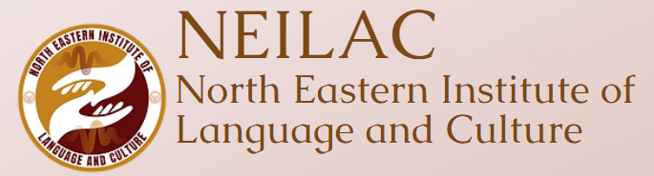

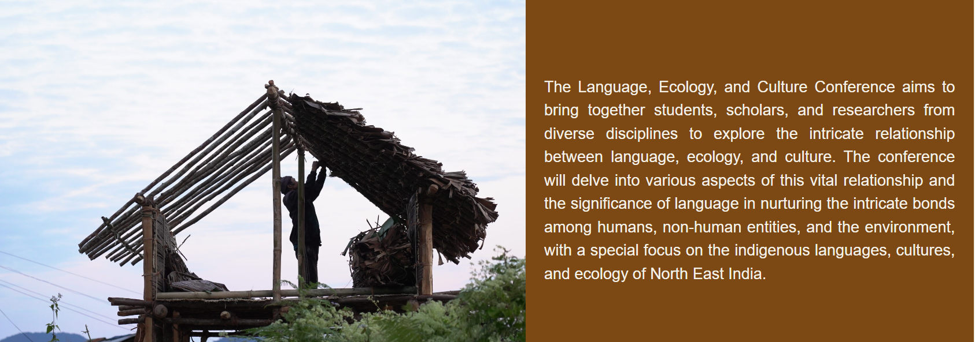

This conference is a part of the forthcoming Festival of Integral Ecology, initiated by the Laudato Si’ Research Institute, based at Campion Hall at the University of Oxford. The festival will be organized in partnership with host institutions around the world, including the UK, India, the United States and Mexico. Although reflecting particular geographical, cultural, political and religious contexts, these events will converge on a single research question:

"What does it mean to address contemporary global challenges through the lens of an "integral ecology" perspective?

Important Dates​

Registration opens: 20 August 2024
Late Registration: 1-15 September 2024 (If seats are available)

Conceptual Background

The conference themes can be approached from a variety of disciplinary backgrounds and frameworks. The following excerpt is from an ecolinguistics/biocultural diversity angle, meant as background reading. Participants of the conference are free to choose other frameworks for their presentations.

Exploration of the connection between language, culture, and the environment began to emerge as a distinct field of study in the 1990s as a response to the widespread loss of linguistic, cultural, and ecological diversity attributed to the socio-economic and political processes prevalent worldwide (see Krauss 1992; Harmon 1996; Mühlhäusler 1995; see Maffi 2005 for an early historical overview). This new field of research departed from earlier discussions on the interaction between languages and their environments, which were primarily anthropocentric and concerned with the influence of the environment on human languages and cultures, as well as how languages shape thought and cognition (especially Sapir 1912; Whorf 1940; for an overview of Whorfianism, see Scholz et al. 2024). The new focus was now on the connection between biological, cultural and linguistic diversity.

As research on language endangerment and species endangerment progressed side by side, deeper connections were proposed between these two seemingly parallel phenomena. For example, it was observed that linguistic diversity hotspots of the world also coincide with ecological diversity hotspots, and ecological degradation in a given biodiversity hotspot is almost invariably accompanied by language endangerment (Maffi 2005). It was also noted that the connection between linguistic diversity and ecological diversity is deeper than can be explained by mere extraneous factors such as geographical isolation or mountainous terrain.

In this context, the idea of ‘coevolution’ was discussed by researchers such as Harmon (1996) and Mühlhäusler (1995), recognizing the intertwined and mutually transformative evolutionary journey for humans and their environments. Humans modify the distinctive ecological systems around them, while also simultaneously being shaped by these very systems. Historically, during this process of mutual transformation, humans acquired specialized knowledge of their environments and developed specialized ways of talking about it. Local languages, “…through which this knowledge was encoded and transmitted, (became) molded by and speciﬁcally adapted to their socioecological environments.” (Maffi 2005: 605; see also Smith 2001).

From this viewpoint, languages are privileged repositories, preserving the historical memories of the common journey together of humans and their environments, in the form of traditional ecological knowledge (TEK). This knowledge is operationalized in people’s daily lives in the form of culture, through various practices, belief systems, and worldviews.

This line of thought has given rise to the concept of Biocultural Diversity, defined as “the diversity of life in all of its manifestations: biological, cultural, and linguistic, which are interrelated (and possibly coevolved) within a complex socio-ecological adaptive system.” (Maffi 2007: 269). Biocultural diversity is seen as an integral manifestation of life itself and the loss of biocultural diversity is thought to have profound implications for the maintenance of life on earth (Maffi 2005: 602; see also Maffi 2001; Mühlhäusler 1995; Smith 2001; Skutnabb-Kangas, Maffi & Harmon 2003; Maffi 2007; Gorenflo et al. 2012; Skutnabb-Kangas & Harmon 2015; Maffi 2018 for various discussions on biocultural diversity and the interdependence of languages and their environments).

The closely related field of ecolinguistics “explores the role of language in the life-sustaining interactions of humans, other species and the physical environment” (definition by the International Ecolinguistic Association, quoted in Stanlaw 2020: 1). It has a twofold aim: First, to formulate linguistic theories that view humans not merely as parts of human societies but as integral components of broader ecosystems. Second, to reflect on the application of linguistics in tackling crucial ecological concerns, from climate change and biodiversity decline to environmental justice (Stanlaw 2020: 1; see also Penz & Fill 2022 and references therein).

This perspective on language offers a path forward not only for linguists but also for all those interested in healing the wounds of destruction caused by the current technocratic era of absolute human dominance over nature and the consequent threat of mass extinction. It is particularly towards indigenous communities, their languages, and cultures that we must turn in humility to rediscover the ways of living harmoniously with nature.

Therefore, this conference aims to bring conversations centered on biocultural diversity to North East India, a part of the Himalayan region, a biodiversity and linguistic diversity hotspot. The loss of linguistic diversity is a major concern in North East India, where more than 80% of its 200-plus indigenous languages currently face various degrees of endangerment. As in other parts of the world, language endangerment in North East India is also accompanied by increasingly severe environmental degradation. In this context, conversations that unite ecological concerns on one hand and linguistic-cultural concerns on the other are imperative. Through these dialogues, the conference aims to discover new, integrated pathways for the preservation and promotion of biocultural diversity. This approach calls for an integral ecology paradigm that perceives humanity, non-human beings, and the environment as inextricable members of the cosmic web of life.

References:

Gorenflo, L. J., Suzanne Romaine, Russell A. Mittermeier & Kristen Walker-Painemilla. 2012. Co-occurrence of linguistic and biological diversity in biodiversity hotspots and high biodiversity wilderness areas. Proceedings of the National Academy of Sciences 109(21), 8032–8037. doi:10.1073/pnas.1117511109 (16 October, 2023).

Harmon, David. 1996. Losing species, losing languages: Connections between biological and linguistic diversity. Southwest Journal of Linguistics 15, 89–108.

Krauss, Michael. 1992. The World’s languages in crisis. Language 68(1), 4–10.

Maffi, Luisa (ed.). 2001. On biocultural diversity : linking language, knowledge, and the environment. Washington, D.C.: Smithsonian Institution Press. http://archive.org/details/isbn_9781560989301 (1 May, 2024).

Maffi, Luisa. 2005. Linguistic, Cultural, and Biological Diversity. Annual Review of Anthropology 34(1), 599–617. doi:10.1146/annurev.anthro.34.081804.120437 (2 April, 2024).

Maffi, Luisa. 2007. Biocultural diversity and sustainability. In Jules Pretty, Andy Ball, Ted Benton, Julia Guivant, David R. Lee, David Orr, Max Pfeffer & Professor Hugh Ward (eds.), The SAGE handbook of environment and society, 267–278. Los Angeles, London, New Delhi, Singapore: SAGE.

Maffi, Luisa. 2018. Biocultural Diversity. The International Encyclopedia of Anthropology, 1–14. John Wiley & Sons, Ltd. doi:10.1002/9781118924396.wbiea1797. https://onlinelibrary.wiley.com/doi/abs/10.1002/9781118924396.wbiea1797 (1 May, 2024).

Mühlhäusler, P. 1995. The interdependence of linguistic and biological diversity. In D Myers (ed.), The Politics of Multiculturalism in Asia/Pacific. Darwin, Aust: North Territory University Press.

Penz, Hermine & Alwin Fill. 2022. Ecolinguistics: History, today, and tomorrow. Journal of World Languages 8(2), 232–253. doi:doi.org/10.1515/jwl-2022-0008.

Sapir, Edward. 1912. Language and environment. American Anthropologist 14(2), 226–242. doi:10.1525/aa.1912.14.2.02a00020 (2 February, 2024).

Scholz, Barbara, Francis Jeffry Pelletier, Geoffrey K. Pullum & Ryan Nefdt. 2024. Whorfianism. The Stanford Encyclopedia of Philosophy. https://plato.stanford.edu/entries/linguistics/whorfianism.html (2 April, 2024).

Skutnabb-Kangas, Tove & David Harmon. 2015. Biological Diversity and Language Diversity: Parallels and Differences. The Routledge Handbook of Ecolinguistics.

Skutnabb-Kangas, Tove, Luisa Maffi & David Harmon. 2003. Sharing a world of difference: the earth’s linguistic, cultural and biological diversity. UNESCO.

Smith, Eric A. 2001. On the coevolution of biological, cultural and linguistic diversity. In Luisa Maffi (ed.), On biocultural diversity : linking language, knowledge, and the environment, 95–117. Washington, D.C.: Smithsonian Institution Press. (1 May, 2024).

Stanlaw, James. 2020. Ecolinguistics. The International Encyclopedia of Linguistic Anthropology, 1–2. John Wiley & Sons, Ltd. doi:10.1002/9781118786093.iela0110. https://onlinelibrary.wiley.com/doi/abs/10.1002/9781118786093.iela0110 (1 May, 2024).

Whorf, Benjamin Lee. 1940. Science and linguistics. Technological Review 41, 229–231, 247–248.

More at https://www.neilac.org.in/conference-call-for-papers/

