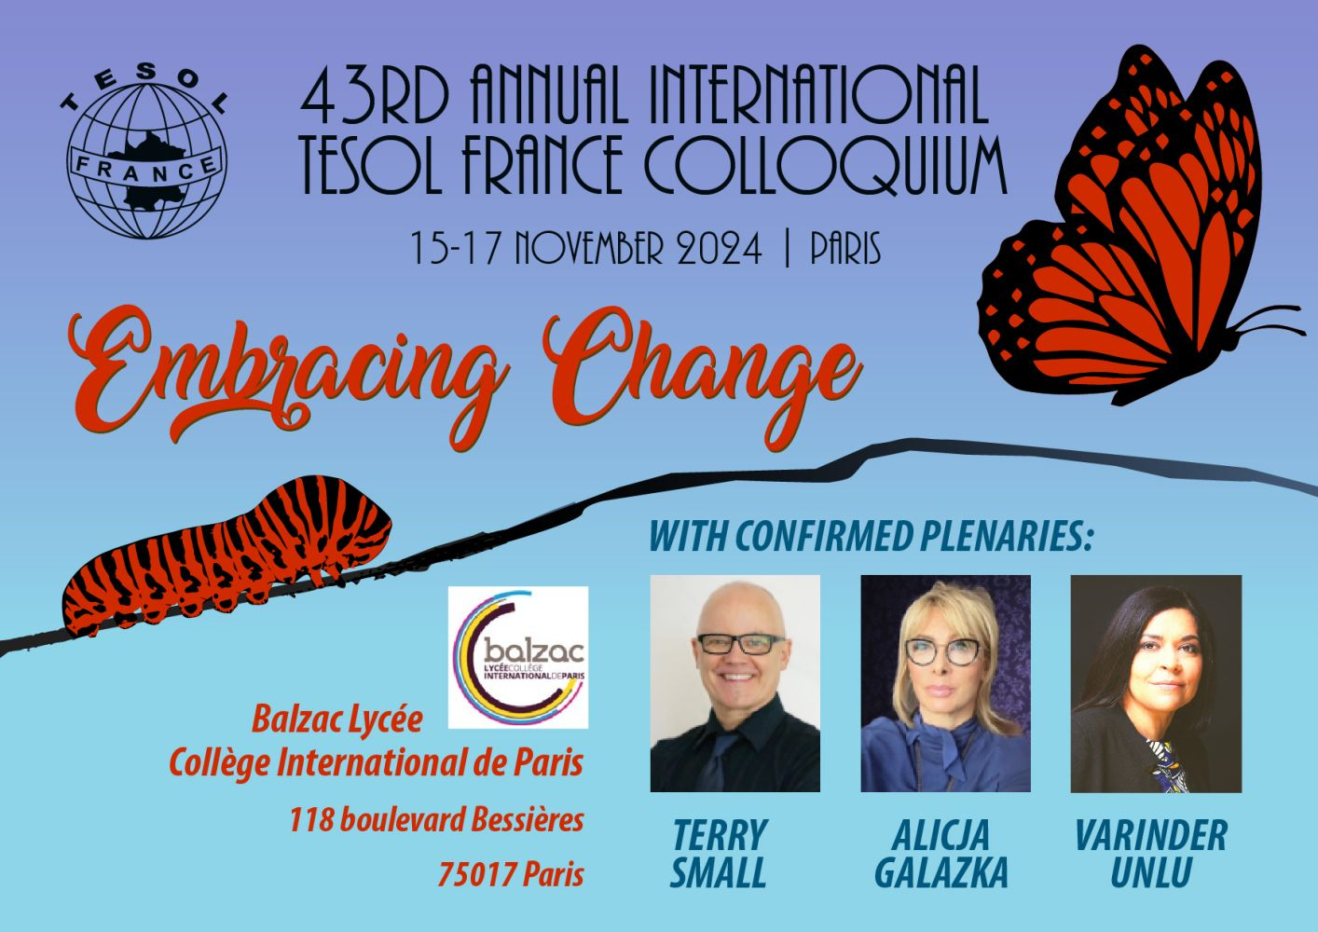

43rd Annual International TESOL France Colloquium
Embracing Change


Dates
15th November, 2024
16th November, 2024
17th November, 2024
Venue
Cité Scolaire Internationale Honoré-de-Balzac, 118 Bd Bessières, 75017 Paris

We welcome you to be part of the 43rd Annual International TESOL France Colloquium for 2024. We are delighted to welcome Terry Small, Varinder Unlu and Alicja Gałązka as our confirmed plenary speakers this year.
The ELT fields are:

- Adult Learners  - Young learners  - Young Adult Learners  - French Learners of English  - Higher Education  - Business English  - English for Specific Purposes  - Technology in the Classroom  - Teacher Training and Development  - Reflective Practices  - Language Testing  - Corpus in the Classroom  - Drama Techniques Development  - French New Educational Reforms  - Digital Learning and Technologies  - Content & Language-Integrated Approaches | - Humor in the Classroom  - Listening Skills  - Reading Skills  - Writing Skills  - Speaking Skills  - Grammar and Vocabulary  - Pronunciation/intonation  - Materials Design and Publishing  - Multilevel classrooms  - Cultural and Intercultural issues  - Classroom Management  - Working conditions  - Dogme in the Classroom  - Project and task based Learning  - Evaluation/ Assessment  - Language Learning & Literacies  - Materials Development & Publishing
Language:
Talks take place in English or in French.
Financial information:
The conference fee is waived for all TESOL France members. However, it's important to note that TESOL France does not offer financial assistance for travel or accommodation expenses. Additionally, we regret to inform you that scholarships are not available.
Logistic information:
- Talks will be scheduled to last 60 minutes each. Please be sure your talk starts and finishes on time.
- Delegates are encouraged to enter a talk even if it has already started.
- Please bring your laptop (PC or Mac). Due to technical constraints at the venue, we are unable to provide computers in the rooms.
- Each room is equipped with a projector, speakers, etc.
- Please bring your own photocopies. A photocopier is not available at the venue.
Our past conferences have followed a schedule similar to the one outlined below. While we cannot guarantee an identical schedule for the upcoming event, we've provided it to offer you a better understanding of the anticipated timing.
Preliminary Conference Times:
Friday | 17:00 to 18.00 | Opening
Friday | 18:15 to 19.15 | 4-5 Conference Talks
Friday | 19.15 to 20.15 | Evening event and stands
Saturday | 9.00 to 18.30 | 20+ Conference Talks and Plenary Session(s)
Saturday | 18.30 to 19.30 | Reception, Poster session, Visiting stands
Saturday | 19:30 to 21.30 | Evening event
Sunday | 9:30 to 16:00 | 20+ Talks, Plenary Session(s), Panel Q&A, Prize Draw
The conference fee (or membership fee) includes welcome reception, registration, access to plenary and parallel sessions, various educational documents and gifts, coffee breaks, cocktail party (Saturday evening), etc.
To stay up-to-date on conference news, we recommend you keep an eye on our website or our TESOL France Facebook page or LinkedIn .

Register at https://www.tesol-france.org/en/call_for_papers.html
See you in Paris



