Eco Issues: Introducing a New, Free-to-access E-textbook Based on the Sustainable Development Goals

Sue Robbins, UK

Sue Robbins is a Senior Lecturer in English Language at the University of Sussex, UK. She has recently published a free-to-access e-textbook for B2/C1 level learners Develop Your English: with the United Nations Sustainable Development Goals. Email: S.Robbins@sussex.ac.uk

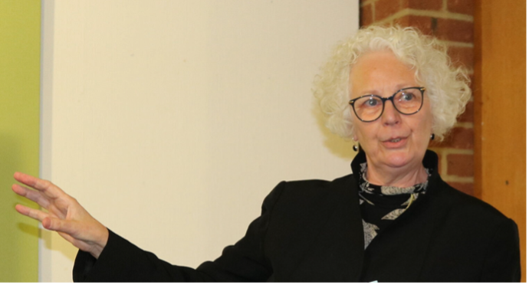

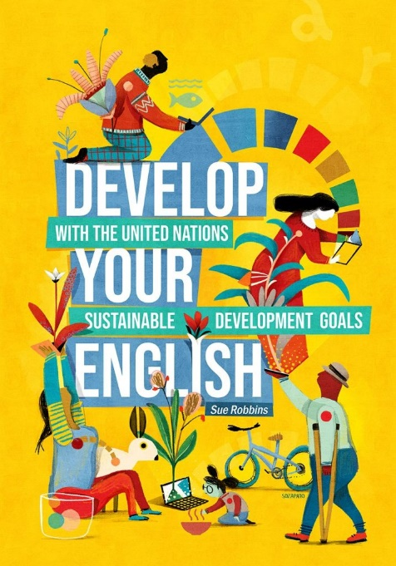
Front cover design by Sozapato

Develop Your English: with the United Nations Sustainable Development Goals
Author: Sue Robbins
Publisher: Open Press at University of Sussex, 2024
https://openpress.sussex.ac.uk/developyourenglish/
e-Book ISBN 9781739214845
DOI: https://doi.org/10.20919/BQOQ6987
Licensed under a Creative Commons Attribution-NonCommercial-NoDerivatives 4.0 International License

In the first article in the new Eco Issues section of this magazine published in April, Alan Maley called on us ‘to exercise the considerable power [we] have to contribute to ongoing attempts to halt the now serious and very real damage to the global ecosystems.’ Like me, I expect you have experienced first-hand the way that teachers can make a difference in changing the mind-sets, and ultimately the behaviours of our students, and this makes our English language classrooms an ideal place to introduce the knowledge of sustainability-related topics that is necessary for the development of global citizens. Through the language learning/teaching process we have an opportunity to equip our students with ‘the knowledge, skills & mindsets that allow individuals to become deeply committed to building a sustainable future and assisting in making informed and effective decisions to this end.’ (United Nations, 2018).

In January this year I published Develop Your English: with the United Nations Sustainable Development Goals, an interactive e-textbook for upper intermediate to advanced level English language learners (B2/C1) that offers perspectives on world issues alongside opportunities to develop English as an international language. Develop Your English incorporates a global perspective into the language learning process through a focus on international themes, organised around the United Nations Sustainable Development Goals. It is published by Open Press at University of Sussex and is Creative Commons licenced, making it free to access. In the interests of accessibility for those in a range of contexts, the e-textbook can also be used offline in EPUB format (where the interactivity is maintained) and can be downloaded in PDF format and printed out. The latter version loses the interactivity but has a full answer key, and the audio files can also be downloaded.

Prior to publication the e-book was reviewed by 16 University of Sussex international students. Here are some of the things they had to say about it:

‘The content expanded my understanding of global challenges and the interconnectedness of sustainable development efforts significantly.'

‘Develop Your English is a transformative expedition into language proficiency, global awareness and sustainable learning.'

‘The units represent a diverse range of groups and geographical areas. This inclusivity adds a valuable dimension to the learning experience, offering exposure to a variety of perspectives. It differs from my previous English language learning materials, providing a richer and more globalised context.'

‘I found the topics really interesting as well as the reading and writing materials. Something I really enjoyed was how the whole world was represented through the stories, as well as how different accents featured in the podcasts.’

‘An aspect that I really liked was the representation of different societies and cultures through each story that is told in text, audio or video, in addition to portraying a range of different accents that are essential to hearing as you learn a language. I was pleased to hear stories that were similar to my own experience, in work or in my own life journey.'

You can see from the Scope & Sequence document that Develop Your English is topic based. There are 4 main themes - each with 2 sub-topics. In each unit the texts (written and audio) connect to the theme/topic and illustrate one of the SDGs. The input isn’t directly about the SDGs, therefore, but serves to contextualise them.

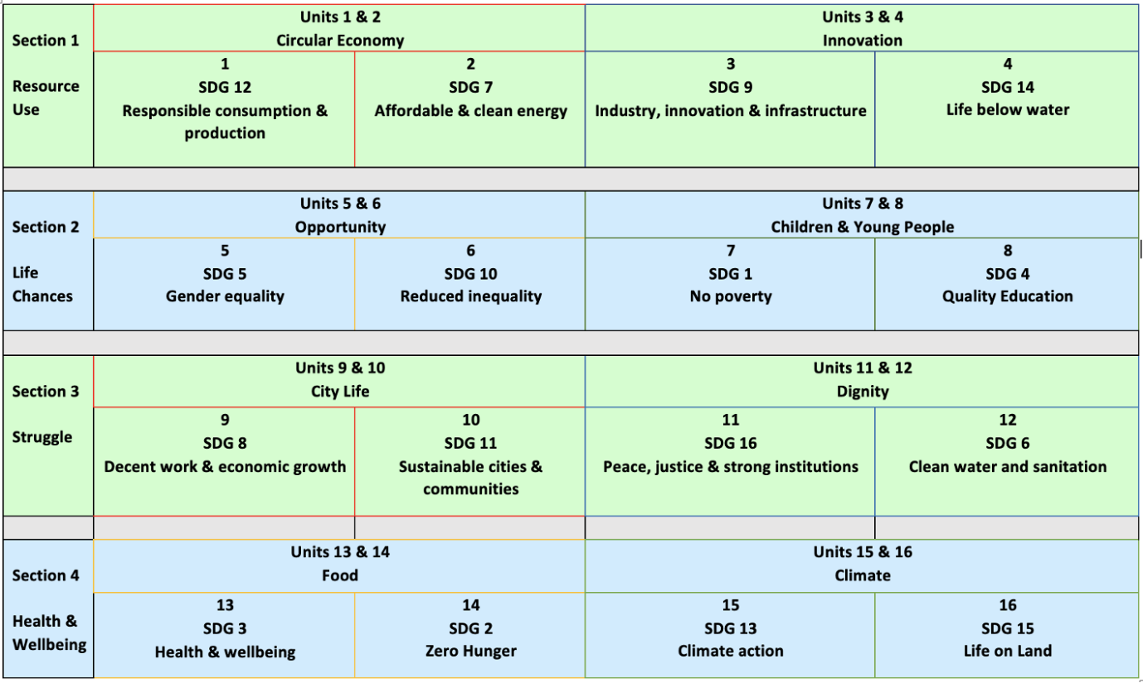

Each of the 16 units contains:
- Authentic, high-quality texts from The Conversation (‘an independent source of news analysis & informed comment written by academic experts, working with professional journalists who help share their knowledge with the world’).
- A focus on grammatical & lexical items derived from the texts, plus tasks to develop all four language skills (the book employs a text-driven approach).
- An infographic to help develop the skill of interpreting visual data.
- Interactive tasks + automated feedback.
- Deliberate recycling of ideas & language to aid retrieval practice.
Extension activities after each pair of units offer learners a choice of additional multi-modal materials.

This image offers you a snapshot:

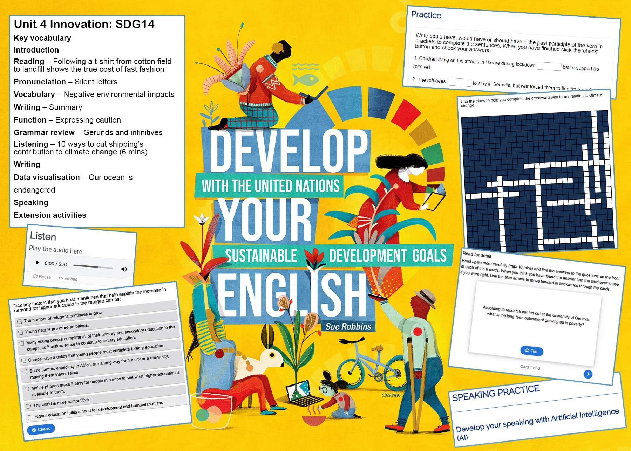

Using Develop Your English in your classroom can create opportunities for students to develop their language skills via universal topics that are relevant to their lives, and simultaneously develop their sustainability literacy. As Alan Maley is at pains to point out – when it comes to addressing the pressing global issues we face, doing nothing is not an option. We can use our influence for the good and help our students become global citizens. As our choice of materials has a part to play in that process can I invite you to access Develop Your English, using the link(s) at the top of the page, and perhaps use some of the materials in your own classroom if appropriate – with no cost to you, your school or your learners. Do get in touch if you have comments or questions

Please check the Pilgrims f2f courses at Pilgrims website.

Please check the Pilgrims online courses at Pilgrims website.

