Whatever Suits You! 26 Uses for a Deck of Playing Cards in TEFL

Stephen Tarbuck, Poland

Stephen Tarbuck is an EFL teacher and IHCYLT Tutor in Training at International House Toruń. He also writes about a variety of TEFL topics and has been published in: The International House Journal, Modern English Teacher, EL Gazette and Humanising Language Teaching. He blogs at: stephentarbuck.wordpress.com

A deck of playing cards

Despite being an object that is known around the world, a deck of playing cards is not a big part of the majority of teachers’ kits. I wouldn’t say that it is a shame, but it does feel like a lost opportunity, because their inclusion is a simple way to add novelty to your TEFL experience.

I’d like to show you some ways to use playing cards to add some novelty in TEFL.To do this I’ve made a list of 26 uses, give yourself a point if you can guess why 26, and then I’ve focused on some of the uses in practice.

Please note that the majority of the uses in the list require you to only use the number cards in the deck. So if you want to try them, you should remove the picture cards (king, jack, joker, queen and the ace)

26 uses for playing cards

- Covering exercise prompts or answers to add a challenge.
- Set up randomised teams
- Set up pairs
- Set up threes
- Introducing functional game language (shuffle the deck, draw a card, sets, clubs, diamonds)
- Randomising discussion opinions (Red = agree, Disagree = Black)
- Generating parts of speech (You assign a card set to a part of speech)
- Listening challenge (when you hear a part of speech - hold up red/number etc)
- Resolving draws in competitions (Draw a card - highest card is the winner)
- Choosing a team captain (highest or lowest number is the captain)
- Classic card magic tricks.
- Laying a set of cards out to function as a map to practise directions. (start at 2 of spades and go…)
- Cards as money for your roleplays.
- Classroom layout (you can use them to mark areas on the floor where you want people to stand)
- Mock cuisenaire rods (the suits are parts of speech and students assemble a sentence)
- Generating interest - asking a question connected to cards.
- Letting a fast finisher shuffle the cards.
- Randomly nominating students (Who has number 3? Ok! What’s the answer?)
- Sharing cultural differences, as different card sets around the world have different suits.
- Random story building (red cards are nouns, black verbs - students generate a story)
- Go fish
- Playing solitaire while waiting for parents
- Practising numbers (play hot seat but with a card on their head)
- Practising superlatives and comparatives (who’s got higher than …)
- Randomising seating (students sit next to someone with the same/different colour)
- Have students design their own card games.

Uses in practice

Set up randomised teams/pairs/threes

If you want to make sure that your student pairings are fair then randomise them! You can give your students number cards and they must find a person with a matching or close number and make a pair.

Here’s an example. After giving a random card to each student, the students use these numbers for reference and find a partner (for example, 2 with 3 or 2 with 2) then go work together. Also, 10 can choose their partner)

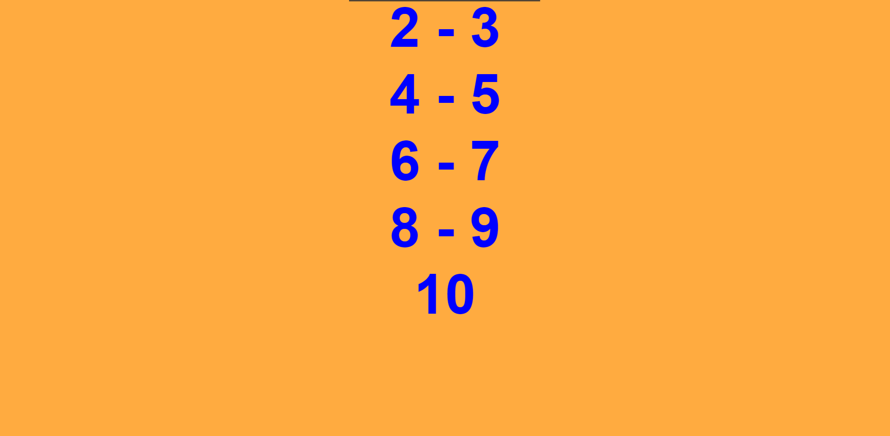

This idea works equally well with making threes or fours as you assign a different range of numbers ( 2 - 4, 5 - 7, 8 - 10, for example) and all students within that range are together.

To make teams you need to have students find other students with a matching colour, which results in a red and a black team.

Randomising opinions in a discussion

Getting students to discuss a statement isn’t always interesting but with a little novelty it can be!

In a workshop I ran, participants made maps using playing cards and then were presented a statement connected to their map. Their response and opinion to the statement was chosen at random by the card they had.

Below is a screenshot of the options they were given. Essentially, if they had a red card they agreed with the statement, if black, they disagreed. Then in pairs they had the discussion and had an opinion they had to express.

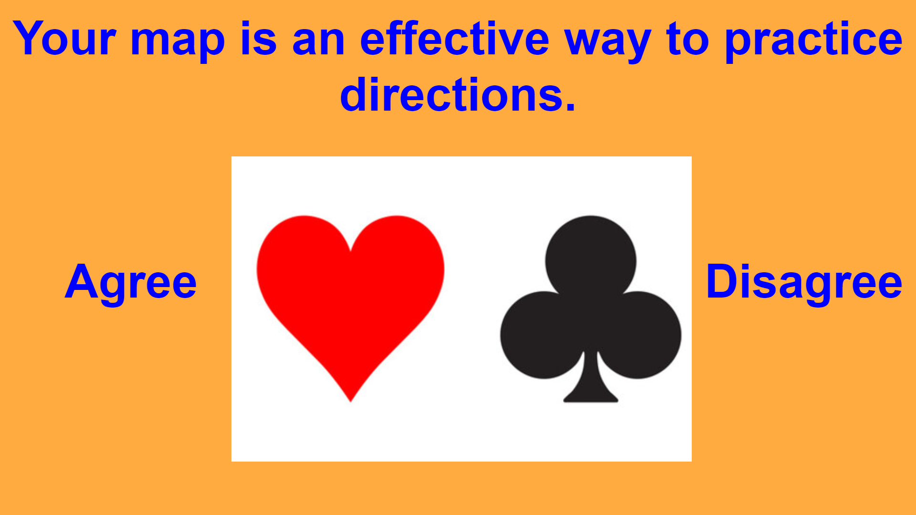

Randomly nominating students for answers

Do you have students who are reluctant to give answers or the same students who always offer their ideas?

A solution, that is random and therefore fair, is that you give each student a number card and when you finish an exercise, you ask: ‘Who has 2?’ The student who has the card tells you the answer to the exercise. You then continue this by asking about the different numbers, ‘Who has 7?’ and so on.

Covering exercise prompts or answers to add a challenge

Coursebooks and exercises can be repetitive but add a little novelty and challenge to them. We can use the cards to cover prompts or possible answers, which means students must think about the answers, with minimal assistance.
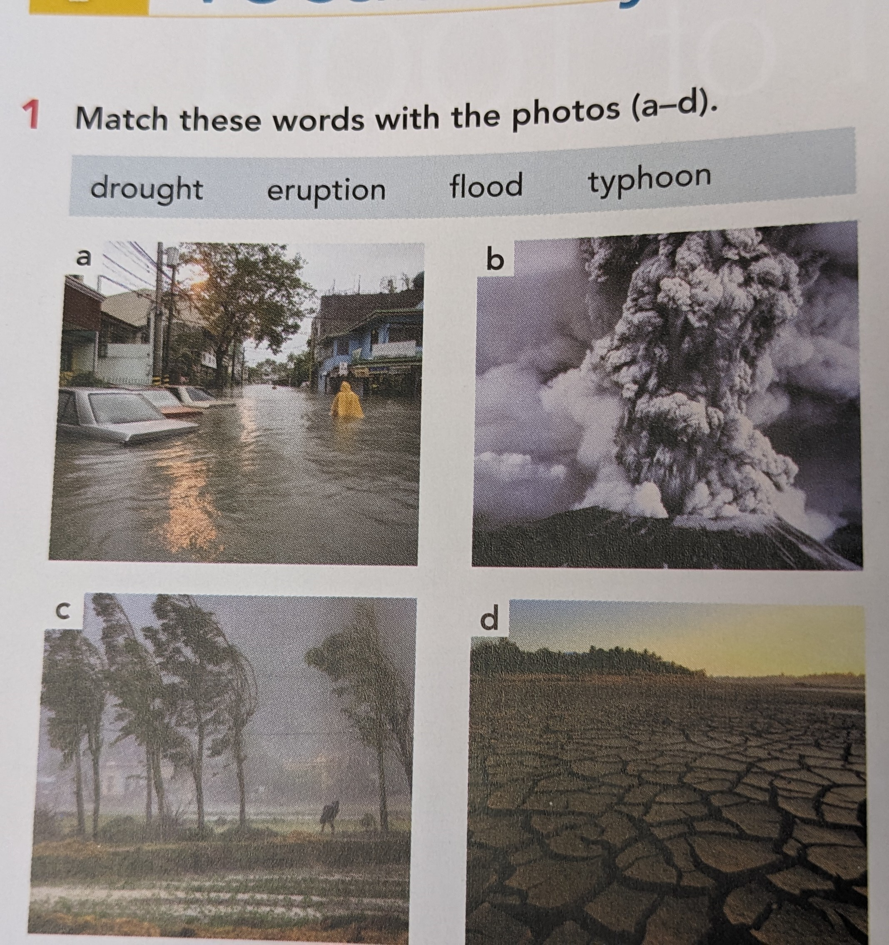
Here’s the idea in practice with an example exercise from: New Close-up B1+.

Before starting the exercise the students were put into pairs, using use number 3 from the list. They are both now sitting together and each student already has a card and their book open at the page.

To add challenge we simply ask the students to cover the prompts and discuss what they think the pictures might be of. Afterwards they remove the card and confirm their ideas.

This principle can be applied to any exercise with prompts, with a particular favourite of mine being a gap fill exercise that gives the students a selection of verbs to choose from for each question.

With the verbs covered, the students are unable to choose from the list, instead, they must predict the most suitable verb from their own language resources.

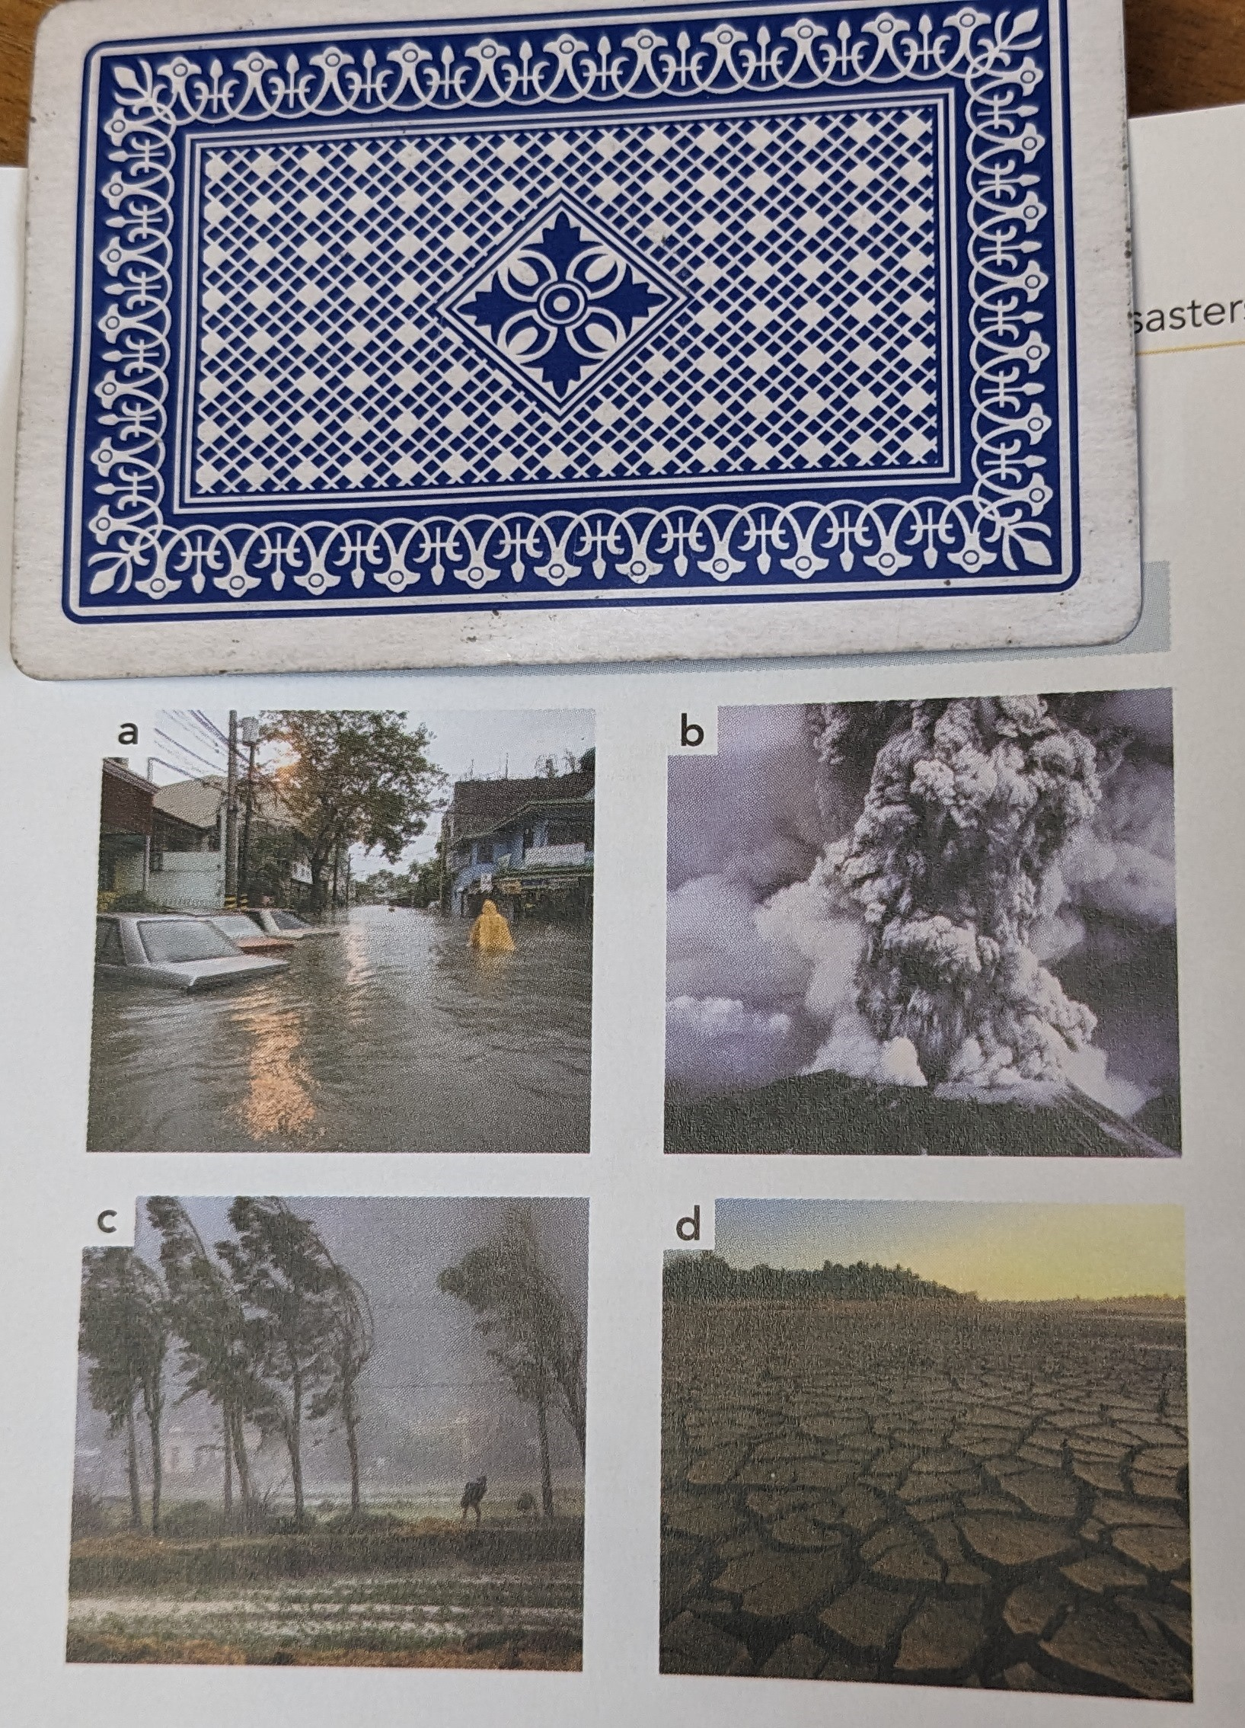

Some final notes

When I was preparing this list it was never my intention to convert the reader to a full-time user of playing cards. But to demonstrate that a deck of playing cards can add fun to the classroom and fun, be it the novelty of randomising interaction patterns to adding a challenge to exercises, means student engagement, which is always important.

I hope you take away a few ideas from the list and I encourage you to experiment with them. Also…. and just in case you didn’t get why I chose 26 uses for the list…… 26 is half the size of a standard deck of cards, minus the jokers.

References

Essenhigh, Louisa, New Close-up B1+, Cengage ELT; 3rd edition (April 18, 2021)

Please check the Pilgrims f2f courses at Pilgrims website.

Please check the Pilgrims online courses at Pilgrims website.

