Letter 1
Hello everyone –

I wanted to share a bit of news – not related to teaching.

A couple of years ago, I was really missing face-to-face teaching and training. So I decided to try something new. There is quite a big English standup comedy scene here in Barcelona. And that's where I found a new hobby. Anyway, three years later, I have a 60-minute show.

And here's the news: my show has been accepted for the Edinburgh Festival – the biggest arts festival in the world (actually called the "Edinburgh Festival Fringe").

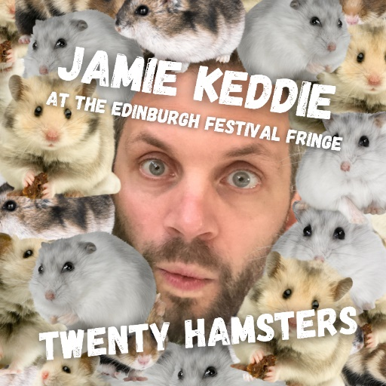

I used to love seeing acts at the festival when I was a teenager. So, as you can imagine, I am pretty excited about this. After finishing my "Video, Image & Story" course at NILE in Norwich, I'll be heading to Edinburgh to perform the show for 8 consecutive days.

So, if you happen to be in Scotland during the last week of August, you know where to come. Or if you know anyone who might be there, please send them to my show and tell them to come and say hi.

Dates: August 20th to 27th (inclusive)
Jamie Keddie

Letter 2

Well, the specific reason I’m getting in touch is that I’m involved with this award scheme called the A.S. Hornby Dictionary Research Awards (ASHDRA), details here:
https://www.hornby-trust.org.uk/projects#ASHDRADictionaryResearchAwards

I'm a member of the adjudicating panel. It’s been going a few years and we’ve had some good projects (there are summaries on the website); the emphasis is on people working in low-resourced areas.

We’re always trying to publicise the scheme, and it struck me that your HLT readership might include some people who’d be good candidates for an award.
Let me know what you think.

Michael Rundell

Letter 3
Dear Hania,
Greetings from Ottawa. Hope all is well. I am not sure if I copied you about my new book, "Peace Portraits: Pathways to Nonkilling", co-published by Creighton University and Center for Global Nonkilling, USA. You may wish to consider including a review note by Joam Evans Pim about the book in a future issue of HPL Magazine. Below is the url and text of review note.
https://nonkilling.org/center/2022/04/17/book-release-peace-portraits-pathways-to-nonkilling/

Warm regards
Bill (Balwant)

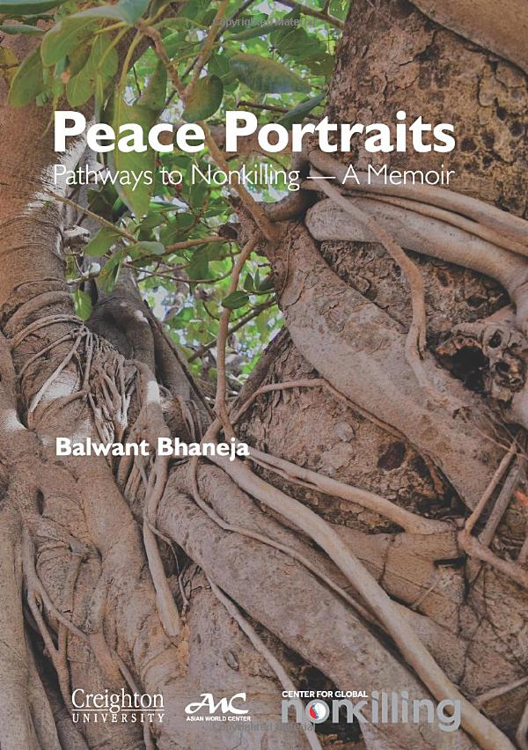

Book release: Peace Portraits, Pathways to Nonkilling

Joám Evans Pim
The Center for Global Nonkilling has just released it most recent book, co-published Creighton University, that artfully explores the intersection between faith, ethics and politics in modern times: Peace Portraits: Pathways to Nonkilling – A Memoir. The intimate autobiographical portraits in the collection reveal how five global peace leaders –Mahatma Gandhi, Lester B. Pearson, Glenn D. Paige, Bhagavan Sri Sathya Sai, and Máiread Corrigan Maguire impacted the author’s life. Using their short biographies, Balwant Bhaneja examines the path of nonviolence and nonkilling.

As Bhaneja writes: “Peace is a much abused word. It has been misused and misspoken by all sorts of leaders in defense of their insurgencies and wars—Stalin mobilized the Soviet Union in the name of peace, Hitler’s war to colonize Europe was to bring peace and prosperity for Germans, and even Bush’s military intervention in Iraq was to introduce peace and democracy in the region to make America look great again. These wars of the previous century were fought in the name of peace which led to the deaths of around 200 million people, mostly innocent civilians.” He adds: “The US involvement in the Afghanistan war in this century has been the longest in any foreign war, 20 years in 2021. You have to be naive to feel high-minded after having paid such a heavy toll, and have the gall to call it a “mission of peace accomplished.“

By bringing together the spiritual life with the political, Bhaneja delves into the nature of personal conscience as embodied in the thoughts and actions of these peace champions. His definition of peace continues to evolve, from internal as peace of mind and personal happiness to peace outside, to see if and how it can be externalized to alleviate physical misery around. It is through this quest he came to learn about Nonkilling Peace and its measure. “Deliberate killing of humans stops progress—you stop killing, progress resumes.”

Professor Glenn D. Paige on Bhaneja’s book commented: “This is a unique contribution to nonkilling literature. Reminiscent of classics like St. Augustine and Tolstoy— it is not a story from bad to good, but from ahimsa to nonkilling—good to good.” The author brings a wealth of experience to this important topic being active in promoting alternative visions of how politics might be conducted. A continuous thread through the book is the question: could we not take a portion of the money and resources put into armaments and military research and instead direct that to a ministry of peace? An interesting and worthwhile work.

Balwant Bhaneja is author of six books. He has written widely on politics, science and arts. His other works include Troubled Pilgrimage: Passaage to Pakistan and Quest for Gandhi: A Nonkilling Journey (also published by CGNK). A former career diplomat with the Canadian Foreign Service, he served in London, Berlin and Bonn.

Peace Portraits is available in paperback on Amazon and also in a digital Kindle edition. It can also be downloaded in PDF at CGNK’s website
( Balwant Bhaneja's article, Aspects of Nonkilling Literature, appeared in Humanizing Peace Language and Teaching magazine in October 2021)

Letter 4

The PIEoneer Awards 2023 finalists announced

We are proud to announce our finalists for the seventh instalment of The PIEoneer Awards.

It has been another hotly contested year, with hundreds of examples of inspiring innovation being demonstrated through the entries. Our list of finalists is a diverse, dynamic collection of the impressive work being done by 144 organisations from 26 countries.

Putting together an entry takes a lot of time and work, so thank you to everyone who entered and congratulations to all our finalists.

Click below to see this year's finalists and maybe a familiar face or two. If you spot someone you know, why not share the good news on social media?

Finalists 2023

Letter 5
Hello Hanna
A new month is upon us and my new month's resolution is to send out a monthly roundup email (every month!)
Here are five things you may have missed:
1. Ten ideas for using book images
In this LessonStream LIVE, I shared ten visual teaching ideas with an emphasis on grammar. All images were sourced from Amazon.com
► Click here to watch the recording
 Click here to download the slideshow
2. On the LessonStream blog
"A silent approach to video"
Silent viewing is a standard way to use video in the classroom. The idea is simple: the teacher plays the video with the sound down and students have to guess what the characters are talking about, what they are saying, etc. However, as we will see in this post, there is an alternative approach that can be a lot more effective.
 Click here to read more
Jamie Keddie

Join LessonStream today

Letter 6
View in browser



Welcome to your Pavilion ELT newsletter

In this edition, Gerhard Erasmus reflects on his experience at IATEFL 2023 and shares his advice for those attending large conferences, and we share the details of an exciting offer for our online event, 'Is the future perfect?'.

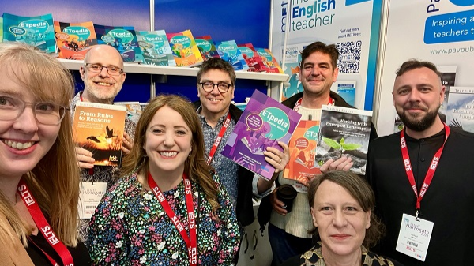

New from Modern English Teacher

Blog – Reflections on IATEFL 2023

For Gerhard Erasmus, it was great to be back face to face at the IATEFL conference, and there was lots of learning. More importantly, there were lots of people, and our connections to people is what makes life special. In this blog, he shares his reflections on the event and his advice for anyone attending similar conferences.

Read now

Letter 7

Welcome to your Pavilion ELT newsletter

In this edition, Chiara Bruzzano lifts the lid on what the research and students say about the main listening difficulties, and how you can leverage them in your classroom, and Rubens Heredia shares five ways you can use songs to teach English.



New from Modern English Teacher

Blog – Listening difficulties: going beyond ‘They speak too fast!’

If your students struggle with listening, you might have to consider facing the source of their problems head on: their listening difficulties. In this blog, Chiara Bruzzano lifts the lid on what the research and students say about the main listening difficulties, and how you can leverage them in your classroom.

Read now

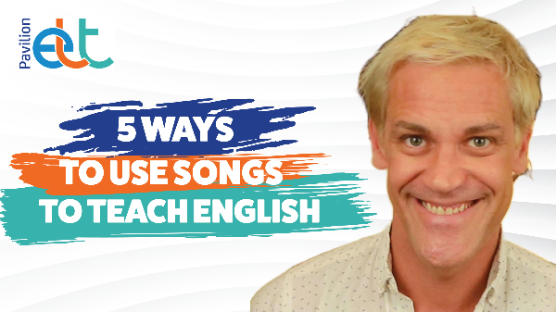

New from Pavilion ELT

Vlog – 5 ways to use songs to teach English

Songs are a very versatile resource that teachers can use to make lessons more engaging and fun. But how can we ensure we are not just filling in the time (or the gaps)? In this video, Rubens Heredia shares five ways you can use songs in your lessons.

Watch now

