Story Poems by Andrew Wright

reviewed by Alan Maley, UK
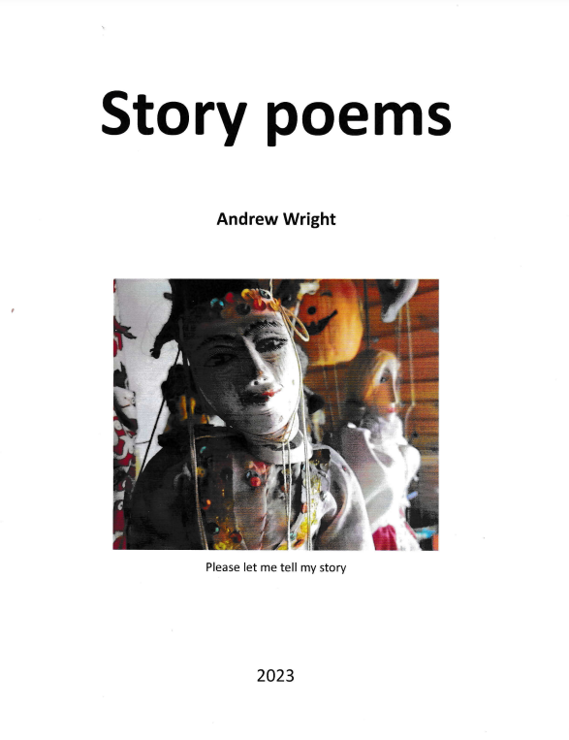
Andrew Wright (2023) Story Poems
Godollo: International Languages Institute.
Price 8 Euros plus postage.
Many readers will be familiar with Andrew Wright’s work as a storyteller. He was a pioneer in putting story-telling on the map for ELT teachers. And his books are still widely used.
But what they may not have realised is that Andrew is a poet as well as a story-teller. In his new book, Story Poems, he offers 20 compelling poems, all based on incidents and reflections from his life.

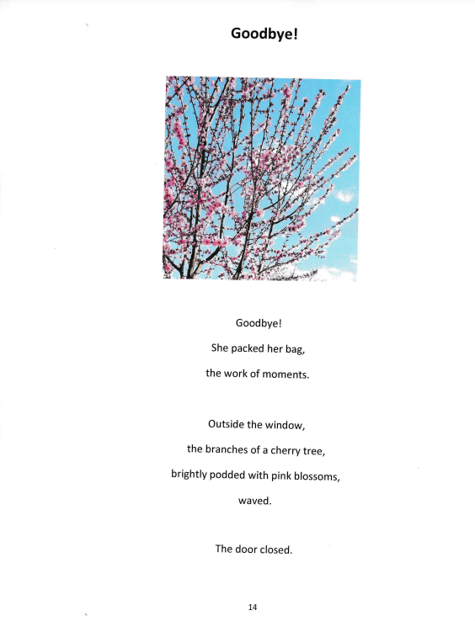

The themes vary from childhood memories, travel incidents, war and the suffering it brings, personal loss, the delight at being alive - and the grief for the loss of old friends (his poem They Came for Him in memory of David Hill is heart-wrenching). He has managed to pack a lot into these 20 poems.
And the language, though simple, is profound and the images are striking. As an example, in his poem to Sappho, the Greek poet in the 7th century BC, he links himself to her:
Do we hold the same long skipping rope
at each end?
Do we turn it
see and share
the jumping of moments
which matter?
The book is in large format and beautifully illustrated with his own colour photographs. So a visual as well as a verbal treasure.
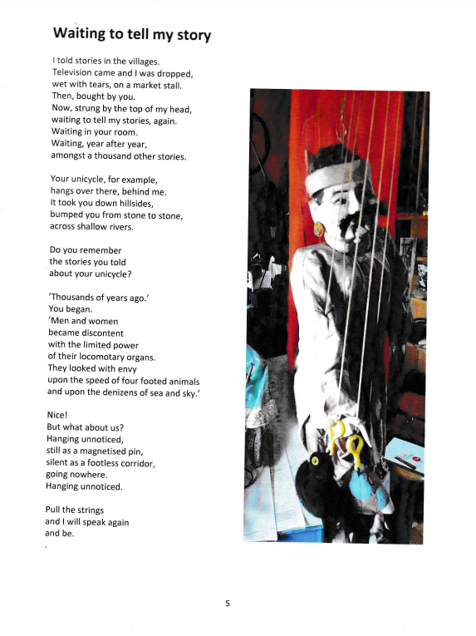

(Copies available from Andrew at andrew@ili.hu)

