Reflections, a New E-book by Alan Maley and Chrysa Papalazarou

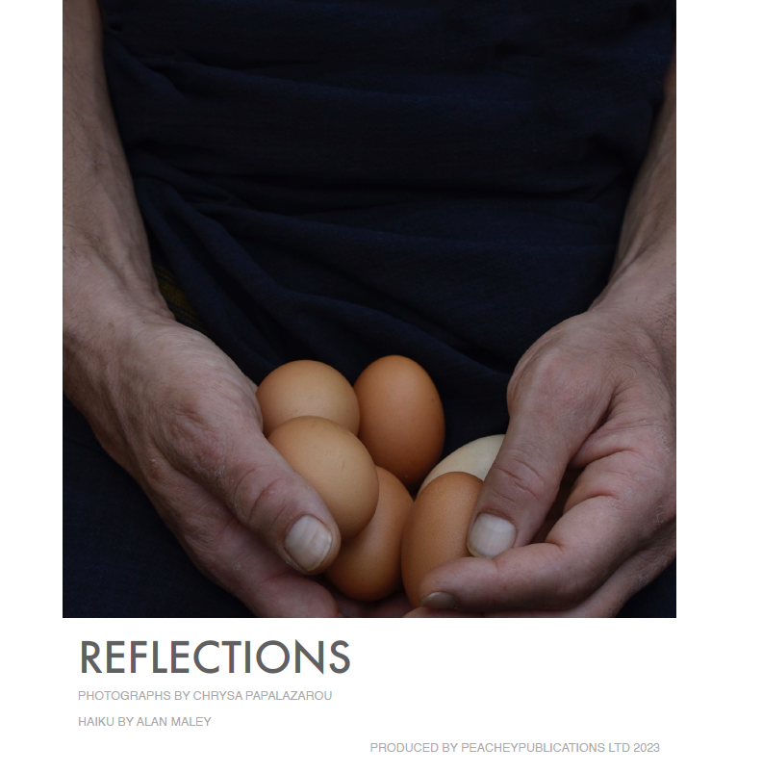

About the book

Reflections is a new e-book by Alan Maley and Chrysa Papalazarou. It is a collection of haikus alongside matching photographs. Alan provided the haikus, and Chrysa the photographs. See the sample pages below.

This is to ask you if you'd be interested in purchasing a copy as part of an attempt to raise money to support the work of Medecins sans Frontieres (MsF), who work in the most difficult and dangerous places to bring medical assistance to vulnerable and distressed populations.

The cost of the book will be on special offer for £5 for a limited period of one month only. Of this, we will be paying £3 to MsF to support their work. We will retain £2 to cover the production costs of the e-book. Once these costs have been recovered, all proceeds will go to MsF.

From the authors

Reflections is a collection of haikus (by Alan) matched with photographs (by Chrysa).
The book arose from the simple idea that by matching a photograph with a poem, something new arises. The juxtaposition of an image and its corresponding verbal manifestation then becomes mutually enriched. The act of combining two channels enhances both of them.

Of course, this is not a new idea. There are plenty of historical examples of using one artistic channel to re-interpret another. Obviously, live collaboration involves the direct interaction between two or more individuals to create something new. There is a long history of such collaborations too, of course, going as far back as Song dynasty China, when poets, painters and calligraphers would collaborate in the co-creation of beautiful scrolls.

What we have attempted here is directly working together to produce something which we hope is greater than the simple sum of its parts. Poems and photograph involve the element of representation; the former of the spoken language and the latter of the visual language. They also both share in common their attempt to collect and preserve a moment in time and communicate this moment through their respective means: rhythm and narrative, light and composition. Finally, they both share a level of abstraction of or reflection upon reality. The poet and the photographer are in a state of heightened awareness; they look intensely, and feel deeply. As this joint work unfolded, these feelings of looking and feeling intensified. This was the outcome of the union of visual and verbal images as they merged, emphasized and evoked each other.

There are instances when the poem/photo pairing is mirror-like. In other cases, the pairings are of a freer interpretation; linked to a feeling, connotation or their suggestive nature. Above all, as often is the case in contexts of collaboration, our meanings existed in our inter-subjective worlds and were interpreted from personal perspectives. Collaboration also involves interpretation. Impressions and notions awaken in front of the viewer’s/reader’s eyes.

We proceeded in two ways. The first part of the book started with the haikus, which Chrysa selected and matched with photographs from her large portfolio. In the second part of the book, we reversed this process: Chrysa supplied Alan with a large selection of black and white photographs from her portfolio “Nostos: homecoming”– he then wrote the original haikus to accompany them.

So here we are with a body of work we have both been happy to have worked on and that has shown us in a way, looking back to the initial doubts in its beginning, that there is some sort of overarching universality in this attempt to fuse our artistic endeavors. That of human creative experience as it aspires to transform lived experience, to appeal to the heart and senses, and keep oblivion at bay through the visual and poetic memory. We hope you will enjoy the result as much as we have enjoyed working on it together.

Sample pages

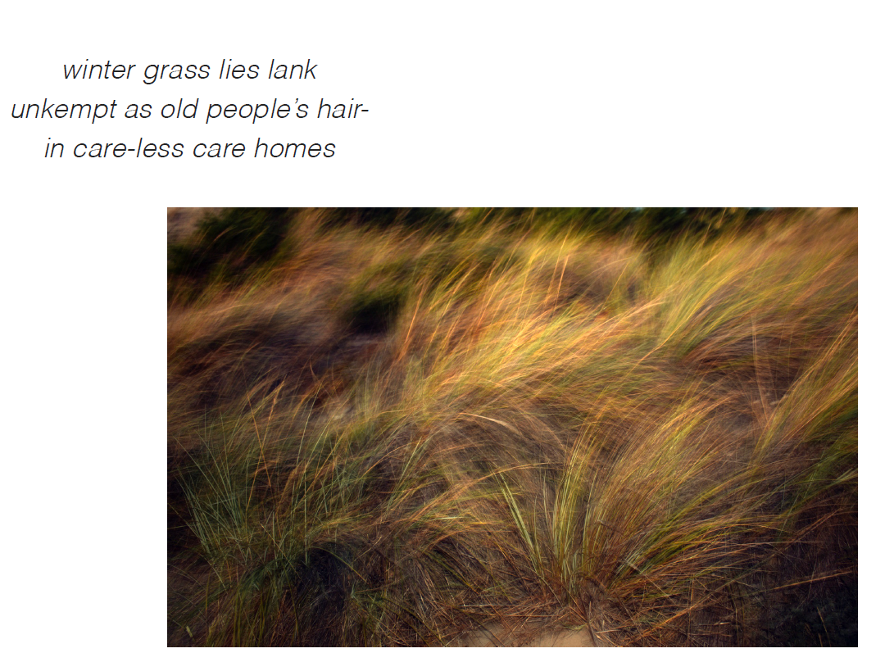

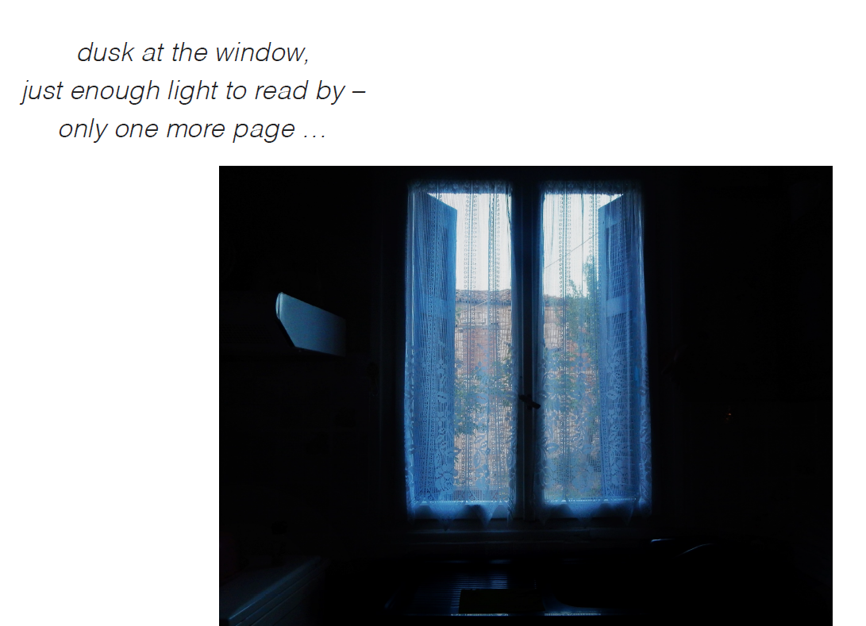

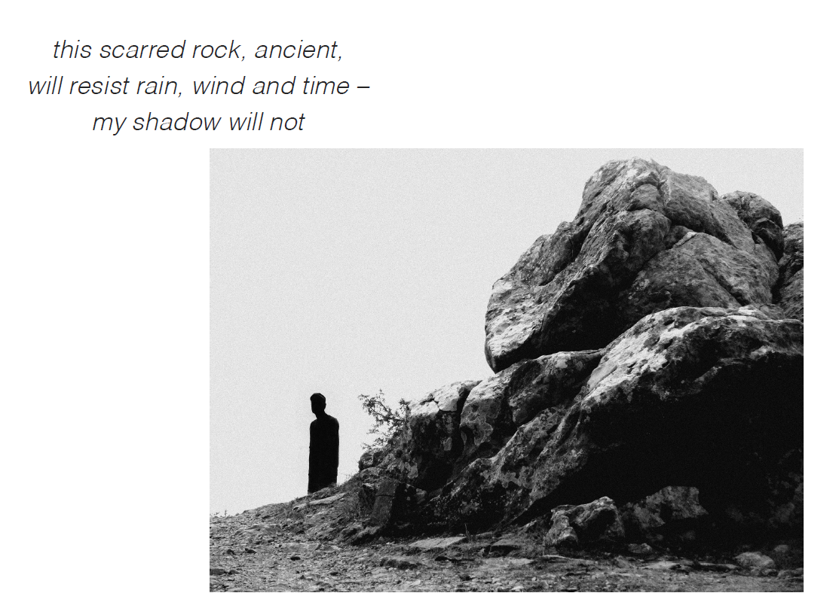
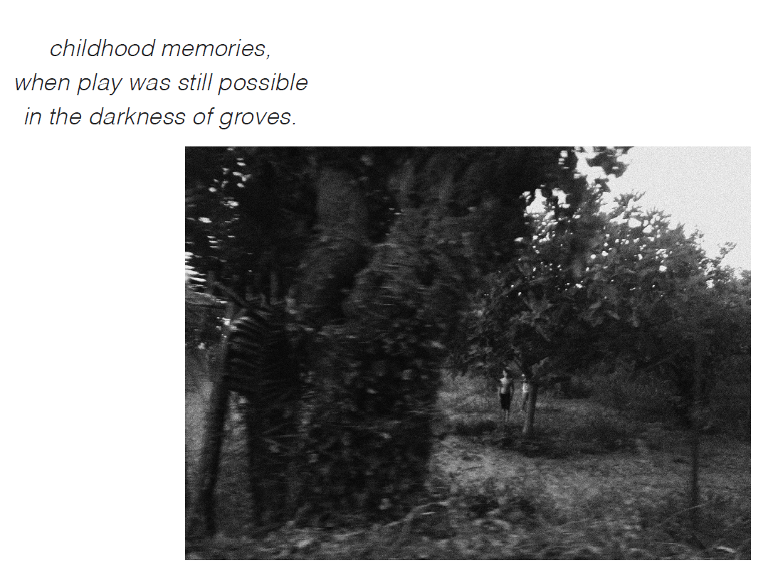

How to buy the book

If you wish to buy a copy of the e-book, please contact Alan (yelamoo@yahoo.co.uk) copying to Chrysa (hryspap@yahoo.gr) to confirm your interest. We will then forward payment details. Once payment has been made, we will then forward the link to you.

