Ready to Run Launches ELT Video Featuring Neurodiversity



Diversity and inclusion is not an option for the ELT community, it is a must.

Digital Learning Associates (DLA) released a video today that covers neurodiversity, as part of the company’s award winning Ready to Run series for ELT. In Sam and his World an 11-year-old boy talks about being on the autism spectrum and describes the “superpowers” he gets from being neurodivergent – skills like being good at maths and puzzles.

DLA cofounder Adam Salkeld said: “Sam is articulate and talks about himself in a way that learners in the upper primary age group can instantly identify with. We love that he is so open and positive. The video not only helps students to develop an understanding of neurodiversity but delivers key English language learning outcomes”.

The authentic video is graded at A1 (CEFR) / Movers (Cambridge Young Learners) level and features a range of natural English that covers vocabulary on describing yourself and your personality, as well as talking about family, hobbies and interests.

DLA’s Head of Product, Elena Deleyto added “Coverage of neurodiversity is an important, but often overlooked, element in EDI strategies so we are delighted to offer this title to our partners in publishing and digital learning. We are already working on more videos in this area.”

Developing an understanding of diversity is also an important priority in Social Emotional Learning (SEL) and in the United Nations Sustainable Development Goals (SDG) framework.

Adam Salkeld said: “Diversity and inclusion is not an option for the ELT community, it is a must. It is simply part of the everyday reality in classrooms, families and communities all over the world, so reflecting it is essential if we are to maintain credibility with teachers and learners alike”.

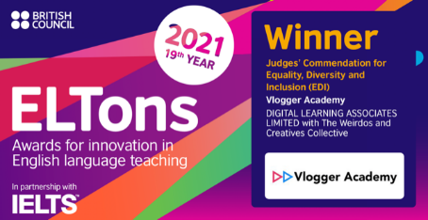

DLA won a Judge’s Commendation for Equality, Diversity and Inclusion in the 2021 British Council ELTons. Sam and his World is just one of over 300 graded authentic video titles from Ready to Run which are available for publishers, digital platforms and course creators all over the world at CEFR A1-B2 and Cambridge Young Learners Starters, Movers and Flyers levels.

Links for further details:

Video transcript for Sam and his World

Learning and teaching resources for Sam and his World at MV (Cambridge Young Learners Movers) level

SEL Lesson Plan for Sam and his World

Ready to Run Young Learners’ Catalogue

Ready to Run Full Catalogue

