

The Wolf was Not Sleeping (Police Care UK edition): Supporting the Children of First Responders with a Heart-warming Bedtime Story
Avril McDonald, New Zealand

With a foreword from HRH Prince William: “This book is dedicated to you, the children of police families and the grown-ups you love. It is here for you when you might be feeling scared or worried about them. Be proud of the important part your family plays in keeping us all safe from trouble or harm.”

A donation will be made to Police Care UK for every copy sold.
ISBN 9781785835742
Published 30th April 2022
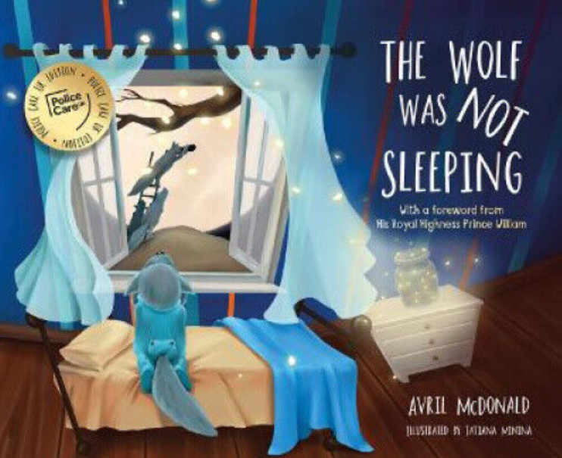

Avril McDonald is the bestselling, award-winning author of the Feel Brave series of books and founder of Feel Brave, a company with a vision to give all children access to tools that help them manage tough emotions and reach their potential. Avril has a Diploma of Education from Wellington College of Education, New Zealand, where she trained as a primary school teacher majoring in music and dance. She then had a varied career in digital entertainment before launching Feel Brave to give teachers and parents simple and practical strategies to help children with their emotional well-being. Her free ‘1 Dose/Day’ emotional well-being programme for children is now used in more than 350 schools across ten countries. Avril is an official partner of the New Zealand Life Education Trust and Patron of Westminster Children’s University.

For the children of first responders and emergency workers, it is often difficult to understand exactly what their parents do at work. Sometimes, they can be worried or concerned about their parents’ safety.

Police Care UK is a charity which supports members of the police family who have been harmed as a result of policing, including the children of officers and staff. They recognised that some children of police families may feel anxious when their parents are at work and wanted to help allay those concerns.

In December 2021 the organisation asked serving police officers working within UK policing who had children aged between 3 and 7 years some questions about their perceptions and experiences of children’s worries or concerns about their parents or guardians working for the police service. The results were staggering: 83% said their children expressed worry or concern about them (or their partner) going to work as a police officer or police staff. 94% of the worries fell into the categories of:

• Dealing with bad people
• Being hurt or injured
• Being involved in dangerous situations.

And 41% of parents expressed doubt as to whether they were fully prepared to respond to their children’s worries or concerns about their work in policing.

As part of its offer to support families of serving police personnel, Police Care UK worked with bestselling author Avril McDonald to create The Wolf was Not Sleeping: Police Care UK edition – a special UK policing edition of a heart-warming bedtime story specially written to soothe the anxiety of children whose parents work as first responders and to help initiate conversations about emotional wellbeing.

The book is an addition to Avril’s award-winning Feel Brave series of books which have been translated into seven different languages and are used and loved all over the world. The books and the Feel Brave organisation aim to help children manage tough emotions and reach their creative potential.

The story in The Wolf was Not Sleeping follows Wolfgang, whose dad works as a helper: when the wolves sound the alarm, he has to leave to help the other creatures in the forest. Each night Wolfgang worries about what might happen if his dad gets the call. His worries are so bad that they keep him awake, and he’s so tired he is falling asleep during the day! A friendly spider leaves a note for Big Dad Wolf to show him how worried Wolfgang is. Big Dad Wolf realises he needs to sit down with Wolfgang to reassure him, and tell him about what happens when he goes to help in the forest. Wolfgang is reassured and learns that things aren’t always as bad as they seem. There are lots of ways in which we can tell or show people how we are feeling – and if we can name a feeling, then we can tame a feeling.

In a follow-up survey, Police Care UK asked the same families what they thought of the book, how it had been received by their young ones and what the potential impact might be. 90% of those surveyed agreed with the statement “The book helped me have conversations about my policing role with the children (or child) in my family”, with 61% agreeing very much or strongly.

For more look here.

