Interviews with Pilgrims Trainers: Hania Kryszewska Editor of Humanising Language Teaching Magazine and and Chaz Pugliese, Director of Education and Teacher Training, Pilgrims – IATEFL 2022

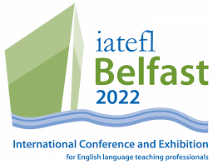

Interview with Hanna Kryszewska
We chat to Hanna about her talk: Lessons learned when teaching B1-C2 levels in COVID-time online classes

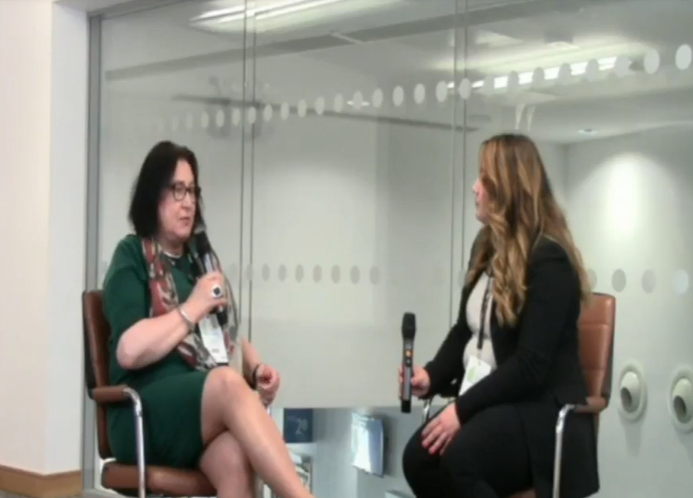
https://business.facebook.com/IATEFL/videos/568997714655116/


Interview with Chaz Pugliese
Chaz talks us about his IATEFL talk Ushering in the 21st century: the emotionally intelligent teacher

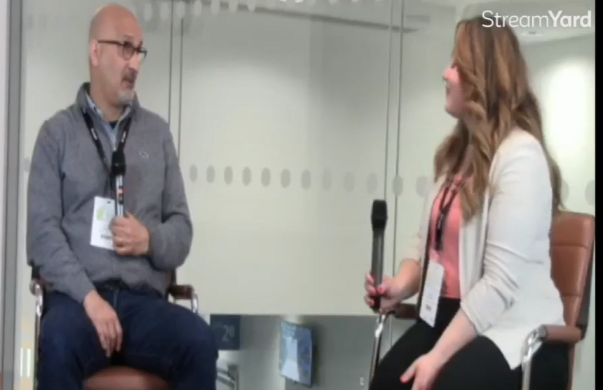
https://business.facebook.com/IATEFL/videos/493015762561259/

