Tune into English

Fergal Kavanagh, Italy

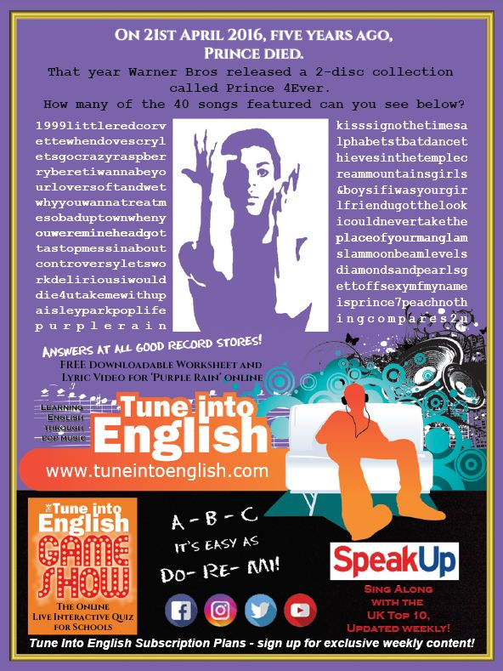
Dear World - Echosmith
The 22nd April is Earth Day! First-time contributor Eleonora Nesti, Florence, has prepared a worksheet with a survey based on a “love letter to the planet.”

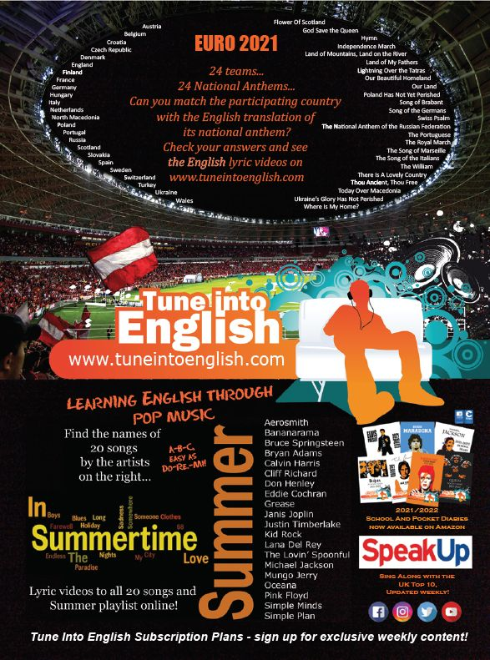

Euro 2021 – National Anthems
Here comes the sun by The Beatles
In the June issue of Speak Up, Tune’s monthly column looks at the story behind and the language used in The Beatles’ Here Comes The Sun. You can read previous columns here.

The Champion – Carrie Underwood feat. Ludacris
This worksheet, submitted by regular contributor Maria Gulczynska, is based on a song written "to celebrate athletes at the top of their game, but also to resonate with people in their everyday lives."
The Rembrandts – I’ll Be There For You
The 30th July is International Day of Friendship. Regular contributor Maria Gulczynska has prepared a worksheet based on the theme song to Friends.


The Doors’ Light My Fire
In Speak Up, Tune’s monthly column looks at the story behind and the language used in The Doors’ Light My Fire. You can read previous columns here.

