Mentoring Teachers to Research their Classrooms: A Practical Handbook by Richard Smith,

reviewed by Brian Welter, Taiwan

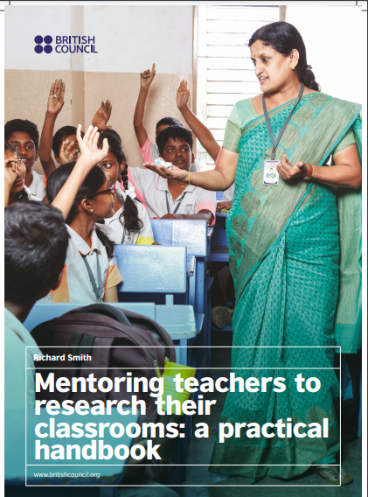

Richard Smith. (2020). Mentoring teachers to research their classrooms: a practical handbook. New Delhi: British Council. 88 pages.
Accessed at https://www.britishcouncil.in/sites/default/files/mentoring_teachers_to_research_their_classrooms_a_practical_handbook.pdf

Mentoring plays a vital role in professional development. A supportive peer can ease the transition for recent graduates or when individuals change schools. Support for teachers facing difficult classroom situations can also reduce burnout and career dissatisfaction. Richard Smith shows what mentors can do for teachers as the latter grow in professional autonomy. Mentoring teachers to research their classrooms provides tips and tools to ensure the necessary scaffolding for career growth through classroom-based research while avoiding an overly directive approach such as making decisions for others. This requires flexibility in switching from coach to motivator to resource person to model. The role is therefore often about knowing when, how, and how much to intervene, and when to step back. While much of this may seem to imply many parallels with teaching itself, Smith makes the case that mentors draw on specialist skills that often differ from teaching skills.

Mentorship is based on mutual respect, including a relationship of equality. This requires a non-judgmental approach and critical self-awareness, as there is a need “to be clear about the type of mentor you want to be” (14). Mentoring empowers and motivates mentees, and includes “sharing knowledge, skills and experience” (14). Such a person is not an advisor, but excels at helping teachers more clearly see their classroom reality and research goals, and increase their critical self-awareness. This requires specific skills, which the author highlights. For instance, one helpful checklist of relevant skills includes, “I am able to imagine another person’s difficulties” (15). The checklist draws attention to the fact that “the affective dimension -- building trust and mutual respect -- is a very important basis” for this work (15).

The book’s twelve chapters are divided into two parts. Part 1, Foundations, features teacher research, the nature of mentoring, mentoring teacher research, research timelines and records, and reflecting on and researching mentoring. Much of this is practical, classroom-based, and problem-oriented. This research focuses on improving a particular aspect of the classroom, such as behavior when the teacher is giving instructions or improving pairwork. The research outcome, while perhaps valuable for a wider audience including colleagues, mostly pertains to the circumstances of the particular classroom of the researcher.

Smith helpfully differentiates among practitioner research, action research, and classroom-based research. These share many things in common, though the goals and focus may diverge. “Action research involves attempting to improve a situation via some kind of new action, and evaluating what does or does not change. This can then lead to a further cycle of attempted change and evaluation” (10). Action research is therefore feasible and measurable, though Smith later on discusses various measurement tools, both quantitative and qualitative.

The interactive, workbook-task types found in every chapter make Mentoring teachers to research their classrooms more of a challenge by prompting reflection from the reader. In discussing “the stages of an (exploratory) research project” (11), Smith notes the actions that a teacher-researcher did to investigate how to help improve students’ writing. The reader is prompted to put the actions in order. One step is, “Audio-record parts of lessons where I explain homework” (11). Interweaving such practical tasks with the wider discussion makes it easier for readers to imagine how this might work in their classrooms. Chapters include QR codes that link to videos of discussions on an aspect of the chapter, followed by further online resources to explore. In this way, this small book packs more of a punch and aids readers in getting started on our own research into the various topics.

Part two includes chapters on topic selection and research questions, data (types, collection, analysis), supporting change-oriented teachers, evaluating change, and helping practitioner researchers reflect on and share research. Particularly helpful is the distinction between topic selection and research questions, and the point that questions need to guide the research. This is an important part of the process because many researchers design questions that are fuzzy, unmanageably broad, or hard-to-measure and analyze.

Smith advocates asking exploratory questions instead of offering direct advice. Yet teachers do need substantial input from their mentor at certain times. For example, a support person can provide criteria to help the teacher-researcher decide on a suitable research topic. The criteria, falling under the headings of “beneficial,” “practicable,” “interesting,” and “important,” focuses on the needs of the teacher, students, and other teachers. Such criteria is crucial for the overall discussion in Mentoring teachers to research their classrooms because some readers may find the aversion to direct advice-giving, along with the emphasis on the affective and relationship dimensions, to sound somewhat shallow or substanceless. The QR-connected video features an individual who “talks about how taking time to explore a situation from different perspectives can help bring clarity” (41).

Chapter 8, Guiding teachers to develop research questions, provides the meatiest advice. An issue or aim needs to be turned into measurable and viable questions. A question can also mold a negative classroom situation into something far more positive and motivating. “My students just don’t seem interested” can become “How can writing essays be more motivating for my students?” Some of the suggested mentor scaffolding of mentees is very useful in this chapter. For example, one task prompts readers to complete mini dialogues in which the teacher is unsure of what to research. The focus once again is on stimulating further exploration instead of offering advice. The following example highlights the use of clarification: “Teacher: ‘I’m concerned that students are always using L1.’ Mentor: ‘When you say ‘always,’ when exactly?’”

The units on data collection and analysis argue that teacher-researchers don’t need to be statisticians and that questionnaires are not the only way to go about research. Qualitative research, such as teacher diaries or recordings of focus group discussions, allow for deeper analysis of issues, Smith contends. He briefly looks at deductive and inductive analysis of qualitative research data to give us a glimpse of the range of methods of analysis. The last chapter on sharing research outlines the many methods for this sharing, though Smith rightly conveys the social aspect of this.

Mentoring research is in fact a social process from the very beginning because of its dialogic nature. No one can tell teachers what to research in their classrooms. Yet teachers often need assistance in identifying the issue and ensuing research questions, carrying out the research and data analysis, and then reporting on the findings. The mentor’s role is to ensure the teachers’ ownership of their entire projects so that they and their students can grow and develop. This type of support builds teacher autonomy.

Please check the Pilgrims f2f courses at Pilgrims website.

Please check the Pilgrims online courses at Pilgrims website.

