Mario, the Poet

Mario Rinvolucri with Hanna Kryszewska, Pilgrims Trainers

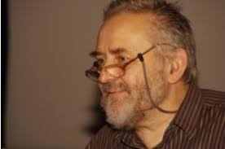

Background
When Mario started to clear his office, he kept sending me bits of texts, notes, activities and letters to be used in HLT if I saw fit. Some of them got published already, this one was waiting for a special occasion. Sadly, I feel this is the day to release the last but one text I treasured.
The context
I think it was 2013 or 2014. We had a long conversation travelling on a train from Warsaw to Gdańsk, which we continued in my flat where he was staying. A unique opportunity. We spend 7 or 8 hours on our own just chatting or keeping silent. Very special. We had each other to ourselves for hours.
The unknown Mario
One of the things he talked about was how children leave the nest and how we need to reestablish our relationships with our partners. Mario had already gone to the process, and he was talking about the changes in married life that take place then. I was listening carefully curious what was awaiting me.
What struck me was the very personal Mario, his thoughts, emotions and inner self we did not often get to see or talk about. This poem shows a different Mario and makes me think of an old photograph featuring Sophie and Mario, sexy and young, on a bike trip in the countryside, probably somewhere near Cambridge.
And now the ominous words: The future is of course behind me. It is now true for both of them.
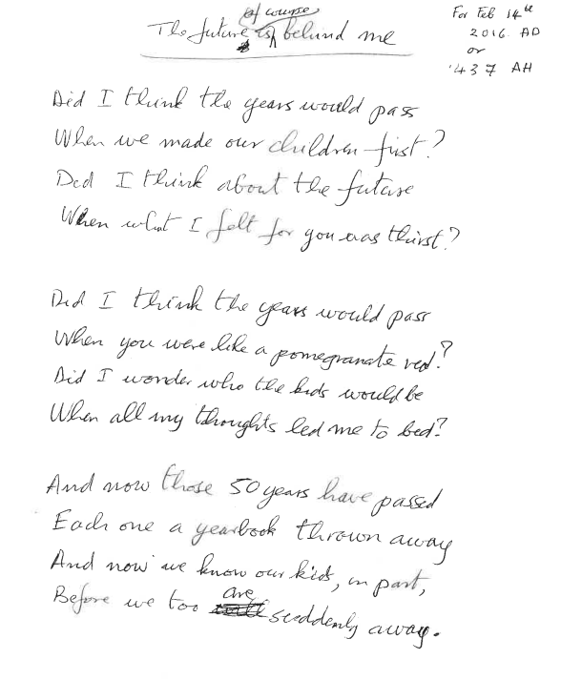
Typically for Mario, the date is given in our western Christian calendar (AD) and the Islamic calendar year (AH).

