

10 Years of ETpedia: 100 Ideas from 10 books

2024 marked the 10 year anniversary of the ETpedia series. The series offers English language teachers across the world thousands of practical teaching tips, ideas and activities. Each book in the series is divided into units of 10 tips on a particular theme or topic, perfect for dipping into whenever needed.

Now you can explore a sample from the 10 books.
Now you can now get the full collection with 100 practical ideas!

Download the activities from the link below.

More about the series here.
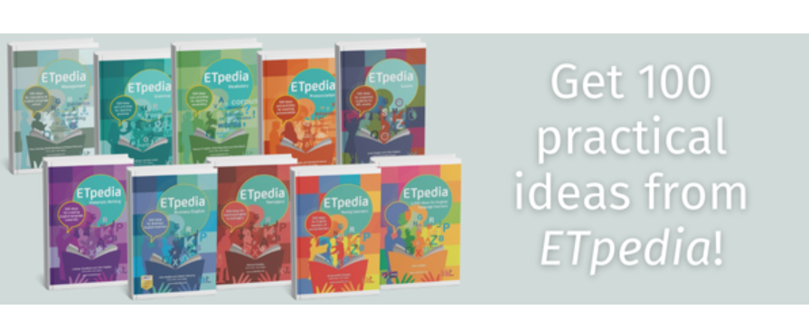
You can download the whole collection of hundred activities below.

