Short Book Reviews
Hanna Kryszewska, Poland
Hanna Kryszewska is a teacher, teacher trainer, trainer of trainers. She was a senior lecturer at the University of Gdańsk, Poland. She is co-author of resource books: Learner Based Teaching, OUP, Towards Teaching, Heinemann, The Standby Book, CUP, Language Activities for Teenagers, CUP, The Company Words Keep, DELTA Publishing, and a course book series for secondary schools: ForMat, Macmillan. She is also co-author of a video-based teacher training course: Observing English Lessons, and online course for Orient Black Swan on 21st Century Skills and Teaching the whole person: Humanising language teaching. Hania is a Pilgrims trainer, OTA trainer and editor of HLT Magazine.
Email: hania.kryszewska@pilgrimsteachertrainig.eu

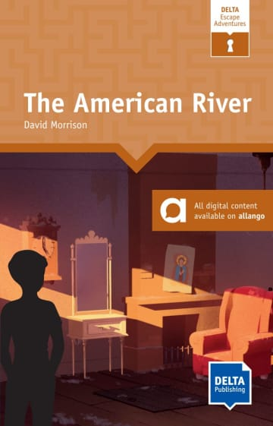

The American River. Level 7/B1. D. Morrison. DELTA Publishing.(2023). ISBN 9783125011540, pp.160. The DELTA Escape Adventures is a relatively new DELTA series. The idea is a bit like an escape room – but on paper. The main principle is Read - think - escape! In each of the books the reader is in a situation from which he or she needs to escape. But to escape you need to read the next chapter first. And not just read! You need to understand what is going on and solve a problem or series of problems as you go along. Fortunately, there are clues that help you. So, you have a clear goal: read and solve problems to escape from something, somebody or somewhere. In other words, there is focus on the task - problem solving and achievement with the involvement, among others, of the 21st Century Skills. The books are a good read thanks to the fact that they are a mixture of fact and fiction, and a CLIL slant with reference to history, geography, art, music and science. The American River is a story of a character trapped in a hotel in the Gold Rush times who meets a lot of curious characters. Additionally, there are plenty of online resources to be found here. Overall, it is a great idea how to make reading more engaging and interactive.

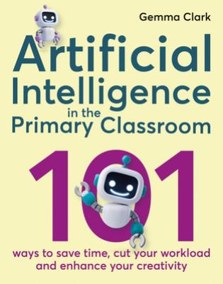

Artificial Intelligence in the Primary classroom. 101 Ways to save time , cut your workload and enhance your creativity. 40 Activities to boost student commitment, motivation and productivity. G. Clark. Crown House Publishing Limited (2024). ISBN 978178583714-2, pp.242. Artificial intelligence or rather how to harness it for education is an issue that interests or sometimes worries many teachers or educators. Harnessing for education is one thing and harnessing it for primary education is yet another. We need to bear in mind artificial intelligence is connected with using technology, and young learners often have limited time set by their parents on how long they can spend time using technology, even if it is just about education. So, the book is about how to introduce technology effectively, how to harness AI so that the children benefit the most. With this book we are in safe hands. Gemma Clark is an experienced primary teacher who wants to instil in children love for learning, and with the help of this book she wants to instil in teachers a passion for innovative teaching with the use of AI. The book spares you long introductions – it is a one pager. The rest of the book are 101 practical ideas; sometimes the lesson procedures are accompanied by some background how the idea for the lesson came about or how it went. Also, they are of varying format and length. So, all very practical. The author focuses on the tool or function you want to use without pointing towards a particular site or AI function. The activity may involve, for example, generating a particular list of words of certain degree of difficulty, asking AI to generate a list of words to describe e.g. a dragon, having AI generate an image to a given description, generate an alternative ending of a story, write a limerick, a reading mystery following given clues, character descriptions and many other. A teacher of English may wonder how useful these ideas and activities will be for a language teacher of English as a foreign language (EFL). Those of you who have tried to use Magic School for EFL purposes will know what I am talking about. Some functions are not suitable for early primary because of the language level. Artificial Intelligence in the Primary classroom has activities which are adaptable for EFL purposes, and some are aimed specifically at teaching children who are learning English as a foreign language. Overall, the activities aim to enrich and liven up lessons, as well as develop learning and learning to learning skills. I mentioned the fact that no websites are mentioned which means the teacher will need time to find a site which offers the function needed to run a given activity, and even more time if you want to find a free site.

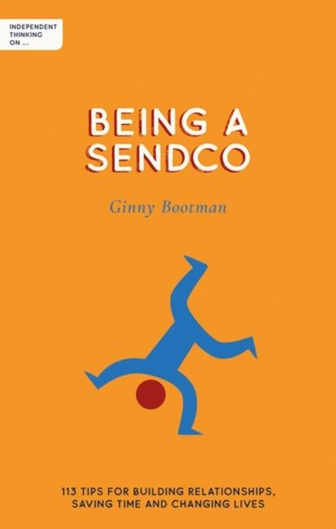

Being a SENDCO. G. Bootman. (2023) Independent Thinking Press. ISBN 978-178135424-7, pp 134. A number of titles in the series Independent thinking on… have been reviewed in HLT. The books are aimed at the teaching community in general, so in my choices I focused more on those relevant to EFL teachers. You may ask, what is there for TEFLers in SENDCO? Many books devoted to SEN fit into SENDOCO, as SENDCO stands for ‘special educational needs and/or disabilities coordinator’. (In some schools they are called SENCOs.) The aim of the book is to present and explore “tried and tested ways to build and cement strong relationships between all those who work with children with additional needs, whether they are teachers, parents, carers or outside agencies”. Many have tried to define a SENDCO professional but I think the best definition comes from the Amazon book description: “A voice. An advocate. A messenger (don’t shoot!). A calm in the storm. A connection. A friend. A forgiveness seeker, not a permission requester. A shot in the dark. A shot at life. The one who listens. The one who knows. The one who cares. The educational professional who campaigns tirelessly on behalf of the children who need more support than most to navigate a system that, at times, seems purposely set up to make them fail.” The full list of the roles of a SENCO teacher is available here on pages I-IV. I love it. It reminds me of the YL teacher’s T shirt:


An EFL teacher is no different from teachers of any other subject when it comes to SEN. If anything, his or her task is even more difficult as they try to use L2 as much as possible ( target language) which may be an obstacle to SEN learners. The book is snappy in addressing 113 areas, in the book simply called ‘tips’ such as: dealing with parents, the role of meetings, technological steps, conversations with children, funds, and many other. Overall, the book is very accessible and informative.

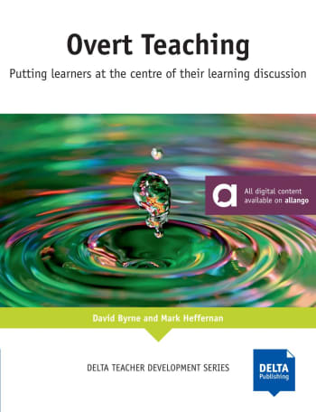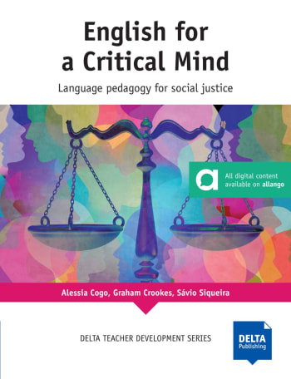
DELTA Teacher Development Series.
Overt Teaching. Putting learners at the centre of their learning discussion. D. Byrne and M. Heffernan. (2023). DELTA Publishing. ISBN 9783125016897, pp. 136.
English for a Critical Mind. Language pedagogy for social justice. A. Cogo, G. V. Crookes, S. Siqueira. (2023). DELTA Publishing. ISBN 9783125017436, pp.168
The two titles come from the renown DELTA Teacher Development Series which features many well known and excellent EFL authors. Many of the publications have become EFL classics and are a must for teacher training and teacher development. These two titles under review in some way belong together, not just because they reached me as one batch.
Overt teaching believes that successful teaching requires active development of the learners, their total awareness, involvement and commitment to the discussion of the process. To start with, overt teaching is about conscious joint decisions regarding classroom management, aims and objectives, discussions and feedback, overt discussions of individual skills and overall reflection. The way I see it, it is about spelling things out how, why and what the teacher and the students do in the classroom instead of doing things ‘ by stealth’. The book presents activities for introducing, developing and implementing this philosophy around areas like awareness, aims and objectives, success criteria, feedback and reflection, and, finally, skills development. Section C looks at teaching contexts, teaching with technology, creating teaching materials, and, finally, working on own teacher development.
English for a Critical Mind takes up the issue of Critical Pedagogy versus Critical Language Pedagogy (CLP), and then Critical Pedagogy in English Language Teaching (ELT). To start with, in a nutshell pedagogy focuses on the transmission of knowledge, while critical language pedagogy goes further and promotes teaching students to think critically and question the information they are given, while Critical ELT Pedagogy involves critical thinking as well as challenging power dynamics, considering inclusive learning environments, addressing social justice issues, and empowering students to become active participants in their own education”.
Note some aspects of critical EFL pedagogy overlap with overt teaching, in fact, some are perfect ways to exercise overt thinking. Critical thinking and overt teaching are very close. When it comes to topics, overt thinking looks at processing whilst critical thinking focuses on social issues. In CLP we need to redefine critical understanding of language, the role and spread of English, and the interaction between CLP and ELF (English as Lingua Franca). Part B in the book offers handouts and sample units, which are great to use, analyse and refer to as models. Part C looks at teacher reflection to help self-development, and areas of action such as: agency, meaning, language, digitalisation and investigation.
The two books should be standing next to each other on your shelf.

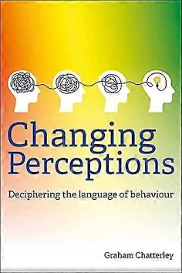

Changing Perceptions. Deciphering the language behaviour. G. Chatterley. (2023) Crown House Publishing Limited. ISBN-978178583675-6, pp. 282. In the recent years I have noticed that more and more frequently we talk about reading images, reading photographs etc; here in this book we talk about reading or deciphering the language of behaviour. Note it is not just deciphering behaviour but deciphering the language of behaviour. Every teacher will understand and recognise the concept of behaviour or eradicating undesirable behaviour. But the author asks the following question about ‘children being school ready’ versus ‘the school being children ready’. I think this is a brilliant question. To start with there are many reasons for poor behaviour: fear, stress, anxiety and being overwhelmed. The author proposes that instead of eradicating and stamping out bad behaviour, we need to learn where it stems from, learn to deal with the causes not just the symptoms. The result will be that we will create and atmosphere of understanding and empathy which will help us build a safer environment, and above all a better understanding between children and adults. The chapters in the book look among others at relationships, our responses, origins of behaviour, short term survival responses, shielding from shame, emotional resilience, power of trauma and many other.

Please check the Pilgrims f2f courses at Pilgrims website.

Please check the Pilgrims in Segovia Teacher Training courses 2025 at Pilgrims website.

