We All Know Stories
Gerry Kenny, France



Mario
Mario Rinvolucri, master teacher, passed away this week at the age of 84. He opened the door to teaching English as a Foreign Language (EFL) for me. Then, once inside, he showed me how to open the windows and let in the light. He loved nothing more than a noisy classroom humming with conversation. He was one of a kind.
One of my very first posts still available on myblog, We all know stories, is about my first chance encounter with Mario.
His legacy is enormous. I can say that now he’s no longer here to disapprove. Not only because he helped create Pilgrims Teacher Training and HLT (Humanising Language Teaching) Magazine which live on, and not just in terms of his prolific and immensely varied writing, but also because he reached so many people individually through his teaching, travelling and correspondence.
He was a giant in the field of teaching EFL. We often talk about standing on the shoulders of giants so we can see further. Mario Rinvolucri was the sort of person who said: “I’d like to see what you’re looking at. Can I look over your shoulder? … Hey, this is new territory!” He was like that. He always saw genius in other people and helped us share what we didn’t always know we had.
When working with storytelling in class, as I have constantly since that first experience of seeing it at work in his teaching back when I started as a trainee, I have often thought as I watch the room buzzing with student narratives that I wished Mario were there to see it. But of course, he always was there, every time.

Acknowledgement: We all know stories
The following piece is a reworked version a text originally published in June 2010 as part of a collective celebration of Mario Rinvolucri’s work and influence by Humanising Language Teaching, the online magazine he founded.

Close encounter with classroom storytelling
We all know stories. But how can they come into classroom learning?
When I first fell into teaching English as a Foreign Language (EFL) in 1981, John Morgan and Mario Rinvolucri were already developing their ideas on the use of storytelling for the language classroom. A chance encounter with Mario Rinvolucri would set me up for a life with storytelling in the classroom. Here’s what happened.
Why not try EFL?
In September 1981, I had been living in France for 6 months where I had begun a whole new life with my wife Sylvie and son Sam. As my British Joint Honours in English and Philosophy from Keele University was not valid in France. I was told I would be accepted as a first-year university student in Toulouse if I wished to start over, but that was not an option. I found paid work as a building labourer, until it became clear that my status as a native speaker of English could be the key to open the door to a new career in teaching.
A newspaper ad in The Guardian caught my eye. It offered a 5-day Introduction to Teaching English as a Foreign Language, and seemed like a step in the right direction. Pilgrims Language Courses in Canterbury had developed the course to help mother-tongue speakers, especially those living or planning to live abroad, to get a toe-hold in the profession. Why not try EFL? I applied and was accepted.
Meeting a real teacher
The course was just what I needed. Something clicked. I identified with the humanistic approach the trainers used and felt at home right away.
Somewhere in the middle of the week, slots were made available for us to go and see a real teacher in the classroom with real students. This was possible because the Pilgrims Language Centre at Kent University ran language classes as well teacher training courses.

Along with 2 fellow trainees I was sent to wait in front of Mario Rinvolucri‘s classroom door. It was the second door on the right after turning left once you’d gone past the Porter’s Lodge at Keynes College. It’s probably still there. We knocked. Mario opened the door, introducing himself, somewhat predictably, as Mario. The rest would be less predictable.
Remember a story to share with the students
He told us that we couldn’t come into the room yet because the students were finishing something, but that this would give us time to prepare. Prepare what exactly? As native speakers, he said, we were models for language students who rarely get the chance for prolonged contact with our variety of English, so it would be good for them to hear us talk. He wanted us to recall a story that we would feel able to tell to the class. The whole class? No, just a group of students. We’d each get a third of the class.
The choice of story was completely open, but it was important for us to feel comfortable telling it. Did he want us to write it down? No, he didn’t. This class had been working with stories already, oral stories he’d told them. They may even be able to tell us a story in exchange, he said. That was the idea, in fact. We’d tell them a story, then maybe they’d tell us one.
If we couldn’t find a story, he continued, we could come back another day. But that would be complicated as our course was a short one. Or perhaps we could go off and observe another class with another teacher? But that may not work either. It was up to us to decide. Mario can be very persuasive. He gave us 10 minutes to get ready and vanished back into the classroom, closing the door behind him.
We all looked at one another. A strange sense of foreboding had crept into the group. We had to come up with something. What to choose? We walked further along the corridor to find somewhere to sit. Fairy stories? Funny stories? We all knew stories from childhood, at least. It was soon clear that each of us would have to choose for ourselves.
I opted for the medieval tale of Sir Gawain and the Green Knight. It was a bit long, but full of action. Anyway, it was story I knew well and liked. I recalled the main events of the story in what would obviously be a new version. The four-part structure in which the original was written came back fairly readily as it had been a major work on the syllabus at university which I’d left just over a year before. Flashes of things I’d visualized as we studied it also returned to memory non-verbally as I retrieved the pieces of the puzzle.
Time to tell our stories
Soon enough, Mario came back to get us and took us to the classroom. This time the door was open and we were allowed to cross the threshold where we came face to face with those real students, all youngish adults of various nationalities looking up expectantly. We were each given a small group to work with.
It was strange, unlike anything I’d experienced before. I have no idea how I told the story, no recollection of choosing my words in any particular way. I just remember my listeners listening and watching me so intensely that I was aware of the sound of my own voice speaking.
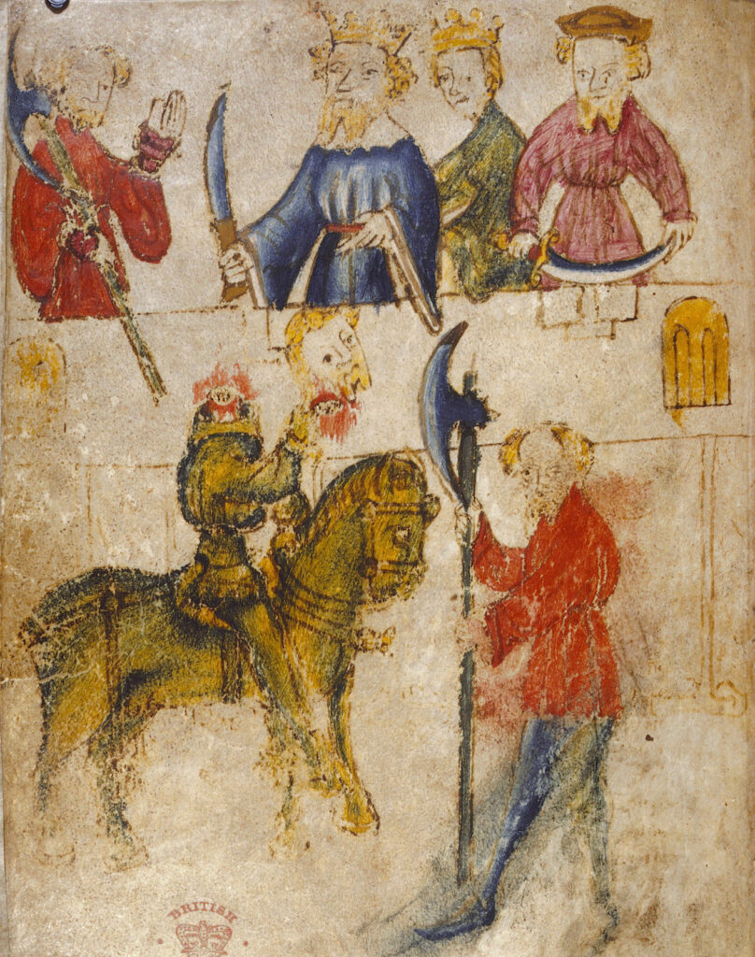
At the end, there was silence. I knew that this was not the time to inform them of the exciting academic debate about the different ways the end of Sir Gawain could be interpreted. But I felt that I had to be the one to speak. Did they enjoy it? Yes. But did they understand? Oh yes. Students can be so reassuring sometimes.
Students tell a story of their own
Then Mario was suddenly back again with our little group, looking different, sitting on the floor this time, looking up at us as we spoke down to him. I couldn’t remember any teacher I had ever had sitting on the floor and looking up at me like that. He suggested that, in return for my story, the students may want to tell me a story. This echoed with the possibility he had mentioned when we met in the corridor. They apparently knew several and it was only a question of choosing.
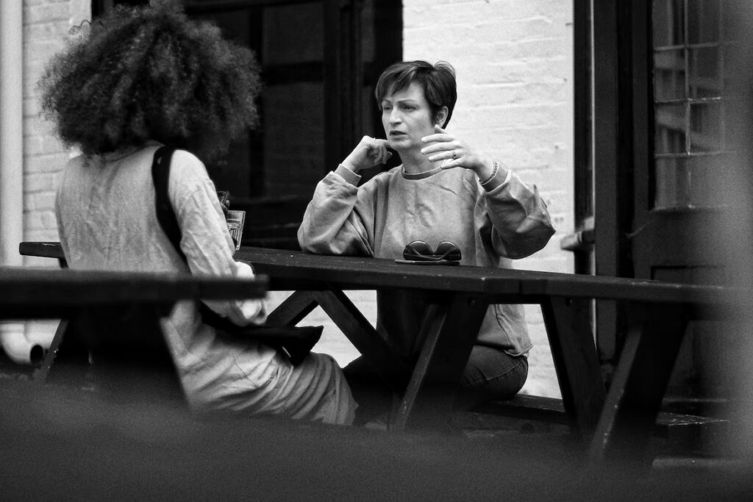
I have no memory of the stories they told, but retain a strong impression of the care with which they told them, and the effect their English had upon me: their odd, individual versions of English mixed in with (m)other tongues reminded me of my own situation as a non-native speaker of French living in France.
And what did my English sound like back then? After all, I wasn’t speaking it every day. Was this the world I was about to enter? Somehow, it was all fitting into place.
Written dialogue as another form of narrative
The last part of the class was taken up with a writing exercise. Mario sat us all round in a circle, students and observers as equals, and told us we were going to write together. He gave us each a blank sheet of paper. He set the scene. We were to imagine ourselves as parents. It was 3 o’clock in the morning. If the teenage son or daughter we had been waiting up for suddenly came through the door, what would we say? We wrote that down and passed our sheet to the person on our left.
We each looked at the page which we’d received from our neighbour. Now, Mario said, we were to put ourselves in the role of the teenager and write our response to what our parent had said. We then passed this back to the person on our right.
And the dialogues shuttled back and forth, right and left. We were ‘parent’ to one and ‘child’ to the other. We weren’t allowed to speak to our partner other than in writing.

This struck me as ingenious in terms of its connection to real-life relationships, and in terms of the potential for development, rather like a sort of written theatre. But Mario wanted more. As we worked, he came round and looked over our shoulders. I noticed students asking him for help occasionally, but otherwise they were pretty much going ahead on their own.
At one point, he told me, so that nobody else could hear, that I wasn’t reading carefully what the other person had written. What did he mean? I was responding to dialogue which was not English. He pointed to a sentence and asked me if I would say something like that. No, but I could understand it. But would I say it? Hmm. Well then, I could change it so that it looked like something I could say. He meant that I was to change what the other person had written? Yes, he said in a dead-pan sort of way, teachers do that, it’s called correction. And that is what I started to do.
By writing my words next to what my partner wrote, I told myself, we were in another sort of communication. It was a mode in which I was showing them that I had understood what they meant, but that English speakers said it another way. There wasn’t enough space on the page to correct some things, so sometimes I simply incorporated what my partner missaid into the next part of the dialogue, correcting it in my reformulation, as you would in ordinary conversation to be kept going.
At the end of the exercise, we pinned up our dialogues on the wall and went round reading them. They were awkward, funny, sad, and even violent sometimes, but they seemed real. One of my partners thanked me quietly for correcting certain mistakes which we observed together uncorrected in other dialogues.
At this point, Mario said that, sadly, it was time for the visitors to go. We said our thankyous and goodbyes and we left.
A seminal moment
It is an understatement to say that this was an important moment in the process of learning to teach. It was seminal. It revealed not only that we all had own individual sources of story within us, but also that there was genuine empowerment to be found for listeners and speakers through storytelling. It presented writing as a communicative, cumulative activity, where writers and readers exercised cooperatively and creatively. It also pointed out that the teacher should never be so caught up in the enjoyment of an exercise as to let attention completely switch off to the need for clarity and correctness when using the target language.
Yes, in an hour and a bit of active participation in my first EFL class, Mario had handed me a teacher training manual which I have been working from ever since. And storytelling has been a consistent part of that.
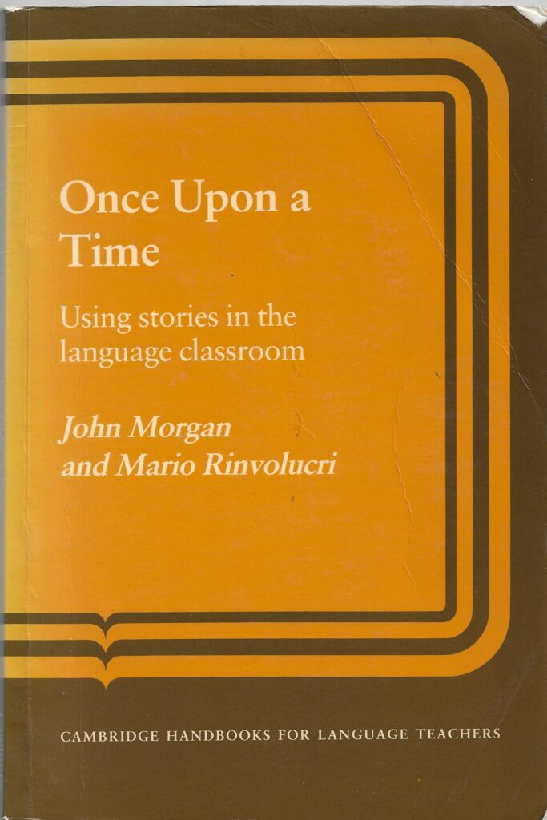
Once Upon a Time
By September 1981, John Morgan and Mario Rinvolucri had already been exploring ways of incorporating storytelling into language teaching for quite a while. Their pilot version of activities would initially appear as a Pilgrims Publication for sale at Pilgrims events in the UK and around the world entitled Once Upon A Time. Cambridge University Press would publish an expanded version of Once Upon A Time in 1983. It is still available to order online.

