Mario, the Teacher Trainer

Mario Rinvolucri, Pilgrims Trainer,
reconstructed from notes by Hania Kryszewska, HLT Editor

Background
When Mario started to clear his office in 2018/2019, the bulk went to Bratislava, but he also kept sending me bits of texts, notes, activities or letters to be used in HLT if I saw fit. Some of them have been published already, this one was waiting for a special occasion. Sadly, I feel this is the day to make public whatever was still left. These are notes from a training session, Mario invited me to conduct a session with his group at Pilgrims, a sequence of training activities which I will try to reconstuct.
Stage 1
He invited me to his class. I delivered a 90-minute training session with a variety of activities and interaction patterns. I had a totally free hand, and Mario was happy not to be involved in the planning. In fact, I think he wanted to be taken by surprise himself and have no knowledge of my plan and intentions. He did not encourage any note taking during the session and wanted everyone just to participate.

Stage 2
After the session, the next day, the participants discussed the session, reconstructed the activities, evaluated it. They followed the questions below.

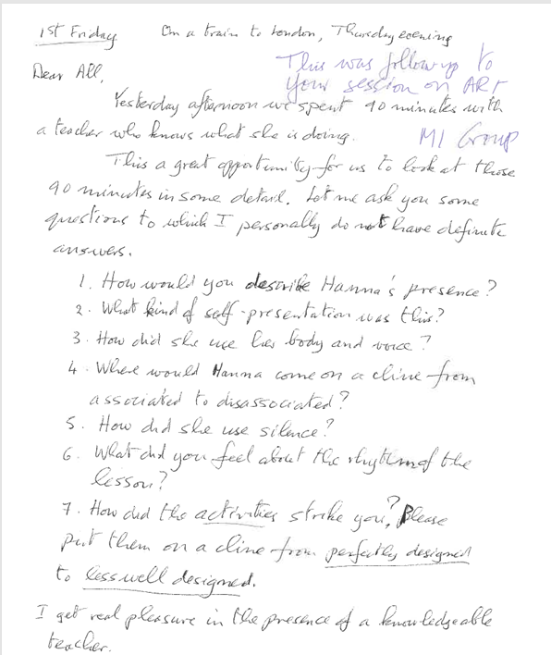

Stage 3
Mario took notes during stage 2 and then presented the tidied-up summary to the group for approval. More discussion followed.

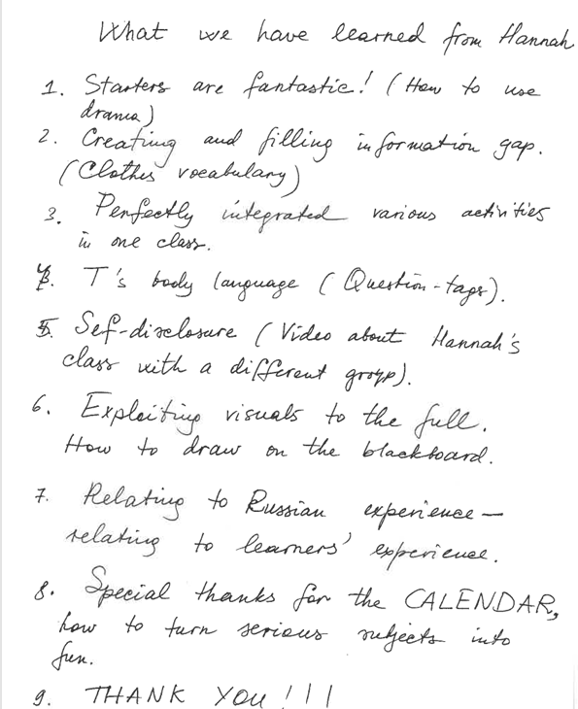

Stage 4
Then he or they together (I am not sure) re-presented the session and comments in mind map form. They made references to key aspects of teacher training. So Generalised followed the earlier reconstruction.
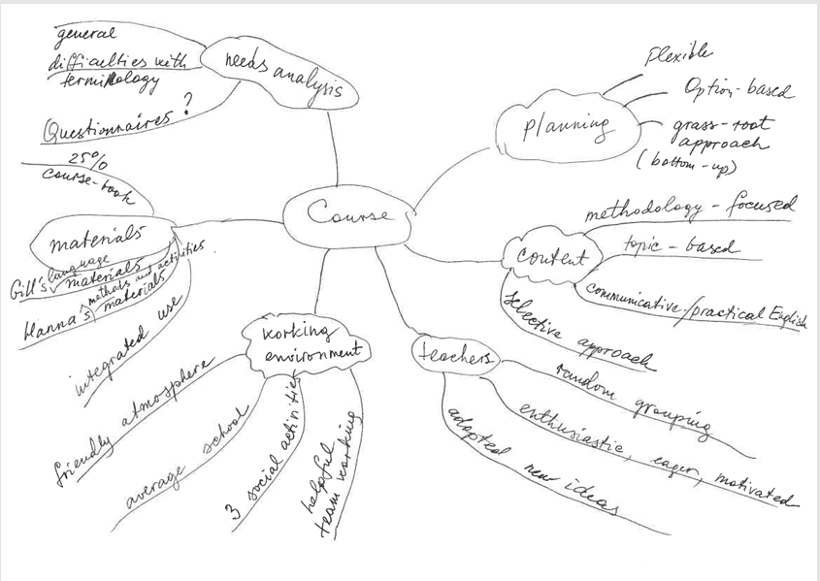

Stage 5
I was invited for a short final informal chat to answer any queries. It ended up being a long one, as everyone had so much to say and to share.

Conclusion
These notes and this reconstruction show what a careful planner Mario was, how he made the trainers notice, observe, comment, conclude and discuss. In other words, how he triggered a process, and how stimulation it was. At the same time, he was a giver, generous giver who shared his ideas for teacher training. The teachers observed a perfect example of the loop input format and learned techniques they could use in their own training sessions. Finally, same time, he was happy to step back or step aside and watch the process he initiated.
Mario’s teacher training style reminds me a bit of how he cooked. Varied menu, something for everyone, focus on details and the best ingredients, rich, almost too filling, generous, welcoming and creating an unforgettable atmosphere.



