More Green, Less Screen!

Lucy Crichton, Brazil

Lucy Crichton is an ELT educator, young learner specialist, and materials writer based in Brazil. She writes for the primary and pre-primary classrooms, focusing on the whole child, meaningful contexts, diversity, and inclusion. She has given lectures all over Latin America, Europe, and Asia. She runs her school, The Secret Garden, which attends children and teenagers. She calls this place her language laboratory and her teaching philosophy comes from her deep love and respect for children. Email: secretgarden.lucy@gmail.com



Green areas in schools

If there’s one thing I’d like to do in my lifetime, it would be to help improve the green areas we see in schools. Don’t get me wrong, I’ve seen some beautiful examples, but sometimes they are off-limits to the students, too small or just pretty landscape gardening to make the building look nice. With such diversity between regions especially in Brazil, I’m aware that often, for financial or geographical reasons, the possibilities are limited. However, playground areas that are rigidly focused on safety and cleanliness alone do not serve our young people or provide them with an essential connection to life and learning!

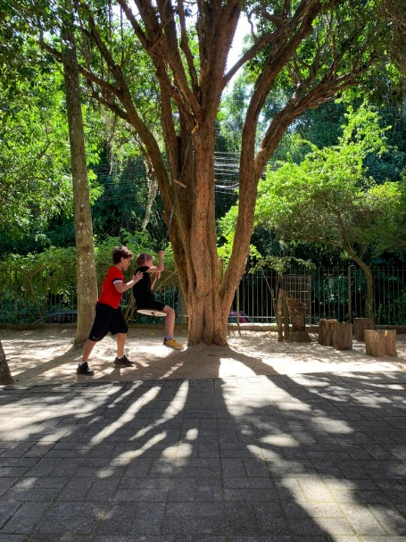
Photo 1: Two boys playing on a tree swing

Never-ending school day

Admittedly modern life has taken nature play away from childhood in general for several reasons including sprawling urbanization, limited access to parks and green areas, and parental fears. Still, worst of all I think, is the never-ending school day and lack of free time to just ‘be’. One thing is clear, access to green spaces is one of the best tools to replace sedentary screen time with active play, improving physical and mental health.

Having worked for over 20 years in an English school with nature at the doorstep, I have seen innumerable benefits for faculty members and students and have strived to share these practices in every plenary, workshop or talk I’ve delivered. So, here I am again to try and convince you to start advocating for more green in your schools! Let me draw out the reason for the title of this article first.
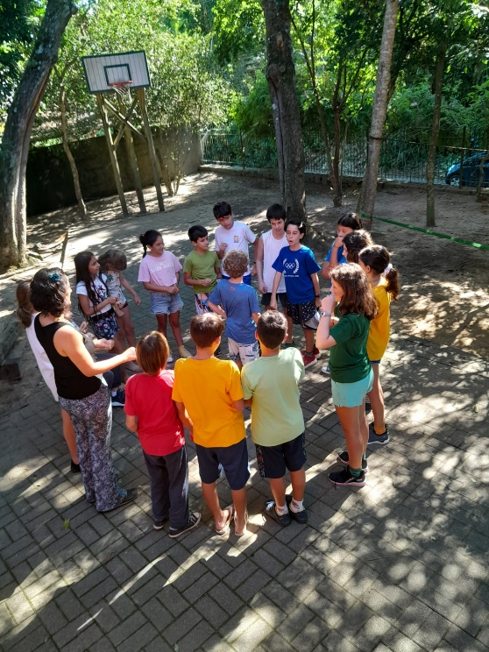
Photo 2: Circle time in the garden
Screen time research

We now have access to a huge body of research that tells us to draw back on screen use and the devastating long-term damage that we see in so many young people, but are we taking heed? The World Health Organisation recommends no screen time for children under two, 1 hour a day for children up to 12, and 2 hours a day for teenagers and adults! Is this possible or even attainable in our modern frenetic lives? Understandably, parents often use screens to keep children entertained or distracted while carrying out other needs but it’s time to review the seeds we are planting! Healthy children need to be active, not static!

Patricia Kuhl, a leading brain scientist says, “What we’ve discovered is that babies, under a year old, do not learn from a machine. Even if you show them captivating videos, the difference in learning is extraordinary. You get genius learning from a live human being, and you get zero learning from a machine.”

So firstly, we need to encourage a sense of awe and wonderment for the natural world in every child so that they feel and understand that it is a part of who they are and what they are made of. From an early age we must allow them to crawl on grass encourage them to make mud pies, climb trees, and watch ants carrying leaves bigger than their bodies! We need to draw their attention to what makes our world beautiful and unique, don’t you think?
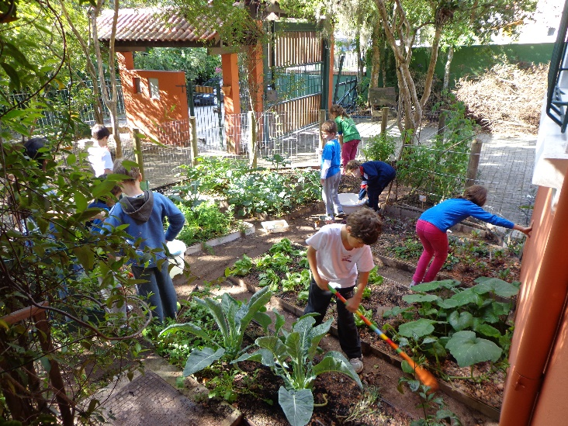
Photo 3: Children planting in the kitchen garden
Introducing plants and watching something grow

Here in Brazil, we are lucky to live in a climate where plants grow rapidly. All young people can gain so much from planting seeds and watching them grow. I have observed many students of varying ages get excited and feel empowered when their bean sprouts and starts to grow leaves. I have seen students who were fussy eaters decide to taste something they have cultivated themselves, wide-eyed teenagers learning new and strange vocabulary and the joy of young scientists as they measure and classify! There is something deeply human about all these activities. After all, we are just like nature, always growing and changing, always adapting to the seasons.

I believe that we can start with some simple initiatives that work in any classroom, gently encouraging this connection while facilitating language learning. Here are two simple examples that you might like to try.
Idea 1: Planting Beans

- Hand out 3 to 5 beans to each student. Have them observe the beans and tell you about their shape and colour. Ask them to say how they think they grow, and where the roots and leaves might start coming from.
- Show them how to fill up a pot with soil and plant 3 beans 2cm under the surface. Use a spray bottle to gently water the pot.
- Place the pots on a windowsill or sunny area in the classroom. Water them regularly and within a week, you should start to see the first sprouts appear.

You can also use vegetable cuttings such as onions, garlic, carrots or celery planted in soil and watch them sprout back to life! These activities are all possible in a school without a garden but if you do have a green space that children can use, so much the better.
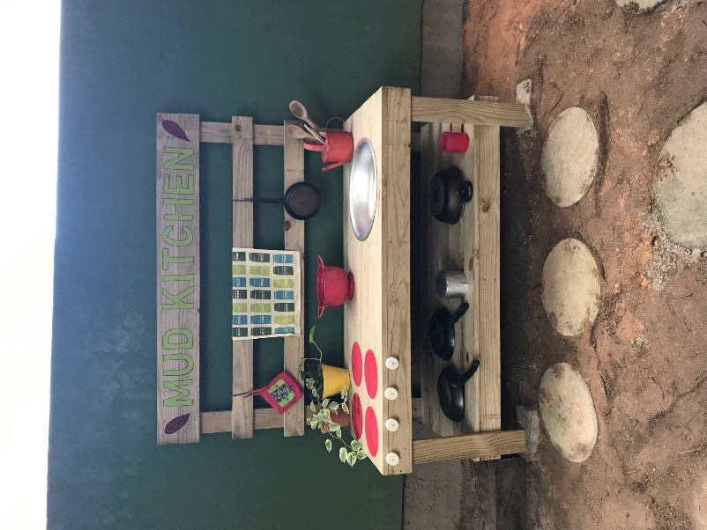
Photo 4: The Mud Kitchen

Idea 2: Building a Mud kitchen

In 2022, post-pandemic, I decided to make and install a Mud Kitchen in my school playground. After all the months children had spent at home, I wanted to provide a space for reconnecting to nature and the outdoors.

- Using plywood, create a simple structure with a small work surface where children can ‘cook’. This structure could be as simple as a wooden plank on bricks.
- Gather mud, leaves, dry flowers, grass, pinecones and fruits, practically anything from the ground can be useful.
- Add a metal basin for water and some watering cans.
- Source old pots and pans and wooden spoons, (no plastics), which will give it a real authentic look and feel.
- Observe the way the students play with the materials. Document the language they use to interact with each other, ex. “Is the pie ready? Mmm, it smells so good!”
- Create some intentional materials such as mini-recipe cards that students can read and follow. As they play, ask them what they are cooking and encourage descriptions in English.
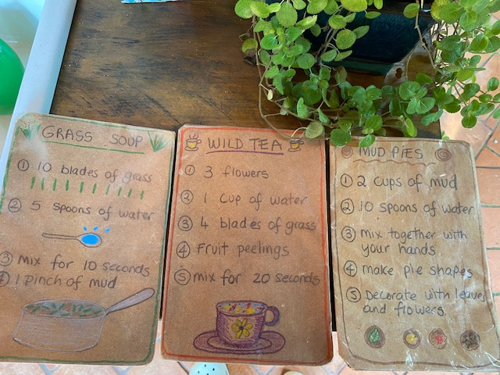
Photo 5: Mud Kitchen recipes

In this fragile world where depression and anxiety are so prevalent, we urgently need to provide more spaces to help and support mental health and well-being for our students, and nature, green areas and outdoor play might just be the answer!

References

Kuhl, P. K. (2014) Early Language Learning and the Social Brain. Cold Spring Harb Symp Quant Bio 79: 211-220.

Hadders-Algra, M. Jornal de Pediatria, 2020 - SciELO Brasil Interactive Media Use and Early Childhood Development

McCormick, R. (2017) Does Access to Green Space Impact the Mental Well-being of Children: A Systematic Review. Journal of Pediatric Nursing, - Elsevier

World Health Organisation New WHO guidelines on physical activity, sedentary behaviour and sleep for children under 5 years of age.

Please check the Pilgrims in Segovia Teacher Training courses 2025 at Pilgrims website.

Please check the Pilgrims f2f courses at Pilgrims website.

