Sky and Water: creativity and artful visuals with very young learners
Chrysa Papalazarou, Greece
Chrysa is currently involved in the administrative side of education, but before that she has taught English to students of all ages for more than twenty years alongside writing, presenting and publishing about her endeavours to use art and foster the development of creative thinking in the ELT classroom. She is interested in how the interweaving of the aesthetic and social awareness component of artworks can introduce wider world issues to students, promote values, and contribute to a more thoughtful and creative flow in English language teaching and learning. Chrysa has created Art Least, a site on art, thinking and creativity in ELT. Chrysa is a member of the C Group and the Visual Arts Circle. She is also a member of “Worlds into Words”, an international creative writing group. E-mail: hryspap@yahoo.gr
Introduction
This article is a description and reflection on a series of teaching sessions with a group of 8-year-old 3rd graders. The lessons aimed at creatively fusing alphabet and word learning with art and a visual literacy component.
Background
In the Greek state school, in the first two years of primary school, students are attending a curriculum of pre-literacy which introduces them to the oral mode of foreign language and tries to develop their social literacies. Thus, it is the 3rd grade when the formal ELT programme starts. It is formal in the sense that it aims at the development of students’ language proficiency.
It all started when we encountered letter F. In the coursebook, letters are presented as initials of particular words (e.g. F for fish and fishbowl) and there are rhymes that contain repetitions of the particular letter/sound relation in a meaningful or funny context. The rhymes aim to promote consolidation and enrichment of vocabulary. There is also visual input designed for each rhyme to facilitate comprehension and memorisation. In the coursebook, letter F is dealt as follows:
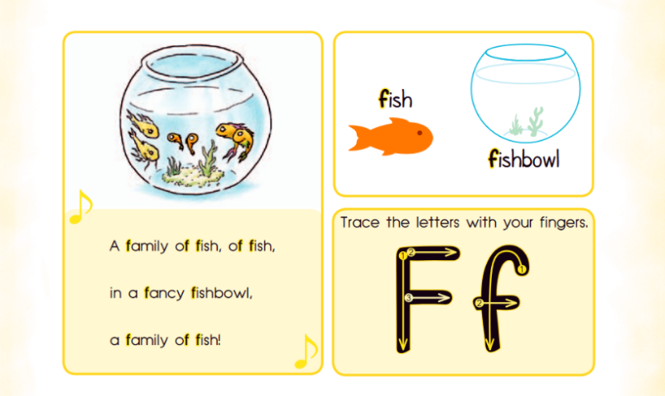
Figure A: coursebook excerpt
It was at that point when one of the students pointed enthusiastically to the classroom door saying: ‘A family of fish, like that!’. He had noticed an artwork on the classroom door. Then, another student noticed the birds while a third one thought the changing pattern in the fish, as we moved downwards, was a sign of their aging. These interesting reactions were the springboard of the teaching sessions that followed.
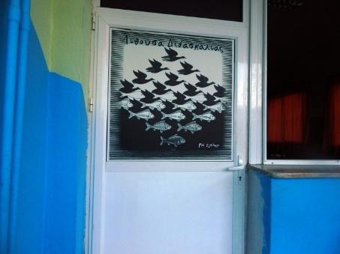
Figure B: The artwork on the classroom door
Sky and water I: Language, visual input, rhyme, rhythm and whole body expression
The artwork on the classroom door was Sky and Water I, a woodcut print, by the Dutch artist M.C. Escher, first printed in 1938. Birds and fish fit into each other like the pieces of a jigsaw puzzle. Each element is alternately foreground or background, depending on whether the eye concentrates on light or dark elements.
I first projected the artwork on the classroom board.
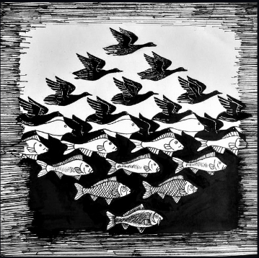
Figure C: Sky and Water I, M.C.Escher 1938
I pointed at the different elements in the artwork and elicited the words ‘fish’ and ‘birds’. I wrote these on the board. We then added before each word ‘a family of’. Next, after each phrase (a family of fish/birds) was heard in the classroom, I asked ‘Where?’ and we came up with the words ‘water’ and ‘sky’. I wrote these on the board as well as ‘in the’. We repeated this quite a few times alternating among whole class response, individual response, and whole class response again.
I reminded students of the little rhyme we had encountered in the coursebook. I prompted them to adjust it to the artwork. Our new rhyme went like this:
A family of fish, of fish
in the water.
A family of birds, of birds
in the sky.
We added some rhythmic clapping. By now they were all very excited.
I then showed them a lovely short animation of the artwork (see references for link). I divided the class into two groups: fish and birds. I turned off the sound of the video. When each element appeared on the screen, the relevant group chanted their part (‘A family of fish, of fish in the water’ or ‘A family of birds, of birds in the sky’). The students enjoyed themselves enormously. I then asked them to chant it in a whispering mode. I also encouraged them to gesture accordingly, i.e. fish group pretended they were swimming, bird group pretended they were flying. Water was mimed by placing hands under our desks, sky by lifting them up. I gestured with them along the way. At the end of the animation, we said ‘Goodbye birds, fly! Goodbye fish, swim!’ Students improvised gestures for ‘fly’ and ‘swim’. We had a great time. Students asked if they could watch the animation for a second time and repeat the activity. I turned on the sound of the video and we repeated the activity. Enthusiasm led us to a third time, too.
Tessellations, word clouds and logos with a hidden message: careful viewing, observing, analysing
I then projected the artwork again and asked students to carefully observe its details. They noticed that there was no space between the fish and bird shapes. Escher’s work consists of geometric shapes that fill the space with congruent forms in rhythmic repetition without leaving any void. These formations are called tessellations. Escher liked to play with positive and negative shapes. In Sky and Water I the birds at the top appear as positive space (a main subject), yet its shape is echoed in the dark negative shapes between the fish. Likewise, the positive shape of the fish at the bottom has its shape repeated in the white spaces between the birds. I invited a couple of students to the board and had them trace with their fingers the fish or bird shape hiding in the negative spaces.
I also showed them some letter tessellations. They identified the letters, we talked about the colours, how the letters appeared face downwards and face upwards covering all the surface.
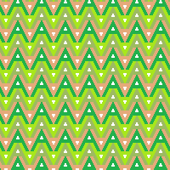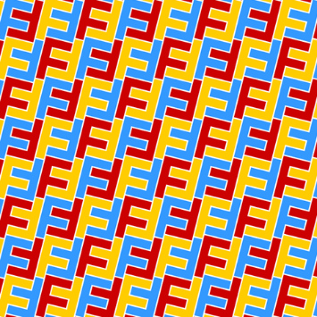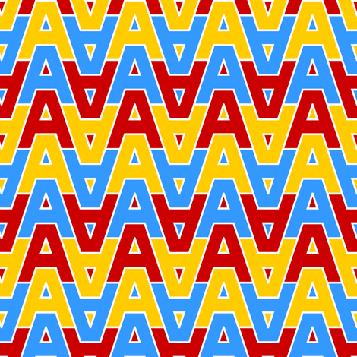
Figure D: Letter tessellations
We then had a look at two word clouds formed by the words and phrases in the rhyme we had previously created in class. The first dealt with the fish part and the second with the bird part. I invited individual students to the board to trace the words in the word clouds using their fingers or a marker. In every word cloud we repeated the relevant part of our rhyme.
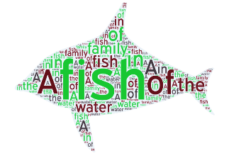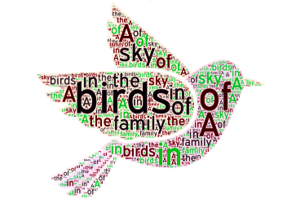
Figure E: Word clouds
Our next activity was an introduction to logos with a hidden message.
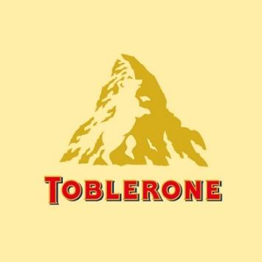
Figure F: Toblerone logo
In the Toblerone logo some students saw a fish and a bird. I initially thought they were influenced by the previous activity so I invited these students to the board to trace the shape they had seen. Then, the first student traced the left hind leg of the bear and it did look like a fish swimming upwards while the second student traced the little shape next to it on the right which again did look like a bird flying. I prompted them to look again carefully in case they could see something else. It was then that some of the students saw the bear hiding in Toblerone’s logo. I told them the story behind this logo.
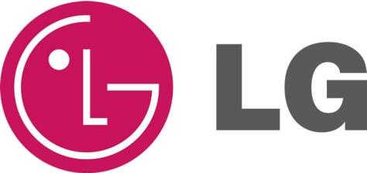
Figure G: LG logo
Most of the students ‘saw’ the face hiding in LG’s logo. One of them said ‘it’s Pacman’ while another said ‘Life is good’. Many students said they had LG products at home. Another student wanted to draw the full face so I invited him to the board. He added the other eye and two little dots under L to indicate the nostrils.

Figure H: Hope for African Children Initiative logo
Almost all the students saw the child looking up to an adult hiding behind the ‘Hope for African Children Initiative’ logo. I was initially taken by surprise since, when I had first looked at it, I had focused on the map of Africa. But then I thought that my young learners were not familiar with world maps so they immediately focused on the shapes of the people. Some students recognised the word Africa(n) in the logo and one said children are hungry and suffer there. We talked a bit about the need to protect children in that place and the message of the logo.
Students were also given a worksheet to complete.
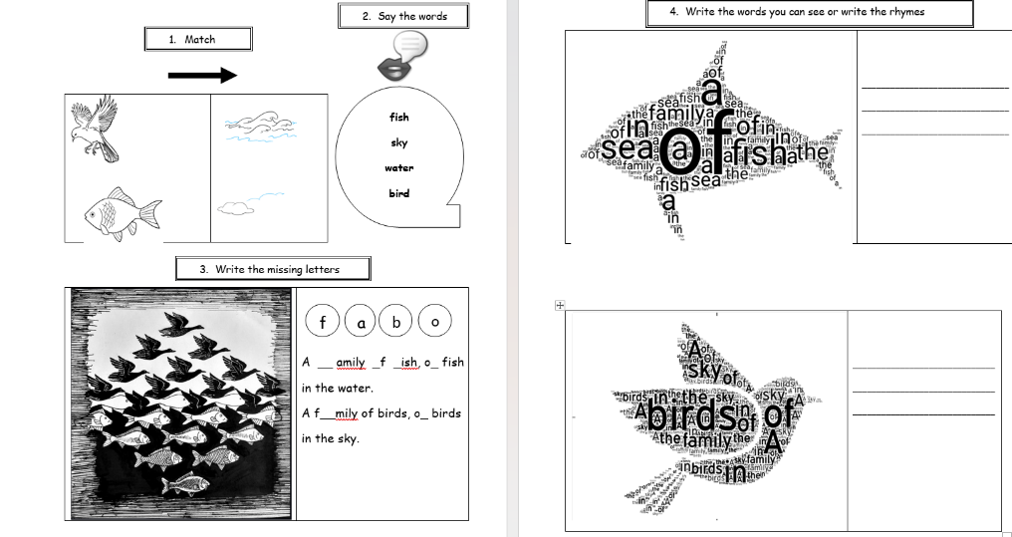
Figure I: Worksheet
My hidden message or image: visual thinking & visual representing
I asked students to work in groups and create an image with a hidden message, or form a word cloud using words we had already encountered. Then, to present their images to their classmates, describe and explain what it was and why they had made it and ask them to guess the hidden image or message.
Groups described and explained what they had created. L1 (Greek) was used by the students for the descriptions. L2 (English) was used for single items in their images that the students knew the English word for. For every image, I offered and asked them to repeat new key words while we revisited words we already knew.
Here is what groups came up with:
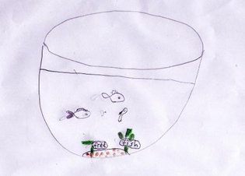  Free fish | The group who had made this wanted to convey the message that fish should not be kept in fishbowls. They had asked me for the word ‘free’ as they were working on their image. (new keyword: free – known words: fish, fishbowl)
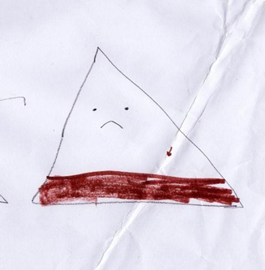  Sad mountain | This is a sad mountain, students said. It’s sad because the water at its feet is dirty. Their answer to why this is so was that people throw rubbish in it. (new key words: mountain, sad, brown, rubbish – known word: water)
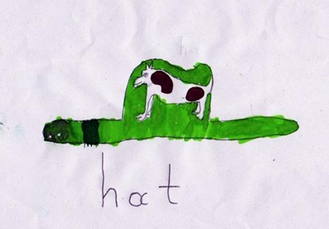  A snake-cow hat | This is a hat, but if you look carefully, it’s also a snake that has swallowed a cow, students said. They had asked for the word hat while working. (new key words: snake, cow, hat, green)
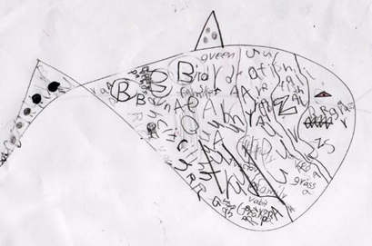  The shark who has eaten too much | This is a shark who has eaten fish, grass, birds, rabbits, grandpa, a family. A very big shark with many things in his belly, students explained. (new key words: shark, grandpa, rabbit, grass – known words: bird, fish, family)
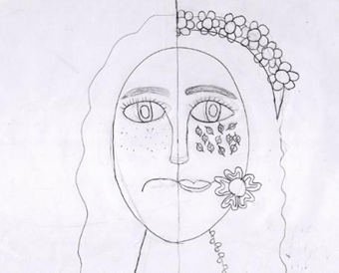  Mrs Nature | Mrs Nature is happy when there are flowers and trees and sad when there is nothing. Students said that people make Mrs Nature sad when they destroy trees and flowers. (new key words: happy, flowers, trees)
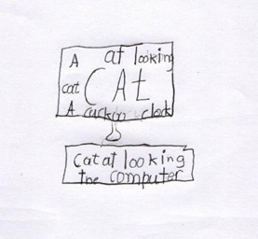  A word cloud for letter C | Students in this group created their own impression of a word cloud based on one of the previous letters we had learned (C) and drawing inspiration from a relevant short rhyme about a cat on a computer in their books. (known words: cat, clock, cuckoo, computer)
Figure J: Students’ work
The fabric of this learning experience
There was a series of elements brought together so as to create a learning experience for these very young learners that combined language, art, visual literacy and catered for an overall multimodal experience for them. These elements were:
In terms of language:
- aiming at early word identification and recognition
- practising chanting a short rhyme related to the artwork
- recognising, in word clouds and tessellations, previously taught words and letters
- completing a worksheet with relevant activities
- recycling previously taught vocabulary
- practising repeating single words spoken slowly and clearly
- encouraging oral vocabulary acquisition through students’ work
In terms of visual literacy:
- encouraging visual literacy micro-skills of careful viewing, observing, analysing (artwork, animated version of the artwork, word clouds, letter tessellations, logos)
- practising uncovering the hidden message in the logos
- encouraging students’ visual literacy micro-skills of visual thinking and visual representing through selecting and creating their own images to convey meaning
In terms of art, creativity and fostering an overall multimodal experience:
- encouraging body gesture to facilitate comprehension and memorisation
- utilising an array of modes (linguistic, visual, auditory, gestural)
- encouraging students’ creative expression through drawing their own hidden messages/images
Language input, activity design, appropriacy and variation all had to be viewed taking into consideration a group of very young learners. Children showed enthusiasm and engagement upon their exposure to a variety of resources (artwork, animated video, letter tessellations, word clouds, logos, written text) and activities. This echoes relevant literature that variation is a sine qua non when working with very young learners. It was also fascinating to observe how 8-year-olds hone their viewing, analyzing and decoding skills as the visual, the verbal, and the gestural interweave and how all these are in a direct conversation with memorisation and comprehension.
Through this experience I noticed the great degree of readiness that very young learners of this age have to embark on creative processes. As their visual thinking and visual representation were put into force, they further built an understanding of the meaning behind their images through perception and imagination. They learnt from words and pictures through building mental representations from both modes. It was interesting that in half of the groups a social awareness thread could be identified (free fish, sad mountain, Mrs Nature) and how they chose to relate their images to the social environment. It was also nice to see humour in their work (the shark who has eaten too much).
This series of lessons was a step beyond my comfort zone, a departure from relevant work with older primary school students. I feel happy to have tried it and to share my insight because it was a new learning experience for me, as well.
References
Avgerinou, M.D. (2002) A Review of the Concept of Visual Literacy. British Journal of Educational Technology, 28(4):280-291.
Dendrinos, B. (ed) (2013) The ‘PEAP’ Programme: English for Young Learners in the Greek Primary School”
Resources
Escher, Sky and Water I
13 famous logos with hidden messages
M.C. Escher: Sky and Water 1 – Animation

