101 EFL Activities for Teaching University Students by Hall Houston

reviewed by James Taylor, US

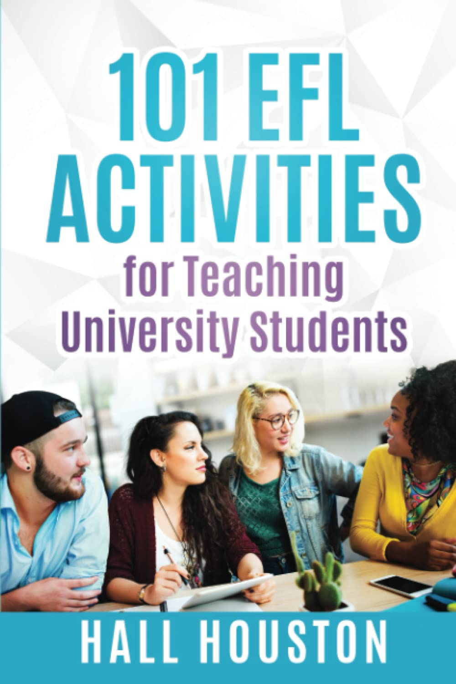

101 EFL Activities for Teaching University Students, published by iTDi TESOL, is a practical collection of classroom ready activities for teachers specialising in, but not limited to, academic students. The author, Hall Houston, states that his main themes are context, group dynamics, and active learning, and it’s possible to see how these three pillars influence the motivating activities that he presents throughout the book.

The book is divided into three sections. Chapter one concentrates on the beginning of courses, including activities for learning names and learning about classmates. The second chapter focuses on the body of the course and includes listening, reading, video and music activities, as well as review and feedback. The final chapter deals with the conclusion of the course. Here the activities are centred around review, reflection and the future.

Although the primary audience for the book is teachers of English for Academic Purposes, many of the activities could be used by other teachers, especially at high school and private language schools. For example, in the activity Expanding the Transcript, students are invited to take a dialogue from a previous lesson and create the dialogue for what happened just before and just after what they had previously seen.

This flexibility is one of the strengths of the book, and the majority of the activities are easily adaptable for a variety of teaching contexts. I also appreciated the context setting that the author does for each chapter. It is good to see how the activities are presented with a clear presentation of the rationale behind them, which in turn makes it easier for the teacher to use them. I also appreciated the Teacher Development Tips at the end of each chapter which allow us to develop professionally with suggested reflection tasks and links to videos and resources.

101 EFL Activities for Teaching University Students is a very well-organised and curated collection of teaching activities that, despite its title, should appeal to a wide variety of ELT professionals. If you are looking for an accessible, go-to guide the next time you are stuck for something to do in class, this is the book for you. It is available for a very reasonable price at itdi.pro/community/publishing/101-efl-activities-for-teaching-university-students/

Please check the Pilgrims f2f courses at Pilgrims website.

Please check the Pilgrims online courses at Pilgrims website.

