Anniversary Humour: Turning 25

found of the net

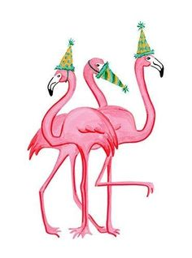

Made in 1999 Aged to perfection!

Our stats

1 magazine
2 editors
25 years
152 issues
300 months
1304 weeks
9132 days
219 168 hours
13 150 080 minutes
789 004 800 seconds

Silver birthdays are when either a man or woman turns 25 years old. Silver can be used to decorate or theme the birthday celebrations of a 25-year-old. Over the years, each year's anniversary is connected to some sort of object or theme, but silver for 25 is one of the oldest traditions.

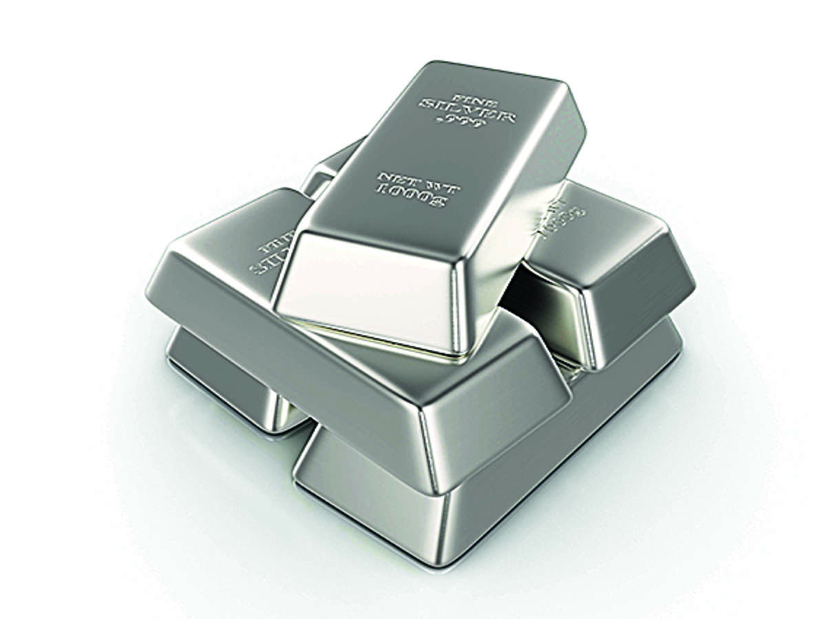

Turning 25 and feeling alive!
25 years of awesomeness!
Cheers to a quarter-century of life! Turning 25, but still feeling like a kid at heart.

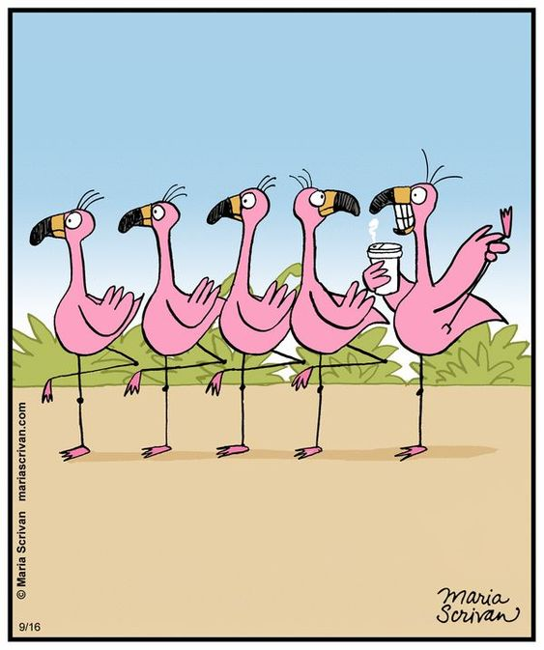
I represent the last 5 years…

