If I Must Die by Refaat Alareer in Many Voices and Languages - An Invitation

Haneen Jadallah, Palestine/ UK, and David Heathfield UK

Haneen Jadallah is an English language teacher, a teacher trainer, and a remote theatre specialist. She has an MA degree in Drama and English Language Teaching at the University of Warwick, UK. She is also a Sahin Family Award winner for exceptional progress at Warwick university. She has a special interest and expertise in drama and language learning and intercultural remote theatre. She has developed her own framework for students to create their own plays and to perform them remotely to the outer world. She is passionate about connecting young people in Palestine with their peers around the world through intercultural link-ups and online theatre.

David Heathfield is a world storyteller, teacher trainer and writer from Exeter, UK. He has authored Storytelling With Our Students and Spontaneous Speaking (both DELTA) and numerous articles and book chapters. He provides Creative and Engaging Storytelling for Teachers (CrEST) courses for worldwide participants on Zoom. He and his wife Tammy Heathfield are also Heathfield Creative English Coaching.
www.davidheathfield.co.uk and www.heathfieldcoaching.co.uk

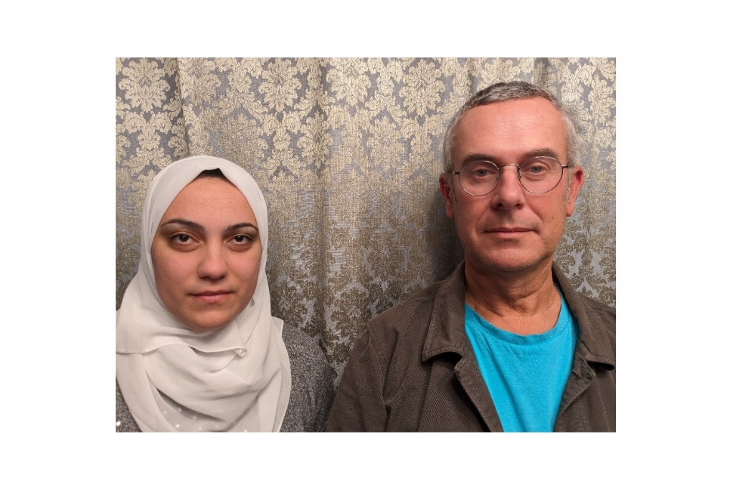

Background

To honour Refaat Alareer, the beloved Palestinian poet, teacher and storyteller who was killed together with family members on 6th December 2023 in an Israeli airstrike, we are inviting you all around the world to record and share the extraordinary poem he posted on 1 November 2023 ‘If I Must Die’ in many voices and languages.

Haneen Jadallah says “Doctor Refaat was one of the professors who taught me in my undergraduate degree, and he was the one who inspired me to start thinking about the power of storytelling and the power of literature to share with the world. He was demanding on us, to kind of push us to share what? To share our stories and what we think with the world. To get us to believe in ourselves that we could start writing and we could start holding the pen and sharing our stories.”

You can learn more about Refaat Alareer online, for example here.

We send our heartfelt condolences to Refaat Alareer’s wife, children and remaining family who survive him and our best wishes to Palestinian people everywhere.

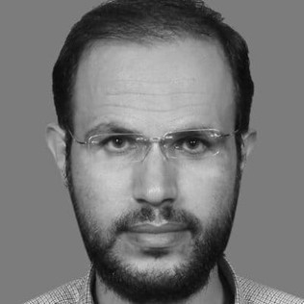

If I Must Die - Dr Refaat Alareer

If I must die,
you must live
to tell my story
to sell my things
to buy a piece of cloth
and some strings,
(make it white with a long tail)
so that a child, somewhere in Gaza
while looking heaven in the eye
awaiting his dad who left in a blaze –
and bid no one farewell
not even to his flesh
not even to himself –
sees the kite, my kite you made, flying up
above
and thinks for a moment an angel is there
bringing back love
If I must die
let it bring hope
let it be a tale.

Lesson ideas

You might translate the poem yourself or you can find translations of the poem into many languages online. Of course, you might choose to share the poem in English, the language in which he wrote this beautiful and prescient poem.

You can invite children and grown-ups you know to join in so that we have plenty of voices and languages. When you upload it to YouTube, use 'not Made for Kids', 'Public' or 'Unlisted' settings and make it a 'Watch' video (not 'shorts').

The playlist

When you share your video with me davidheathfield@hotmail.co.uk, I can add it to the playlist.

We do appreciate all of you who have already contributed to this playlist which is a growing testament to the power of the spoken word in calling for change.

Sef Townsend - Yiddish
Despina Varda Avraamides - Greek
Despina Varda Avraamides - English
Letty Segura - Spanish
Georgia from Cyprus' 12-year-old daughter - English
Ruth Kirkpatrick - Scots
Mechthild Lier - German
Mwana Ummy Ally and Tina Mtui - English and Kiswahili
Rebeca Robles - English
Rebeca Robles - Spanish
Evi Karydi and daughter Neleia- English and Greek together
Fiona Collins - Welsh
Jackie Ross - Doric
Şüheda Şahin - Turkish
Tammy Heathfield - French
Zahra Afsah - Farsi
Zahra Afsah and Mehdi Farhadian - Farsi
Sara (9) - Italian
Torgrim Mellum Stene - Norwegian
Lightness Isojick - Iraqw
Lightness Isojick and her eleven-year-old daughter Rosemary - English and Iraqw
Farah Saeed - Urdu
Fahima Begum - Bengali
Zahid - Baluchi
Sejuti - Portuguese
Lisa Schneidau - English
Nicholas Pawlowski - English
Simona Stambazzi - Italian
Sowmya Srinivasan - Tamil
Shilpa Story Rack - Hindi
Poonam Joshy - Hindi
Rukhsana Haque - Assamese
Tracy Chipman - English
Anagha Prasad - Kannada
Sree Karuna - Telugu
Min Wild - Afrikaans
Mariela Mondaca - Spanish
Deepa Ahuja Ramani - Sindhi
Lavanya Prasad - dialect of Tamil (sung)
Neena Girish - Malayalam
Dayang Kasimeh - Bahasa Melayu
Dayang Kasimeh - English
Kenza Omayr - Arabic
Larisa Chernova – Ukrainian

May I invite more of you to share the poem in whichever languages you choose on YouTube and on other social media pages and groups? His Voice Shall Always Remain.

Note

David and Haneen are both members of the new Facebook group ELT Professionals for Palestine.
If you support Palestinians and would like to find out about joining: LinkedIn is https://www.linkedin.com/company/elt-professionals-for-palestine/about/?viewAsMember=true.
Instagram: @elt_for_palestine
Email: elt4palestine@gmail.com
Link to Haneen's fundraiser: Re-uniting with my Family and Rebuilding Lives https://www.gofundme.com/f/reuniting-with-my-family-and-rebuilding-life?fbclid

