

Host Leadership Gathering

7 Vincent van Gogh St, Sofia, Bulgaria

3-4 June, 2024

Whether you are a seasoned Host Leadership practitioner hoping to move forward or you have only just become aware of the benefits of this new look at leadership and want to know how to engage people in meaningful initiatives, you are welcome to participate and contribute.

Understanding Host leadership

At the core of Host Leadership is the exploration of the metaphor of host as leader, and leader as host. The idea is both practical and transformational. It is practical because the use of its framework of two steps, four positions, six roles helps build engagement and bring out people’s best work. And it is transformational because, by thinking about the leader as a host, we are ready to act in a world of awareness and flexibility.

What will happen at the gathering

The 2024 Gathering in Sofia is dedicated to producing benefits for all the participants and their teams / organisations. We want to continue building productive relationships among experienced Host Leadership practitioners, sharpen our thinking and generate practical ideas.

Day One is about exploring the vast territory of Host Leadership, spreading ideas, clues and possibilities. We look forward to short talks and workshops from people who use the host model in their daily and professional lives. We invite you to share your thoughts and practices.

Look forward to the keynote address of Dr Mark McKergow and a conversation with our guest speaker. If you wish, we can enjoy the first evening of the Gathering together. Dinner will take place somewhere nice and delicious. It is included in the price of the registration ticket.

Day Two is an Open Space day – participatory, inclusive and collaborative.

Be part of the Host Leadership gathering

We bring in our stories, questions, paradoxes, strategies, insights and set out on our joint Host Leadership journeys of discovery. Each and everyone of us has their unique experiences, valuable ideas, visions, and questions that can enrich us all. Let’s take a step towards hosting and guesting in the emerging world of the Gathering.

Learn more about host leading from Mark McKergow’s TEDxKazimierz talk.

We extend our hearty welcome to you!

Leah Davcheva
leah.davcheva@gmail.com

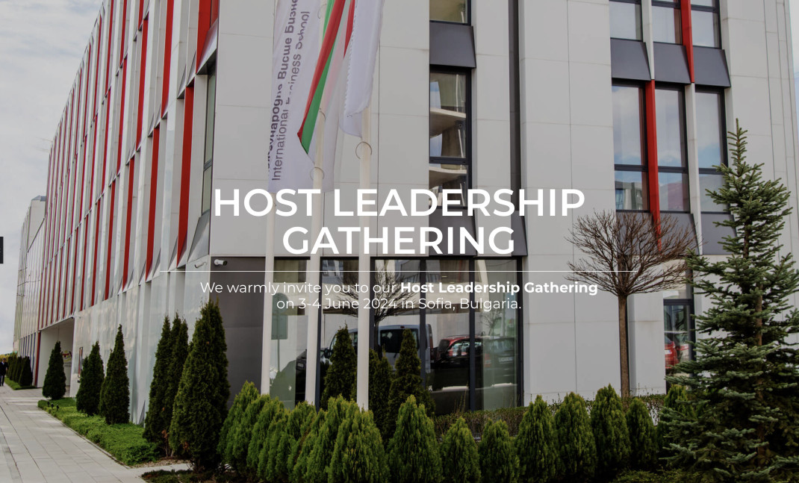

Register now.

More at: https://hostleadership.ahamoments.eu/

