Having AI as an Assistant in Oral Presentation Skills Practices

Duangjaichanok Pansa, Thailand

Duangjaichanok is a teacher teaching English at King Mongkut’s University of Technology Thonburi, Thailand. Her interest includes integrating technology in language learning and teaching, and language testing and assessment. Emil: duangjaichanok.pan@mail.kmutt.ac.th

Teaching English as a Foreign Language to students whose interests are related to hard skills and their own limited proficiency in using English well, such as engineering and science students, is really challenging, particularly when it comes to oral presentation skills. This article aims to share my teaching experiences by using AI as an assistant to aid students in going through the oral presentation skills course.

As you may know, as of the end of 2023, there are several applications or programs supported by AI (artificial intelligence) to facilitate our lives for different purposes, and so does education (see Best AI Tools and Services (topai.tools)). For those applications supporting learning and practicing English speaking skills, most are freemium - the user needs to purchase them to access better service or some features, and installation is needed.

Within these various applications, users have a chance to practice with prompts and activities provided. It hardly allows users to customize their practice contents. Using existing applications for practicing giving presentations might not be suitable for my intention; therefore, I need to apply other kinds of AI to facilitate my students’ practices and scaffold their learning processes. I need to figure out tools or AI to help facilitate my students in crafting the script for the presentations, providing feedback on speaking practice, and identifying mistakes. Importantly, the applications should be user-friendly and free of charge to allow all students to take advantage of this opportunity.

Crafting the script for the presentation

‘Google search’ was used as a primary search engine for decent information in Thai or English, depending on their preferences. After arranging ideas and information, ‘google translation’ was introduced to help translate the scripts from Thai to English. To ensure the accuracy of the whole script, I recommended that students have their scripts checked for language correctness using tools such as Grammarly, QuillBot, ChatGPT, and so on. The free-of-charge ones are recommended. At this point, some teachers might be worried about their job security—whether AI will replace them. Based on my experience, our students still need us! The teacher will still provide guidance to students to support them at any spots they require.

Practicing speaking skills

Ideally, all teachers in speaking class would love to provide immediate feedback on individual performance and help each student deal with mistakes, and so do I. However, with the time constraint and other related issues, it is really hard to arrange that session. Rather than that, providing explicit face-to-face feedback on students’ performance may lead to a loss of face and confidence in practicing speaking skills. With all these conditions, I came up with the use of technology and AI for assistance in the following practices:

To learn how to pronounce

A program, e.g., Google Translate, allowing students to upload their texts and generate voice to guide them to read the text aloud, was recommended. By clicking the ‘listen’ button, students will hear an example of how to read a long text or how to pronounce a single word. Moreover, each student can adjust the speed of the reader among three levels: normal, slow, and slower. Not only are they learning pronunciation from the program, but they can also read along with the machine as well. Also, each word can be chosen in order to gain more information, such as IPA transcription, definition, example, and related words, which open another learning door for the students.

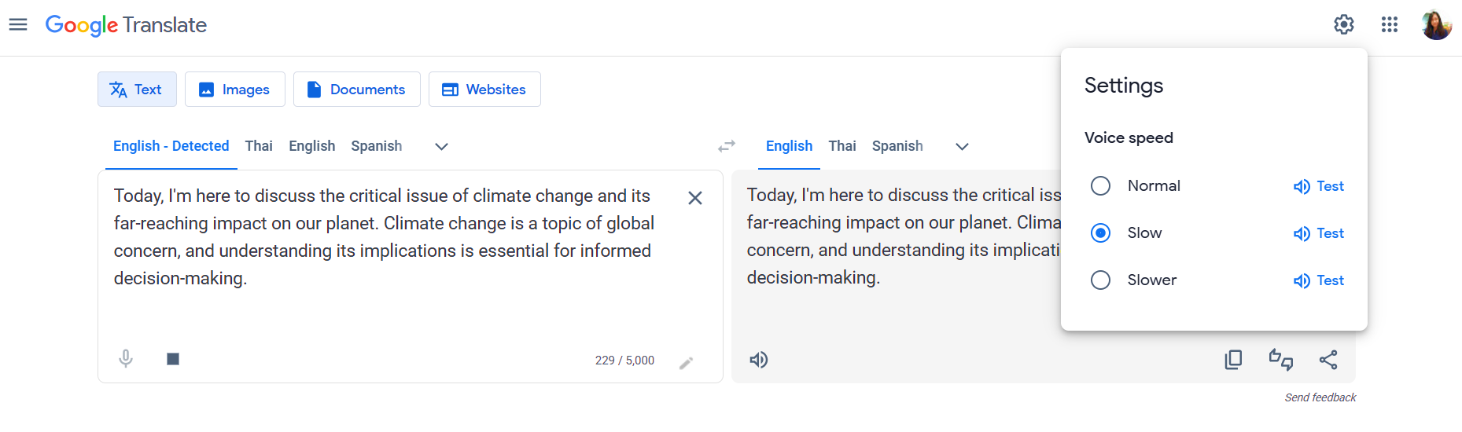

To provide immediate feedback

After learning the pronunciation, students can start practicing their own pronunciation by speaking out and letting the program transcribe what it hears by clicking on the ‘translate by voice’ button. By doing so, the students are noticing how the program or interlocutor perceives what they say and considering if those are words intended to be said. Then, words, phrases, or sentences can be identified when they need enhancement.

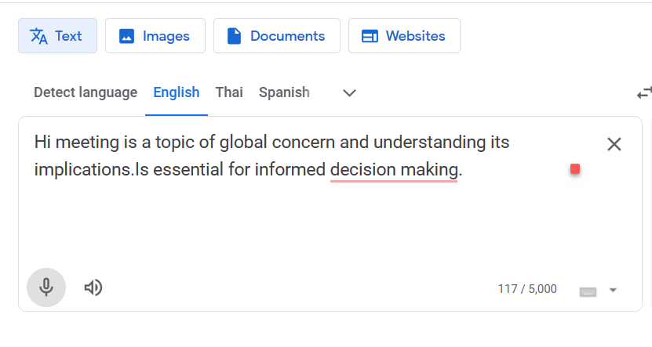
Students can keep practicing these two techniques from time to time until they gain more confidence in them. The issues of time and place to practice speaking skills can be forgotten in this case; students can practice their skills both whenever and wherever.

Students’ comments

By introducing this activity and having students practice speaking skills throughout the semester, most students reacted positively, and some pointed out limitations.
- A good tool for doing self-reflection
By using the program to teach and to transcribe their speeches, students can observe how well they can perform and whether they need to enhance any spots to be more ready for a particular oral presentation. “I can see my mistakes and improvements after hard practice," Student A said.
- It’s like playing a game.
Since this function is new to the student, particularly in language class, along with the provision of immediate feedback by the AI, it’s challenging for students who aim to get all words correct as they intended; they need to repeat the process multiple times. It seems like they are playing games and trying to overcome the quests by keeping practicing their pronunciation until they are all correct.
- A good opportunity to promote self-esteem
Students regard this activity as a very meaningful activity to allow them to really practice speaking skills with unlimited immediate feedback. When the students can see how they can overcome their weaknesses, it can raise their self-esteem and give them more confidence and motivation to keep practicing and enhancing their speaking skills. “This is the first time I can see myself doing something well. I had never pronounced the sounds of /s/ and /k/ correctly. I keep drilling and dare to say it without getting shy, like I did in front of other people. Finally, I can say it, and the program can hear my /s/ and /k/. I appreciated myself a lot, which I had never felt before," said Student B.

Limitations

Some limitations and challenges still occur for both teachers and students. First, due to the capacity of students’ devices and connections, sometimes it’s hard to access good practices. Rather than receiving encouragement to practice, some students experienced discouragement. Another challenge was that the AI program couldn’t accurately recognize proper nouns or words, especially those from other languages, such as Thai names or specific places. Therefore, it was like the students still had error mistakes to fix; it became guilt.

In summary, I think this activity is successful in terms of providing chances for students to practice speaking skills and receive immediate feedback without getting shy throughout the process. Having AI as an assistant is a good practice for a teacher who has several classes to take responsibility for. This is just an example of how we, as language teachers, apply available AI in our classroom. I am sure that by the time this article is published, there might be other useful applications or programs launched on the market that we can make use of as part of our teaching. Keep updating on new trends. Using AI as our assistant rather than having it replace us as teachers is one way we may contribute to our community!

Please check the Pilgrims f2f courses at Pilgrims website.

Please check the Pilgrims online courses at Pilgrims website.

