Present Continuous: Theater Clowning in Learning the Language of the Other
Robert McNeer, Italy

Robert McNeer is cofounder of the innovative cultural center “La Luna nel Pozzo” in southern Italy. There he runs a summer festival now in its 20th year. He is also an actor and theatrical author (recent titles include “My Own Private Ithaca: the Odyssey for non-Swimmers”). He is a clown and theater facilitator who has worked with Danish hospital clowns, European Waldorf educators, and German inclusive work communities. www.la-luna-nel-pozzo.com
E-mail: teatrolalunanelpozzo@gmail.com

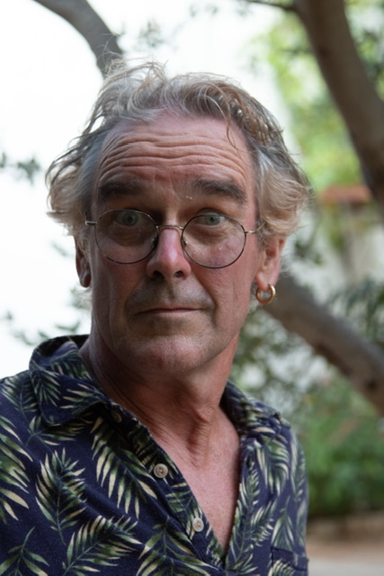

“What has been formed is immediately transformed again, and if we wish to arrive at a living perception of nature, we must remain as mobile and flexible as the example she sets for us.”
(Goethe, 1959, p.18)

I would like to talk about the place of theater and improvisational clown techniques in the learning of foreign languages. I have in previous editions of HLT and elsewhere described my use of these tools with English language teachers in the context of “English Week” (McNeer, 2003; McNeer, 2013, McNeer 2022).

In this article I am expanding the term “foreign language” to include not just that of a culture or nationality different from one’s own, but also the “foreign languages” spoken, not always verbally, by those whose cognitive and perceptive capacities are radically other. To explore this thought, I will draw upon my experience of theatrical work with people with cognitive disabilities here at La Luna nel Pozzo in southern Italy, as well as our theatrical collaboration with the inclusive Eins und Alles community near Stuttgart, Germany (https://www.eins-und-alles.de/).

Following Rudolf Steiner’s suggestion that the different languages in our world shape the inner life and viewpoints of their speakers in their own ways - revealing unique and totally varying aspects of human nature (Steiner, 1923), I would propose that the more other the foreign language learned is, the greater the imaginative stretch necessary to become fluent in that language, and consequently the greater the scope for the newly-expanded inner life of the learner.

In the case of actors with cognitive disabilities, and in the context of theater (not only tolerant, but positively welcoming of ambiguity) the mutual effort made to understand and be understood — between actor and actor, actor and director, actor and audience — creates a language field in which this expansion of the inner life of the participants, fueled by willed imagination, is reciprocal and joyfully exponential.

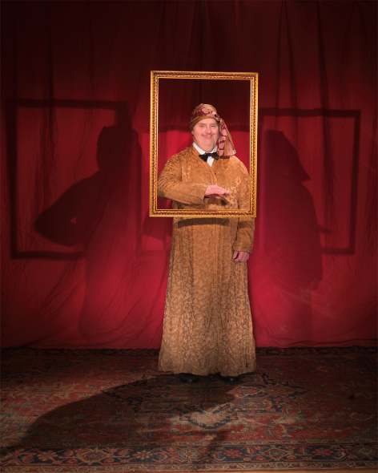

Massimo delights in making the audience laugh. He has the melodramatic visual vocabulary and the comic timing of a silent screen actor: One of his favorites is dying center front, miraculously resuscitating with “O sole mio…”

Special needs? Or special skills?

In our cultural center here in Ostuni (Brindisi province), Italy, my wife Pia Wachter and I have been working theatrically with people with cognitive disabilities for more than twenty years. Especially with regards to the theater clowning aspect of our work, I am constantly reminded of what a remarkable presence our actors have, and the brilliance with which they negotiate the theatrical space. (To avoid misunderstandings: The clowning work we have developed here, “Lunar Clowning”, is in the tradition of the “theater clown”, based on improvisation in an open, vibrant dialogue with the audience, the other actors and the space. This clowning has nothing to do with the skills and techniques of the “circus clown”, such as tumbling, juggling etc.)

At one point in time, the usual term for the actors we work with was “special needs”. I think, this term is no longer in general use, and rightly so, as it’s rather misleading. In my experience, the fundamental needs of these people are universal human needs: to be seen, to be understood, and to be included.

To be seen
Especially here in southern Italy, where there is a real dearth of public or private support programs in this sector, the people we work with tend towards invisibility in society. After 8th grade, when they can no longer follow the intellectual rigors of the school, they are commonly passed back to the attentions of the family, sometimes the church, and whatever time-occupying activities are proposed by the municipal or provincial government. Invisibility is a real problem.

To be understood
These people are often rendered invisible in “normal life” for the simple reason that they are not understood. Many of them have speech defects, and/or such slow or erratic response patterns that many people are put off from dialogue, not having the patience, or interest, to understand them. In this sense, their languages are indeed very foreign to their interlocutors. Regional dialects are very much alive in Italy, but more than dialects, these people speak idiolects: they are often nations of one, understood, at best, by a few close family members.

To be included
Neither being seen, nor understood, can naturally result in a sense of isolation. Of course, Italian family ties are very strong but outside of the family the support system is very sparse, especially here in the south. Once the school years are finished, the sense of inclusion in the collective identity of the club or sports team, of being a part of a larger social picture beyond the family, is rare.

To be seen, to be understood, and to be included — these needs are very alive in our actors, but as you will have noticed, there is nothing in any way special about them. Their fulfillment is of course very different in each case but the needs themselves are not special at all. On the contrary, they are so universal as to define us, in some ways, in our humanity.

The theater which we practice, inasmuch as it sincerely looks to address these needs, takes on an existential importance. Theater can address deep questions with other than cognitive intelligences: the emotional, social, kinesthetic, spatial, rhythmical and musical senses are all vital parts of its vocabulary.

And theater is a profoundly communal experience: it only happens when witnessed. And the manner in which we observe one another is of fundamental importance.

And there was light

Our clown work is grounded in what the humanist psychologist Carl Rogers called “unconditional positive regard”. In a beautiful image, he compares looking at a human being with looking at a sunset:

“When I look at a sunset, I don't find myself saying, ‘Soften the orange a bit on the right hand corner.’ I don't try to control a sunset. I watch with awe as it unfolds.” (Rogers, 1980)

Unconditional positive regard comes from a capacity to witness the remarkable in the ordinary, and helps one to perceive process more than result: not what you are, but what you are becoming. The open-endedness of this gaze, the sense of ongoing potential, is critical to the clown’s philosophy.

Carl Rogers noted how important this attitude is in the therapist, creating an energy field in which the person so witnessed can flower, discovering in herself resources which she might not have known she had. This is an attitude which I carefully nurture when teaching teachers, as I consider it fundamental to the learning process. Many of them struggle with this practice, having such ingrained cognitive structures of judgment: judgment of themselves, inextricably entwined with judgment of the other. My work often involves the painstaking dismantling of these ingrained attitudes.

And here is the remarkable thing: this vicious cycle of judgment and self-judgment, so deeply entrenched in the “normal” people that I work with, is basically non-existent in the differently abled people that I know. (A side note: Terminology is daunting. Many terms have come and gone, some wildly inappropriate, some cruel, some just silly. My favorite is the famous fairytale, “Snow White and the Seven Vertically-Challenged People”. I tend towards “differently abled”, especially in a theatrical context, for reasons that will become clear, using “cognitive disabilities” when speaking in a more general context. The problem comes of course from generalizing about individual truths.) Their lack of self-judgment makes these actors brilliant theater clowns, charged with an optimistic spontaneity which is disarming. Our actors have what I call the healthy egoism of the child: all of them, always, are ready and eager to get onto the stage, to bask in the attention of the audience.

And critically, they bring exactly the same enthusiasm to their gaze as an audience. And this is their genius: these remarkable humans are living fully, without calculation, Carl Rogers’ “unconditional positive regard”. And the results are exponential: The pure joy generated here on our Tuesday theater evenings is immeasurable. These people are in such empathetic resonance with the events onstage that those events are enormously enriched. It is reciprocally generated, i.e. in dialogue between performer and audience, such that both performer and audience are transformed.

Present continuous: Being here now

I call the state of these actors “present continuous”, effortlessly carrying the audience with them into an ongoing world of empathetic resonance, as fluid and transformative as nature herself. This is the state into which Goethe invites us, in the quote above, in order to profoundly engage with the world. Our cognitively disabled actors have an intuitive access to this state, a high form of intelligence unfortunately unrecognized by the cognitive institutions most of us grew up with.

In this sense I consider these people to be teachers: they are fundamentally at home in a world that we “normopaths” must struggle to enter, fluent in a language which fascinates us but which we have imperfectly learned.

And theater clowning is a marvelous vocabulary for practicing this language. I have taken to inviting one or another of our Down syndrome actors to participate every time I lead an intercultural clown workshop here at La Luna nel Pozzo. People are often surprised to discover that one of the clowns has Down syndrome. But as soon as we start playing, it becomes clear who is teaching whom. At this point, the term “disability” is just silly. We could call them “differently abled” as long as we recognize that in this context “differently” means more able, and not less so.

I find the presence of an actor with Down syndrome the most efficacious way to help people enter the clown’s state of joyful unknowing, innocently open and happy to try anything, to go anywhere, to say “yes”, rather than “let me think”. This is a language worth learning, and our differently abled actors are proficient, and prolific, teachers.

Turning tables

One of my most satisfying teaching experiences has been when we bring our actors to help us teach theater courses in the local high schools. It’s wonderful to see the reactions of the adolescent students, leaning on the wall with their arms folded over their chests in a “yeah, whatever” attitude, when my wife and I enter, two elderly flower children, followed by a motley crew, unkempt and befuddled. The youngsters have no idea how to take this, there are no available canons.

But once the first game starts — the “name game”, for instance, in which one after another in the circle pronounces their own name with a made-up gesture, to be echoed by the whole group — that’s when our actors hit the ground running. And the school kids recognize, “These people are amazing clowns: they are completely themselves, they’re funny, and they’re fearless.”

And that’s when the miracle takes place — usually in the first 20 minutes — when the adolescents drop the cynical act and jump in to play: joyful, and grateful. Because our actors have taught them, quickly and effortlessly, that it’s okay. It’s okay to be different. In fact, it’s a lot of fun. That’s when the adolescents start saying: “I want to go onstage with Massimo! With Francesca! Let me! Me!” That’s when the tables are turned, when the “disabled” are ably leading the “abled”, and everyone’s just fine with that, joyfully ready for more. That’s when the adolescents, learning a new language, can change viewpoints, as Steiner suggests, finding in themselves another “I”, more fearless, and much more fun.

These are moments of initiation into what I think of as a community of kindness, moving mostly under the radar, but occasionally bursting forth in gratuitous public acts of joy and gratitude. One such public celebration is our annual visit to Eins und Alles in Germany.

“One and All”

Eins und Alles is an inclusive work- and residential community near Stuttgart. We have had the privilege and pleasure of collaborating with them theatrically for the last several years. In this ongoing project, we have annually coproduced an inclusive international theater production for their autumn “KunstSinnFestival” since 2017.

Regarding the question of social engagement with disability, our annual autumn pilgrimage to Eins und Alles is like ascending through many of Dante’s circles to something which looks to our eyes like paradise.

Their community is based on anthroposophical principles. They operate in the understanding that the spirit of those with and without disabilities are of equal dignity, needs, and capacities for development. Consequently, persons with and without disabilities have equal standing in the community. The subsequent dialogue is articulated in innovative and perhaps unexpected ways.

Nestled in the forested hills outside of Welzheim, the visitor to Eins und Alles (a good weekend can see 2000 visitors, between families, school classes, art and nature lovers) will find

• a café and coffee roasting laboratory
• an organic restaurant
• an animal “oasis”
• an interactive “perception museum”
• a sensory sculpture park
• a “blind house”, to be explored without sight

All of these attractions are staffed by people with a wide spectrum of abilities.

This is a far cry from the southern Italian perspective, in which our differently abled friends struggle simply to be seen, understood and included, and can’t dream of having meaningful employment, of spending their own wages or inhabiting a place of their own, independent of their families. Visiting Eins und Alles is, for the differently abled Italians and the caregivers who are accompanying them, entering very foreign territory indeed.

But you wouldn’t know it to see the reactions of our actors and their German counterparts (see “Perfectly Imperfect”, https://youtu.be/HmjJdkBNBUk). From the first moment they meet, it is like the reunion of long-separated family: embraces and hoots of laughter and conversation. The fact of not speaking the same language doesn’t seem to give anyone pause: their common language is delight.

It is a deeply-felt sense of joy which has fueled our ongoing project from the start. This is the motor which has helped us create plays ex novo — from improvisation, with about a week of rehearsal time — year after year since 2017.

Time, not timing

1: Ask me why I am the greatest living standup comedian in the world?
2: Okay, why are you the greatest living standup comedian in —
1: Timing.

This joke points to an important question in theater vocabulary which it shares with music, and in fact with communication in general: The question of timing. The audience laughs, if it does, with (usually unconscious) pleasure in rhythm, in this case with the unexpected interruption of rhythm.

A musician who we’ve collaborated with talks about the relationship between our differently abled actors and musical meter; about the metronome as the representation of “standard” or “objective” rhythm. He says he recognized quite early in our work together that in order to successfully collaborate with these people, we would have to “throw out the metronome”.

This approach invites us to call into question not just the standard of rhythm but a lot of standard assumptions about theater: that those who move more easily are the best dancers; that those who understand the words are the ones who should monopolize the dialogue; that obsessive behavior should be necessarily repressed…

We have one German actor from Eins und Alles - I’ll call him Manfred Fuchs - who, due to some sort of a mental deficit, doesn’t appear to follow the thread of the argument at all, or very little. He has some speech, but it consists mostly of clichéd conversational fragments (“Well you’re a fine one...” or "That’s the ticket…”), comic parodies of the way many people speak to him. He tends towards long, rather autistic sequences in which he slowly pulls his pockets inside out, or examines the front and back of his hands with the solemn gaze of Buster Keaton, suddenly breaking out with manically jovial non-sequitur: “There we go! He’s the man…!” He’s deeply and apparently unwittingly comic, much appreciated by the others, who are very affectionate and amused in his presence. But with time we have realized that he is, in fact, following more than he appears to, following rhythmical games, for instance. If we pass a clapping rhythm around the circle and his turn comes, he slowly absorbs the waiting silence, looks around to each in turn, traces the trajectory of arrival, takes his hands out of his pockets, looks at them, looks at us again, looks to where he is to pass the rhythm, at us again, then claps his hands, once: “That’s the ticket!” Every move is consequential, but there are so many steps, and so slowly taken, that he appears to be in another, more or less parallel, world.

In one of our productions, we gave Manfred the role of the philosopher: dressed in a toga, with a laurel wreath on his brow. He stood in the middle of a circle of actors who imitated all of his actions as precisely as they could. As he gazed thoughtfully and silently into the middle distance, so did they. If he turned inside out one pocket at a time, or held up one finger to examine it minutely, so did they. If he spoke, they nodded their heads in solemn appreciation of whatever cliché was verbalized. Manfred meanwhile, with great dignity acknowledged their attention.

The scene was perhaps five minutes long. Sometimes very little happened, sometimes more. Sometimes he spoke, and sometimes he chose not to. I was very interested in the audience‘s response to this scene, and I discerned two different currents. Those who knew Manfred as a bit of a clown laughed early, and knowingly. If he did something, they quickly responded, although they seemed to become a little hesitant when very little happened. Those who were meeting him for the first time, on the other hand, brought a different quality. They were ready to enjoy the scene but not sure what he was “supposed” to do. Their laughter started perhaps a little more hesitantly but they seemed to relax sooner into the scene’s rhythm. As the minutes went by, and there were no signs from the other actors that anything was amiss, I had the feeling that the slowing rhythm of the first group met the gradual opening from the second group until we were all of us, audience and actors, united in giving our full attention to Manfred, who was fully aware of everyone’s attention — and enjoying it with dignified pleasure — as he himself listened to the listening in the room. It was for me a beautiful embodiment of “the philosopher”.

It was also very moving. In that scene Manfred reminded me of the art of Billie Holiday, who used her very limited vocal range (just over one octave) and a very quiet voice to bring the audience so close to her that we can sense with awe the vastness of the soul which expresses so much with so little. She also used unexpected rhythms — often just behind or just in front of the beat — to offer us a breathtaking glimpse at her very being, a new and deeply personal language. In “Embraceable you”, for instance, her remaining implacably behind the beat gives us a sense of what she is not saying, such that a pretty straight-forward lyric takes on a remarkable, mysterious depth.

We work on the assumption that our actors are intrinsic artists but that we have to learn their language in order to share that art. And when we do, they will shine with their unique beauty.

I’ve spoken of Manfred trying to tease out some of the rich subtleties of a few minutes on the stage. But each actor has his own dialect: one with the physical comic sense of the English music hall; one with a phenomenally stretched physique, rhythmic-obsessive rocking and a booming bass vocabulary of three phrases: “Bye-bye, Urlaub”, and “Nutella”; one woman who never speaks, but when she smiles she lights up the stage…
Our job is to create the context in which each of these deeply personal sensibilities can move the space, advance the story, and illuminate the audience with the miracle of pure being.

We are able to do this because we are interested in time, rather than just timing. It’s true that we put the play together at Eins und Alles in a few short days. But it’s also true that behind those few days are many more that we spend together, not mounting the play, but just being together, relaxed and interested.

With the Italians we’ve been leading an ongoing weekly evening in which we practice theater games together — mirroring, echoing, rhythmical dance and clown exercises — for almost ten years. We sometimes conduct joyous “Clown Down” happenings, open workshops in which they invite the audience to join them onstage. Of course, that’s not possible for the Germans, but they do spend a week here in springtime, an intensive theater workshop, as well as sightseeing and swimming in the sea.

This is a chance for us to enter into relaxed dialogue with them, unencumbered by a priori ideas of what is “right” or even what is “necessary”, practicing Rogers’ “unconditional positive regard”, to really see and understand one another, enjoying a community of kindness. And we have learned this language from them, from their perennial, nonjudgmental enthusiasm.

Of course our Italian/German team — directors, musicians, scene designers, actors and caregivers — brings the experience of many years of creating theater, with the skills to give coherent, repeatable form to improvisational settings. But the dialogue mastered — between actor and actor, actor and director, actor and audience — is only partly attributable to what we professionals bring to the table.

The challenge in our theater work with these remarkable individuals is to help the audience, in just an hour’s time, to become sufficiently versed in the many idiolects spoken, manifesting the deeper truth enfolded in a kaleidoscopic vision.

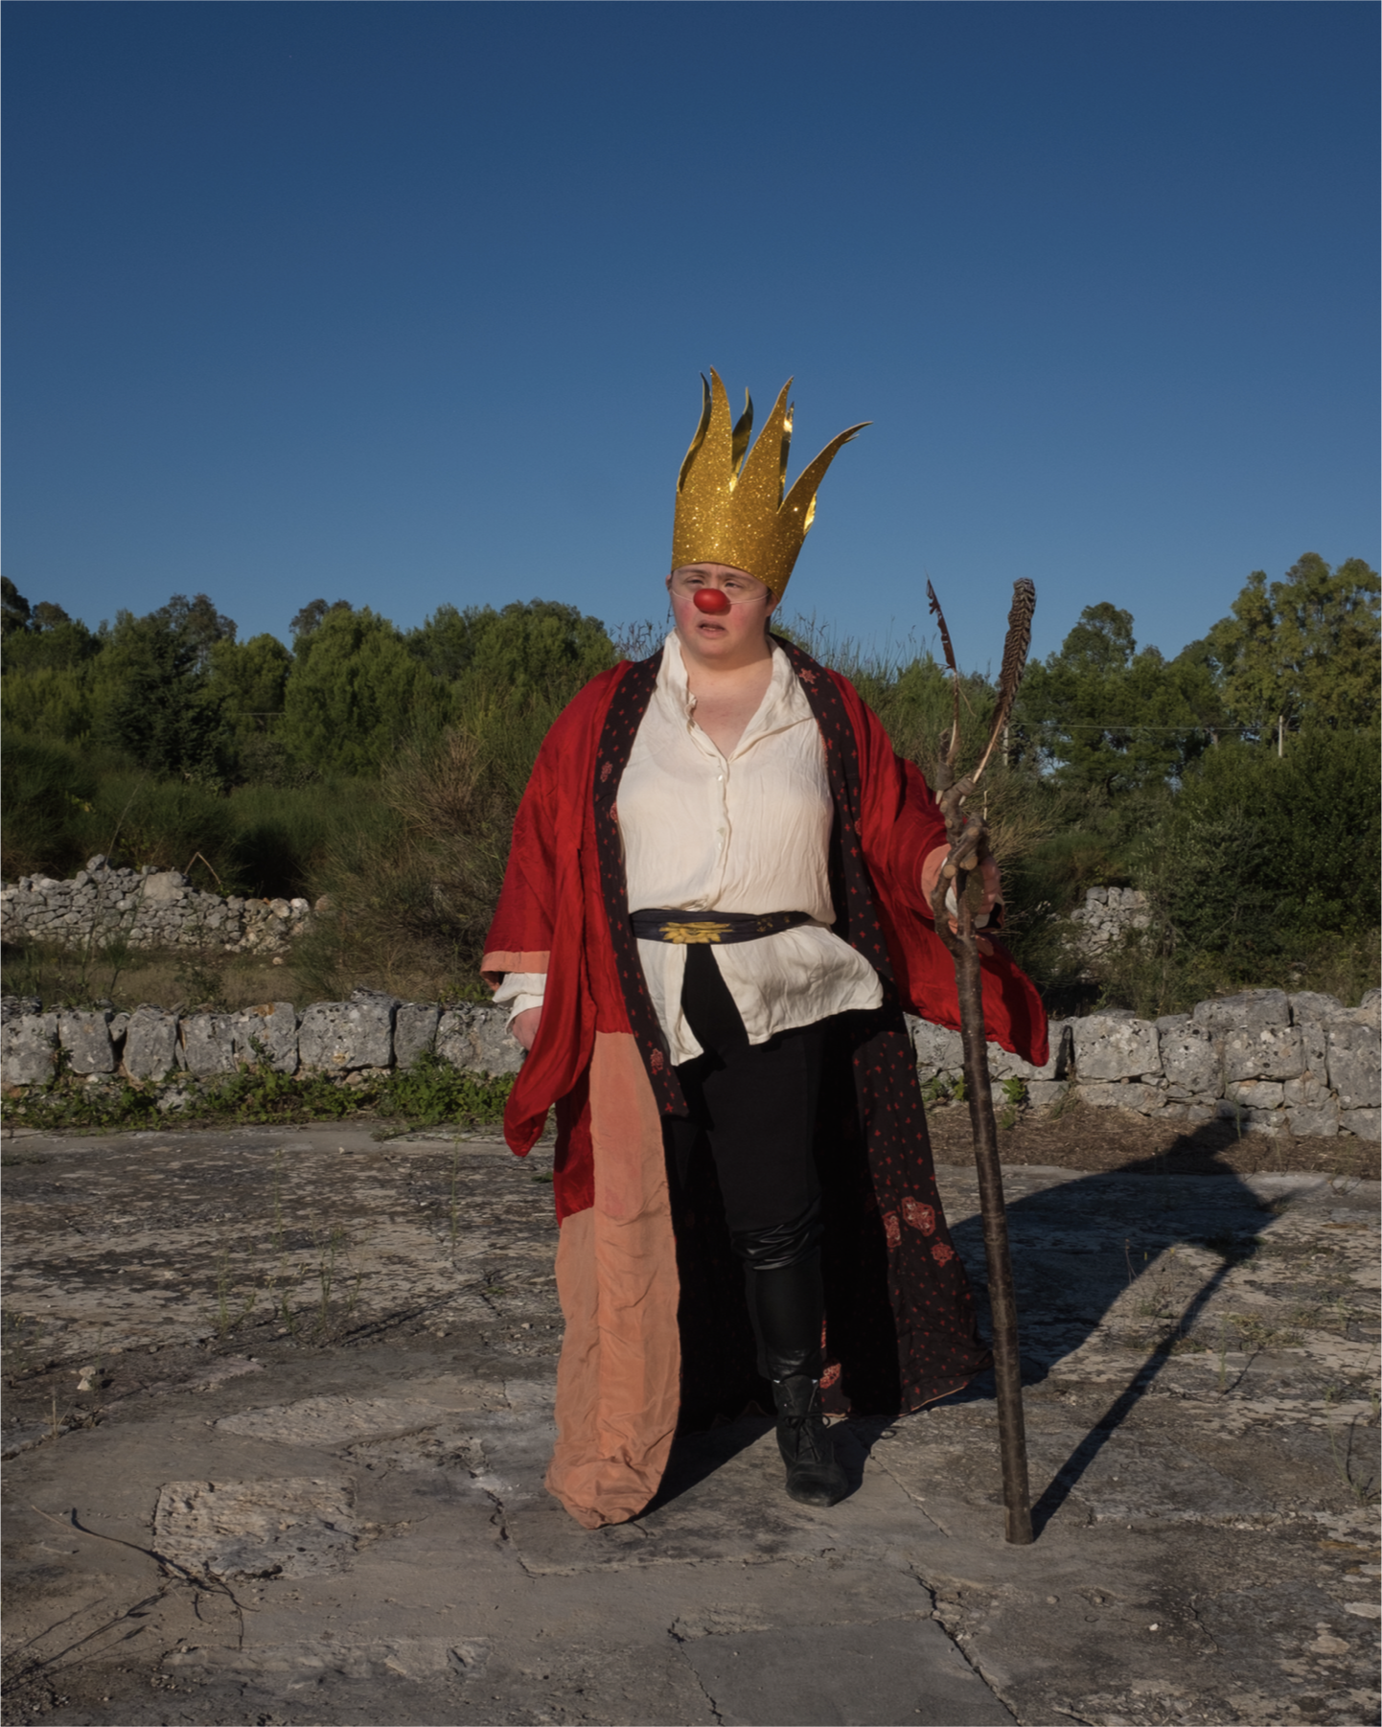

Francesca has a sort of echolalia, verbally and physically imitating her stage partner. At the same time, she presents as a complex character in her own right: She likes to play a sorceress, practicing magic movements between martial arts and voodoo.

Mind the gap

With these intentions we approach the final encounter, that with the public. Our productions are always a kind of communal falling in love, in which the audience gradually realizes that they are not going to watch “disabled” people doing their best with the help of their selfless caregivers. Instead, they witness an artistic explosion in which the distinction between “abled” and “disabled” is meaningless: a glorious parade of fiercely individual artists weaves a rich tapestry between laughter and tears.

I have no doubt that the joyful excitement which characterizes our plays, and, in fact, the whole period of our visits, is in large part due to, and not despite, the vast gap between our native tongues. It is not always easy or comfortable, creating a show in the conditions we have. But the profound engagement of the imagination required to bridge that gap — between the cognitive, pseudo-rational language to which we “normopaths” are accustomed, and the wild, emotional, obsessional free-association of our non-cognitized friends — this willed imagination is its own reward. It is high octane co-creation of reality, the stuff that dreams are made of.

And not just dreams. One of the actresses in our last show had, weeks before, hurt her foot and was still letting herself be pushed around in a wheelchair, although in theory she could have long since begun walking. In the story one of the characters, a cleaning man who accidentally finds himself piloting a rocket through a shower of shooting stars, invites the audience to make a wish. Swept into the narrative, the mother of the actress in the wheelchair silently wished that her daughter would find the motivation to walk again. And when the final song arrived and all the actors were dancing, the actress was so happy to join that she stood right up, stood up and sang. This is the power of imagination.

“Imagination is more important than knowledge” (Einstein, 1924)

As I’ve said, I consider these people to be my teachers. By that I don’t mean to imply a hierarchical relationship: Yes, they are instinctively beyond me in their capacity to live in the moment as great clowns. But teaching is also a dialogue, to which, as Steiner reminds us (Steiner, 1923), each speaker brings an inner life, a unique viewpoint. To the dialogue I personally bring a sincere curiosity regarding the encounter itself, a deep appreciation of the improvisation of words and gesture which is language.

Following Goethe, I hope to remain as mobile and flexible as nature herself, that those words and gestures, alight with imagination, may bridge the gap between us with continuous presence: an improbable and deeply satisfying dance of meaning.

- - - - - - - - - - -

The photos are by kind permission of our scene and light designer, Tea Primiterra. They are from her photo project, “Onirinauti” (“DreamDwellers”), expected in book form in 2024.

References

Einstein, A. (1929, Oct. 26). “What Life Means to Einstein.” The Saturday Evening Post. https://archive.org/details/WhatLifeMeansToEinstein_201712.
Goethe, J. W. v. (1959). Faust, Part I. Translated by P. Wayne. Penguin Books.
McNeer, R. (2003). Teachers Learn Stage Presence and Poetry Speaking or: Eternity’s Sunrise. HLT 5 (1). http://old.hltmag.co.uk/jan03/sart7.htm
McNeer, R. (2013). Mime, Metaphor and the Wildness of Words. HLT 15 (5). http://old.hltmag.co.uk/oct13/sart03.htm
McNeer, R. (2022). Listening at the Threshold: Perceptive Play with Voice, Word and Body. Scenario XII (2).
Rogers, C. (1980). A Way of Being. Houghton Mifflin Harcourt.
Steiner, R. (1986). Gegenwärtiges Geistesleben und Erziehung. (GA 307). Lectures, Ilkley, UK, August 1923.

Please check the Pilgrims f2f courses at Pilgrims website.

Please check the Pilgrims online courses at Pilgrims website.

