The Teacher Trainer Journal (the TTJ) from Pilgrims

Phil Dexter, UK

The Pilgrims Teacher Trainer Journal has been published by Pilgrims since the early 1980’s initiated by Tessa Woodward and supported by Marian Nicholson with high reputation in the world of ELT and teacher education. Initially as a print journal and since 2006 also in digital format. In 2020 Tessa and Marian decided to focus on other professional interests and I was asked to take on the management and editing of the journal. The journal is now digital only and is free to access without subscription published four times a year. Tessa ensured the highest professional quality and standards in the publication of the journal for over 40 years. An essential aspect of these standards is that we can all learn from evidence informed global good practice though understanding how global good practice is reflected specifically in different local contexts is an important element in understanding the meaning of humanistic teaching and learning. These are standards and an approach I aim to continue and reflect in the journal.

To access the Teacher Trainer Journal, go to https://pilgrimsttj.com Scroll down and you will see this image
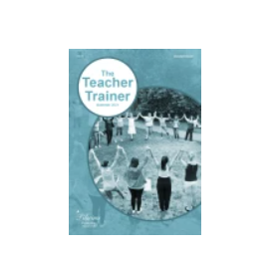

Click on the image - the first time you may see a site map. Click on continue and this will disappear and you will go directly to the flip book version of the journal. When you have opened the journal you can scroll back and forward through the journal pages. Any links in the articles or the references can also be accessed. If you are looking for the extensive archive with content going back to 2006 go to the menu on the top right hand side of the page. In the current issue there is an index of contributions in digital form from 2016 onwards.

Top news is that we have begun a very exciting cooperation with the British Council Teacher Educator network and in the next issue, in April, we will be reviewing a range of booklets that have been produced on teacher education available on the British Council Teaching English website https://www.teachingenglish.org.uk/publications/case-studies-insights-and-research. The reviews will be on the themes of inclusive practices and special educational needs, research, motivation/creativity and teaching and learning online

We would love to receive contributions in terms of articles, interviews, book and resources reviews from teacher educators globally.

A brief description of the guidelines for writers can be found on the website. For more detailed information contact Phil - phil.dexter@pilgrimsttj.com

Phil Dexter
Editor
Pilgrims Teacher Trainer Journal



