Incorporating Foreign Languages into a Concept of Experience-Based Learning: A Short Report on a New Project

Miriam Watson-Kastell, Germany

Miriam Watson-Kastell is a teacher at the Freie Waldorfschule Marburg, Germany. For several years, she has been part of a group of Waldorf teachers, who share ideas about experience-based learning. Her current professional interests are health, education and drama.
Email: m.watson-kastell@waldorfschulemarburg.de

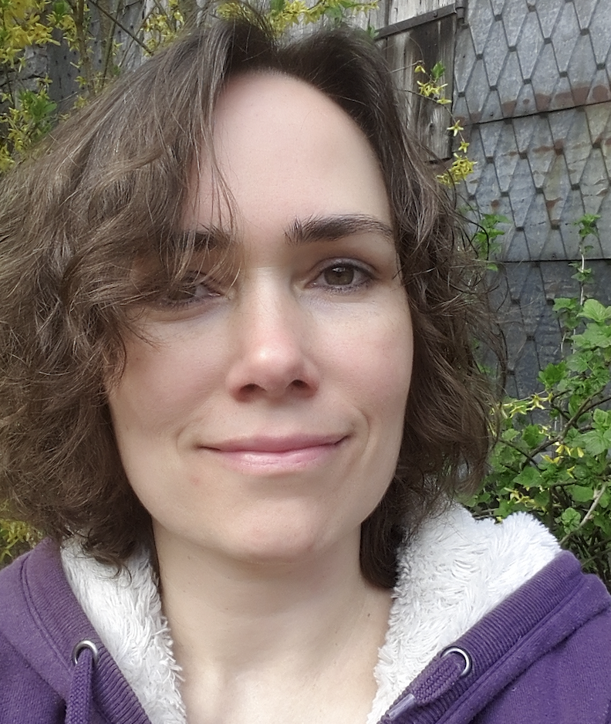

In recent years, numerous discoveries from the neurosciences have significantly improved our understanding of the nature of learning processes and consequently changed our ideas of schooling. One direction this research can lead to is the concept of experience-based learning which has always been a part of the Waldorf curriculum.

There are currently several initiatives in Waldorf education which work towards integrating a combination of traditional Waldorf pedagogy and new approaches to experience-based learning. In developing concepts like these it also becomes necessary to find new ways of incorporating the foreign language lessons into this approach to learning. In 2022, the Waldorf school in Marburg, Germany decided to offer a second grade 1 (in addition to its traditional Waldorf class 1) which started with 12 pupils and aimed at a more practical learning path. As the class and English teacher, I will try to explain the concept and the way foreign languages are taught.

Unlike in a traditional Waldorf context, there is no weekly schedule and there are no subjects (apart from eurythmy - an expressive movement art developed by Rudolf Steiner). The only existing structure is a daily routine of different learning phases which are defined by the place and the role the teachers play in the learning process. Every day starts with a phase of free learning/playing, which we call the “children’s time”. There is a range of options (games, toys to train different motoric skills, crayons, books and an outdoor space) and the children choose for themselves what helps them to ‘arrive at’ school and to find their place within the class. Throughout the course of the lower school years, this is slowly transformed into a time for individual repetition or student projects. On average this phase takes about 15 minutes.

The next phase is called “class time” which means that the whole group works together following the input of the teacher. In this respect, it is similar to the main lesson in a traditional Waldorf classroom. After a ‘rhythmical part’ consisting of songs, rhymes or other group activities, the children usually work on the standard topics of arithmetic, writing/reading and drawing. The class time finishes with a communal breakfast and a short break in the school yard and lasts, on average, about 80 minutes.

The next phase, which we call the “doing time” (Schaffenszeit) can take many different forms but often takes place outside of the classroom. We have access to a nearby garden which offers the possibility to play or work. We also have a small wooden hut which can be used as a workshop and sometimes the large school garden or woodwork workshop are available. The activities during this phase can either be things that actually need doing (like collecting apples in the school garden), things that we choose to do (like baking an apple cake) or creative activities (like working with clay). The activities are often voluntary and there is also the choice of simply playing instead, but certain activities are obligatory. This phase takes about 90 minutes and can be followed by another short break (if necessary).

The school day finishes with a 30-minute communal phase of “story time” which means the teacher tells a fairy tale or another kind of story, but it can also include a final game or a review of the day.

Being the English teacher of my own class, I am very flexible in the way that I integrate my language lessons, but I have had to find a way to incorporate French into our curriculum as well. We follow the established concept of periodic language teaching at our school which means that the class has a period of 4 or 5 weeks of English lessons and then a period of 4 or 5 weeks of French lessons. Together with the French teacher, I decided to have an English or French day once a week. That means that we aim to let the whole daily routine take place in the foreign language. For English, this means that during the children’s time I try to speak to individual children in English and ask them simple questions about their activities. There are often other adults (e.g. a volunteer or an intern) present, so I speak to them in English about my plans for the day. Afterwards, the class time is held in English and since the children are very familiar with the way we work it is no problem for them to follow the instructions. So far, I have only made an exception for the work on the alphabet because I wanted to introduce the German letters first. But it is quite possible to teach arithmetic and drawing in English in grade 1.

For the practical phase, I have tried to choose activities that do not require too much explanation, or that repeat topics that I want to practise in the foreign language (like counting). The day ends with an English story (and sometimes a game). Since the children find it rather challenging to listen to English the whole day, I sometimes choose to have a certain part of the daily routine be in German to give them a break, but the ideal would be to keep it completely in English throughout this day. I often choose a song or rhyme which we also practise throughout the week, or I tell an English story several times to increase the language input.

For the French periods our French teacher joins us for almost the entire day and works in a similar way with the class. When possible, I team-teach with our French teacher which gives me the opportunity to also incorporate aspects of the French lesson throughout the week.

I can not draw on years of experience with this new way of teaching foreign languages in the lower school, but in my opinion it addresses a lot of the problems which frequently occur nowadays in teaching foreign languages. In more traditional Waldorf settings, there are increasingly children who find it difficult to join in during purely oral English lessons, yet become fully engaged and happy as soon as they have “something to do”. They also often find it fascinating to listen to a conversation in English which team-teaching allows for more easily. Even children who struggle with languages but have great practical skills can become “good in English” because they really want to be able to join in with the practical activities.

I have not yet developed a definite plan of how this concept can be continued in middle school, but more intensive exposure to the foreign language by adding a second English/French day or longer phases like occasional English/French weeks and hopefully/eventually a trip to England/France or an exchange could be possibilities.

For this new method, foreign language teachers must be willing to expand their skills and learn more about teaching the topics of the main lesson as well as practical skills. From my own experience, I can already say that I find it very rewarding to be able to combine my English skills with other interests.

Please check the Pilgrims f2f courses at Pilgrims website.

Please check the Pilgrims online courses at Pilgrims website.

