Learning in the Foreign Language about the World, the Other and the Self

Ulrike Sievers, Germany

Ulrike Sievers is an English teacher at a Waldorf/Steiner school in Hamburg. She is interested in all forms of creative writing and storytelling. She has published a book on a holistic approach to foreign language teaching and learning Creative Teaching, Sustainable learning (2017) and is co-initiator of the online platform for teachers www.e-learningwaldorf.de. She is interested in developing ways of deep learning by bringing creative and inclusive activities into the language classroom.
Email: ulrike-sievers@web.de

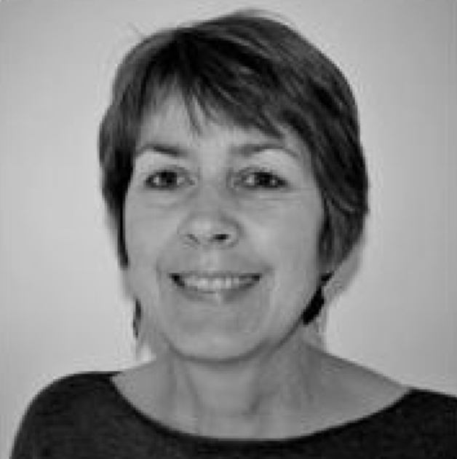

Introduction

I see the aims of language lessons not only in enabling learners to use words and structures correctly to express facts, thoughts, ideas and emotions in an adequate way - I see learning languages also as a chance to open up new views and perspectives on oneself, the other and the world. Language lessons can help pupils to develop courage and self-confidence, tolerance of ambiguity and appreciation of diversity. Hence learning a new language is supporting and enriching a learner’s personal development that reaches far beyond acquiring pure language skills.

In the upper classes, when the pupils have advanced in their skills of using English as a foreign language, we generally teach in the language rather than teaching about the language. Learning languages opens possibilities for young adults to develop their identity as well as an understanding of other people and other cultures.

As examples of this approach, I am going to share experiences and observations from two classes in which I teach English as a foreign language. I am fortunate to be able to teach in block lessons of 90 minutes per day for three weeks. However, similar projects can be taught in regular weekly lessons as well, they just need a longer span of time.

People who changed the world

In class 10 pupils are about 16 years old. In former years I have generally experienced this as an age at which ideals are formed and expressed. However, in recent years, I have observed that quite a few adolescents are already quite frustrated and disillusioned in their views on the world. Having been confronted with so much news about climate change, wars, catastrophes etc. some young people hold the view that “we can’t change anything anymore anyway and therefore it doesn’t matter what we do or don’t do.” This observation made me think about how I could use my English lessons in a way that would connect the pupils to the world of ideals again and would encourage them by giving them the chance to realize that there are and always have been people who fight for a better world and have changed the world for the better in some way.

I start the block or project on “People who changed the world” by introducing the biography of a person who has made some profound contribution to the fields of politics or society. As the pupils have often already heard about Mahatma Gandhi, Martin Luther King or Nelson Mandela in other lessons, I try to find less known people and start with the introduction of a woman, e.g. Wangari Maathai, instead. I tell the class about her life and ideas and we discover together what she has achieved by following her intentions. Language-wise this part is about listening to my narration, looking at some pictures, maybe reading a text and diving into the field of ideals and action together, as well as looking at the consequences these may have on a person’s life. At the end of this first phase, I introduce the project peacejam.org to the class and by watching an introductory video and looking around on the website, the pupils get an idea of the origin of this global initiative whose aim it is to encourage young people and motivate them to become change makers themselves.

In a second step, I provide the class with a collection of texts - some of them taken from the book We Speak as One - in which Nobel peace laureates “speak” to young people, tell them about their lives and ideas, and share some important messages with them. The texts have a manageable size of two to three pages. Additionally, I provide some texts about people who “changed the world” from other sources, always keeping in mind that the collection of all these people should represent a diversity in aims, cultural/ethnic backgrounds as well as in gender. The class is asked to divide into groups of two to three pupils who then have several lessons to work on their texts - each group chooses one person - find additional background information and prepare a presentation about their “change maker” which will be delivered to the class together with a poster at the end of the week.

After listening to all the presentations and getting to know people who have changed the world in so many different ways, we come back to the everyday heroes we are surrounded by. The question “Do you know any people whom you admire for what they do?” invites the pupils to think about people they know and it is always amazing to read about or listen to the stories that the pupils share (orally or in written texts). Encouraged by what human beings are able to do, the pupils are invited to develop their own little project or initiative with which they could make a change in some way. As class 10 students have got to know many different forms of analog or digital “texts” in their lives, the possibilities of such a project are vast and the results range from very practical activities such as baking cupcakes and bringing them to a refugee camp in town or helping in a homeless shelter to deliver lunch, to more literary forms such as writing poetry slam contributions about one’s dreams or writing a rap song about collecting garbage in your neighborhood and turning it into a music video - cutting and editing included.

Growing up

Two years later, in class 12, the pupils who are about 18 years old are about to leave school. They have become grown-ups and will potentially be parents themselves. I think that school also has the task to prepare young people for the huge responsibility of accompanying children on their way into this world once they might become parents themselves. Therefore, I like to use some time in my English classes to turn the pupils’ attention to the development of children and young adults. This topic is informative and reflective at the same time, providing basic knowledge about reflexes, motor development and the importance of free play for children in their early years and inviting the pupils to remember their own experiences and reflect on their memories.

Thanks to digital media there is quite a lot of valuable video material available, as for example, the film “Babies” which presents the first year of the development of four babies in four different parts of the world: Tokio, Namibia, San Francisco and Mongolia. I invite the pupils to observe closely the influences of the environment in the babies’ lives and at the same time to discover similarities in child development that are shown in the film. For young adults it is quite interesting to discover the developmental similarities between babies who grow up in such completely different surroundings and at the same time elaborate on the different effects that growing up in rural Mongolia in contrast to growing up in urban, ultra-modern Tokio might have on children. The topic is closely related to the students’ own experiences and memories.

Once we have moved on to kindergarten age, most pupils can remember their own childhood and they like talking about their favorite games, special emotional moments and early experiences of friendship. I use the chance to point out the importance of free play, using some governmental documents written for young parents in which the benefits of play are explained in a rather systematic way. Since the pupils at our school have been on a three-week-work experience in various kindergartens, we can also compare different pedagogical contexts. Along the way I assign different tasks such as retelling their favorite story, writing a letter to an early childhood friend in which they describe a conflict situation in retrospect or pretending to be a kindergarten teacher and formulating an email to the parents in which they explain the importance of play for a child’s healthy development.

Moving on towards school, they remember together the first day of school - compare this experience with classmates who started school at another place - and get a general idea of the way in which Waldorf pedagogy addresses and tries to support the various developmental steps that children and teenagers pass through on their journey to becoming adults.

In addition to reflecting on their own memories and listening to what I am telling them, they watch documentaries about educational concepts, listen to podcasts or watch TED talks about various childhood or teenage issues and they read stories in which childhood experiences are processed. In this way many different ways of expressing thoughts and feelings are brought to their attention - which opens the field for their own choices in the last phase of this project.

Their task is to choose any topic related to childhood and growing up, do some research about it, gather information and prepare some sort of presentation for the whole class. In class twelve, the pupils have learned about most forms of text - analog as well digital - and so they can choose the format that suits their topic and that they feel comfortable with. I am always amazed about the broad range of topics that the pupils come up with; some close to and motivated by their own experiences, others more out in the world. The diversity of topics is matched by the variety of formats, ranging from TED talks and podcasts, documentaries and explanatory videos, newspaper articles, informative presentations and classic essays.

Since the choice of theme is rather open/wide, the motivation is usually pretty high and the fact that all this is done in a foreign language is hardly noticed as a hindrance. With respect to correcting and giving feedback to these texts, I deal differently with different students. Depending on the language level of the pupils, I focus either more or less attention on basic language accuracy and a generally adequate structure and content, or I encourage the pupils to widen their language skills by looking up synonyms, trying out new sentence structures or including some new stylistic means. This feedback is given on a very individual level and enables the young adults to decide for themselves how much effort they want to put into improving their language skills. Regardless of the language level, the results are usually received with great interest by the class, each contribution is appreciated and also serves as a chance to practice listening skills.

Apart from the content level, which no doubt is worthwhile in itself, this block invites the pupils to try out various ways of expressing their thoughts and ideas. After 12 years of school, young adults have collected a lot of experiences - in lessons, in social classroom situations, in using another language - and consequently have something to say and give to the world. Thus, they are invited to find their own voices and share their experiences, their views and ideas with a broader audience - which might be the class or even other classes or parents as representatives of the wider world.

Conclusion

With these two examples of teaching English as a foreign language in classes ten and twelve, I want to show how learning another language or rather learning in another language can widen the experiences of young learners and hence contribute to their personal development. By learning about People who changed the world, young people learn about the power of ideals. In the context of the theme Growing up, pupils are invited to reflect on their individual childhood experiences and are introduced to some basic knowledge about child development and different pedagogical concepts. All in all, they are challenged to listen to various perspectives, develop the power of judgment, and formulate their own ideas in their own voices.

References

Sievers, U. (2017). Creative Teaching, Sustainable Learning, BoD.

Focus Features. (2009, December 1). Babies [Video]. Youtube. https://youtu.be/vB36k0hGxDM

Please check the Pilgrims f2f courses at Pilgrims website.

Please check the Pilgrims online courses at Pilgrims website.

